

**Aadithya Prabhath**

**A compilation of my lab reports from CISCO CCNP**

**CCNP LAB REPORTS**

Aadithya Prabhath

# Table of Contents

Table of Contents 1

LAB 0: WINDOWS 11 FORMAT AND INSTALL 4

Purpose 5

Background Information on Lab Concepts 5

Lab Summary 6

Problems 21

LAB 1: CONFIGURING MULTI-AREA OSPF 22

Purpose 23

Background Information on Lab Concepts 23

Lab Summary 23

Lab Commands 24

Network Diagram 25

Configurations 26

Problems 57

Conclusion 58

LAB 2: CONFIGURING EBGP 59

Purpose 60

Background Information on Lab Concepts 60

Lab Summary 61

Lab Commands 62

Network Diagram 64

Configurations, Routing Tables, & Pings 65

Problems 101

Conclusion 101

LAB 3: CONFIGURING IBGP 103

Purpose 104

Background Information on Lab Concepts 104

Lab Summary 105

Lab Commands 106

Network Diagram 108

Configurations, Routing Tables, & Pings 109

Problems 166

Conclusion 167

LAB 4: AWS LABS 1-3 168

Purpose 169

Background Information on Lab Concepts 169

Lab Summary 169

Lab 1 169

Lab 2 186

Lab 3 194

Problems 204

Conclusion 204

LAB 5: AWS LABS 4-6 206

Purpose 207

Background Information on Lab Concepts 207

Lab Summary 208

Lab 4 208

Lab 5 224

Lab 6 239

Problems 260

Conclusion 260

LAB 6: WIRELESS ACCESS POINT LAB 262

Purpose 263

Background Information on Lab Concepts 263

Lab Summary 264

Lab Commands 264

Network Diagram 266

Configurations 267

R1 267

S1 271

AP 274

Pings 280

Problems 288

Conclusion 288

LAB 7: LAYER 2 ATTACK LAB 289

Purpose 290

Background Information on Lab Concepts 290

Lab Summary 291

Lab Commands 291

Network Diagram 292

Rogue DHCP 292

ARP Poisoning/MAC Overflow 293

Problems 293

Conclusion 293

LAB 8: IS-IS LAB 294

Purpose 295

Background Information on Lab Concepts 295

Lab Summary 296

Lab Commands 296

Network Diagram 297

Configurations 297

Problems 317

Conclusion 317





|  |
| --- |
| LAB 0: WINDOWS 11 FORMAT AND INSTALL Aadithya Prabhath |

## Purpose

Our goal in this lab is to learn how to format and install Windows 11 on a machine starting from a blank drive. We will also install some key programs like Putty, Wireshark, and Office 365 that are critical to completing future labs. We will gain familiarity with the steps involved in formatting a drive from scratch.

## Background Information on Lab Concepts

Windows 11 is the latest version of Microsoft’s operating system for x86 and ARM processor architecture. It only supports 64-bit processors for security reasons. We will be using it in this lab because it is the newest version of Windows, and is more secure than its predecessor, Windows 10. In this lab, we will be using an external medium (a flash drive) to load the OS from so that the OS can then be copied over to the hard drive. To do this, we will be interrupting the normal boot sequence by pressing F12 during the Power On Self-Test (POST) sequence. This will enable us to enter the BIOS setup utility and choose the location to boot from. We will select the computer to boot from the flash drive. Once we do so, we will tell the computer to install Windows 11 on the hard drive. After this is done and the OS has been written onto the hard drive, we can then proceed to install critical applications. In this lab, we will be installing Firefox, Wireshark, PuTTY, and Lenovo Commercial Vantage. Installing Firefox is not a core part of this lab, but I chose to do so as an add-on because it is more customizable, and it tends to work better when trying to establish a console connection to devices using HTTP(S). Wireshark is a packet capture tool that can be used to analyze network traffic to determine if traffic is flowing correctly. PuTTY is a CLI that allows us to establish a console connection over a serial channel. We will use it to configure routers and switches in future labs. Lastly, Lenovo Commercial Vantage is a device management software that enables our instructor and network administrator to push software updates to our devices, as well as allowing us to ensure firmware and software more easily are up to date.

## Lab Summary

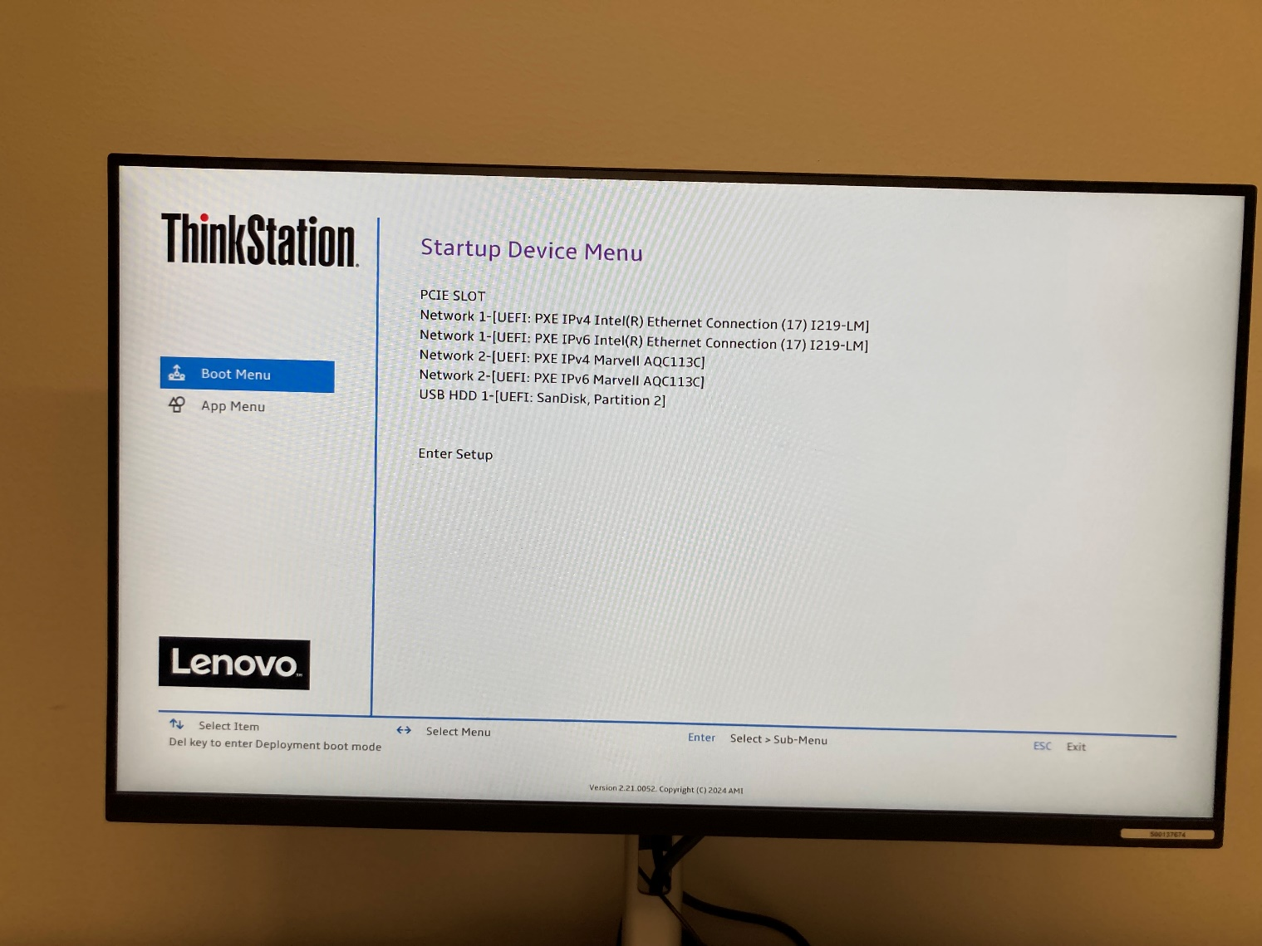

1. Once the hard drive and flash drive are plugged in, power on the computer. During the POST sequence, press F12 to enter the BIOS setup utility. Select the USB as the boot media. Click the Enter key to select.

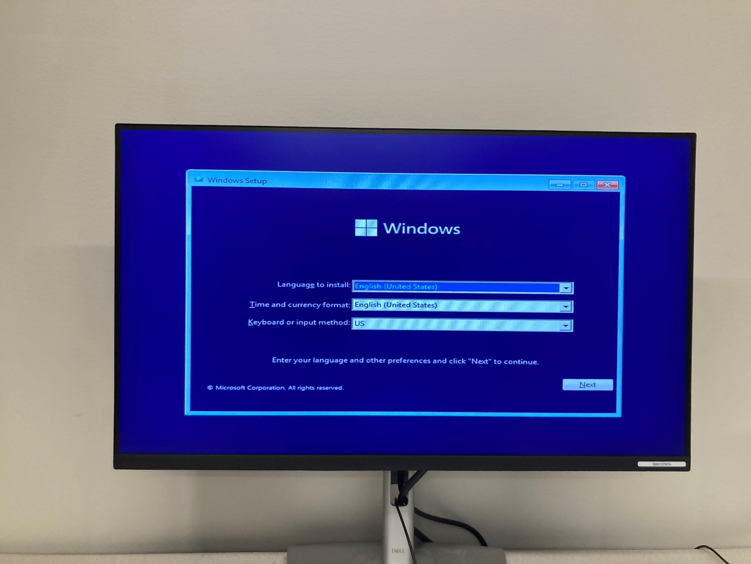

2. Select the regional information like language and keyboard layout.

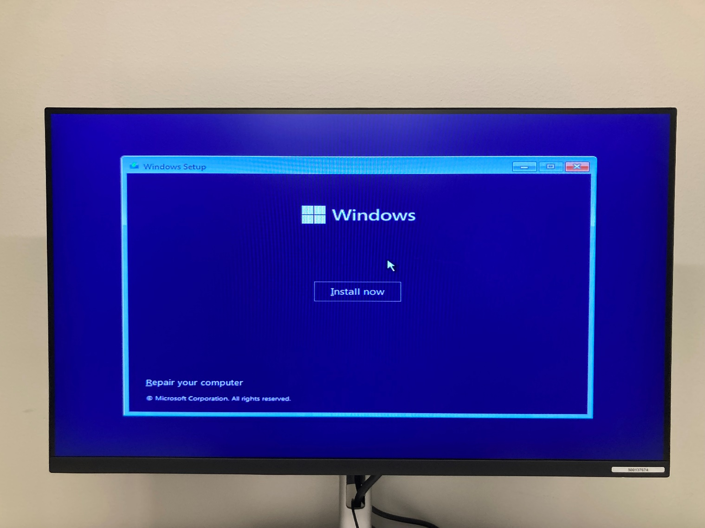

3. Click the Install Now button to start the process of installing Windows.

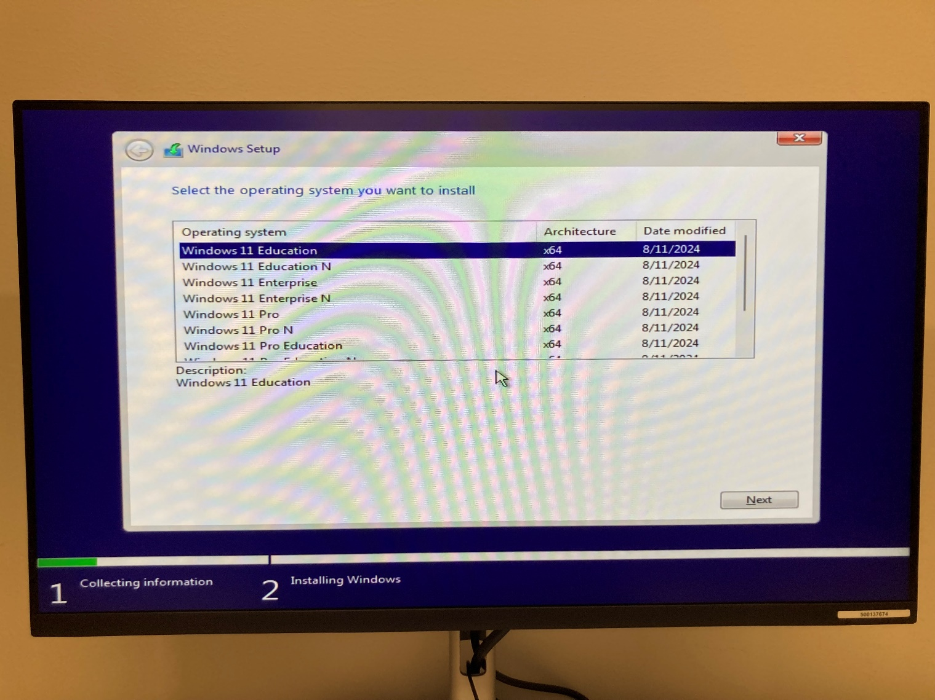

4. Select the OS version that you want to use. In this lab, we will be using Windows 11 Education. Click “Next.”

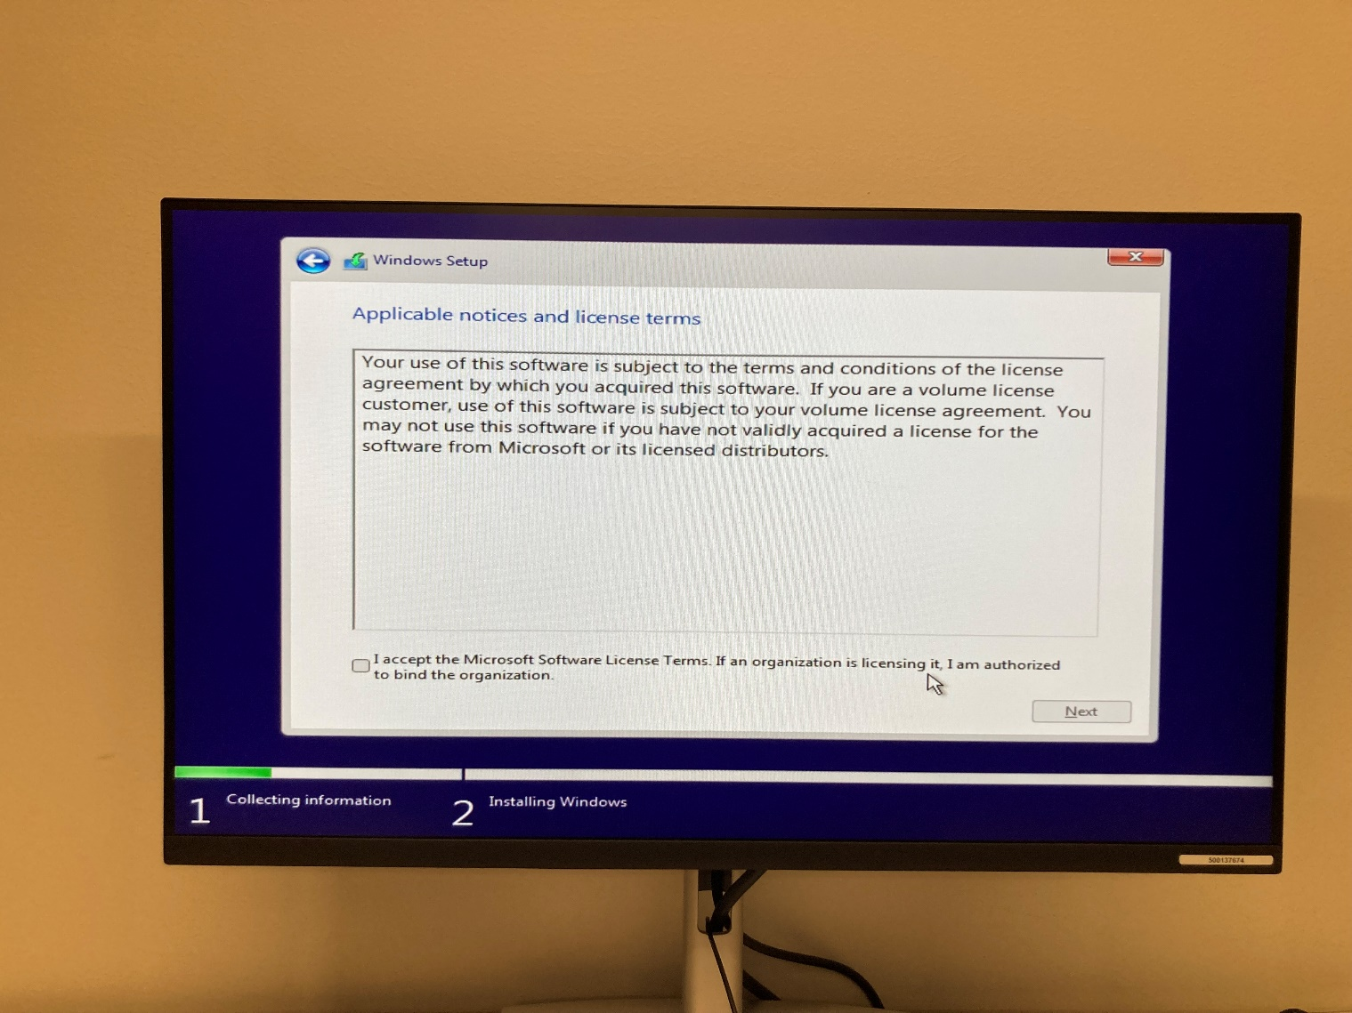

5. Accept the License Agreement. Then click “Next.”

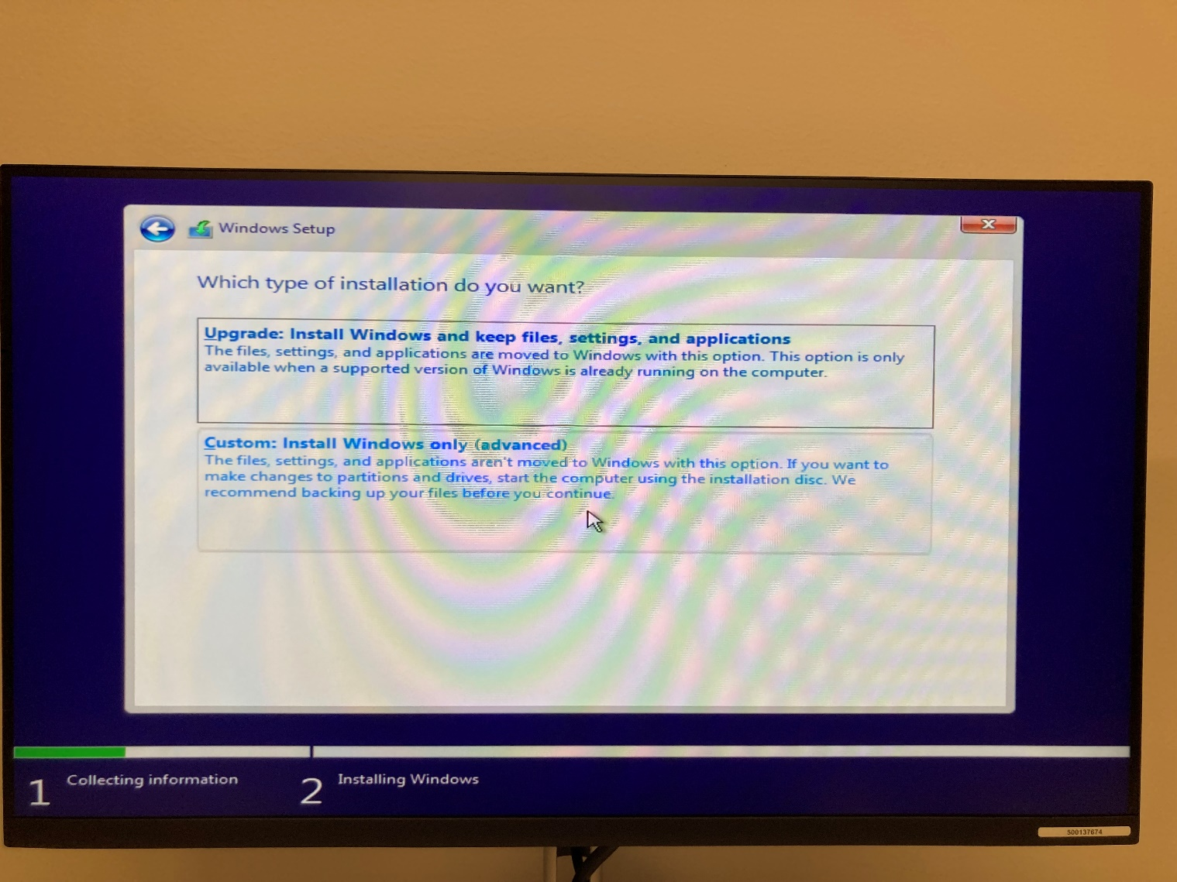

6. Select “Custom” to overwrite the previous information on the hard drive.

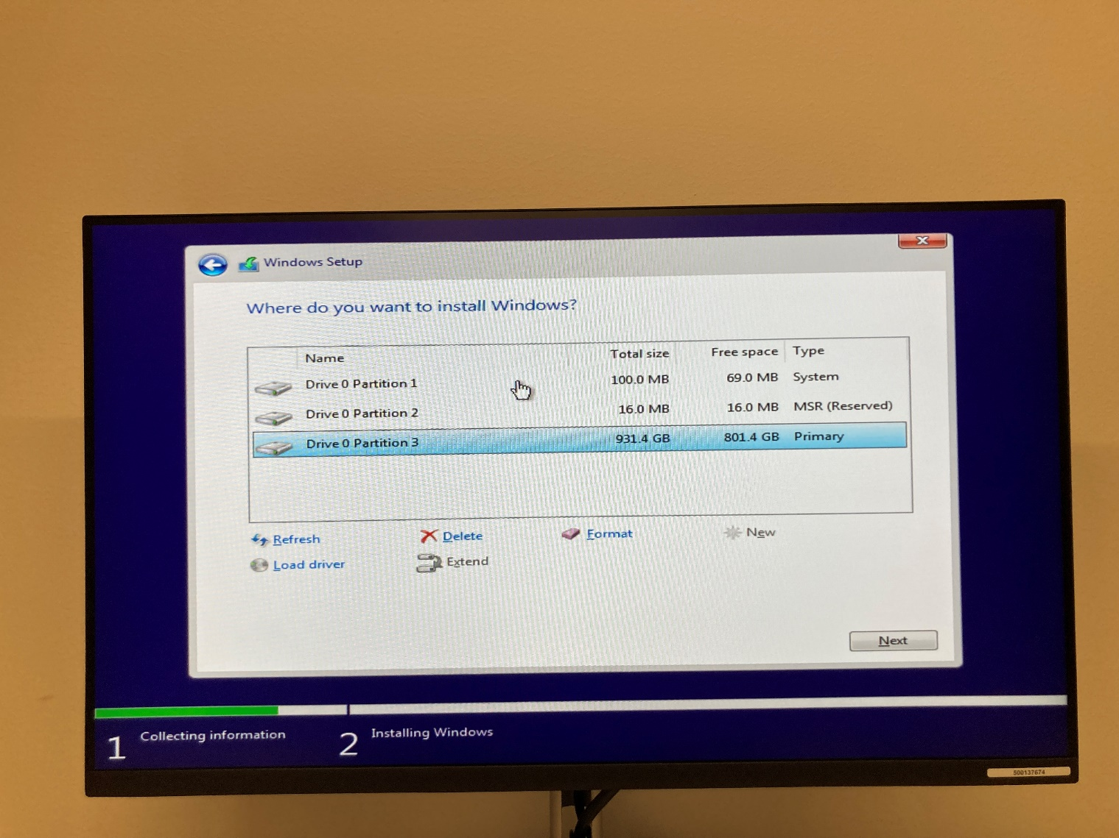

7. Select a partition of the drive to install the OS on. We selected partition three because it is the primary partition and has the most space.

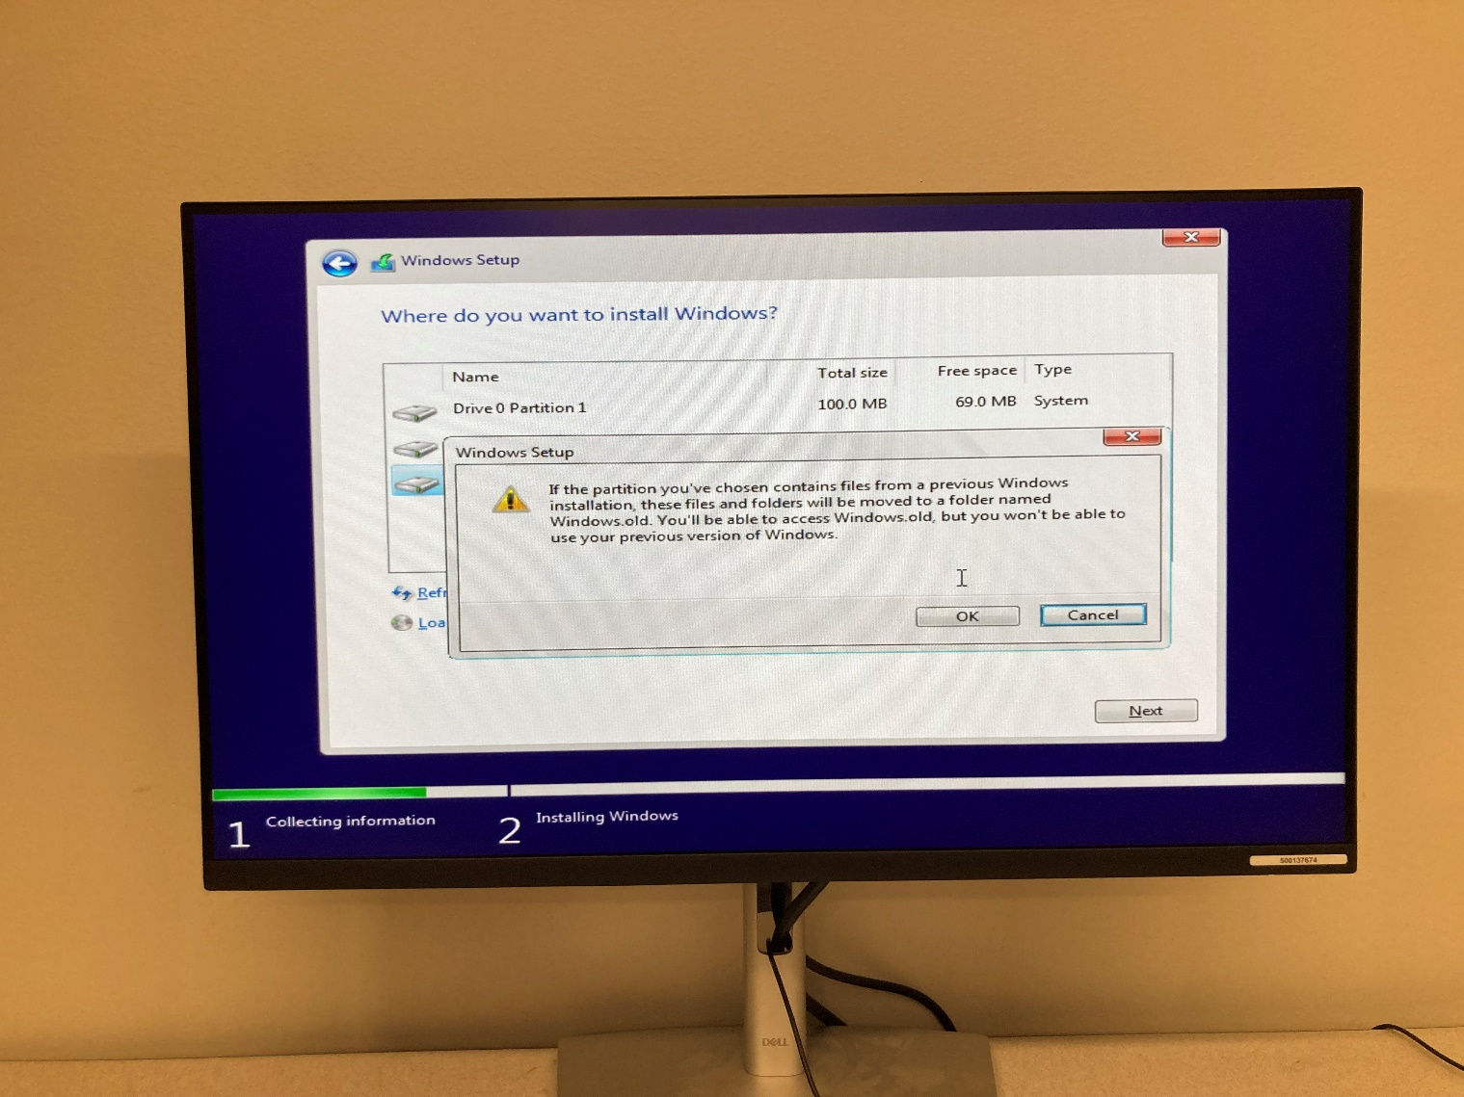

8. Click “OK” to begin the process of installing the OS.

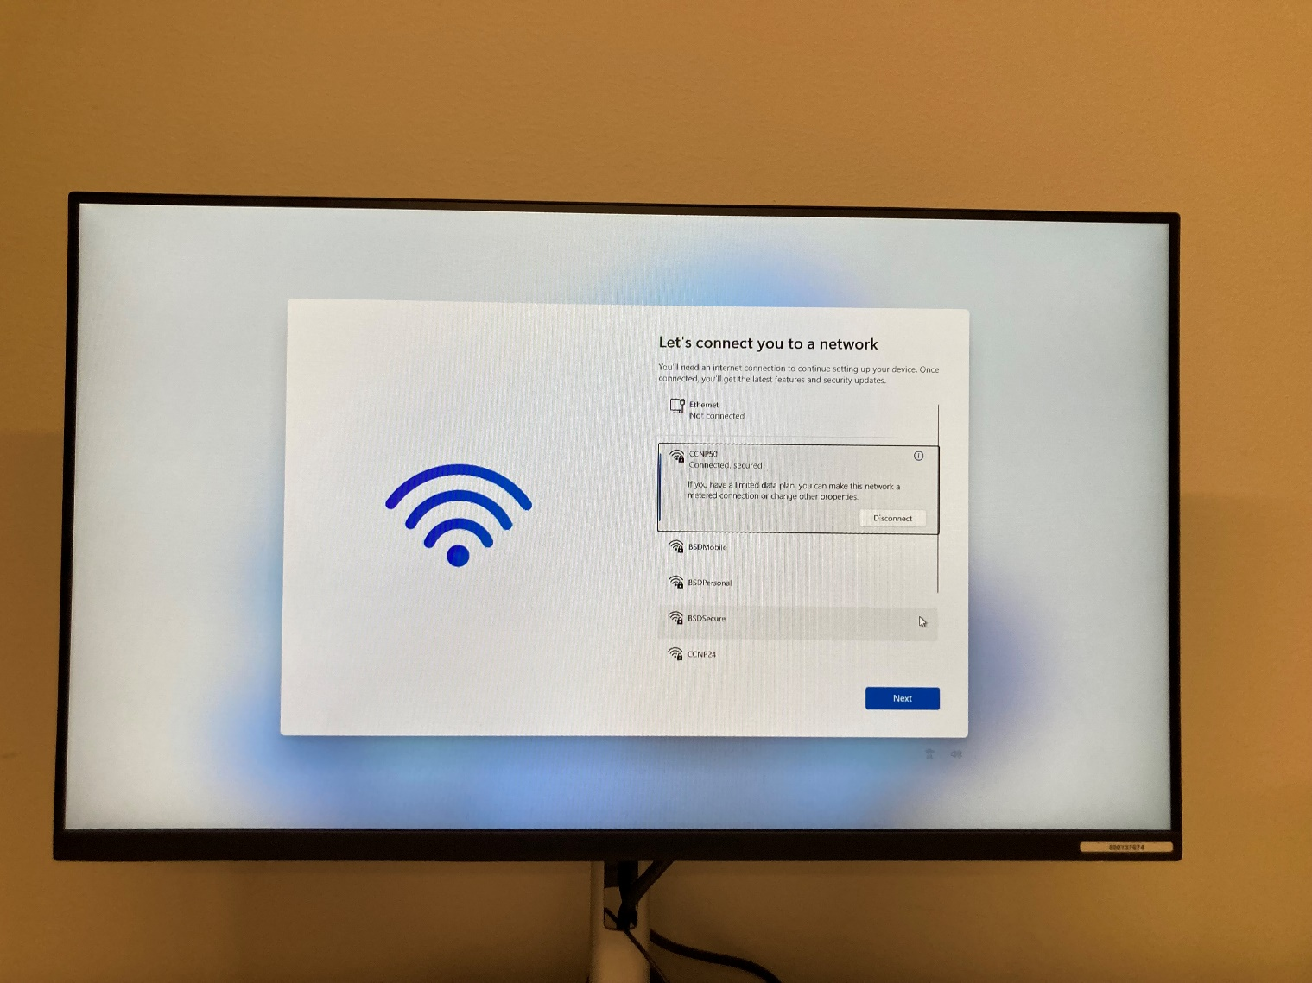

9. Once prompted, select a Wi-Fi network to connect to and enter the password to connect to it.

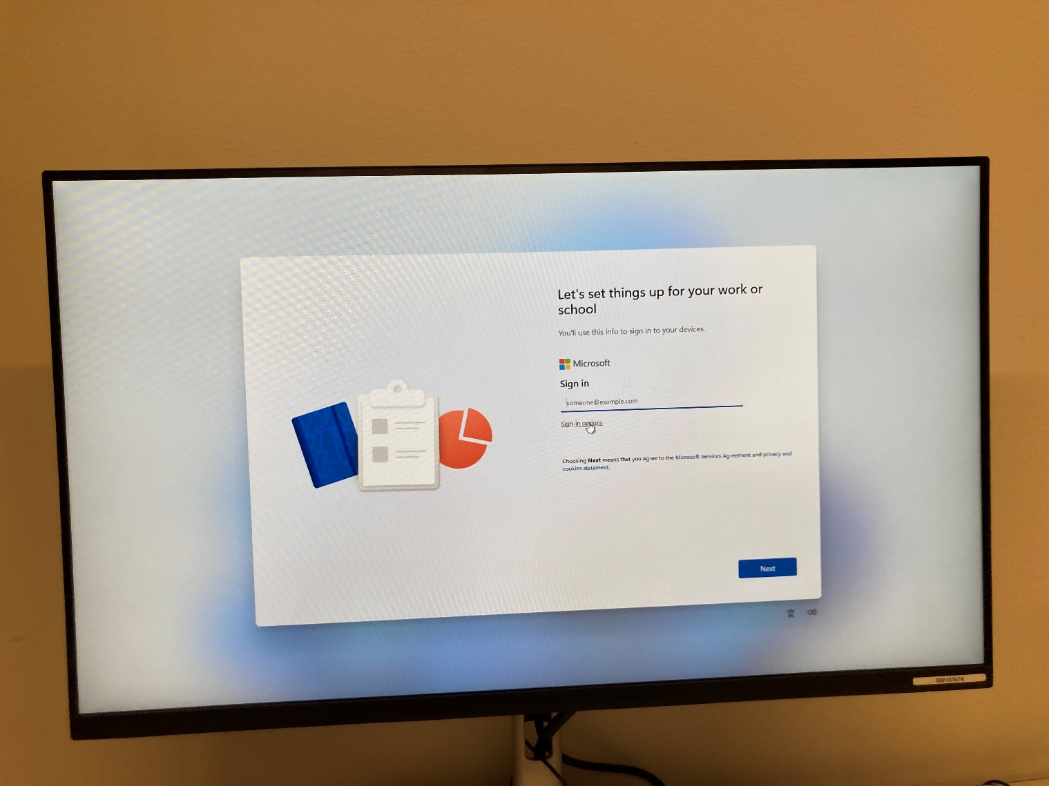

10. Click the “Sign-in Options” button to start the process of setting up a local login.

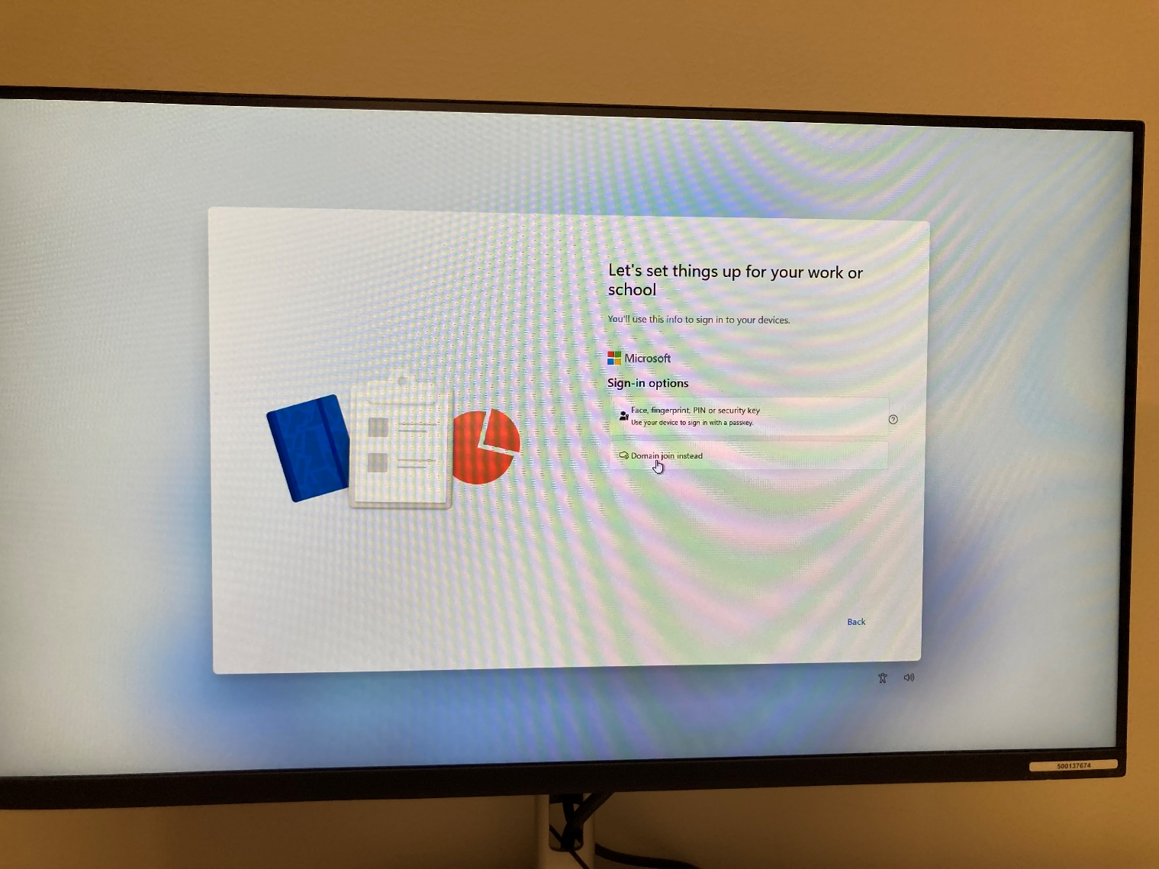

11. Click the “Domain Join Instead” button to set up the account locally.

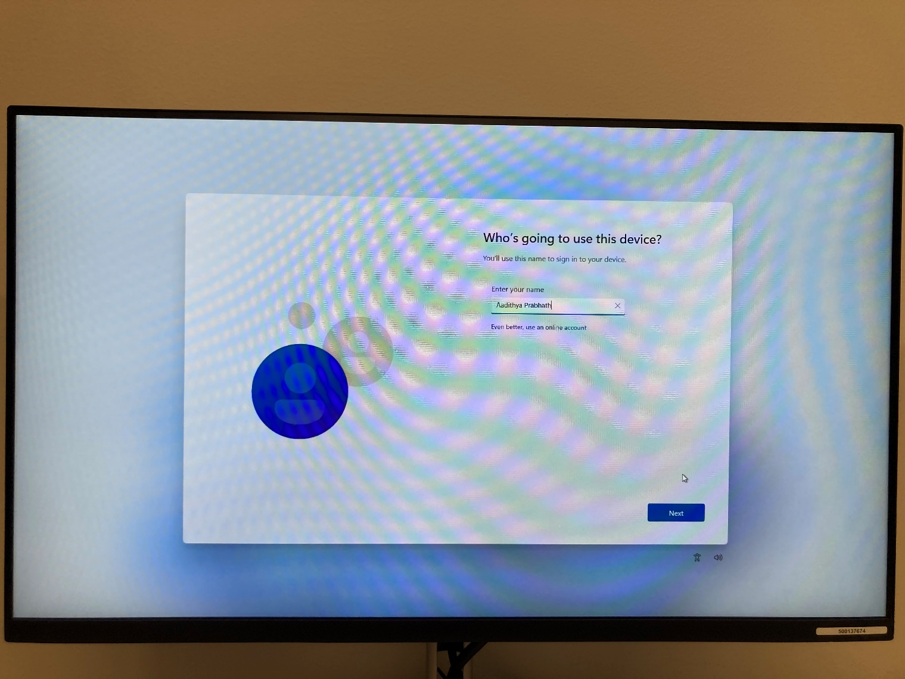

12. Enter your name. Click “Next.”

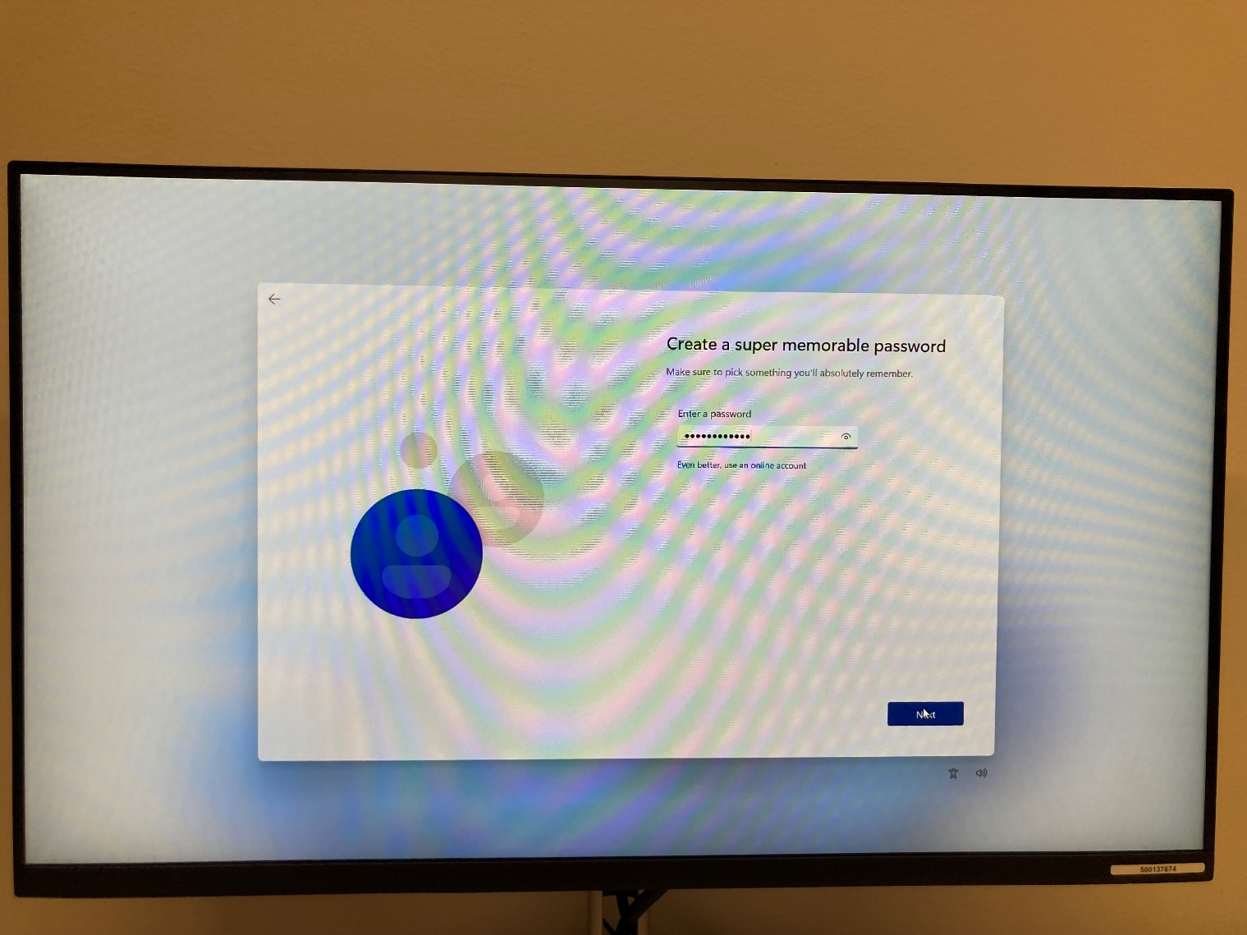

13. Enter a secure password. For maximum security, ensure that the password is at least twelve characters and uses a mixture of upper- and lower-case letters, numbers, and symbols. Click “Next.”

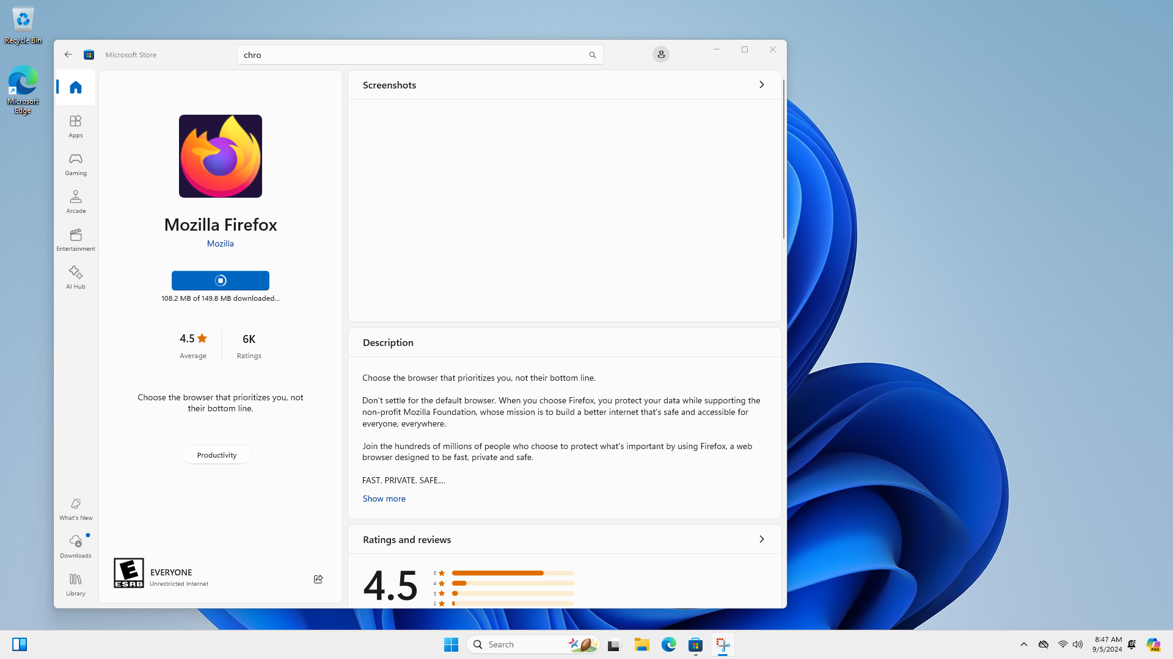

14.Open the Microsoft Store app. Search for Firefox. Download and install Firefox. We will be using Firefox because it is more customizable than Chrome.

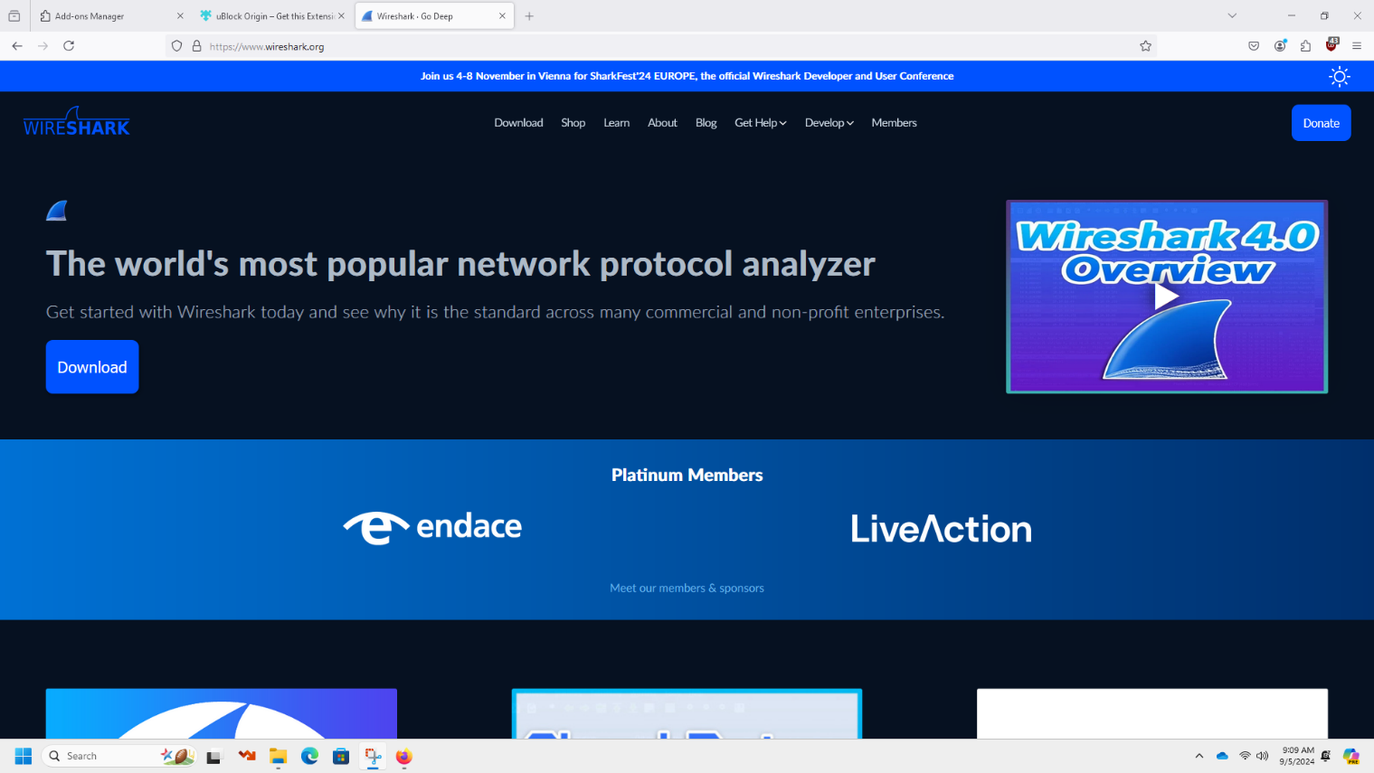

15. Open Firefox. Go to <https://www.wireshark.org/>. Click on the button that says “Download.”

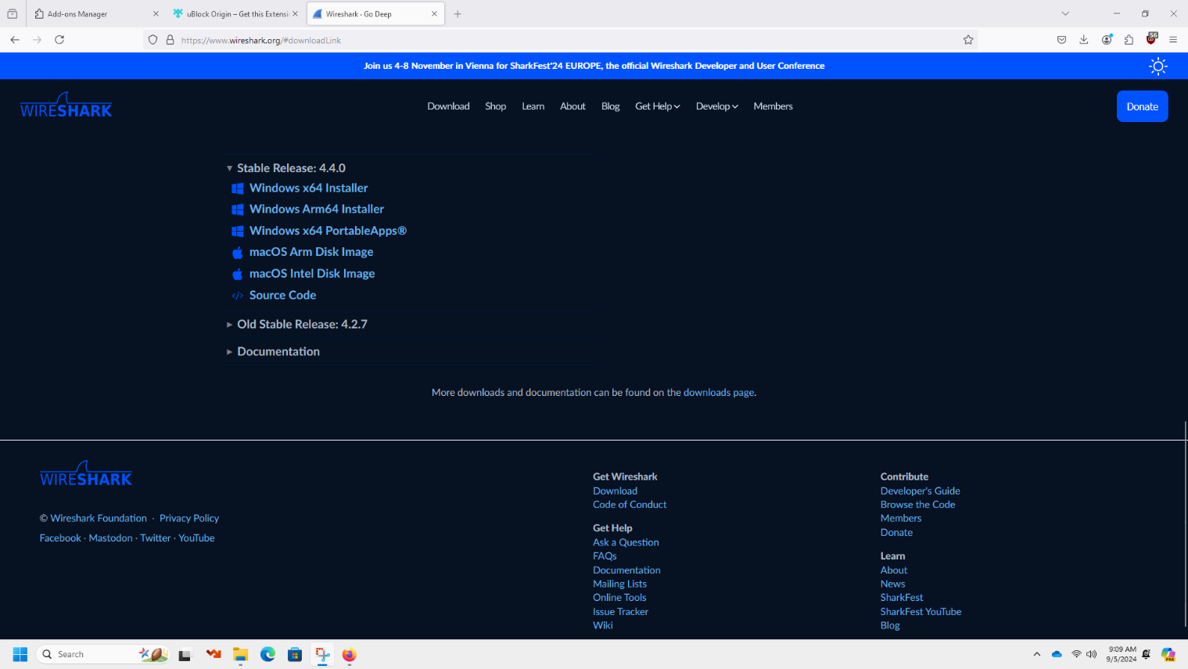

16. Click on the “Windows x64 Installer” link. Download the installer. Run the installer to start the process of installing Wireshark.

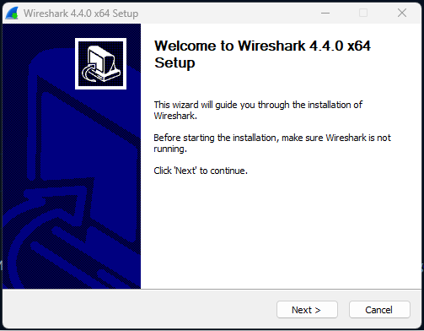

17. Click “Next”.

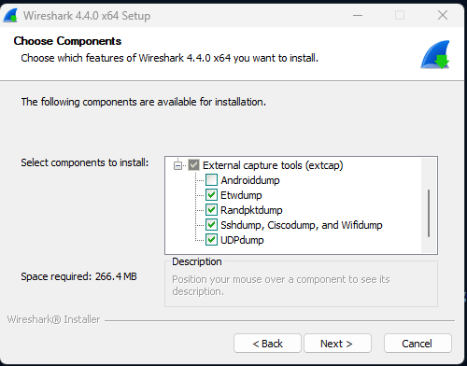

18. Select all components except Androiddump. We cannot use Androiddump because we are using a windows machine. All other components can be used when packet sniffing.

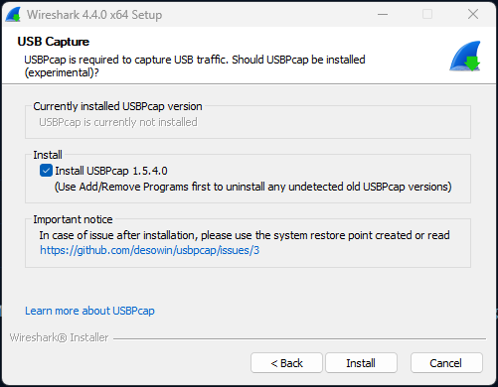

19. Although most of our labs will not be using USBPcap, having the option to use it is still useful to have so we will install it.

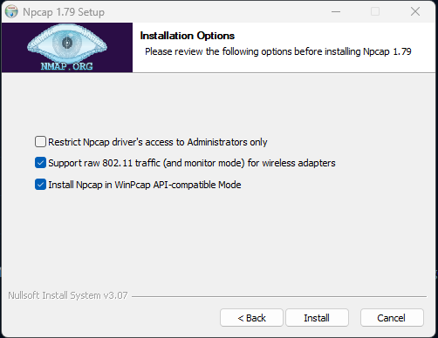

20. Npcap is a critical part of the functioning of Wireshark. We enable all the settings except locking it to Administrators, because we do not need to lock it to administrators. After this, the wizard will continue to install Wireshark.

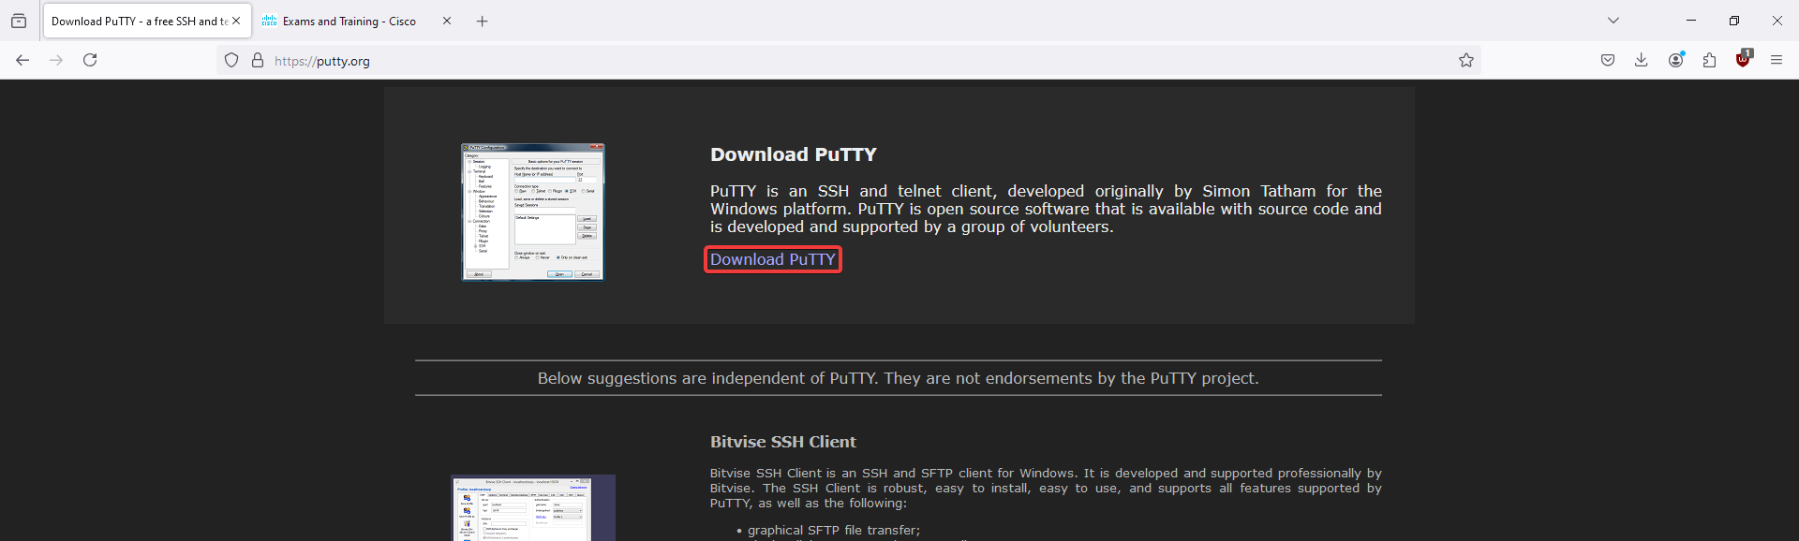

21. Go to <https://putty.org>. Click on the link that reads “Download PuTTY.”

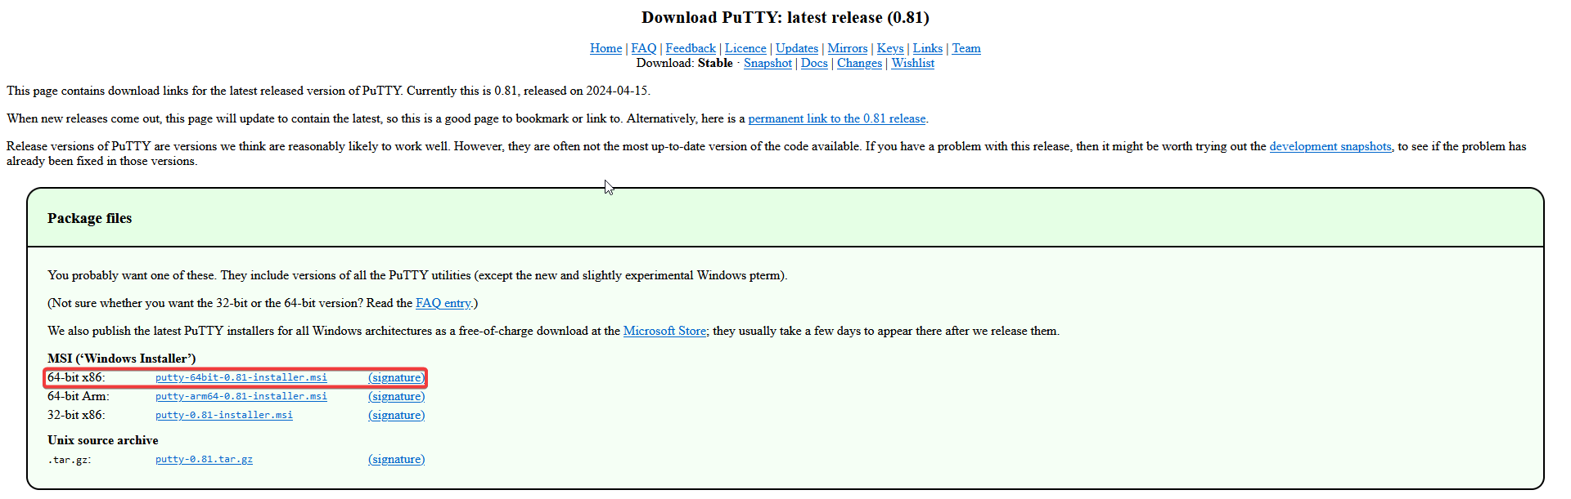

22. Click on the link for the 64-bit x86 version. Download the installer.

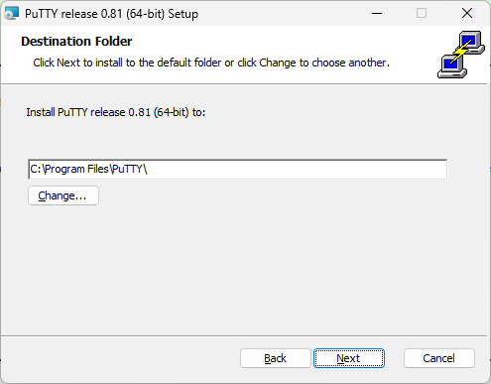

23. Select a location for PuTTY to be installed. Click “Next.”

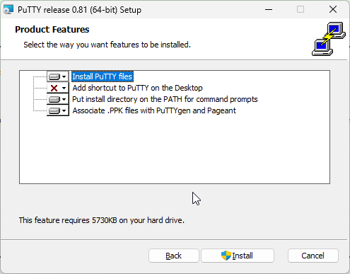

24. Click “Install”.

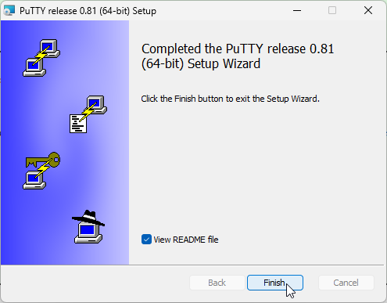

25. Click “Finish” to complete the installation.

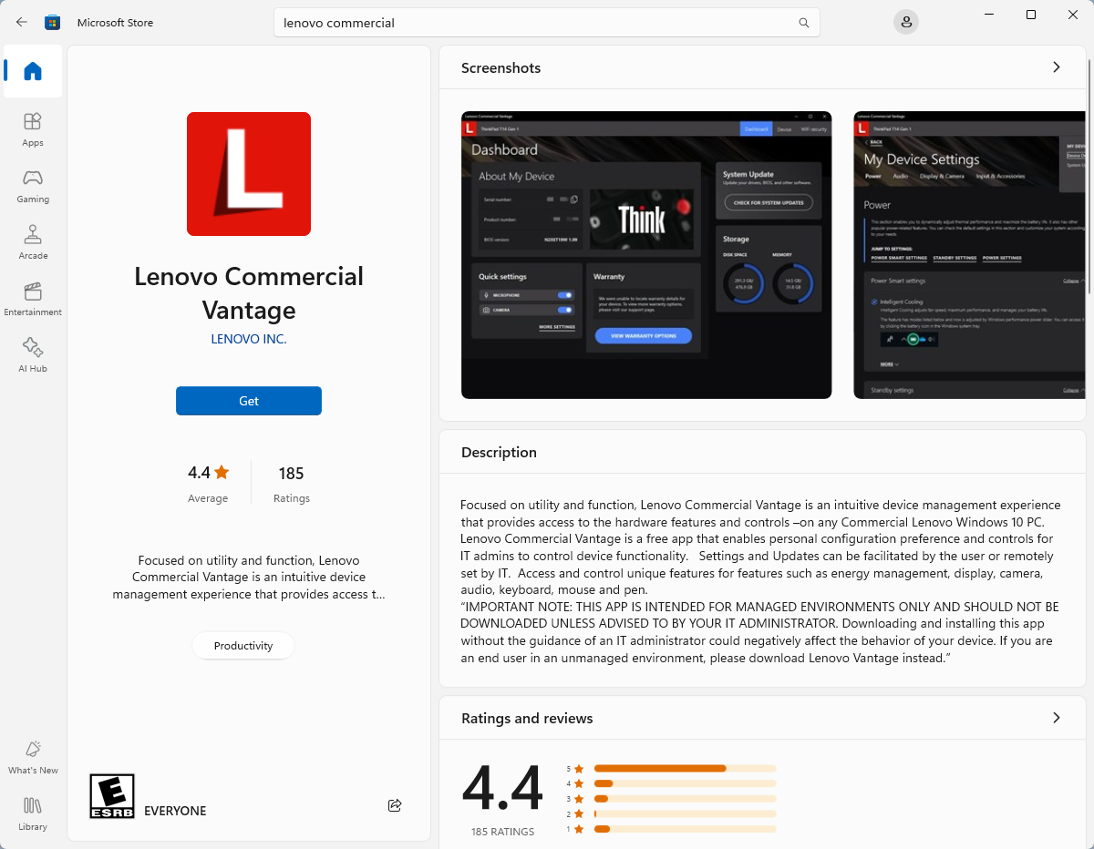

26. Search for Lenovo Commercial Vantage on the Windows Store. Click “Get.”

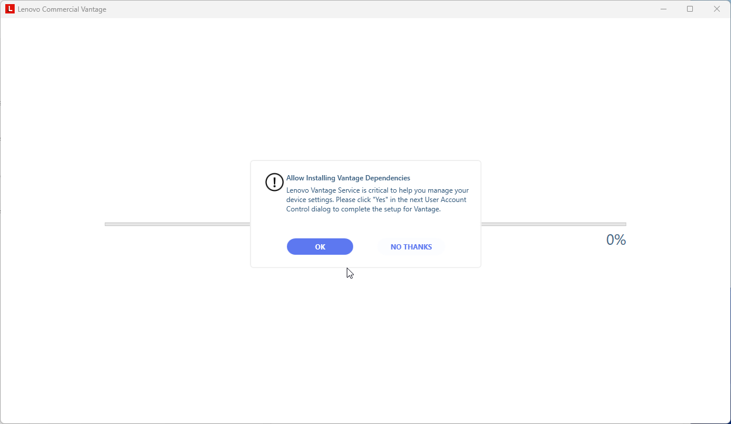

27. Click “OK” to enable Lenovo Commercial Vantage to configure your device.

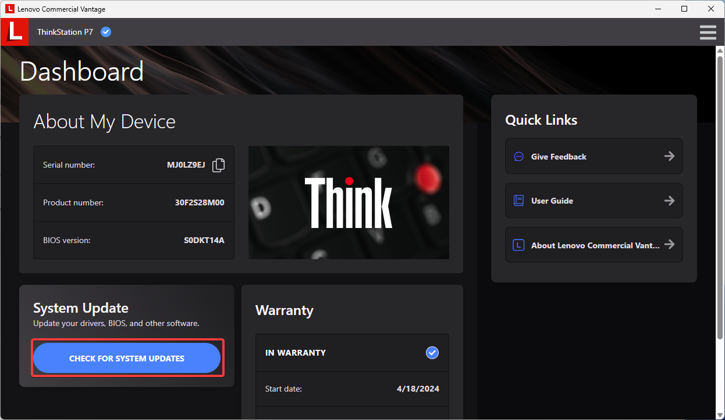

28. The most up-to-date version of Windows 11 is different than the one from the flash drive. To ensure that Windows is up to date, click the “Check for System Updates” button.

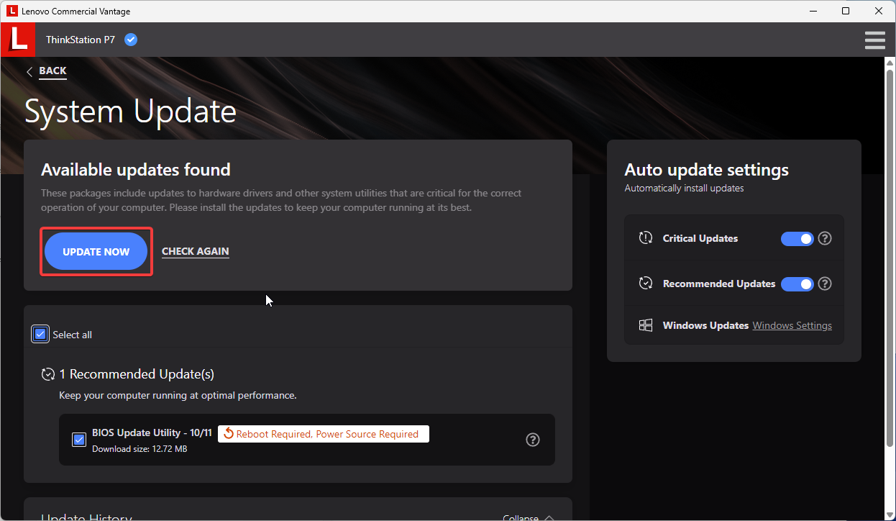

29. If updates are available, click the “Update Now” button.

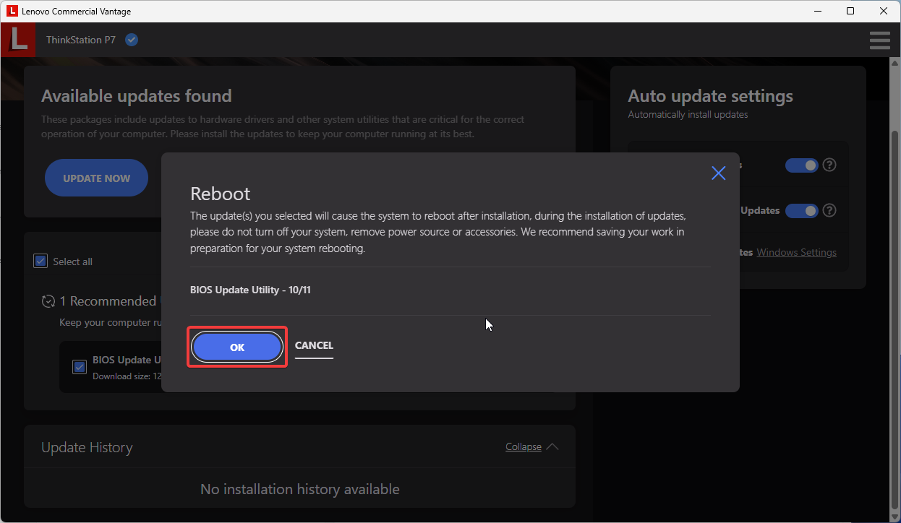

30. Click “OK” to enable the computer to reboot and finish updating.

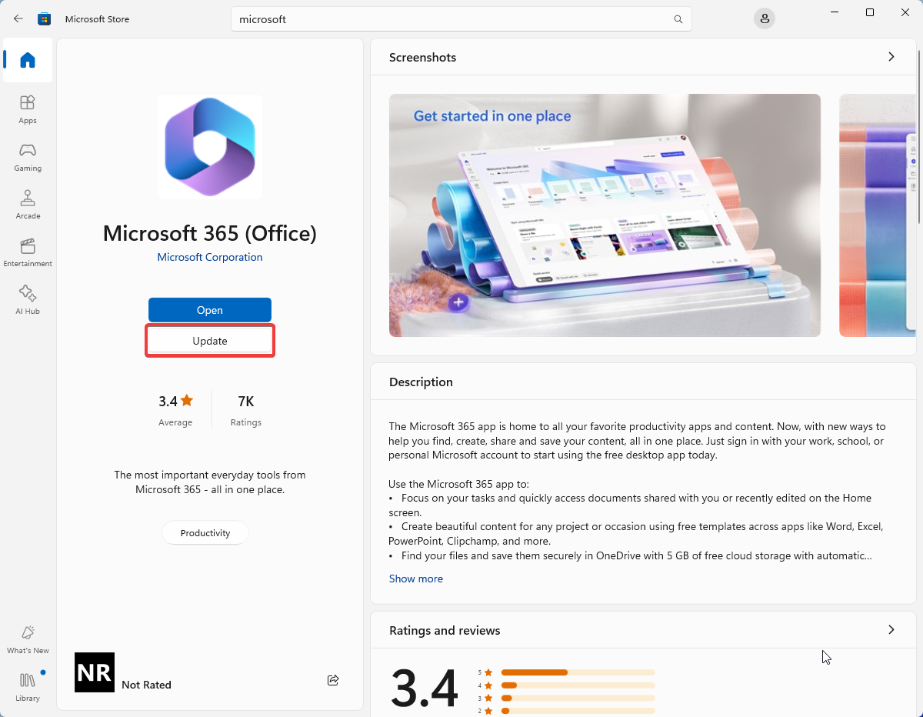

31. In the version of Windows 11 that we used, Microsoft 365 was already installed, but it was out of date. Search for Microsoft 365 in the Microsoft Store. Click the “Update” button to update Microsoft 365.

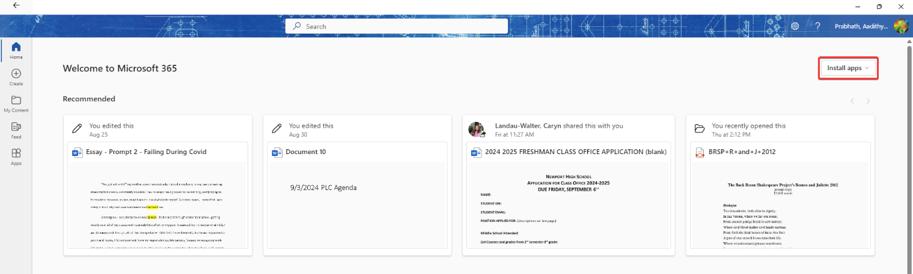

32. After Microsoft 365 has updated, the actual apps like Word, Excel, PowerPoint, etc. will not have been installed. To install them, open Microsoft 365 and click the “Install Apps” button.

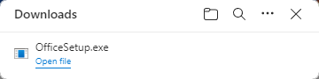

33. Open the file that was downloaded when the “Install Apps” button was clicked. This will run an installer that will install the Microsoft 365 apps.

## Problems

Overall, we did not have many problems in this lab. Our biggest issue occurred when we were trying to boot the computer after we completed the lab. The computer spent a few minutes looking for a valid boot media. This was caused by the boot order being incorrectly ordered. We reordered the boot order, which fixed the issue.

|  |
| --- |
| LAB 1: CONFIGURING MULTI-AREA OSPF Aadithya Prabhath |
| Cisco white logo transparent PNG - StickPNG |



## Purpose

Our goal in this lab is to learn how to configure routers to run multi-Area OSPF for IPV4 and IPV6. It is important to learn how to configure multi-Area OSPF because most large networks use it to distribute routing information efficiently.

## Background Information on Lab Concepts

OSPF is a routing algorithm that stands for Open Shortest Path First. It is an interior gateway protocol, or IGP, that is designed to operate within an Autonomous System. It is typically used in enterprise networks. OSPF uses routing metrics to construct a routing table which is used to forward traffic. Typically, OSPF uses link bandwidth to calculate link cost. This is done by dividing the speed of a link by a reference bandwidth, typically 10000. This allows load balancing by choosing routes that transport the most data as quickly as possible. Once the topology of the network is detected, a router in each area is elected as the designated router. The designated router serves to centralize the updates from other routers in the network to reduce bandwidth consumed by OSPF traffic. OSPF networks are divided into areas to make it easier for administrators to manage networks. By splitting up a network into areas, the configurations for each can be managed individually, simplifying the configuration. There are many types of OSPF areas, but in this lab, we will be using a backbone area and two regular areas. The backbone area is typically designated as area 0. All other areas need to be able to connect to the backbone area. The backbone area allows traffic from the network to flow across it. At the edge of each area, there is a router that is designated as an Area Border Router, or ABR. The job of the ABR is to create summary routes to other areas and manage traffic between areas. We will also be running OSPFv3 in this lab. OSPFv3 is the IPv6-compatible version of OSPF. It runs per link, rather than per subnet, making it much easier to configure.

## Lab Summary

Our first step in this lab was to design the network topology. We decided to split the network into three areas. Next, we wrote the configurations for the routers and switches. In the configurations, we configured the OSPF process IDs and assigned each subnet to an area. We then configured each of the interfaces with IP and OSPF information. Lastly, we configured the PCs with the appropriate IP address information to ensure connectivity.

## Lab Commands

-sdm prefer dual default: This command is entered on a layer 3 switch. This enables the switch to route both IPv4 and IPv6 traffic.

-ipv6 unicast: This command is entered on a router. It enables the router to route IPv6 traffic.

-router id x.x.x.x: This command is used to assign a router ID. to a router. The xs represent any numbers that can be used as the router ID.

-router ospf x:This command is entered on a router. The letter x represents the OSPF process ID. This allows you to configure OSPF on a router.

-priority x: This command enables you to select the which router is most likely to become the designated router. The value of x can range for 0-127. A router with a priority of 0 can never be a designated router. A router with a priority of 127 will always be the designated router, unless another router has a priority of 127, in which case they go to a run-off.

-network x.x.x.x x.x.x.x area x: This command is used to designate a network that is connected to a router as part of a specific OSPF area. The first set of xs represents the network address. The second set of xs represents the wildcard mask of the subnet. The last x represents the area that the network is a part of.

-ip ospf x area x: This command is used to bind an interface to an area. The first x represents the OSPF process id. The second x represents the area that the interface is being bound to.

-ipv6 ospf x area x: This command is used to bind an interface that is using IPv6 to an area. The first x represents the OSPF process id. The second x represents the area that the interface is being bound to.

## Network Diagram

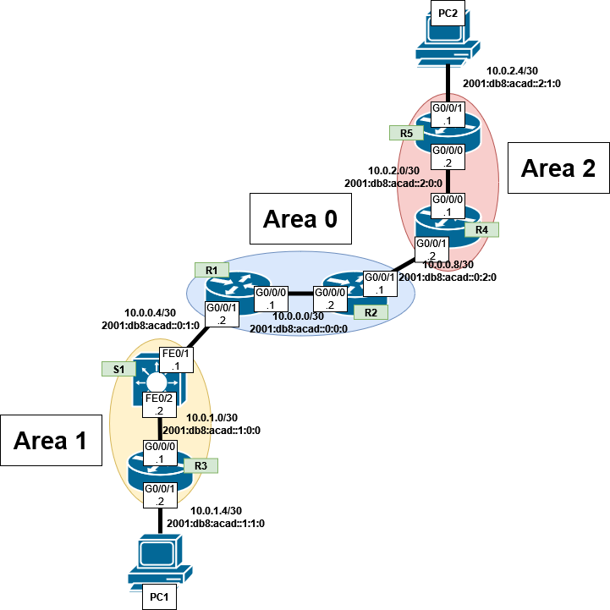

## Configurations

-------------------------------------**R1**--------------------------------------R1#show run

Building configuration...

Current configuration : 1687 bytes

!

! Last configuration change at 15:35:47 UTC Thu Sep 26 2024

!

version 15.5

service timestamps debug datetime msec

service timestamps log datetime msec

no platform punt-keepalive disable-kernel-core

!

hostname R1

!

boot-start-marker

boot-end-marker

!

!

vrf definition Mgmt-intf

!

address-family ipv4

exit-address-family

!

address-family ipv6

exit-address-family

!

!

no aaa new-model

!

!

!

!

!

!

!

!

!

!

!

no ip domain lookup

!

!

!

ipv6 unicast-routing

!

!

!

!

!

!

!

subscriber templating

vtp domain cisco

vtp mode transparent

multilink bundle-name authenticated

!

!

!

!

license udi pid ISR4321/K9 sn FDO214421BY

!

spanning-tree extend system-id

!

!

redundancy

mode none

!

!

vlan internal allocation policy ascending

!

!

!

!

!

!

interface GigabitEthernet0/0/0

ip address 10.0.0.1 255.255.255.252

ip ospf 1 area 0

negotiation auto

ipv6 address 2001:DB8:ACAD::1/112

ipv6 ospf 1 area 0

!

interface GigabitEthernet0/0/1

ip address 10.0.0.5 255.255.255.252

ip ospf 1 area 0

negotiation auto

ipv6 address 2001:DB8:ACAD::1:2/112

ipv6 ospf 1 area 0

!

interface Serial0/1/0

!

interface Serial0/1/1

!

interface GigabitEthernet0/2/0

negotiation auto

!

interface GigabitEthernet0/2/1

negotiation auto

!

interface GigabitEthernet0

vrf forwarding Mgmt-intf

no ip address

shutdown

negotiation auto

!

interface Vlan1

no ip address

shutdown

!

router ospf 1

router-id 1.1.1.1

priority 127

network 10.0.0.0 0.0.0.3 area 0

network 10.0.0.4 0.0.0.3 area 0

!

ip forward-protocol nd

no ip http server

no ip http secure-server

ip tftp source-interface GigabitEthernet0

!

!

ipv6 router ospf 1

!

!

!

!

control-plane

!

!

line con 0

stopbits 1

line aux 0

stopbits 1

line vty 0 4

login

!

!

end

R1#sho ip ro

Codes: L - local, C - connected, S - static, R - RIP, M - mobile, B - BGP

D - EIGRP, EX - EIGRP external, O - OSPF, IA - OSPF inter area

N1 - OSPF NSSA external type 1, N2 - OSPF NSSA external type 2

E1 - OSPF external type 1, E2 - OSPF external type 2

i - IS-IS, su - IS-IS summary, L1 - IS-IS level-1, L2 - IS-IS level-2

ia - IS-IS inter area, * - candidate default, U - per-user static route

o - ODR, P - periodic downloaded static route, H - NHRP, l - LISP

a - application route

+ - replicated route, % - next hop override, p - overrides from PfR

Gateway of last resort is not set

10.0.0.0/8 is variably subnetted, 9 subnets, 2 masks

C 10.0.0.0/30 is directly connected, GigabitEthernet0/0/0

L 10.0.0.1/32 is directly connected, GigabitEthernet0/0/0

C 10.0.0.4/30 is directly connected, GigabitEthernet0/0/1

L 10.0.0.5/32 is directly connected, GigabitEthernet0/0/1

O 10.0.0.8/30 [110/2] via 10.0.0.2, 00:12:53, GigabitEthernet0/0/0

O IA 10.0.1.0/30 [110/2] via 10.0.0.6, 00:09:36, GigabitEthernet0/0/1

O IA 10.0.1.4/30 [110/3] via 10.0.0.6, 00:09:36, GigabitEthernet0/0/1

O IA 10.0.2.0/30 [110/3] via 10.0.0.2, 00:12:08, GigabitEthernet0/0/0

O IA 10.0.2.4/30 [110/4] via 10.0.0.2, 00:11:28, GigabitEthernet0/0/0

R1# sho ipv rou

IPv6 Routing Table - default - 9 entries

Codes: C - Connected, L - Local, S - Static, U - Per-user Static route

B - BGP, R - RIP, I1 - ISIS L1, I2 - ISIS L2

IA - ISIS interarea, IS - ISIS summary, D - EIGRP, EX - EIGRP external

ND - ND Default, NDp - ND Prefix, DCE - Destination, NDr - Redirect

O - OSPF Intra, OI - OSPF Inter, OE1 - OSPF ext 1, OE2 - OSPF ext 2

ON1 - OSPF NSSA ext 1, ON2 - OSPF NSSA ext 2, a - Application

C 2001:DB8:ACAD::/112 [0/0]

via GigabitEthernet0/0/0, directly connected

L 2001:DB8:ACAD::1/128 [0/0]

via GigabitEthernet0/0/0, receive

C 2001:DB8:ACAD::1:0/112 [0/0]

via GigabitEthernet0/0/1, directly connected

O 2001:DB8:ACAD::2:0/112 [110/2]

via FE80::B6A8:B9FF:FE47:92C0, GigabitEthernet0/0/0

OI 2001:DB8:ACAD::1:0:0/112 [110/2]

via FE80::EE30:91FF:FE92:C841, GigabitEthernet0/0/1

OI 2001:DB8:ACAD::1:1:0/112 [110/3]

via FE80::EE30:91FF:FE92:C841, GigabitEthernet0/0/1

OI 2001:DB8:ACAD::2:0:0/112 [110/3]

via FE80::B6A8:B9FF:FE47:92C0, GigabitEthernet0/0/0

OI 2001:DB8:ACAD::2:1:0/112 [110/4]

via FE80::B6A8:B9FF:FE47:92C0, GigabitEthernet0/0/0

L FF00::/8 [0/0]

via Null0, receive

R1#show ip ospf nei

Neighbor ID Pri State Dead Time Address Interface

6.6.6.6 1 FULL/DR 00:00:39 10.0.0.6 GigabitEthernet0/0/1

2.2.2.2 1 FULL/DR 00:00:31 10.0.0.2 GigabitEthernet0/0/0

-------------------------------------**R2**--------------------------------------R2#show run

Building configuration...

Current configuration : 1659 bytes

!

! Last configuration change at 15:21:56 UTC Thu Sep 26 2024

!

version 15.5

service timestamps debug datetime msec

service timestamps log datetime msec

no platform punt-keepalive disable-kernel-core

!

hostname R2

!

boot-start-marker

boot-end-marker

!

!

vrf definition Mgmt-intf

!

address-family ipv4

exit-address-family

!

address-family ipv6

exit-address-family

!

!

no aaa new-model

!

!

!

!

!

!

!

!

!

!

!

no ip domain lookup

!

!

!

ipv6 unicast-routing

!

!

!

!

!

!

!

subscriber templating

!

multilink bundle-name authenticated

!

!

!

!

license udi pid ISR4321/K9 sn FDO214420QQ

license accept end user agreement

license boot level securityk9

!

spanning-tree extend system-id

!

!

redundancy

mode none

!

!

!

!

!

vlan internal allocation policy ascending

!

!

!

!

!

!

!

!

!

!

!

!

!

!

!

!

!

!

!

!

!

!

interface GigabitEthernet0/0/0

ip address 10.0.0.2 255.255.255.252

ip ospf 1 area 0

negotiation auto

ipv6 address 2001:DB8:ACAD::2/112

ipv6 ospf 1 area 0

!

interface GigabitEthernet0/0/1

ip address 10.0.0.10 255.255.255.252

ip ospf 1 area 0

negotiation auto

ipv6 address 2001:DB8:ACAD::2:2/112

ipv6 ospf 1 area 0

!

interface Serial0/1/0

!

interface Serial0/1/1

!

interface GigabitEthernet0

vrf forwarding Mgmt-intf

no ip address

shutdown

negotiation auto

!

interface Vlan1

no ip address

shutdown

!

router ospf 1

router-id 2.2.2.2

priority 126

network 10.0.0.0 0.0.0.3 area 0

network 10.0.0.8 0.0.0.3 area 0

!

ip forward-protocol nd

no ip http server

no ip http secure-server

ip tftp source-interface GigabitEthernet0

!

!

ipv6 router ospf 1

!

!

!

!

control-plane

!

!

line con 0

stopbits 1

line aux 0

stopbits 1

line vty 0 4

login

!

!

end

---------------------------------------------

R2#show ip route

Codes: L - local, C - connected, S - static, R - RIP, M - mobile, B - BGP

D - EIGRP, EX - EIGRP external, O - OSPF, IA - OSPF inter area

N1 - OSPF NSSA external type 1, N2 - OSPF NSSA external type 2

E1 - OSPF external type 1, E2 - OSPF external type 2

i - IS-IS, su - IS-IS summary, L1 - IS-IS level-1, L2 - IS-IS level-2

ia - IS-IS inter area, * - candidate default, U - per-user static route

o - ODR, P - periodic downloaded static route, H - NHRP, l - LISP

a - application route

+ - replicated route, % - next hop override, p - overrides from PfR

Gateway of last resort is not set

10.0.0.0/8 is variably subnetted, 9 subnets, 2 masks

C 10.0.0.0/30 is directly connected, GigabitEthernet0/0/0

L 10.0.0.2/32 is directly connected, GigabitEthernet0/0/0

O 10.0.0.4/30 [110/2] via 10.0.0.1, 00:17:23, GigabitEthernet0/0/0

C 10.0.0.8/30 is directly connected, GigabitEthernet0/0/1

L 10.0.0.10/32 is directly connected, GigabitEthernet0/0/1

O IA 10.0.1.0/30 [110/3] via 10.0.0.1, 00:17:23, GigabitEthernet0/0/0

O IA 10.0.1.4/30 [110/4] via 10.0.0.1, 00:17:23, GigabitEthernet0/0/0

O IA 10.0.2.0/30 [110/2] via 10.0.0.9, 00:19:55, GigabitEthernet0/0/1

O IA 10.0.2.4/30 [110/3] via 10.0.0.9, 00:19:16, GigabitEthernet0/0/1

---------------------------------------------

R2#show ipv route

IPv6 Routing Table - default - 10 entries

Codes: C - Connected, L - Local, S - Static, U - Per-user Static route

B - BGP, R - RIP, H - NHRP, I1 - ISIS L1

I2 - ISIS L2, IA - ISIS interarea, IS - ISIS summary, D - EIGRP

EX - EIGRP external, ND - ND Default, NDp - ND Prefix, DCE - Destination

NDr - Redirect, O - OSPF Intra, OI - OSPF Inter, OE1 - OSPF ext 1

OE2 - OSPF ext 2, ON1 - OSPF NSSA ext 1, ON2 - OSPF NSSA ext 2

a - Application

C 2001:DB8:ACAD::/112 [0/0]

via GigabitEthernet0/0/0, directly connected

L 2001:DB8:ACAD::2/128 [0/0]

via GigabitEthernet0/0/0, receive

O 2001:DB8:ACAD::1:0/112 [110/2]

via FE80::B6A8:B9FF:FE01:B510, GigabitEthernet0/0/0

C 2001:DB8:ACAD::2:0/112 [0/0]

via GigabitEthernet0/0/1, directly connected

L 2001:DB8:ACAD::2:2/128 [0/0]

via GigabitEthernet0/0/1, receive

OI 2001:DB8:ACAD::1:0:0/112 [110/3]

via FE80::B6A8:B9FF:FE01:B510, GigabitEthernet0/0/0

OI 2001:DB8:ACAD::1:1:0/112 [110/4]

via FE80::B6A8:B9FF:FE01:B510, GigabitEthernet0/0/0

OI 2001:DB8:ACAD::2:0:0/112 [110/2]

via FE80::521C:B0FF:FE2D:7101, GigabitEthernet0/0/1

OI 2001:DB8:ACAD::2:1:0/112 [110/3]

via FE80::521C:B0FF:FE2D:7101, GigabitEthernet0/0/1

L FF00::/8 [0/0]

via Null0, receive

---------------------------------------------

R2#show ip ospf nei

Neighbor ID Pri State Dead Time Address Interface

4.4.4.4 1 FULL/DR 00:00:39 10.0.0.9 GigabitEthernet0/0/1

1.1.1.1 1 FULL/BDR 00:00:33 10.0.0.1 GigabitEthernet0/0/0

-------------------------------------**R3**--------------------------------------

R3#show run

Building configuration...

Current configuration : 1692 bytes

!

! Last configuration change at 15:42:20 UTC Thu Sep 26 2024

!

version 15.5

service timestamps debug datetime msec

service timestamps log datetime msec

no platform punt-keepalive disable-kernel-core

!

hostname R3

!

boot-start-marker

boot-end-marker

!

!

vrf definition Mgmt-intf

!

address-family ipv4

exit-address-family

!

address-family ipv6

exit-address-family

!

!

no aaa new-model

!

!

!

!

!

!

!

!

!

!

!

no ip domain lookup

!

!

!

ipv6 unicast-routing

!

!

!

!

!

!

!

subscriber templating

vtp domain cisco

vtp mode transparent

!

multilink bundle-name authenticated

!

!

!

!

license udi pid ISR4321/K9 sn FDO214420HY

license boot level securityk9

!

spanning-tree extend system-id

!

!

redundancy

mode none

!

!

!

!

!

vlan internal allocation policy ascending

!

vlan 10,20

!

!

!

!

!

!

!

!

!

!

!

!

!

!

!

!

!

!

!

!

!

!

interface GigabitEthernet0/0/0

ip address 10.0.1.1 255.255.255.252

ip ospf 1 area 1

negotiation auto

ipv6 address 2001:DB8:ACAD::1:0:1/112

ipv6 ospf 1 area 1

!

interface GigabitEthernet0/0/1

ip address 10.0.1.6 255.255.255.252

ip ospf 1 area 1

negotiation auto

ipv6 address 2001:DB8:ACAD::1:1:2/112

ipv6 ospf 1 area 1

!

interface Serial0/1/0

no ip address

!

interface Serial0/1/1

no ip address

!

interface GigabitEthernet0

vrf forwarding Mgmt-intf

no ip address

negotiation auto

!

interface Vlan1

no ip address

!

router ospf 1

router-id 3.3.3.3

network 10.0.1.0 0.0.0.3 area 1

network 10.0.1.4 0.0.0.3 area 1

!

ip forward-protocol nd

no ip http server

no ip http secure-server

ip tftp source-interface GigabitEthernet0

!

!

ipv6 router ospf 1

!

!

!

!

control-plane

!

!

line con 0

stopbits 1

line aux 0

stopbits 1

line vty 0 4

login

!

!

end

---------------------------------------------

R3#show ip route

Codes: L - local, C - connected, S - static, R - RIP, M - mobile, B - BGP

D - EIGRP, EX - EIGRP external, O - OSPF, IA - OSPF inter area

N1 - OSPF NSSA external type 1, N2 - OSPF NSSA external type 2

E1 - OSPF external type 1, E2 - OSPF external type 2

i - IS-IS, su - IS-IS summary, L1 - IS-IS level-1, L2 - IS-IS level-2

ia - IS-IS inter area, * - candidate default, U - per-user static route

o - ODR, P - periodic downloaded static route, H - NHRP, l - LISP

a - application route

+ - replicated route, % - next hop override, p - overrides from PfR

Gateway of last resort is not set

10.0.0.0/8 is variably subnetted, 9 subnets, 2 masks

O IA 10.0.0.0/30 [110/3] via 10.0.1.2, 00:24:21, GigabitEthernet0/0/0

O IA 10.0.0.4/30 [110/2] via 10.0.1.2, 00:24:21, GigabitEthernet0/0/0

O IA 10.0.0.8/30 [110/4] via 10.0.1.2, 00:24:21, GigabitEthernet0/0/0

C 10.0.1.0/30 is directly connected, GigabitEthernet0/0/0

L 10.0.1.1/32 is directly connected, GigabitEthernet0/0/0

C 10.0.1.4/30 is directly connected, GigabitEthernet0/0/1

L 10.0.1.6/32 is directly connected, GigabitEthernet0/0/1

O IA 10.0.2.0/30 [110/5] via 10.0.1.2, 00:24:21, GigabitEthernet0/0/0

O IA 10.0.2.4/30 [110/6] via 10.0.1.2, 00:24:21, GigabitEthernet0/0/0

---------------------------------------------

R3#show ipv route

IPv6 Routing Table - default - 10 entries

Codes: C - Connected, L - Local, S - Static, U - Per-user Static route

B - BGP, R - RIP, H - NHRP, I1 - ISIS L1

I2 - ISIS L2, IA - ISIS interarea, IS - ISIS summary, D - EIGRP

EX - EIGRP external, ND - ND Default, NDp - ND Prefix, DCE - Destination

NDr - Redirect, O - OSPF Intra, OI - OSPF Inter, OE1 - OSPF ext 1

OE2 - OSPF ext 2, ON1 - OSPF NSSA ext 1, ON2 - OSPF NSSA ext 2

a - Application

OI 2001:DB8:ACAD::/112 [110/3]

via FE80::EE30:91FF:FE92:C842, GigabitEthernet0/0/0

OI 2001:DB8:ACAD::1:0/112 [110/2]

via FE80::EE30:91FF:FE92:C842, GigabitEthernet0/0/0

OI 2001:DB8:ACAD::2:0/112 [110/4]

via FE80::EE30:91FF:FE92:C842, GigabitEthernet0/0/0

C 2001:DB8:ACAD::1:0:0/112 [0/0]

via GigabitEthernet0/0/0, directly connected

L 2001:DB8:ACAD::1:0:1/128 [0/0]

via GigabitEthernet0/0/0, receive

C 2001:DB8:ACAD::1:1:0/112 [0/0]

via GigabitEthernet0/0/1, directly connected

L 2001:DB8:ACAD::1:1:2/128 [0/0]

via GigabitEthernet0/0/1, receive

OI 2001:DB8:ACAD::2:0:0/112 [110/5]

via FE80::EE30:91FF:FE92:C842, GigabitEthernet0/0/0

OI 2001:DB8:ACAD::2:1:0/112 [110/6]

via FE80::EE30:91FF:FE92:C842, GigabitEthernet0/0/0

L FF00::/8 [0/0]

via Null0, receive

---------------------------------------------

R3#show ospf nei

OSPFv3 1 address-family ipv6 (router-id 10.0.1.1)

Neighbor ID Pri State Dead Time Interface ID Interface

10.0.0.6 1 FULL/BDR 00:00:31 468 GigabitEthernet0/0/0

-------------------------------------**R4**--------------------------------------R4#show run

Building configuration...

Current configuration : 1662 bytes

!

! Last configuration change at 15:20:45 UTC Thu Sep 26 2024

!

version 15.5

service timestamps debug datetime msec

service timestamps log datetime msec

no platform punt-keepalive disable-kernel-core

!

hostname R4

!

boot-start-marker

boot-end-marker

!

!

vrf definition Mgmt-intf

!

address-family ipv4

exit-address-family

!

address-family ipv6

exit-address-family

!

!

no aaa new-model

!

!

!

!

!

!

!

!

!

!

!

no ip domain lookup

!

!

!

ipv6 unicast-routing

!

!

!

!

!

!

!

subscriber templating

!

multilink bundle-name authenticated

!

!

!

!

license udi pid ISR4321/K9 sn FDO21491LXV

license accept end user agreement

license boot level securityk9

!

spanning-tree extend system-id

!

!

redundancy

mode none

!

!

!

!

!

vlan internal allocation policy ascending

!

!

!

!

!

!

!

!

!

!

!

!

!

!

!

!

!

!

!

!

!

!

interface GigabitEthernet0/0/0

ip address 10.0.2.1 255.255.255.252

ip ospf 1 area 2

negotiation auto

ipv6 address 2001:DB8:ACAD::2:0:1/112

ipv6 ospf 1 area 2

!

interface GigabitEthernet0/0/1

ip address 10.0.0.9 255.255.255.252

ip ospf 1 area 0

negotiation auto

ipv6 address 2001:DB8:ACAD::2:1/112

ipv6 ospf 1 area 0

!

interface Serial0/1/0

!

interface Serial0/1/1

!

interface GigabitEthernet0

vrf forwarding Mgmt-intf

no ip address

shutdown

negotiation auto

!

interface Vlan1

no ip address

shutdown

!

router ospf 1

router-id 4.4.4.4

network 10.0.0.8 0.0.0.3 area 0

network 10.0.2.0 0.0.0.3 area 2

!

ip forward-protocol nd

no ip http server

no ip http secure-server

ip tftp source-interface GigabitEthernet0

!

!

ipv6 router ospf 1

!

!

!

!

control-plane

!

!

line con 0

stopbits 1

line aux 0

stopbits 1

line vty 0 4

login

!

!

end

---------------------------------------------

R4#show ip route

Codes: L - local, C - connected, S - static, R - RIP, M - mobile, B - BGP

D - EIGRP, EX - EIGRP external, O - OSPF, IA - OSPF inter area

N1 - OSPF NSSA external type 1, N2 - OSPF NSSA external type 2

E1 - OSPF external type 1, E2 - OSPF external type 2

i - IS-IS, su - IS-IS summary, L1 - IS-IS level-1, L2 - IS-IS level-2

ia - IS-IS inter area, * - candidate default, U - per-user static route

o - ODR, P - periodic downloaded static route, H - NHRP, l - LISP

a - application route

+ - replicated route, % - next hop override, p - overrides from PfR

Gateway of last resort is not set

10.0.0.0/8 is variably subnetted, 9 subnets, 2 masks

O 10.0.0.0/30 [110/2] via 10.0.0.10, 00:29:04, GigabitEthernet0/0/1

O 10.0.0.4/30 [110/3] via 10.0.0.10, 00:26:22, GigabitEthernet0/0/1

C 10.0.0.8/30 is directly connected, GigabitEthernet0/0/1

L 10.0.0.9/32 is directly connected, GigabitEthernet0/0/1

O IA 10.0.1.0/30 [110/4] via 10.0.0.10, 00:26:22, GigabitEthernet0/0/1

O IA 10.0.1.4/30 [110/5] via 10.0.0.10, 00:26:22, GigabitEthernet0/0/1

C 10.0.2.0/30 is directly connected, GigabitEthernet0/0/0

L 10.0.2.1/32 is directly connected, GigabitEthernet0/0/0

O 10.0.2.4/30 [110/2] via 10.0.2.2, 00:28:15, GigabitEthernet0/0/0

---------------------------------------------

R4#show ipv route

IPv6 Routing Table - default - 10 entries

Codes: C - Connected, L - Local, S - Static, U - Per-user Static route

B - BGP, R - RIP, H - NHRP, I1 - ISIS L1

I2 - ISIS L2, IA - ISIS interarea, IS - ISIS summary, D - EIGRP

EX - EIGRP external, ND - ND Default, NDp - ND Prefix, DCE - Destination

NDr - Redirect, O - OSPF Intra, OI - OSPF Inter, OE1 - OSPF ext 1

OE2 - OSPF ext 2, ON1 - OSPF NSSA ext 1, ON2 - OSPF NSSA ext 2

a - Application

O 2001:DB8:ACAD::/112 [110/2]

via FE80::B6A8:B9FF:FE47:92C1, GigabitEthernet0/0/1

O 2001:DB8:ACAD::1:0/112 [110/3]

via FE80::B6A8:B9FF:FE47:92C1, GigabitEthernet0/0/1

C 2001:DB8:ACAD::2:0/112 [0/0]

via GigabitEthernet0/0/1, directly connected

L 2001:DB8:ACAD::2:1/128 [0/0]

via GigabitEthernet0/0/1, receive

OI 2001:DB8:ACAD::1:0:0/112 [110/4]

via FE80::B6A8:B9FF:FE47:92C1, GigabitEthernet0/0/1

OI 2001:DB8:ACAD::1:1:0/112 [110/5]

via FE80::B6A8:B9FF:FE47:92C1, GigabitEthernet0/0/1

C 2001:DB8:ACAD::2:0:0/112 [0/0]

via GigabitEthernet0/0/0, directly connected

L 2001:DB8:ACAD::2:0:1/128 [0/0]

via GigabitEthernet0/0/0, receive

O 2001:DB8:ACAD::2:1:0/112 [110/2]

via FE80::6EDD:30FF:FEB6:6030, GigabitEthernet0/0/0

L FF00::/8 [0/0]

via Null0, receive

---------------------------------------------

R4#show ip ospf nei

Neighbor ID Pri State Dead Time Address Interface

2.2.2.2 1 FULL/BDR 00:00:34 10.0.0.10 GigabitEthernet0/0/1

5.5.5.5 1 FULL/DR 00:00:35 10.0.2.2 GigabitEthernet0/0/0

-------------------------------------**R3**--------------------------------------R5#show run

Building configuration...

Current configuration : 1641 bytes

!

! Last configuration change at 15:20:19 UTC Thu Sep 26 2024

!

version 15.5

service timestamps debug datetime msec

service timestamps log datetime msec

no platform punt-keepalive disable-kernel-core

!

hostname R5

!

boot-start-marker

boot-end-marker

!

!

vrf definition Mgmt-intf

!

address-family ipv4

exit-address-family

!

address-family ipv6

exit-address-family

!

!

no aaa new-model

!

!

!

!

!

!

!

!

!

!

!

no ip domain lookup

!

!

!

ipv6 unicast-routing

!

!

!

!

!

!

!

subscriber templating

vtp domain cisco

vtp mode transparent

multilink bundle-name authenticated

!

!

!

!

license udi pid ISR4321/K9 sn FDO21400XZX

!

spanning-tree extend system-id

!

!

redundancy

mode none

!

!

vlan internal allocation policy ascending

!

!

!

!

!

!

interface GigabitEthernet0/0/0

ip address 10.0.2.2 255.255.255.252

ip ospf 1 area 2

negotiation auto

ipv6 address 2001:DB8:ACAD::2:0:2/112

ipv6 ospf 1 area 2

!

interface GigabitEthernet0/0/1

ip address 10.0.2.6 255.255.255.252

ip ospf 1 area 2

negotiation auto

ipv6 address 2001:DB8:ACAD::2:1:2/112

ipv6 ospf 1 area 2

!

interface Serial0/1/0

no ip address

shutdown

!

interface Serial0/1/1

no ip address

shutdown

!

interface GigabitEthernet0

vrf forwarding Mgmt-intf

no ip address

shutdown

negotiation auto

!

interface Vlan1

no ip address

shutdown

!

router ospf 1

router-id 5.5.5.5

network 10.0.2.0 0.0.0.3 area 2

network 10.0.2.4 0.0.0.3 area 2

!

ip forward-protocol nd

no ip http server

no ip http secure-server

ip tftp source-interface GigabitEthernet0

!

!

ipv6 router ospf 1

!

!

!

!

control-plane

!

!

line con 0

stopbits 1

line aux 0

stopbits 1

line vty 0 4

login

!

!

end

---------------------------------------------

R5#show ip route

Codes: L - local, C - connected, S - static, R - RIP, M - mobile, B - BGP

D - EIGRP, EX - EIGRP external, O - OSPF, IA - OSPF inter area

N1 - OSPF NSSA external type 1, N2 - OSPF NSSA external type 2

E1 - OSPF external type 1, E2 - OSPF external type 2

i - IS-IS, su - IS-IS summary, L1 - IS-IS level-1, L2 - IS-IS level-2

ia - IS-IS inter area, * - candidate default, U - per-user static route

o - ODR, P - periodic downloaded static route, H - NHRP, l - LISP

a - application route

+ - replicated route, % - next hop override, p - overrides from PfR

Gateway of last resort is not set

10.0.0.0/8 is variably subnetted, 9 subnets, 2 masks

O IA 10.0.0.0/30 [110/3] via 10.0.2.1, 00:31:22, GigabitEthernet0/0/0

O IA 10.0.0.4/30 [110/4] via 10.0.2.1, 00:29:25, GigabitEthernet0/0/0

O IA 10.0.0.8/30 [110/2] via 10.0.2.1, 00:31:22, GigabitEthernet0/0/0

O IA 10.0.1.0/30 [110/5] via 10.0.2.1, 00:29:29, GigabitEthernet0/0/0

O IA 10.0.1.4/30 [110/6] via 10.0.2.1, 00:29:29, GigabitEthernet0/0/0

C 10.0.2.0/30 is directly connected, GigabitEthernet0/0/0

L 10.0.2.2/32 is directly connected, GigabitEthernet0/0/0

C 10.0.2.4/30 is directly connected, GigabitEthernet0/0/1

L 10.0.2.6/32 is directly connected, GigabitEthernet0/0/1

---------------------------------------------

R5#show ipv route

IPv6 Routing Table - default - 10 entries

Codes: C - Connected, L - Local, S - Static, U - Per-user Static route

B - BGP, R - RIP, I1 - ISIS L1, I2 - ISIS L2

IA - ISIS interarea, IS - ISIS summary, D - EIGRP, EX - EIGRP external

ND - ND Default, NDp - ND Prefix, DCE - Destination, NDr - Redirect

O - OSPF Intra, OI - OSPF Inter, OE1 - OSPF ext 1, OE2 - OSPF ext 2

ON1 - OSPF NSSA ext 1, ON2 - OSPF NSSA ext 2, a - Application

OI 2001:DB8:ACAD::/112 [110/3]

via FE80::521C:B0FF:FE2D:7100, GigabitEthernet0/0/0

OI 2001:DB8:ACAD::1:0/112 [110/4]

via FE80::521C:B0FF:FE2D:7100, GigabitEthernet0/0/0

OI 2001:DB8:ACAD::2:0/112 [110/2]

via FE80::521C:B0FF:FE2D:7100, GigabitEthernet0/0/0

OI 2001:DB8:ACAD::1:0:0/112 [110/5]

via FE80::521C:B0FF:FE2D:7100, GigabitEthernet0/0/0

OI 2001:DB8:ACAD::1:1:0/112 [110/6]

via FE80::521C:B0FF:FE2D:7100, GigabitEthernet0/0/0

C 2001:DB8:ACAD::2:0:0/112 [0/0]

via GigabitEthernet0/0/0, directly connected

L 2001:DB8:ACAD::2:0:2/128 [0/0]

via GigabitEthernet0/0/0, receive

C 2001:DB8:ACAD::2:1:0/112 [0/0]

via GigabitEthernet0/0/1, directly connected

L 2001:DB8:ACAD::2:1:2/128 [0/0]

via GigabitEthernet0/0/1, receive

L FF00::/8 [0/0]

via Null0, receive

---------------------------------------------

R5#show ip ospf nei

Neighbor ID Pri State Dead Time Address Interface

4.4.4.4 1 FULL/BDR 00:00:39 10.0.2.1 GigabitEthernet0/0/0

-------------------------------------**S1**--------------------------------------R5#show run

Building configuration...

Current configuration : 2588 bytes

!

version 12.2

no service pad

service timestamps debug datetime msec

service timestamps log datetime msec

no service password-encryption

!

hostname S1

!

boot-start-marker

boot-end-marker

!

!

!

!

no aaa new-model

system mtu routing 1500

authentication mac-move permit

ip subnet-zero

ip routing

no ip domain-lookup

!

!

ipv6 unicast-routing

!

!

!

!

!

!

spanning-tree mode pvst

spanning-tree etherchannel guard misconfig

spanning-tree extend system-id

!

vlan internal allocation policy ascending

!

!

!

!

interface FastEthernet0/1

no switchport

ip address 10.0.0.6 255.255.255.252

ip ospf 1 area 0

ipv6 address 2001:DB8:ACAD::1:2/112

ipv6 ospf 1 area 0

!

interface FastEthernet0/2

no switchport

ip address 10.0.1.2 255.255.255.252

ip ospf 1 area 1

ipv6 address 2001:DB8:ACAD::1:0:2/112

ipv6 ospf 1 area 1

!

interface FastEthernet0/3

!

interface FastEthernet0/4

!

interface FastEthernet0/5

!

interface FastEthernet0/6

!

interface FastEthernet0/7

!

interface FastEthernet0/8

!

interface FastEthernet0/9

!

interface FastEthernet0/10

!

interface FastEthernet0/11

!

interface FastEthernet0/12

!

interface FastEthernet0/13

!

interface FastEthernet0/14

!

interface FastEthernet0/15

!

interface FastEthernet0/16

!

interface FastEthernet0/17

!

interface FastEthernet0/18

!

interface FastEthernet0/19

!

interface FastEthernet0/20

!

interface FastEthernet0/21

!

interface FastEthernet0/22

!

interface FastEthernet0/23

!

interface FastEthernet0/24

!

interface FastEthernet0/25

!

interface FastEthernet0/26

!

interface FastEthernet0/27

!

interface FastEthernet0/28

!

interface FastEthernet0/29

!

interface FastEthernet0/30

!

interface FastEthernet0/31

!

interface FastEthernet0/32

!

interface FastEthernet0/33

!

interface FastEthernet0/34

!

interface FastEthernet0/35

!

interface FastEthernet0/36

!

interface FastEthernet0/37

!

interface FastEthernet0/38

!

interface FastEthernet0/39

!

interface FastEthernet0/40

!

interface FastEthernet0/41

!

interface FastEthernet0/42

!

interface FastEthernet0/43

!

interface FastEthernet0/44

!

interface FastEthernet0/45

!

interface FastEthernet0/46

!

interface FastEthernet0/47

!

interface FastEthernet0/48

!

interface GigabitEthernet0/1

!

interface GigabitEthernet0/2

!

interface GigabitEthernet0/3

!

interface GigabitEthernet0/4

!

interface Vlan1

no ip address

!

router ospf 1

router-id 6.6.6.6

log-adjacency-changes

network 10.0.0.4 0.0.0.3 area 0

network 10.0.1.0 0.0.0.3 area 1

!

ip classless

ip http server

ip http secure-server

!

!

ip sla enable reaction-alerts

ipv6 router ospf 1

log-adjacency-changes

!

!

!

!

!

line con 0

line vty 5 15

!

end

S1#sho ip ro

Codes: C - connected, S - static, R - RIP, M - mobile, B - BGP

D - EIGRP, EX - EIGRP external, O - OSPF, IA - OSPF inter area

N1 - OSPF NSSA external type 1, N2 - OSPF NSSA external type 2

E1 - OSPF external type 1, E2 - OSPF external type 2

i - IS-IS, su - IS-IS summary, L1 - IS-IS level-1, L2 - IS-IS level-2

ia - IS-IS inter area, * - candidate default, U - per-user static route

o - ODR, P - periodic downloaded static route

Gateway of last resort is not set

10.0.0.0/30 is subnetted, 7 subnets

O 10.0.0.8 [110/3] via 10.0.0.5, 00:06:46, FastEthernet0/1

O IA 10.0.2.0 [110/4] via 10.0.0.5, 00:06:46, FastEthernet0/1

O 10.0.0.0 [110/2] via 10.0.0.5, 00:06:46, FastEthernet0/1

C 10.0.1.0 is directly connected, FastEthernet0/2

O IA 10.0.2.4 [110/5] via 10.0.0.5, 00:06:46, FastEthernet0/1

C 10.0.0.4 is directly connected, FastEthernet0/1

O 10.0.1.4 [110/2] via 10.0.1.1, 00:06:56, FastEthernet0/2

S1#sho ipv ro

IPv6 Routing Table - Default - 10 entries

Codes: C - Connected, L - Local, S - Static, U - Per-user Static route

B - BGP, R - RIP, D - EIGRP, EX - EIGRP external

O - OSPF Intra, OI - OSPF Inter, OE1 - OSPF ext 1, OE2 - OSPF ext 2

ON1 - OSPF NSSA ext 1, ON2 - OSPF NSSA ext 2

O 2001:DB8:ACAD::/112 [110/2]

via FE80::B6A8:B9FF:FE01:B511, FastEthernet0/1

C 2001:DB8:ACAD::1:0/112 [0/0]

via FastEthernet0/1, directly connected

L 2001:DB8:ACAD::1:2/128 [0/0]

via FastEthernet0/1, receive

O 2001:DB8:ACAD::2:0/112 [110/3]

via FE80::B6A8:B9FF:FE01:B511, FastEthernet0/1

C 2001:DB8:ACAD::1:0:0/112 [0/0]

via FastEthernet0/2, directly connected

L 2001:DB8:ACAD::1:0:2/128 [0/0]

via FastEthernet0/2, receive

O 2001:DB8:ACAD::1:1:0/112 [110/2]

via FE80::B6A8:B9FF:FE01:AE50, FastEthernet0/2

OI 2001:DB8:ACAD::2:0:0/112 [110/4]

via FE80::B6A8:B9FF:FE01:B511, FastEthernet0/1

OI 2001:DB8:ACAD::2:1:0/112 [110/5]

via FE80::B6A8:B9FF:FE01:B511, FastEthernet0/1

L FF00::/8 [0/0]

via Null0, receive

S1#sho ip ospf neigh

Neighbor ID Pri State Dead Time Address Interface

1.1.1.1 1 FULL/BDR 00:00:39 10.0.0.5 FastEthernet0/1

3.3.3.3 1 FULL/BDR 00:00:35 10.0.1.1 FastEthernet0/2

-------------------------------------**PC1**-------------------------------------C:\Users\Aadithya Prabhath>tracert 10.0.2.6

Tracing route to 10.0.2.6 over a maximum of 30 hops

1 <1 ms <1 ms <1 ms 10.0.1.6

2 2 ms 2 ms 2 ms 10.0.1.2

3 <1 ms <1 ms <1 ms 10.0.0.5

4 1 ms <1 ms <1 ms 10.0.0.2

5 <1 ms <1 ms <1 ms 10.0.0.9

6 <1 ms <1 ms <1 ms 10.0.2.6

Trace complete.

C:\Users\Aadithya Prabhath>tracert 2001:db8:acad::2:1:1

Tracing route to 2001:db8:acad::2:1:1 over a maximum of 30 hops

1 <1 ms <1 ms <1 ms 2001:db8:acad::1:1:2

2 2 ms 1 ms 1 ms 2001:db8:acad::1:0:2

3 <1 ms <1 ms <1 ms 2001:db8:acad::1

4 1 ms <1 ms <1 ms 2001:db8:acad::2

5 1 ms <1 ms <1 ms 2001:db8:acad::2:1

6 1 ms <1 ms <1 ms 2001:db8:acad::2:0:2

7 1 ms 1 ms <1 ms 2001:db8:acad::2:1:1

Trace complete.

C:\Users\Aadithya Prabhath>ping 10.0.2.6

Pinging 10.0.2.6 with 32 bytes of data:

Reply from 10.0.2.6: bytes=32 time<1ms TTL=250

Reply from 10.0.2.6: bytes=32 time<1ms TTL=250

Reply from 10.0.2.6: bytes=32 time<1ms TTL=250

Reply from 10.0.2.6: bytes=32 time<1ms TTL=250

Ping statistics for 10.0.2.6:

Packets: Sent = 4, Received = 4, Lost = 0 (0% loss),

Approximate round trip times in milli-seconds:

Minimum = 0ms, Maximum = 0ms, Average = 0ms

C:\Users\Aadithya Prabhath>ping 2001:db8:acad::2:1:1

Pinging 2001:db8:acad::2:1:1 with 32 bytes of data:

Reply from 2001:db8:acad::2:1:1: time=1ms

Reply from 2001:db8:acad::2:1:1: time=1ms

Reply from 2001:db8:acad::2:1:1: time=1ms

Reply from 2001:db8:acad::2:1:1: time=1ms

Ping statistics for 2001:db8:acad::2:1:1:

Packets: Sent = 4, Received = 4, Lost = 0 (0% loss),

Approximate round trip times in milli-seconds:

Minimum = 1ms, Maximum = 1ms, Average = 1ms

C:\Users\Aadithya Prabhath>ipconfig

Windows IP Configuration

Ethernet adapter Ethernet 2:

Media State . . . . . . . . . . . : Media disconnected

Connection-specific DNS Suffix . :

Ethernet adapter Ethernet:

Connection-specific DNS Suffix . :

IPv6 Address. . . . . . . . . . . : 2001:db8:acad::1:1:1

Link-local IPv6 Address . . . . . : fe80::6686:6984:d533:d76d%14

IPv4 Address. . . . . . . . . . . : 10.0.1.5

Subnet Mask . . . . . . . . . . . : 255.255.255.252

Default Gateway . . . . . . . . . : 2001:db8:acad::1:1:2

fe80::b6a8:b9ff:fe01:ae51%14

10.0.1.6

-------------------------------------**PC2**-------------------------------------C:\Users\Allen Wu>tracert 2001:db8:acad::1:1:1

Tracing route to 2001:db8:acad::1:1:1 over a maximum of 30 hops

1 * <1 ms <1 ms 2001:db8:acad::2:1:2

2 1 ms <1 ms <1 ms 2001:db8:acad::2:0:1

3 <1 ms <1 ms <1 ms 2001:db8:acad::2:2

4 1 ms <1 ms <1 ms 2001:db8:acad::1

5 3 ms 9 ms 1 ms 2001:db8:acad::1:2

6 1 ms 1 ms 1 ms 2001:db8:acad::1:0:1

7 1 ms 1 ms 1 ms 2001:db8:acad::1:1:1

Trace complete.

C:\Users\Allen Wu>ping 2001:db8:acad::1:1:1

Pinging 2001:db8:acad::1:1:1 with 32 bytes of data:

Reply from 2001:db8:acad::1:1:1: time=1ms

Reply from 2001:db8:acad::1:1:1: time=1ms

Reply from 2001:db8:acad::1:1:1: time=1ms

Reply from 2001:db8:acad::1:1:1: time=1ms

Ping statistics for 2001:db8:acad::1:1:1:

   Packets: Sent = 4, Received = 4, Lost = 0 (0% loss),

Approximate round trip times in milli-seconds:

   Minimum = 1ms, Maximum = 1ms, Average = 1ms

---------------------------------------------

C:\Users\Allen Wu>tracert 10.0.1.5

Tracing route to DESKTOP-ETOO76H [10.0.1.5]

over a maximum of 30 hops:

1 <1 ms <1 ms <1 ms 10.0.2.6

2 <1 ms <1 ms <1 ms 10.0.2.1

3 <1 ms <1 ms <1 ms 10.0.0.10

4 <1 ms <1 ms <1 ms 10.0.0.1

5 2 ms 2 ms 1 ms 10.0.0.6

6 <1 ms <1 ms <1 ms 10.0.1.1

7 1 ms 1 ms <1 ms DESKTOP-ETOO76H [10.0.1.5]

Trace complete.

C:\Users\Allen Wu>ping 10.0.1.5

Pinging 10.0.1.5 with 32 bytes of data:

Reply from 10.0.1.5: bytes=32 time=1ms TTL=122

Reply from 10.0.1.5: bytes=32 time=1ms TTL=122

Reply from 10.0.1.5: bytes=32 time=1ms TTL=122

Reply from 10.0.1.5: bytes=32 time=1ms TTL=122

Ping statistics for 10.0.1.5:

   Packets: Sent = 4, Received = 4, Lost = 0 (0% loss),

Approximate round trip times in milli-seconds:

   Minimum = 1ms, Maximum = 1ms, Average = 1ms

---------------------------------------------

C:\Users\Allen Wu>ipconfig

Windows IP Configuration

Ethernet adapter Ethernet 2:

Media State . . . . . . . . . . . : Media disconnected

Connection-specific DNS Suffix . :

Ethernet adapter Ethernet:

Connection-specific DNS Suffix . :

IPv6 Address. . . . . . . . . . . : 2001:db8:acad::2:1:1

Link-local IPv6 Address . . . . . : fe80::6a34:dcbf:98d2:a3f%17

IPv4 Address. . . . . . . . . . . : 10.0.2.5

Subnet Mask . . . . . . . . . . . : 255.255.255.252

Default Gateway . . . . . . . . . : 2001:db8:acad::2:1:2

fe80::6edd:30ff:feb6:6031%17

10.0.2.6

## Problems

In this lab we encountered a few major problems, primarily caused by user error and poor communication. In our original configuration for R4, we had accidentally duplicated an IPv6 address. This caused the network to no longer function as we had an address collision. We resolved this issue by correcting the IPv6 address and reading our future configurations more carefully to prevent these errors. We also had some minor miscommunications when we were preparing our network diagrams and determining IP addresses for our devices. We had accidentally switched some of the numbers in the addresses, leading to our pings failing. We resolved this issue by reconciling our network diagrams and correcting the IP addresses. Lastly, we did not realize that to utilize a port on a Layer 3 switch as a router port, we needed to enter the no switchport command on the appropriate interfaces. This command allowed us to assign individual ports IP addresses, enabling the Layer 3 switch to route traffic.

## Conclusion

In this lab we learned how to set up a network topology using multiple routers. We also learned how to set up a Layer 3 switch to route IP and IPv6 traffic. We learned about the function of OSPF and the advantages of using multiple areas of OSPF instead of a single area. We also learned how to configure OSPF on a Layer 3 switch.

|  |
| --- |
| LAB 2: CONFIGURING EBGP Aadithya Prabhath |
| Cisco white logo transparent PNG - StickPNG |



## Purpose

To design, construct, and configure a network that uses multiple autonomous systems that run different routing protocols, and transmit traffic through them by connecting the autonomous systems with eBGP.

## Background Information on Lab Concepts

BGP is an exterior gateway protocol that is designed to route information between autonomous systems (AS). It is a path-vector routing protocol, as opposed to a distance vector routing protocol (RIP) or link state routing protocol (OSPF). It uses TCP port 179. BGP is primarily used to send traffic in large networks. Each AS consists of multiple subnets and routers, all united within a single domain. The Internet is made up of multiple ASes. ASes can include ISPs, corporations, and governmental organizations. BGP’s job is to facilitate communication between these ASes, as well as allow traffic to be routed through them. This can be important if, for example: a host within a corporation is attempting to connect to a government server. The host sends the traffic through the corporate network, till it reaches an autonomous system boundary router (ASBR). The corporate ASBR is connected to the ISP’s ASBR, and routing information is exchanged between them. The corporate ASBR forwards the traffic to the ISP’s ASBR, which then transmits the traffic through its network. This continues until the traffic reaches the ASBR that connects to the government’s ASBR. The ISP’s ASBR then forwards the traffic to the government’s AS, which can then direct the request to the correct server. Although the ISP’s routers are not directly configured with the knowledge of the topology of the government’s network, they are able to learn routes by using information shared by the government’s ASBR through BGP. Likewise, the ISP’s routers then share that information to other connected ASBRs through BGP, providing a seamless connection between ASes that are not directly connected. Because these routes are not subject to change often, BGP has an administrative distance of 20, signaling that the routes are very reliable. However, if BGP routes are unstable, BGP does not converge very quickly because it is designed to handle traffic over networks that do not change very much, like inter-ISP network infrastructure. Although BGP does not support IPv6 by default, it can be configured to distribute both IPv4 and IPv6 routes. To do this, it divides its routes into address families. The address family denotes the type of address (IPv4 or IPv6) that the route is for. To simulate multiple ASes in our lab, we created three pairs of routers, each running a different interior routing protocol. The protocols we chose to use are RIP, OSPF, and EIGRP. RIP is a distance-vector protocol that uses hop count as its metric. RIP is one of the oldest routing protocols, having been officially standardized in 1988, despite being in use for many years before then. RIP is an extremely simple protocol to configure because there are no parameters to configure. However, this also limits its functionality, due to being less versatile. It also has a max hop count of fifteen, which limits the size that networks using RIP can reach. We used RIPv2 with an IPv6 extension. RIPv2 shares routing information using the multicast addresses 224.0.0.9 and ff02::9. RIP is not used much today due to being worse in every way compared to protocols like OSPF and EIGRP, but we chose to use it in this lab because we wanted to learn about different routing protocols. OSPF is a routing algorithm that uses link-state routing. It is an interior gateway protocol, or IGP, that is designed to operate within an Autonomous System. It is typically used in enterprise networks. OSPF uses routing metrics to construct a routing table which is used to forward traffic. Typically, OSPF uses link bandwidth to calculate link cost. This is done by dividing the speed of a link by a reference bandwidth, typically 10000. This allows load balancing by choosing routes that transport the most data as quickly as possible. Once the topology of the network is detected, a router in each area is elected as the designated router. The designated router serves to centralize the updates from other routers in the network to reduce bandwidth consumed by OSPF traffic. EIGRP is a Cisco proprietary distance-vector interior routing protocol. It is an evolution of IGRP. Like RIP, EIGRP is a distance-vector protocol. Unlike RIP, it can use many parameters and metrics to calculate route cost, combining bandwidth, delay, reliability, load, and MTU. This allows a greater degree of customizability compared to OSPF and RIP. Another big advantage of EIGRP is that it only broadcasts routing information if there has been a change in the routing table. EIGRP does not use TCP or UDP to ensure messages are accurately sent. Instead, it directly sends messages over IP.

## Lab Summary

Our first step in this lab was to design the network topology. We decided to split the network into three autonomous systems. Next, we wrote the configurations for the routers. In the configurations, we configured OSPF, RIP, EIGRP, and eBGP. We declared BGP neighbors for each of the ASes. We then configured each of the interfaces with IP and dynamic routing protocol information. Lastly, we configured the PCs with the appropriate IP address information to ensure connectivity.

## Lab Commands

-sdm prefer dual default: This command is entered on a layer three switch. This enables the switch to route both IPv4 and IPv6 traffic.

-ipv6 unicast: This command is entered on a router. It enables the router to route IPv6 traffic.

-router id x.x.x.x: This command is used to assign a router ID. to a router. The xs represent any numbers that can be used as the router ID.

-router ospf x: This command is entered on a router. The letter x represents the OSPF process ID. This allows the configuration of OSPF on a router.

-priority x: This command enables the selection of which router is most likely to become the designated router. The value of x can range for 0-127. A router with a priority of 0 can never be a designated router. A router with a priority of 127 will always be the designated router, unless another router has a priority of 127, in which case they go to a run-off.

-network x.x.x.x x.x.x.x area x: This command is used to designate a network that is connected to a router as part of a specific OSPF area. The first set of xs represents the network address. The second set of xs represents the wildcard mask of the subnet. The last x represents the area that the network is a part of.

-ip ospf x area x: This command is used to bind an interface to an area. The first x represents the OSPF process id. The second x represents the area that the interface is being bound to.

-ipv6 ospf x area x: This command is used to bind an interface that is using IPv6 to an area. The first x represents the OSPF process id. The second x represents the area that the interface is being bound to.

-neighbor x.x.x.x remote-as x: This command is used to declare a BGP neighbor. The x.x.x.x represents the IP address of the neighbor. This can be either an IPv4 or IPv6 address. The second x represents the AS number that the neighbor belongs to.

-neighbor x.x.x.x activate: This command activates the connection to a BGP neighbor.

-address family ipv4: This command allows the configuration of IPv4 BGP routing information, like neighbors and route redistributions.

-address family ipv6: This command allows the configuration of IPv6 BGP routing information, like neighbors and route redistributions.

-redistribute ospf x match external: This command is used to redistribute OSPF external routes from process id. x. This allows BGP routes to neighbors to propagate from one side of an AS to another.

-redistribute connected: This command is used to redistribute routes to all directly connected routers.

-redistribute bgp x: This command is used to redistribute BGP routing information from BGP AS number x to the interior routing protocol this is command was used in.

-redistribute *protocol* metric *bandwidth delay reliability loading MTU:* This command is used to redistribute routes from other protocols into EIGRP. If metrics are not manually configured in EIGRP, the route will not be used. Thus, it is necessary to manually configure the route. The *bandwidth* field represents the bandwidth of the link in kilobits per second. The *delay* field represents the delay of the link, in 10 microsecond increments. The *reliability* field goes from 0-255, where 255 is 100% reliable. The *loading* field also goes from 0-255, where 255 is 100% loaded. Lastly, the *MTU* fields represents the largest packet size that can be transmitted, in 1-byte increments. EIGRP can also be configured to use the default metric value, but we did not use that in this lab.

-router rip: This command is used to enable the RIP protocol on a router.

-ipv6 router rip *name:* This command is used to enable the IPv6 extension for RIP. The process must be given a *name.*

-ipv6 rip *name* enable: This command is used to enable IPv6 RIP on an interface.

## Network Diagram

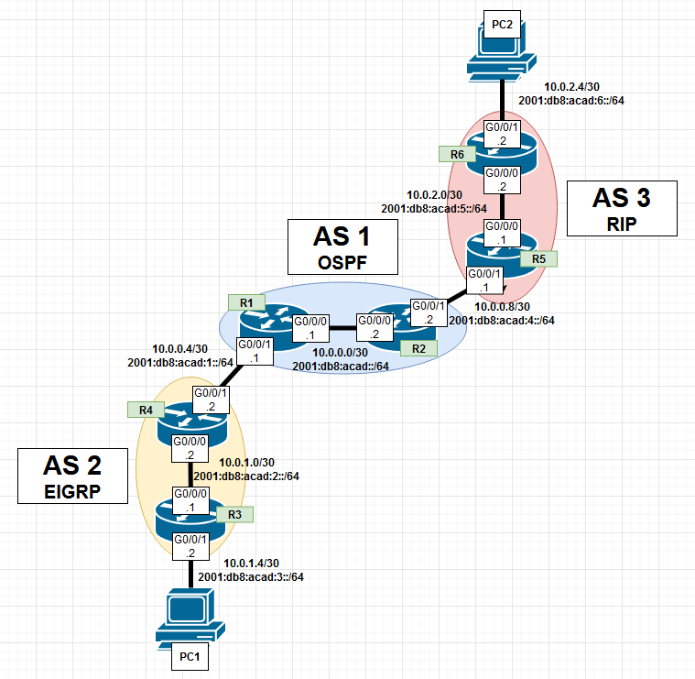

## Configurations, Routing Tables, & Pings

Router 1:

R1#sho run

Building configuration...

Current configuration : 2475 bytes

Last configuration change at 15:58:05 UTC Fri Nov 1 2024

version 15.5

service timestamps debug datetime msec

service timestamps log datetime msec

no platform punt-keepalive disable-kernel-core

hostname R1

boot-start-marker

boot-end-marker

vrf definition Mgmt-intf

address-family ipv4

exit-address-family

address-family ipv6

exit-address-family

no aaa new-model

no ip domain lookup

ipv6 unicast-routing

subscriber templating

vtp domain cisco

vtp mode transparent

multilink bundle-name authenticated

license udi pid ISR4321/K9 sn FDO214421BY

spanning-tree extend system-id

redundancy

mode none

vlan internal allocation policy ascending

interface GigabitEthernet0/0/0

ip address 10.0.0.1 255.255.255.252

ip ospf 1 area 0

negotiation auto

ipv6 address 2001:DB8:ACAD::1/64

ipv6 ospf 1 area 0

interface GigabitEthernet0/0/1

ip address 10.0.0.5 255.255.255.252

ip ospf 1 area 0

negotiation auto

ipv6 address 2001:DB8:ACAD:1::1/64

ipv6 ospf 1 area 0

interface Serial0/1/0

no ip address

shutdown

interface Serial0/1/1

no ip address

shutdown

interface GigabitEthernet0/2/0

no ip address

shutdown

negotiation auto

interface GigabitEthernet0/2/1

no ip address

shutdown

negotiation auto

interface GigabitEthernet0

vrf forwarding Mgmt-intf

no ip address

shutdown

negotiation auto

interface Vlan1

no ip address

shutdown

router ospf 1

router-id 1.1.1.1

priority 127

redistribute connected subnets

redistribute bgp 1 subnets

network 10.0.0.0 0.0.0.3 area 0

network 10.0.0.4 0.0.0.3 area 0

router bgp 1

bgp router-id 1.1.1.1

bgp log-neighbor-changes

neighbor 10.0.0.6 remote-as 2

neighbor 2001:DB8:ACAD:1::2 remote-as 2

address-family ipv4

network 10.0.0.0 mask 255.255.255.252

redistribute connected

redistribute ospf 1 match internal external 1 external 2

neighbor 10.0.0.6 activate

no neighbor 2001:DB8:ACAD:1::2 activate

exit-address-family

address-family ipv6

redistribute connected

redistribute ospf 1 match internal external 1 external 2

network 2001:DB8:ACAD::/64

neighbor 2001:DB8:ACAD:1::2 activate

exit-address-family

ip forward-protocol nd

no ip http server

no ip http secure-server

ip tftp source-interface GigabitEthernet0

ipv6 router ospf 1

redistribute connected

redistribute bgp 1

control-plane

R1#sho ip rout

Codes: L - local, C - connected, S - static, R - RIP, M - mobile, B - BGP

D - EIGRP, EX - EIGRP external, O - OSPF, IA - OSPF inter area

N1 - OSPF NSSA external type 1, N2 - OSPF NSSA external type 2

E1 - OSPF external type 1, E2 - OSPF external type 2

i - IS-IS, su - IS-IS summary, L1 - IS-IS level-1, L2 - IS-IS level-2

ia - IS-IS inter area, * - candidate default, U - per-user static route

o - ODR, P - periodic downloaded static route, H - NHRP, l - LISP

a - application route

+ - replicated route, % - next hop override, p - overrides from PfR

Gateway of last resort is not set

10.0.0.0/8 is variably subnetted, 9 subnets, 2 masks

C 10.0.0.0/30 is directly connected, GigabitEthernet0/0/0

L 10.0.0.1/32 is directly connected, GigabitEthernet0/0/0

C 10.0.0.4/30 is directly connected, GigabitEthernet0/0/1

L 10.0.0.5/32 is directly connected, GigabitEthernet0/0/1

O 10.0.0.8/30 [110/2] via 10.0.0.2, 01:31:37, GigabitEthernet0/0/0

B 10.0.1.0/30 [20/0] via 10.0.0.6, 01:32:10

B 10.0.1.4/30 [20/3072] via 10.0.0.6, 01:26:24

O E2 10.0.2.0/30 [110/1] via 10.0.0.2, 01:30:08, GigabitEthernet0/0/0

O E2 10.0.2.4/30 [110/1] via 10.0.0.2, 01:29:37, GigabitEthernet0/0/0

R1#sho ipv rout

IPv6 Routing Table - default - 10 entries

Codes: C - Connected, L - Local, S - Static, U - Per-user Static route

B - BGP, R - RIP, I1 - ISIS L1, I2 - ISIS L2

IA - ISIS interarea, IS - ISIS summary, D - EIGRP, EX - EIGRP external

ND - ND Default, NDp - ND Prefix, DCE - Destination, NDr - Redirect

O - OSPF Intra, OI - OSPF Inter, OE1 - OSPF ext 1, OE2 - OSPF ext 2

ON1 - OSPF NSSA ext 1, ON2 - OSPF NSSA ext 2, a - Application

C 2001:DB8:ACAD::/64 [0/0]

via GigabitEthernet0/0/0, directly connected

L 2001:DB8:ACAD::1/128 [0/0]

via GigabitEthernet0/0/0, receive

C 2001:DB8:ACAD:1::/64 [0/0]

via GigabitEthernet0/0/1, directly connected

L 2001:DB8:ACAD:1::1/128 [0/0]

via GigabitEthernet0/0/1, receive

B 2001:DB8:ACAD:2::/64 [20/0]

via FE80::521C:B0FF:FE2D:7101, GigabitEthernet0/0/1

B 2001:DB8:ACAD:3::/64 [20/3072]

via FE80::521C:B0FF:FE2D:7101, GigabitEthernet0/0/1

O 2001:DB8:ACAD:4::/64 [110/2]

via FE80::B6A8:B9FF:FE47:92C0, GigabitEthernet0/0/0

OE2 2001:DB8:ACAD:5::/64 [110/1]

via FE80::B6A8:B9FF:FE47:92C0, GigabitEthernet0/0/0

Router 2:

R2#sho run

Building configuration...

Current configuration : 2383 bytes

Last configuration change at 15:37:33 UTC Fri Nov 1 2024

version 15.5

service timestamps debug datetime msec

service timestamps log datetime msec

no platform punt-keepalive disable-kernel-core

hostname R2

boot-start-marker

boot-end-marker

vrf definition Mgmt-intf

address-family ipv4

exit-address-family

address-family ipv6

exit-address-family

R2#sho run

Building configuration...

Current configuration : 2383 bytes

Last configuration change at 15:37:33 UTC Fri Nov 1 2024

version 15.5

service timestamps debug datetime msec

service timestamps log datetime msec

no platform punt-keepalive disable-kernel-core

hostname R2

boot-start-marker

boot-end-marker

vrf definition Mgmt-intf

address-family ipv4

exit-address-family

address-family ipv6

exit-address-family

R2#sho run

R2#sho run

Building configuration...

Current configuration : 2383 bytes

Last configuration change at 15:37:33 UTC Fri Nov 1 2024

version 15.5

service timestamps debug datetime msec

service timestamps log datetime msec

no platform punt-keepalive disable-kernel-core

hostname R2

boot-start-marker

boot-end-marker

vrf definition Mgmt-intf

address-family ipv4

exit-address-family

address-family ipv6

exit-address-family

no aaa new-model

no ip domain lookup

ipv6 unicast-routing

subscriber templating

multilink bundle-name authenticated

license udi pid ISR4321/K9 sn FDO214420QQ

license accept end user agreement

license boot level securityk9

spanning-tree extend system-id

redundancy

mode none

vlan internal allocation policy ascending

interface GigabitEthernet0/0/0

ip address 10.0.0.2 255.255.255.252

ip ospf 1 area 0

negotiation auto

ipv6 address 2001:DB8:ACAD::2/64

ipv6 ospf 1 area 0

interface GigabitEthernet0/0/1

ip address 10.0.0.10 255.255.255.252

ip ospf 1 area 0

negotiation auto

ipv6 address 2001:DB8:ACAD:4::2/64

ipv6 ospf 1 area 0

interface Serial0/1/0

no ip address

shutdown

interface Serial0/1/1

no ip address

shutdown

interface GigabitEthernet0

vrf forwarding Mgmt-intf

no ip address

shutdown

negotiation auto

interface Vlan1

no ip address

shutdown

router ospf 1

router-id 2.2.2.2

redistribute connected subnets

redistribute bgp 1 subnets

network 10.0.0.0 0.0.0.3 area 0

network 10.0.0.8 0.0.0.3 area 0

router bgp 1

bgp router-id 2.2.2.2

bgp log-neighbor-changes

neighbor 10.0.0.9 remote-as 3

neighbor 2001:DB8:ACAD:4::1 remote-as 3

address-family ipv4

network 10.0.0.0 mask 255.255.255.252

redistribute connected

redistribute ospf 1 match internal external 1 external 2

neighbor 10.0.0.9 activate

no neighbor 2001:DB8:ACAD:4::1 activate

exit-address-family

address-family ipv6

redistribute connected

redistribute ospf 1 match internal external 1 external 2

network 2001:DB8:ACAD::/64

neighbor 2001:DB8:ACAD:4::1 activate

exit-address-family

ip forward-protocol nd

no ip http server

no ip http secure-server

ip tftp source-interface GigabitEthernet0

ipv6 router ospf 1

redistribute connected

redistribute bgp 1

control-plane

line con 0

stopbits 1

line aux 0

stopbits 1

line vty 0 4

login

end

R2#sho ip rout

Codes: L - local, C - connected, S - static, R - RIP, M - mobile, B - BGP

D - EIGRP, EX - EIGRP external, O - OSPF, IA - OSPF inter area

N1 - OSPF NSSA external type 1, N2 - OSPF NSSA external type 2

E1 - OSPF external type 1, E2 - OSPF external type 2

i - IS-IS, su - IS-IS summary, L1 - IS-IS level-1, L2 - IS-IS level-2

ia - IS-IS inter area, * - candidate default, U - per-user static route

o - ODR, P - periodic downloaded static route, H - NHRP, l - LISP

a - application route

+ - replicated route, % - next hop override, p - overrides from PfR

Gateway of last resort is not set

10.0.0.0/8 is variably subnetted, 9 subnets, 2 masks

C 10.0.0.0/30 is directly connected, GigabitEthernet0/0/0

L 10.0.0.2/32 is directly connected, GigabitEthernet0/0/0

O 10.0.0.4/30 [110/2] via 10.0.0.1, 01:34:54, GigabitEthernet0/0/0

C 10.0.0.8/30 is directly connected, GigabitEthernet0/0/1

L 10.0.0.10/32 is directly connected, GigabitEthernet0/0/1

O E2 10.0.1.0/30 [110/1] via 10.0.0.1, 01:34:08, GigabitEthernet0/0/0

O E2 10.0.1.4/30 [110/1] via 10.0.0.1, 01:28:21, GigabitEthernet0/0/0

B 10.0.2.0/30 [20/0] via 10.0.0.9, 01:32:05

B 10.0.2.4/30 [20/1] via 10.0.0.9, 01:31:35

R2#sho ipv rout

IPv6 Routing Table - default - 10 entries

Codes: C - Connected, L - Local, S - Static, U - Per-user Static route

B - BGP, R - RIP, H - NHRP, I1 - ISIS L1

I2 - ISIS L2, IA - ISIS interarea, IS - ISIS summary, D - EIGRP

EX - EIGRP external, ND - ND Default, NDp - ND Prefix, DCE - Destination

NDr - Redirect, O - OSPF Intra, OI - OSPF Inter, OE1 - OSPF ext 1

OE2 - OSPF ext 2, ON1 - OSPF NSSA ext 1, ON2 - OSPF NSSA ext 2

a - Application

C 2001:DB8:ACAD::/64 [0/0]

via GigabitEthernet0/0/0, directly connected

L 2001:DB8:ACAD::2/128 [0/0]

via GigabitEthernet0/0/0, receive

O 2001:DB8:ACAD:1::/64 [110/2]

via FE80::B6A8:B9FF:FE01:B510, GigabitEthernet0/0/0

OE2 2001:DB8:ACAD:2::/64 [110/1]

via FE80::B6A8:B9FF:FE01:B510, GigabitEthernet0/0/0

OE2 2001:DB8:ACAD:3::/64 [110/1]

via FE80::B6A8:B9FF:FE01:B510, GigabitEthernet0/0/0

C 2001:DB8:ACAD:4::/64 [0/0]

via GigabitEthernet0/0/1, directly connected

L 2001:DB8:ACAD:4::2/128 [0/0]

via GigabitEthernet0/0/1, receive

B 2001:DB8:ACAD:5::/64 [20/0]

via FE80::6EDD:30FF:FEB6:6031, GigabitEthernet0/0/1

B 2001:DB8:ACAD:6::/64 [20/2]

via FE80::6EDD:30FF:FEB6:6031, GigabitEthernet0/0/1

L FF00::/8 [0/0]

via Null0, receive

Router 3:

R3#sho run

Building configuration...

Current configuration : 1659 bytes

Last configuration change at 17:09:54 UTC Fri Nov 1 2024

version 15.5

service timestamps debug datetime msec

service timestamps log datetime msec

no platform punt-keepalive disable-kernel-core

hostname R3

boot-start-marker

boot-end-marker

vrf definition Mgmt-intf

address-family ipv4

exit-address-family

address-family ipv6

exit-address-family

no aaa new-model

no ip domain lookup

ipv6 unicast-routing

subscriber templating

vtp domain cisco

vtp mode transparent

multilink bundle-name authenticated

license udi pid ISR4321/K9 sn FDO214420HY

license boot level securityk9

spanning-tree extend system-id

redundancy

mode none

vlan internal allocation policy ascending

vlan 10,20

interface GigabitEthernet0/0/0

ip address 10.0.1.1 255.255.255.252

negotiation auto

ipv6 address 2001:DB8:ACAD:2::1/64

ipv6 enable

ipv6 eigrp 2

interface GigabitEthernet0/0/1

ip address 10.0.1.6 255.255.255.252

negotiation auto

ipv6 address 2001:DB8:ACAD:3::2/64

ipv6 enable

ipv6 eigrp 2

interface Serial0/1/0

no ip address

interface Serial0/1/1

no ip address

interface GigabitEthernet0

vrf forwarding Mgmt-intf

no ip address

negotiation auto

interface Vlan1

no ip address

router eigrp 2

network 10.0.1.0 0.0.0.3

network 10.0.1.4 0.0.0.3

ip forward-protocol nd

no ip http server

no ip http secure-server

ip tftp source-interface GigabitEthernet0

ipv6 router eigrp 2

eigrp router-id 3.3.3.3

control-plane

line con 0

stopbits 1

line aux 0

stopbits 1

line vty 0 4

login

end

R3#sho ip rout

Codes: L - local, C - connected, S - static, R - RIP, M - mobile, B - BGP

D - EIGRP, EX - EIGRP external, O - OSPF, IA - OSPF inter area

N1 - OSPF NSSA external type 1, N2 - OSPF NSSA external type 2

E1 - OSPF external type 1, E2 - OSPF external type 2

i - IS-IS, su - IS-IS summary, L1 - IS-IS level-1, L2 - IS-IS level-2

ia - IS-IS inter area, * - candidate default, U - per-user static route

o - ODR, P - periodic downloaded static route, H - NHRP, l - LISP

a - application route

+ - replicated route, % - next hop override, p - overrides from PfR

Gateway of last resort is not set

10.0.0.0/8 is variably subnetted, 9 subnets, 2 masks

D EX 10.0.0.0/30

[170/25600512] via 10.0.1.2, 01:36:39, GigabitEthernet0/0/0

D 10.0.0.4/30 [90/3072] via 10.0.1.2, 01:37:23, GigabitEthernet0/0/0

D EX 10.0.0.8/30

[170/25600512] via 10.0.1.2, 01:35:39, GigabitEthernet0/0/0

C 10.0.1.0/30 is directly connected, GigabitEthernet0/0/0

L 10.0.1.1/32 is directly connected, GigabitEthernet0/0/0

C 10.0.1.4/30 is directly connected, GigabitEthernet0/0/1

L 10.0.1.6/32 is directly connected, GigabitEthernet0/0/1

D EX 10.0.2.0/30

[170/25600512] via 10.0.1.2, 01:25:25, GigabitEthernet0/0/0

D EX 10.0.2.4/30

[170/25600512] via 10.0.1.2, 01:25:25, GigabitEthernet0/0/0

R3#sho ipv rout

IPv6 Routing Table - default - 10 entries

Codes: C - Connected, L - Local, S - Static, U - Per-user Static route

B - BGP, R - RIP, H - NHRP, I1 - ISIS L1

I2 - ISIS L2, IA - ISIS interarea, IS - ISIS summary, D - EIGRP

EX - EIGRP external, ND - ND Default, NDp - ND Prefix, DCE - Destination

NDr - Redirect, O - OSPF Intra, OI - OSPF Inter, OE1 - OSPF ext 1

OE2 - OSPF ext 2, ON1 - OSPF NSSA ext 1, ON2 - OSPF NSSA ext 2

a - Application

EX 2001:DB8:ACAD::/64 [170/25600512]

via FE80::521C:B0FF:FE2D:7100, GigabitEthernet0/0/0

D 2001:DB8:ACAD:1::/64 [90/3072]

via FE80::521C:B0FF:FE2D:7100, GigabitEthernet0/0/0

C 2001:DB8:ACAD:2::/64 [0/0]

via GigabitEthernet0/0/0, directly connected

L 2001:DB8:ACAD:2::1/128 [0/0]

via GigabitEthernet0/0/0, receive

C 2001:DB8:ACAD:3::/64 [0/0]

via GigabitEthernet0/0/1, directly connected

L 2001:DB8:ACAD:3::2/128 [0/0]

via GigabitEthernet0/0/1, receive

EX 2001:DB8:ACAD:4::/64 [170/25600512]

via FE80::521C:B0FF:FE2D:7100, GigabitEthernet0/0/0

EX 2001:DB8:ACAD:5::/64 [170/25600512]

via FE80::521C:B0FF:FE2D:7100, GigabitEthernet0/0/0

EX 2001:DB8:ACAD:6::/64 [170/25600512]

via FE80::521C:B0FF:FE2D:7100, GigabitEthernet0/0/0

L FF00::/8 [0/0]

via Null0, receive

Router 4:

R4#sho run

Building configuration...

Current configuration : 2423 bytes

Last configuration change at 15:39:13 UTC Fri Nov 1 2024

version 15.5

service timestamps debug datetime msec

service timestamps log datetime msec

no platform punt-keepalive disable-kernel-core

hostname R4

boot-start-marker

boot-end-marker

vrf definition Mgmt-intf

address-family ipv4

exit-address-family

address-family ipv6

exit-address-family

no aaa new-model

no ip domain lookup

ipv6 unicast-routing

subscriber templating

vtp domain cisco

vtp mode transparent

multilink bundle-name authenticated

license udi pid ISR4321/K9 sn FDO21491LXV

license accept end user agreement

license boot level securityk9

spanning-tree extend system-id

redundancy

mode none

vlan internal allocation policy ascending

vlan 2

name v2

vlan 3

name v3

vlan 4

name v4

vlan 10,20

interface GigabitEthernet0/0/0

ip address 10.0.1.2 255.255.255.252

negotiation auto

ipv6 address 2001:DB8:ACAD:2::2/64

ipv6 eigrp 2

interface GigabitEthernet0/0/1

ip address 10.0.0.6 255.255.255.252

negotiation auto

ipv6 address 2001:DB8:ACAD:1::2/64

ipv6 eigrp 2

interface Serial0/1/0

no ip address

shutdown

interface Serial0/1/1

no ip address

shutdown

interface GigabitEthernet0

vrf forwarding Mgmt-intf

no ip address

shutdown

negotiation auto

interface Vlan1

no ip address

shutdown

router eigrp 2

network 10.0.0.4 0.0.0.3

network 10.0.1.0 0.0.0.3

redistribute bgp 2 metric 100 1 255 1 1500

router bgp 2

bgp router-id 3.3.3.3

bgp log-neighbor-changes

neighbor 10.0.0.5 remote-as 1

neighbor 2001:DB8:ACAD:1::1 remote-as 1

address-family ipv4

network 10.0.1.0 mask 255.255.255.252

network 10.0.1.4 mask 255.255.255.252

redistribute connected

redistribute eigrp 2

neighbor 10.0.0.5 activate

no neighbor 2001:DB8:ACAD:1::1 activate

exit-address-family

address-family ipv6

redistribute connected

redistribute eigrp 2

network 2001:DB8:ACAD:1::/64

network 2001:DB8:ACAD:2::/64

neighbor 2001:DB8:ACAD:1::1 activate

exit-address-family

ip forward-protocol nd

no ip http server

no ip http secure-server

ip tftp source-interface GigabitEthernet0

ipv6 router eigrp 2

eigrp router-id 4.4.4.4

redistribute bgp 2 metric 100 1 255 1 1500

control-plane

line con 0

stopbits 1

line aux 0

stopbits 1

line vty 0 4

login

end

R4#sho ip route

Codes: L - local, C - connected, S - static, R - RIP, M - mobile, B - BGP

D - EIGRP, EX - EIGRP external, O - OSPF, IA - OSPF inter area

N1 - OSPF NSSA external type 1, N2 - OSPF NSSA external type 2

E1 - OSPF external type 1, E2 - OSPF external type 2

i - IS-IS, su - IS-IS summary, L1 - IS-IS level-1, L2 - IS-IS level-2

ia - IS-IS inter area, * - candidate default, U - per-user static route

o - ODR, P - periodic downloaded static route, H - NHRP, l - LISP

a - application route

+ - replicated route, % - next hop override, p - overrides from PfR

Gateway of last resort is not set

10.0.0.0/8 is variably subnetted, 9 subnets, 2 masks

B 10.0.0.0/30 [20/0] via 10.0.0.5, 01:37:26

C 10.0.0.4/30 is directly connected, GigabitEthernet0/0/1

L 10.0.0.6/32 is directly connected, GigabitEthernet0/0/1

B 10.0.0.8/30 [20/2] via 10.0.0.5, 01:36:25

C 10.0.1.0/30 is directly connected, GigabitEthernet0/0/0

L 10.0.1.2/32 is directly connected, GigabitEthernet0/0/0

D 10.0.1.4/30 [90/3072] via 10.0.1.1, 01:30:51, GigabitEthernet0/0/0

B 10.0.2.0/30 [20/1] via 10.0.0.5, 01:26:11

B 10.0.2.4/30 [20/1] via 10.0.0.5, 01:26:11

R4#sho ipv rout

IPv6 Routing Table - default - 10 entries

Codes: C - Connected, L - Local, S - Static, U - Per-user Static route

B - BGP, R - RIP, H - NHRP, I1 - ISIS L1

I2 - ISIS L2, IA - ISIS interarea, IS - ISIS summary, D - EIGRP

EX - EIGRP external, ND - ND Default, NDp - ND Prefix, DCE - Destination

NDr - Redirect, O - OSPF Intra, OI - OSPF Inter, OE1 - OSPF ext 1

OE2 - OSPF ext 2, ON1 - OSPF NSSA ext 1, ON2 - OSPF NSSA ext 2

a - Application

B 2001:DB8:ACAD::/64 [20/0]

via FE80::B6A8:B9FF:FE01:B511, GigabitEthernet0/0/1

C 2001:DB8:ACAD:1::/64 [0/0]

via GigabitEthernet0/0/1, directly connected

L 2001:DB8:ACAD:1::2/128 [0/0]

via GigabitEthernet0/0/1, receive

C 2001:DB8:ACAD:2::/64 [0/0]

via GigabitEthernet0/0/0, directly connected

L 2001:DB8:ACAD:2::2/128 [0/0]

via GigabitEthernet0/0/0, receive

D 2001:DB8:ACAD:3::/64 [90/3072]

via FE80::B6A8:B9FF:FE01:AE50, GigabitEthernet0/0/0

B 2001:DB8:ACAD:4::/64 [20/2]

via FE80::B6A8:B9FF:FE01:B511, GigabitEthernet0/0/1

B 2001:DB8:ACAD:5::/64 [20/1]

via FE80::B6A8:B9FF:FE01:B511, GigabitEthernet0/0/1

B 2001:DB8:ACAD:6::/64 [20/1]

via FE80::B6A8:B9FF:FE01:B511, GigabitEthernet0/0/1

L FF00::/8 [0/0]

via Null0, receive

**Router 5:**

R5#sho run

Building configuration...

Current configuration : 2136 bytes

Last configuration change at 15:15:14 UTC Fri Nov 1 2024

version 15.5

service timestamps debug datetime msec

service timestamps log datetime msec

no platform punt-keepalive disable-kernel-core

hostname R5

boot-start-marker

boot-end-marker

vrf definition Mgmt-intf

address-family ipv4

exit-address-family

address-family ipv6

exit-address-family

no aaa new-model

no ip domain lookup

ipv6 unicast-routing

subscriber templating

vtp domain cisco

vtp mode transparent

multilink bundle-name authenticated

license udi pid ISR4321/K9 sn FDO21400XZX

spanning-tree extend system-id

redundancy

mode none

vlan internal allocation policy ascending

interface GigabitEthernet0/0/0

ip address 10.0.2.1 255.255.255.252

negotiation auto

ipv6 address 2001:DB8:ACAD:5::1/64

ipv6 rip routing enable

interface GigabitEthernet0/0/1

ip address 10.0.0.9 255.255.255.252

negotiation auto

ipv6 address 2001:DB8:ACAD:4::1/64

ipv6 rip routing enable

interface Serial0/1/0

no ip address

shutdown

interface Serial0/1/1

no ip address

shutdown

interface GigabitEthernet0

vrf forwarding Mgmt-intf

no ip address

shutdown

negotiation auto

interface Vlan1

no ip address

shutdown

router rip

version 2

redistribute bgp 3 metric 1

network 10.0.0.0

router bgp 3

bgp router-id 5.5.5.5

bgp log-neighbor-changes

neighbor 10.0.0.10 remote-as 1

neighbor 2001:DB8:ACAD:4::2 remote-as 1

address-family ipv4

network 10.0.2.0 mask 255.255.255.252

network 10.0.2.4 mask 255.255.255.252

redistribute connected

redistribute rip

neighbor 10.0.0.10 activate

no neighbor 2001:DB8:ACAD:4::2 activate

exit-address-family

address-family ipv6

network 2001:DB8:ACAD:5::/64

network 2001:DB8:ACAD:6::/64

neighbor 2001:DB8:ACAD:4::2 activate

exit-address-family

ip forward-protocol nd

no ip http server

no ip http secure-server

ip tftp source-interface GigabitEthernet0

ipv6 router rip routing

redistribute bgp 3 metric 1

control-plane

line con 0

stopbits 1

line aux 0

stopbits 1

line vty 0 4

login

end

R5#sho ip rout

Codes: L - local, C - connected, S - static, R - RIP, M - mobile, B - BGP

D - EIGRP, EX - EIGRP external, O - OSPF, IA - OSPF inter area

N1 - OSPF NSSA external type 1, N2 - OSPF NSSA external type 2

E1 - OSPF external type 1, E2 - OSPF external type 2

i - IS-IS, su - IS-IS summary, L1 - IS-IS level-1, L2 - IS-IS level-2

ia - IS-IS inter area, * - candidate default, U - per-user static route

o - ODR, P - periodic downloaded static route, H - NHRP, l - LISP

a - application route

+ - replicated route, % - next hop override, p - overrides from PfR

Gateway of last resort is not set

10.0.0.0/8 is variably subnetted, 9 subnets, 2 masks

B 10.0.0.0/30 [20/0] via 10.0.0.10, 01:38:11

B 10.0.0.4/30 [20/2] via 10.0.0.10, 01:38:11

C 10.0.0.8/30 is directly connected, GigabitEthernet0/0/1

L 10.0.0.9/32 is directly connected, GigabitEthernet0/0/1

B 10.0.1.0/30 [20/1] via 10.0.0.10, 01:26:37

B 10.0.1.4/30 [20/1] via 10.0.0.10, 01:26:37

C 10.0.2.0/30 is directly connected, GigabitEthernet0/0/0

L 10.0.2.1/32 is directly connected, GigabitEthernet0/0/0

R 10.0.2.4/30 [120/1] via 10.0.2.2, 00:00:04, GigabitEthernet0/0/0

R5# sho ipv rout

IPv6 Routing Table - default - 10 entries

Codes: C - Connected, L - Local, S - Static, U - Per-user Static route

B - BGP, R - RIP, I1 - ISIS L1, I2 - ISIS L2

IA - ISIS interarea, IS - ISIS summary, D - EIGRP, EX - EIGRP external

ND - ND Default, NDp - ND Prefix, DCE - Destination, NDr - Redirect

O - OSPF Intra, OI - OSPF Inter, OE1 - OSPF ext 1, OE2 - OSPF ext 2

ON1 - OSPF NSSA ext 1, ON2 - OSPF NSSA ext 2, a - Application

B 2001:DB8:ACAD::/64 [20/0]

via FE80::B6A8:B9FF:FE47:92C1, GigabitEthernet0/0/1

B 2001:DB8:ACAD:1::/64 [20/2]

via FE80::B6A8:B9FF:FE47:92C1, GigabitEthernet0/0/1

B 2001:DB8:ACAD:2::/64 [20/1]

via FE80::B6A8:B9FF:FE47:92C1, GigabitEthernet0/0/1

B 2001:DB8:ACAD:3::/64 [20/1]

via FE80::B6A8:B9FF:FE47:92C1, GigabitEthernet0/0/1

C 2001:DB8:ACAD:4::/64 [0/0]

via GigabitEthernet0/0/1, directly connected

L 2001:DB8:ACAD:4::1/128 [0/0]

via GigabitEthernet0/0/1, receive

C 2001:DB8:ACAD:5::/64 [0/0]

via GigabitEthernet0/0/0, directly connected

L 2001:DB8:ACAD:5::1/128 [0/0]

via GigabitEthernet0/0/0, receive

R 2001:DB8:ACAD:6::/64 [120/2]

via FE80::521C:B0FF:FE2D:6800, GigabitEthernet0/0/0

L FF00::/8 [0/0]

via Null0, receive

Router 6:

R6#sho run

Building configuration...

Current configuration : 1648 bytes

Last configuration change at 15:14:46 UTC Fri Nov 1 2024

version 15.5

service timestamps debug datetime msec

service timestamps log datetime msec

no platform punt-keepalive disable-kernel-core

hostname R6

boot-start-marker

boot-end-marker

vrf definition Mgmt-intf

address-family ipv4

exit-address-family

address-family ipv6

exit-address-family

no aaa new-model

no ip domain lookup

ipv6 unicast-routing

subscriber templating

vtp domain cisco

vtp mode transparent

multilink bundle-name authenticated

license udi pid ISR4321/K9 sn FDO21491FHX

spanning-tree extend system-id

redundancy

mode none

vlan internal allocation policy ascending

interface GigabitEthernet0/0/0

ip address 10.0.2.2 255.255.255.252

negotiation auto

ipv6 address 2001:DB8:ACAD:5::2/64

ipv6 rip routing enable

interface GigabitEthernet0/0/1

ip address 10.0.2.6 255.255.255.252

negotiation auto

ipv6 address 2001:DB8:ACAD:6::2/64

ipv6 rip routing enable

interface GigabitEthernet0/1/0

no ip address

shutdown

negotiation auto

interface GigabitEthernet0/1/1

no ip address

shutdown

negotiation auto

interface GigabitEthernet0

vrf forwarding Mgmt-intf

no ip address

shutdown

negotiation auto

interface Vlan1

no ip address

shutdown

router rip

version 2

passive-interface GigabitEthernet0/0/1

network 10.0.0.0

ip forward-protocol nd

no ip http server

no ip http secure-server

ip tftp source-interface GigabitEthernet0

ipv6 router rip routing

control-plane

line con 0

stopbits 1

line aux 0

stopbits 1

line vty 0 4

login

end

R6#sho ip rout

Codes: L - local, C - connected, S - static, R - RIP, M - mobile, B - BGP

D - EIGRP, EX - EIGRP external, O - OSPF, IA - OSPF inter area

N1 - OSPF NSSA external type 1, N2 - OSPF NSSA external type 2

E1 - OSPF external type 1, E2 - OSPF external type 2

i - IS-IS, su - IS-IS summary, L1 - IS-IS level-1, L2 - IS-IS level-2

ia - IS-IS inter area, * - candidate default, U - per-user static route

o - ODR, P - periodic downloaded static route, H - NHRP, l - LISP

a - application route

+ - replicated route, % - next hop override, p - overrides from PfR

Gateway of last resort is not set

10.0.0.0/8 is variably subnetted, 9 subnets, 2 masks

R 10.0.0.0/30 [120/1] via 10.0.2.1, 00:00:06, GigabitEthernet0/0/0

R 10.0.0.4/30 [120/1] via 10.0.2.1, 00:00:06, GigabitEthernet0/0/0

R 10.0.0.8/30 [120/1] via 10.0.2.1, 00:00:06, GigabitEthernet0/0/0

R 10.0.1.0/30 [120/1] via 10.0.2.1, 00:00:06, GigabitEthernet0/0/0

R 10.0.1.4/30 [120/1] via 10.0.2.1, 00:00:06, GigabitEthernet0/0/0

C 10.0.2.0/30 is directly connected, GigabitEthernet0/0/0

L 10.0.2.2/32 is directly connected, GigabitEthernet0/0/0

C 10.0.2.4/30 is directly connected, GigabitEthernet0/0/1

L 10.0.2.6/32 is directly connected, GigabitEthernet0/0/1

R6# sho ipv rout

IPv6 Routing Table - default - 10 entries

Codes: C - Connected, L - Local, S - Static, U - Per-user Static route

B - BGP, R - RIP, I1 - ISIS L1, I2 - ISIS L2

IA - ISIS interarea, IS - ISIS summary, D - EIGRP, EX - EIGRP external

ND - ND Default, NDp - ND Prefix, DCE - Destination, NDr - Redirect

O - OSPF Intra, OI - OSPF Inter, OE1 - OSPF ext 1, OE2 - OSPF ext 2

ON1 - OSPF NSSA ext 1, ON2 - OSPF NSSA ext 2, a - Application

R 2001:DB8:ACAD::/64 [120/2]

via FE80::6EDD:30FF:FEB6:6030, GigabitEthernet0/0/0

R 2001:DB8:ACAD:1::/64 [120/2]

via FE80::6EDD:30FF:FEB6:6030, GigabitEthernet0/0/0

R 2001:DB8:ACAD:2::/64 [120/2]

via FE80::6EDD:30FF:FEB6:6030, GigabitEthernet0/0/0

R 2001:DB8:ACAD:3::/64 [120/2]

via FE80::6EDD:30FF:FEB6:6030, GigabitEthernet0/0/0

R 2001:DB8:ACAD:4::/64 [120/2]

via FE80::6EDD:30FF:FEB6:6030, GigabitEthernet0/0/0

C 2001:DB8:ACAD:5::/64 [0/0]

via GigabitEthernet0/0/0, directly connected

L 2001:DB8:ACAD:5::2/128 [0/0]

via GigabitEthernet0/0/0, receive

C 2001:DB8:ACAD:6::/64 [0/0]

via GigabitEthernet0/0/1, directly connected

L 2001:DB8:ACAD:6::2/128 [0/0]

via GigabitEthernet0/0/1, receive

L FF00::/8 [0/0]

via Null0, receive

Pings/Trace Routes:

C:\Users\Aadithya Prabhath>ping 10.0.2.5

Pinging 10.0.2.5 with 32 bytes of data:

Reply from 10.0.2.5: bytes=32 time=1ms TTL=122

Reply from 10.0.2.5: bytes=32 time=1ms TTL=122

Reply from 10.0.2.5: bytes=32 time=1ms TTL=122

Reply from 10.0.2.5: bytes=32 time=1ms TTL=122

Ping statistics for 10.0.2.5:

Packets: Sent = 4, Received = 4, Lost = 0 (0% loss),

Approximate round trip times in milli-seconds:

Minimum = 1ms, Maximum = 1ms, Average = 1ms

C:\Users\Aadithya Prabhath>tracert 10.0.2.5

Tracing route to DESKTOP-CH27SQT [10.0.2.5]

over a maximum of 30 hops:

1 <1 ms <1 ms <1 ms 10.0.1.6

2 <1 ms <1 ms <1 ms 10.0.1.2

3 <1 ms <1 ms <1 ms 10.0.0.5

4 <1 ms <1 ms <1 ms 10.0.0.2

5 <1 ms <1 ms <1 ms 10.0.0.9

6 <1 ms <1 ms <1 ms 10.0.2.2

7 1 ms 1 ms <1 ms DESKTOP-CH27SQT [10.0.2.5]

Trace complete.

C:\Users\Aadithya Prabhath>ping 2001:db8:acad:6::1

Pinging 2001:db8:acad:6::1 with 32 bytes of data:

Reply from 2001:db8:acad:6::1: time=1ms

Reply from 2001:db8:acad:6::1: time=1ms

Reply from 2001:db8:acad:6::1: time=1ms

Reply from 2001:db8:acad:6::1: time=1ms

Ping statistics for 2001:db8:acad:6::1:

Packets: Sent = 4, Received = 4, Lost = 0 (0% loss),

Approximate round trip times in milli-seconds:

Minimum = 1ms, Maximum = 1ms, Average = 1ms

C:\Users\Aadithya Prabhath>tracert 2001:db8:acad:6::1

Tracing route to DESKTOP-CH27SQT [2001:db8:acad:6::1]

over a maximum of 30 hops:

1 <1 ms <1 ms <1 ms 2001:db8:acad:3::2

2 <1 ms <1 ms <1 ms 2001:db8:acad:2::2

3 <1 ms <1 ms <1 ms 2001:db8:acad:1::1

4 <1 ms <1 ms <1 ms 2001:db8:acad::2

5 <1 ms <1 ms <1 ms 2001:db8:acad:4::1

6 <1 ms <1 ms <1 ms 2001:db8:acad:5::2

7 1 ms 1 ms <1 ms DESKTOP-CH27SQT [2001:db8:acad:6::1]

## Problems

The first problem we encountered in our lab occurred when we were trying to get IPv4 BGP to work. Although BGP was correctly distributing routing information between peers, those routers were not sharing that information with the rest of their network. To remedy this, we added *redistribute* commands to allow routers to share routing information. This also enabled BGP routes to propagate through the network, allowing AS 2 to learn about the routing information for AS 3. The next issue we had occurred when we were trying to configure RIPng to allow for IPv6 RIP routing. In our original topology, we were running small IPv6 subnets with a /112 prefix. Because RIP is so old and is such a limited protocol, it was not correctly sharing IPv6 routing information. To fix this, we redid our IPv6 subnetting scheme such that we could use a /64 prefix instead. This resolved our issues with RIP and cleaned up our configuration, reducing opportunities for simple typos to occur. Throughout our troubleshooting process, we also learned how to effectively use the *debug* command. When EIGRP routes were not redistributing correctly, we used the *debug* command, as well as the EIGRP database and other logging tools to determine that the issue had occurred because we had not defined an EIGRP metric. This led to the routes having a distance of infinity, causing them to not be added to the routing table. We made similar use of the debug tool to solve the aforementioned issues with RIP and BGP.

## Conclusion

In this lab we learned how to set up a network consisting of multiple ASes. We also learned how to use EIGRP and RIP to route traffic. We learned how to integrate BGP with protocols like OSPF, EIGRP, and RIP to allow traffic to be routed through ASes. Lastly, and perhaps most importantly, we learned how to effectively use the *debug* command as well as logs and protocol databases to troubleshoot issues we encountered in our network. This skill will prove extremely helpful in future labs by allowing us to determine more quickly what the issue in a network is and correct it.

|  |
| --- |
| LAB 3: CONFIGURING IBGP Aadithya Prabhath |
| Cisco white logo transparent PNG - StickPNG |



## Purpose

To design, construct, and configure a network that uses multiple autonomous systems that run different routing protocols, and transmit traffic through them by connecting the autonomous systems with eBGP. We will also be using iBGP on the middle AS to ensure reliability and scalability.

## Background Information on Lab Concepts

BGP is an exterior gateway protocol that is designed to route information between autonomous systems (AS). It is a path-vector routing protocol, as opposed to a distance vector routing protocol (EIGRP) or link state routing protocol (OSPF). It uses TCP port 179. BGP is primarily used to send traffic in large networks. Each AS consists of multiple subnets and routers, all united within a single domain. The Internet is made up of multiple ASes. ASes can include ISPs, corporations, and governmental organizations. BGP’s job is to facilitate communication between these ASes, as well as allow traffic to be routed through them. This can be important if, for example: a host within a corporation is attempting to connect to a government server. The host sends the traffic through the corporate network, till it reaches an autonomous system boundary router (ASBR). The corporate ASBR is connected to the ISP’s ASBR, and routing information is exchanged between them. The corporate ASBR forwards the traffic to the ISP’s ASBR, which then transmits the traffic through its network. This continues until the traffic reaches the ASBR that connects to the government’s ASBR. The ISP’s ASBR then forwards the traffic to the government’s AS, which can then direct the request to the correct server. Although the ISP’s routers are not directly configured with the knowledge of the topology of the government’s network, they are able to learn routes by using information shared by the government’s ASBR through BGP. Likewise, the ISP’s routers then share that information to other connected ASBRs through BGP, providing a seamless connection between ASes that are not directly connected. Because these routes are not subject to change often, BGP has an administrative distance of 20, signaling that the routes are very reliable. However, if BGP routes are unstable, BGP does not converge very quickly because it is designed to handle traffic over networks that do not change very much, like inter-ISP network infrastructure. Although BGP does not support IPv6 by default, it can be configured to distribute both IPv4 and IPv6 routes. To do this, it divides its routes into address families. The address family denotes the type of address (IPv4 or IPv6) that the route is for. We will be using iBGP to redistribute external routes within the middle AS. On the previous lab, we used redistribute commands to have the routers propagate eBGP routes by converting them into IGP routes, which then get converted back to eBGP routes at the edge routers. In this lab, we instead used iBGP to redistribute eBGP routes within an AS. This improves scalability because only routes that need to share external routes need to be configured with iBGP, and it also improves security because only routers that are handling external traffic need to be configured with iBGP. To simulate multiple ASes in our lab, we created three pairs of routers, each running a different interior routing protocol. The protocols we chose to use are OSPF and EIGRP. OSPF is a routing algorithm that uses link-state routing. It is an interior gateway protocol, or IGP, that is designed to operate within an Autonomous System. It is typically used in enterprise networks. OSPF uses routing metrics to construct a routing table which is used to forward traffic. Typically, OSPF uses link bandwidth to calculate link cost. This is done by dividing the speed of a link by a reference bandwidth, typically 10000. This allows load balancing by choosing routes that transport the most data as quickly as possible. Once the topology of the network is detected, a router in each area is elected as the designated router. The designated router serves to centralize the updates from other routers in the network to reduce bandwidth consumed by OSPF traffic. EIGRP is a Cisco proprietary distance-vector interior routing protocol. It is an evolution of IGRP. EIGRP is a distance-vector protocol. It can use many parameters and metrics to calculate route cost, combining bandwidth, delay, reliability, load, and MTU. This allows a greater degree of customizability compared to OSPF. Another big advantage of EIGRP is that it only broadcasts routing information if there has been a change in the routing table. EIGRP does not use TCP or UDP to ensure messages are accurately sent. Instead, it directly sends messages over IP.

## Lab Summary

Our first step in this lab was to design the network topology. We decided to split the network into three autonomous systems. Next, we wrote the configurations for the routers. In the configurations, we configured OSPF, EIGRP, and eBGP. We declared BGP neighbors for each of the ASes. We then configured each of the interfaces with IP and dynamic routing protocol information. We then configured AS 2 to use IBGP on R4. Lastly, we configured the PCs with the appropriate IP address information to ensure connectivity.

## Lab Commands

-sdm prefer dual default: This command is entered on a layer three switch. This enables the switch to route both IPv4 and IPv6 traffic.

-ipv6 unicast: This command is entered on a router. It enables the router to route IPv6 traffic.

-router id x.x.x.x: This command is used to assign a router ID. to a router. The xs represent any numbers that can be used as the router ID.

-router ospf x: This command is entered on a router. The letter x represents the OSPF process ID. This allows the configuration of OSPF on a router.

-priority x: This command enables the selection of which router is most likely to become the designated router. The value of x can range for 0-127. A router with a priority of 0 can never be a designated router. A router with a priority of 127 will always be the designated router, unless another router has a priority of 127, in which case they go to a run-off.

-network x.x.x.x x.x.x.x area x: This command is used to designate a network that is connected to a router as part of a specific OSPF area. The first set of xs represents the network address. The second set of xs represents the wildcard mask of the subnet. The last x represents the area that the network is a part of.

-ip ospf x area x: This command is used to bind an interface to an area. The first x represents the OSPF process id. The second x represents the area that the interface is being bound to.

-ipv6 ospf x area x: This command is used to bind an interface that is using IPv6 to an area. The first x represents the OSPF process id. The second x represents the area that the interface is being bound to.

-neighbor x.x.x.x remote-as x: This command is used to declare a BGP neighbor. The x.x.x.x represents the IP address of the neighbor. This can be either an IPv4 or IPv6 address. The second x represents the AS number that the neighbor belongs to.

-neighbor x.x.x.x activate: This command activates the connection to a BGP neighbor. If done without using the network x.x.x.x command, it allows the destination to be treated as a BGP peer without being directly connected.

-network x.x.x.x: This command is used to designate a BGP peer as being a directly connected peer.

-address family ipv4: This command allows the configuration of IPv4 BGP routing information, like neighbors and route redistributions.

-address family ipv6: This command allows the configuration of IPv6 BGP routing information, like neighbors and route redistributions.

-redistribute ospf x match external: This command is used to redistribute OSPF external routes from process id. x. This allows BGP routes to neighbors to propagate from one side of an AS to another.

-redistribute connected: This command is used to redistribute routes to all directly connected routers.

-redistribute bgp x: This command is used to redistribute BGP routing information from BGP AS number x to the interior routing protocol this is command was used in.

-redistribute *protocol* metric *bandwidth delay reliability loading MTU:* This command is used to redistribute routes from other protocols into EIGRP. If metrics are not manually configured in EIGRP, the route will not be used. Thus, it is necessary to manually configure the route. The *bandwidth* field represents the bandwidth of the link in kilobits per second. The *delay* field represents the delay of the link, in 10 microsecond increments. The *reliability* field goes from 0-255, where 255 is 100% reliable. The *loading* field also goes from 0-255, where 255 is 100% loaded. Lastly, the *MTU* fields represents the largest packet size that can be transmitted, in 1-byte increments. EIGRP can also be configured to use the default metric value, but we did not use that in this lab.

## Network Diagram

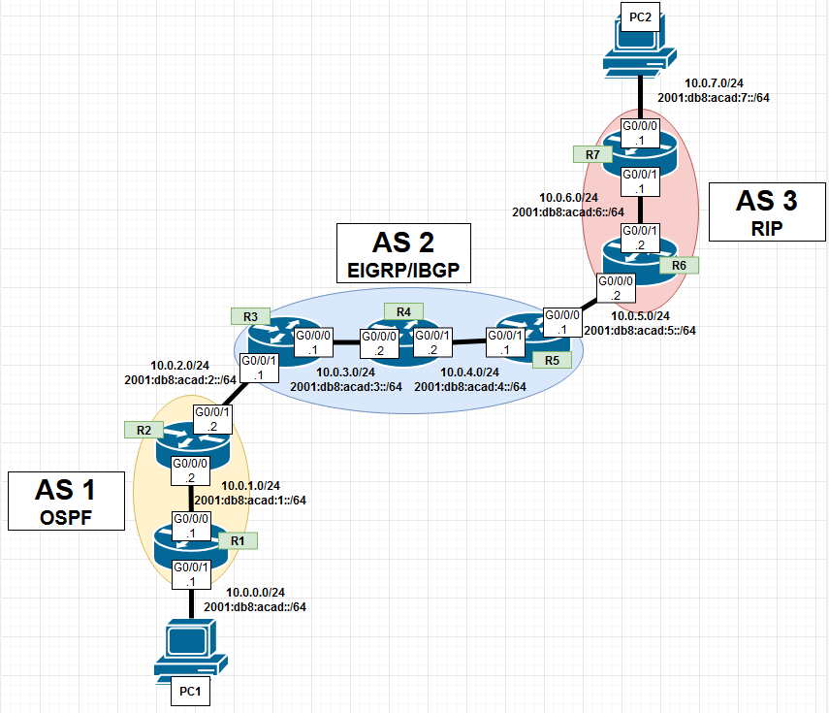

## 

## Configurations, Routing Tables, & Pings

C:\Users\Aadithya Prabhath>ping 10.0.7.2

Pinging 10.0.7.2 with 32 bytes of data:

Reply from 10.0.7.2: bytes=32 time=1ms TTL=121

Reply from 10.0.7.2: bytes=32 time=1ms TTL=121

Reply from 10.0.7.2: bytes=32 time=1ms TTL=121

Reply from 10.0.7.2: bytes=32 time=1ms TTL=121

Ping statistics for 10.0.7.2:

Packets: Sent = 4, Received = 4, Lost = 0 (0% loss),

Approximate round trip times in milli-seconds:

Minimum = 1ms, Maximum = 1ms, Average = 1ms

C:\Users\Aadithya Prabhath>ping 2001:db8:acad:7::2

Pinging 2001:db8:acad:7::2 with 32 bytes of data:

Reply from 2001:db8:acad:7::2: time=6ms

Reply from 2001:db8:acad:7::2: time=1ms

Reply from 2001:db8:acad:7::2: time=1ms

Reply from 2001:db8:acad:7::2: time=1ms

Ping statistics for 2001:db8:acad:7::2:

Packets: Sent = 4, Received = 4, Lost = 0 (0% loss),

Approximate round trip times in milli-seconds:

Minimum = 1ms, Maximum = 6ms, Average = 2ms

C:\Users\Aadithya Prabhath>tracert 10.0.7.2

Tracing route to DESKTOP-CH27SQT [10.0.7.2]

over a maximum of 30 hops:

1 <1 ms <1 ms <1 ms 10.0.0.1

2 <1 ms <1 ms <1 ms 10.0.1.2

3 2 ms <1 ms <1 ms 10.0.2.1

4 <1 ms <1 ms <1 ms 10.0.3.2

5 <1 ms <1 ms <1 ms 10.0.4.1

6 <1 ms <1 ms 1 ms 10.0.5.2

7 1 ms <1 ms <1 ms 10.0.6.1

8 1 ms 1 ms 1 ms DESKTOP-CH27SQT [10.0.7.2]

Trace complete.

C:\Users\Aadithya Prabhath>tracert 2001:db8:acad:7::2

Tracing route to 2001:db8:acad:7::2 over a maximum of 30 hops

1 <1 ms <1 ms <1 ms 2001:db8:acad::1

2 <1 ms <1 ms <1 ms 2001:db8:acad:1::2

3 <1 ms <1 ms <1 ms 2001:db8:acad:2::1

4 1 ms <1 ms <1 ms 2001:db8:acad:3::2

5 1 ms <1 ms <1 ms 2001:db8:acad:4::1

6 1 ms <1 ms <1 ms 2001:db8:acad:5::2

7 1 ms <1 ms <1 ms 2001:db8:acad:6::1

8 1 ms 1 ms <1 ms 2001:db8:acad:7::2

Trace complete.

C:\Users\Allen Wu>tracert 10.0.0.2

Tracing route to DESKTOP-ETOO76H [10.0.0.2]

over a maximum of 30 hops:

1 <1 ms <1 ms <1 ms 10.0.7.1

2 <1 ms <1 ms <1 ms 10.0.6.2

3 <1 ms <1 ms <1 ms 10.0.5.1

4 <1 ms <1 ms <1 ms 10.0.4.2

5 <1 ms <1 ms <1 ms 10.0.3.1

6 <1 ms <1 ms <1 ms 10.0.2.2

7 1 ms <1 ms <1 ms 10.0.1.1

8 1 ms <1 ms 1 ms DESKTOP-ETOO76H [10.0.0.2]

Trace complete.

C:\Users\Allen Wu>tracert 2001:db8:acad::2

Tracing route to 2001:db8:acad::2 over a maximum of 30 hops

1 <1 ms <1 ms <1 ms 2001:db8:acad:7::1

2 <1 ms <1 ms <1 ms 2001:db8:acad:6::2

3 <1 ms <1 ms <1 ms 2001:db8:acad:5::1

4 1 ms <1 ms 1 ms 2001:db8:acad:4::2

5 1 ms <1 ms 1 ms 2001:db8:acad:3::1

6 1 ms <1 ms <1 ms 2001:db8:acad:2::2

7 1 ms <1 ms 1 ms 2001:db8:acad:1::1

8 1 ms 1 ms <1 ms 2001:db8:acad::2

Trace complete.

----------------------------R7---------------------------------------

R7#sho run

Building configuration...

Current configuration : 1740 bytes

Last configuration change at 17:03:47 UTC Wed Dec 18 2024

version 15.5

service timestamps debug datetime msec

service timestamps log datetime msec

no platform punt-keepalive disable-kernel-core

hostname R7

boot-start-marker

boot-end-marker

vrf definition Mgmt-intf

address-family ipv4

exit-address-family

address-family ipv6

exit-address-family

no aaa new-model

no ip domain lookup

ipv6 unicast-routing

subscriber templating

vtp domain cisco

vtp mode transparent

multilink bundle-name authenticated

license udi pid ISR4321/K9 sn FDO214420G3

spanning-tree extend system-id

redundancy

mode none

vlan internal allocation policy ascending

vlan 10,20

interface GigabitEthernet0/0/0

ip address 10.0.7.1 255.255.255.0

ip ospf 3 area 0

negotiation auto

ipv6 address 2001:DB8:ACAD:7::1/64

ipv6 ospf 3 area 0

interface GigabitEthernet0/0/1

ip address 10.0.6.1 255.255.255.0

ip ospf 3 area 0

negotiation auto

ipv6 address 2001:DB8:ACAD:6::1/64

ipv6 ospf 3 area 0

interface Serial0/1/0

no ip address

shutdown

interface Serial0/1/1

no ip address

shutdown

interface GigabitEthernet0

vrf forwarding Mgmt-intf

no ip address

shutdown

negotiation auto

interface Vlan1

no ip address

shutdown

router ospf 3

router-id 7.7.7.7

priority 127

redistribute connected subnets

network 10.0.6.0 0.0.0.255 area 0

network 10.0.7.0 0.0.0.255 area 0

ip forward-protocol nd

no ip http server

no ip http secure-server

ip tftp source-interface GigabitEthernet0

ipv6 router ospf 7

redistribute connected

ipv6 router ospf 3

control-plane

line con 0

stopbits 1

line aux 0

stopbits 1

line vty 0 4

login

end

R7#sho ip route

Codes: L - local, C - connected, S - static, R - RIP, M - mobile, B - BGP

D - EIGRP, EX - EIGRP external, O - OSPF, IA - OSPF inter area

N1 - OSPF NSSA external type 1, N2 - OSPF NSSA external type 2

E1 - OSPF external type 1, E2 - OSPF external type 2

i - IS-IS, su - IS-IS summary, L1 - IS-IS level-1, L2 - IS-IS level-2

ia - IS-IS inter area, * - candidate default, U - per-user static route

o - ODR, P - periodic downloaded static route, H - NHRP, l - LISP

a - application route

+ - replicated route, % - next hop override, p - overrides from PfR

Gateway of last resort is not set

10.0.0.0/8 is variably subnetted, 10 subnets, 2 masks

O E2 10.0.0.0/24 [110/1] via 10.0.6.2, 00:25:40, GigabitEthernet0/0/1

O E2 10.0.1.0/24 [110/1] via 10.0.6.2, 00:26:15, GigabitEthernet0/0/1

O E2 10.0.2.0/24 [110/1] via 10.0.6.2, 00:26:15, GigabitEthernet0/0/1

O E2 10.0.3.0/24 [110/1] via 10.0.6.2, 00:26:15, GigabitEthernet0/0/1

O E2 10.0.4.0/24 [110/1] via 10.0.6.2, 00:26:15, GigabitEthernet0/0/1

O 10.0.5.0/24 [110/2] via 10.0.6.2, 00:26:15, GigabitEthernet0/0/1

C 10.0.6.0/24 is directly connected, GigabitEthernet0/0/1

L 10.0.6.1/32 is directly connected, GigabitEthernet0/0/1

C 10.0.7.0/24 is directly connected, GigabitEthernet0/0/0

L 10.0.7.1/32 is directly connected, GigabitEthernet0/0/0

R7#sho ipv route

IPv6 Routing Table - default - 11 entries

Codes: C - Connected, L - Local, S - Static, U - Per-user Static route

B - BGP, R - RIP, I1 - ISIS L1, I2 - ISIS L2

IA - ISIS interarea, IS - ISIS summary, D - EIGRP, EX - EIGRP external

ND - ND Default, NDp - ND Prefix, DCE - Destination, NDr - Redirect

O - OSPF Intra, OI - OSPF Inter, OE1 - OSPF ext 1, OE2 - OSPF ext 2

ON1 - OSPF NSSA ext 1, ON2 - OSPF NSSA ext 2, a - Application

OE2 2001:DB8:ACAD::/64 [110/1]

via FE80::521C:B0FF:FE2D:6801, GigabitEthernet0/0/1

OE2 2001:DB8:ACAD:1::/64 [110/1]

via FE80::521C:B0FF:FE2D:6801, GigabitEthernet0/0/1

OE2 2001:DB8:ACAD:2::/64 [110/1]

via FE80::521C:B0FF:FE2D:6801, GigabitEthernet0/0/1

OE2 2001:DB8:ACAD:3::/64 [110/1]

via FE80::521C:B0FF:FE2D:6801, GigabitEthernet0/0/1

OE2 2001:DB8:ACAD:4::/64 [110/1]

via FE80::521C:B0FF:FE2D:6801, GigabitEthernet0/0/1

O 2001:DB8:ACAD:5::/64 [110/2]

via FE80::521C:B0FF:FE2D:6801, GigabitEthernet0/0/1

C 2001:DB8:ACAD:6::/64 [0/0]

via GigabitEthernet0/0/1, directly connected

L 2001:DB8:ACAD:6::1/128 [0/0]

via GigabitEthernet0/0/1, receive

C 2001:DB8:ACAD:7::/64 [0/0]

via GigabitEthernet0/0/0, directly connected

L 2001:DB8:ACAD:7::1/128 [0/0]

via GigabitEthernet0/0/0, receive

L FF00::/8 [0/0]

via Null0, receive

-----------------------------------------------R6--------------------------------------------

R6#sho run

Building configuration...

Current configuration : 2366 bytes

Last configuration change at 16:48:18 UTC Wed Dec 18 2024

version 15.5

service timestamps debug datetime msec

service timestamps log datetime msec

no platform punt-keepalive disable-kernel-core

hostname R6

boot-start-marker

boot-end-marker

vrf definition Mgmt-intf

address-family ipv4

exit-address-family

address-family ipv6

exit-address-family

no aaa new-model

no ip domain lookup

ipv6 unicast-routing

subscriber templating

vtp domain cisco

vtp mode transparent

multilink bundle-name authenticated

license udi pid ISR4321/K9 sn FDO21491FHX

spanning-tree extend system-id

redundancy

mode none

vlan internal allocation policy ascending

interface GigabitEthernet0/0/0

ip address 10.0.5.2 255.255.255.0

ip ospf 3 area 0

negotiation auto

ipv6 address 2001:DB8:ACAD:5::2/64

ipv6 ospf 3 area 0

interface GigabitEthernet0/0/1

ip address 10.0.6.2 255.255.255.0

ip ospf 3 area 0

negotiation auto

ipv6 address 2001:DB8:ACAD:6::2/64

ipv6 ospf 3 area 0

interface GigabitEthernet0/1/0

no ip address

shutdown

negotiation auto

interface GigabitEthernet0/1/1

no ip address

shutdown

negotiation auto

interface GigabitEthernet0

vrf forwarding Mgmt-intf

no ip address

shutdown

negotiation auto

interface Vlan1

no ip address

shutdown

router ospf 3

router-id 6.6.6.6

redistribute connected subnets

redistribute bgp 3 subnets

network 10.0.5.0 0.0.0.255 area 0

network 10.0.6.0 0.0.0.255 area 0

router bgp 3

bgp router-id 6.6.6.6

bgp log-neighbor-changes

neighbor 10.0.5.1 remote-as 2

neighbor 2001:DB8:ACAD:5::1 remote-as 2

address-family ipv4

network 10.0.5.0 mask 255.255.255.0

redistribute connected

redistribute ospf 3 match internal external 1 external 2

neighbor 10.0.5.1 activate

no neighbor 2001:DB8:ACAD:5::1 activate

exit-address-family

address-family ipv6

redistribute connected

redistribute ospf 3 match internal external 1 external 2

network 2001:DB8:ACAD:5::/64

neighbor 2001:DB8:ACAD:5::1 activate

exit-address-family

ip forward-protocol nd

no ip http server

no ip http secure-server

ip tftp source-interface GigabitEthernet0

ipv6 router ospf 3

redistribute connected

redistribute bgp 3

control-plane

line con 0

stopbits 1

line aux 0

stopbits 1

line vty 0 4

login

end

R6#sho ip route

Codes: L - local, C - connected, S - static, R - RIP, M - mobile, B - BGP

D - EIGRP, EX - EIGRP external, O - OSPF, IA - OSPF inter area

N1 - OSPF NSSA external type 1, N2 - OSPF NSSA external type 2

E1 - OSPF external type 1, E2 - OSPF external type 2

i - IS-IS, su - IS-IS summary, L1 - IS-IS level-1, L2 - IS-IS level-2

ia - IS-IS inter area, * - candidate default, U - per-user static route

o - ODR, P - periodic downloaded static route, H - NHRP, l - LISP

a - application route

+ - replicated route, % - next hop override, p - overrides from PfR

Gateway of last resort is not set

10.0.0.0/8 is variably subnetted, 10 subnets, 2 masks

B 10.0.0.0/24 [20/0] via 10.0.5.1, 00:27:24

B 10.0.1.0/24 [20/0] via 10.0.5.1, 00:28:35

B 10.0.2.0/24 [20/0] via 10.0.5.1, 00:28:35

B 10.0.3.0/24 [20/0] via 10.0.5.1, 00:28:35

B 10.0.4.0/24 [20/0] via 10.0.5.1, 00:28:35

C 10.0.5.0/24 is directly connected, GigabitEthernet0/0/0

L 10.0.5.2/32 is directly connected, GigabitEthernet0/0/0

C 10.0.6.0/24 is directly connected, GigabitEthernet0/0/1

L 10.0.6.2/32 is directly connected, GigabitEthernet0/0/1

O 10.0.7.0/24 [110/2] via 10.0.6.1, 00:27:08, GigabitEthernet0/0/1

R6#sho ipv route

IPv6 Routing Table - default - 11 entries

Codes: C - Connected, L - Local, S - Static, U - Per-user Static route

B - BGP, R - RIP, I1 - ISIS L1, I2 - ISIS L2

IA - ISIS interarea, IS - ISIS summary, D - EIGRP, EX - EIGRP external

ND - ND Default, NDp - ND Prefix, DCE - Destination, NDr - Redirect

O - OSPF Intra, OI - OSPF Inter, OE1 - OSPF ext 1, OE2 - OSPF ext 2

ON1 - OSPF NSSA ext 1, ON2 - OSPF NSSA ext 2, a - Application

B 2001:DB8:ACAD::/64 [20/0]

via FE80::6EDD:30FF:FEB6:6030, GigabitEthernet0/0/0

B 2001:DB8:ACAD:1::/64 [20/0]

via FE80::6EDD:30FF:FEB6:6030, GigabitEthernet0/0/0

B 2001:DB8:ACAD:2::/64 [20/0]

via FE80::6EDD:30FF:FEB6:6030, GigabitEthernet0/0/0

B 2001:DB8:ACAD:3::/64 [20/0]

via FE80::6EDD:30FF:FEB6:6030, GigabitEthernet0/0/0

B 2001:DB8:ACAD:4::/64 [20/0]

via FE80::6EDD:30FF:FEB6:6030, GigabitEthernet0/0/0

C 2001:DB8:ACAD:5::/64 [0/0]

via GigabitEthernet0/0/0, directly connected

L 2001:DB8:ACAD:5::2/128 [0/0]

via GigabitEthernet0/0/0, receive

C 2001:DB8:ACAD:6::/64 [0/0]

via GigabitEthernet0/0/1, directly connected

L 2001:DB8:ACAD:6::2/128 [0/0]

via GigabitEthernet0/0/1, receive

O 2001:DB8:ACAD:7::/64 [110/2]

via FE80::B6A8:B9FF:FE01:BEA1, GigabitEthernet0/0/1

L FF00::/8 [0/0]

via Null0, receive

R6#

-------------------------------------------------------R5-------------------------------------------------------

R5#sho

*Dec 18 16:48:50.770: %SYS-5-CONFIG_I: Configured from console by con

R5#sho run

Building configuration...

Current configuration : 2421 bytes

Last configuration change at 16:48:50 UTC Wed Dec 18 2024

version 15.5

service timestamps debug datetime msec

service timestamps log datetime msec

no platform punt-keepalive disable-kernel-core

hostname R5

boot-start-marker

boot-end-marker

vrf definition Mgmt-intf

address-family ipv4

exit-address-family

address-family ipv6

exit-address-family

no aaa new-model

no ip domain lookup

ipv6 unicast-routing

subscriber templating

vtp domain cisco

vtp mode transparent

multilink bundle-name authenticated

license udi pid ISR4321/K9 sn FDO21400XZX

spanning-tree extend system-id

redundancy

mode none

vlan internal allocation policy ascending

interface GigabitEthernet0/0/0

ip address 10.0.5.1 255.255.255.0

negotiation auto

ipv6 address 2001:DB8:ACAD:5::1/64

ipv6 eigrp 2

interface GigabitEthernet0/0/1

ip address 10.0.4.1 255.255.255.0

negotiation auto

ipv6 address 2001:DB8:ACAD:4::1/64

ipv6 eigrp 2

interface Serial0/1/0

no ip address

shutdown

interface Serial0/1/1

no ip address

shutdown

interface GigabitEthernet0

vrf forwarding Mgmt-intf

no ip address

shutdown

negotiation auto

interface Vlan1

no ip address

shutdown

router eigrp 2

network 10.0.4.0 0.0.0.255

network 10.0.5.0 0.0.0.255

router bgp 2

bgp router-id 5.5.5.5

bgp log-neighbor-changes

neighbor 10.0.3.1 remote-as 2

neighbor 10.0.4.2 remote-as 2

neighbor 10.0.5.2 remote-as 3

neighbor 2001:DB8:ACAD:3::1 remote-as 2

neighbor 2001:DB8:ACAD:4::2 remote-as 2

neighbor 2001:DB8:ACAD:5::2 remote-as 3

address-family ipv4

network 10.0.4.0 mask 255.255.255.0

network 10.0.5.0 mask 255.255.255.0

neighbor 10.0.3.1 activate

neighbor 10.0.4.2 activate

neighbor 10.0.5.2 activate

no neighbor 2001:DB8:ACAD:3::1 activate

no neighbor 2001:DB8:ACAD:4::2 activate

no neighbor 2001:DB8:ACAD:5::2 activate

exit-address-family

address-family ipv6

network 2001:DB8:ACAD:4::/64

network 2001:DB8:ACAD:5::/64

neighbor 2001:DB8:ACAD:3::1 activate

neighbor 2001:DB8:ACAD:4::2 activate

neighbor 2001:DB8:ACAD:5::2 activate

exit-address-family

ip forward-protocol nd

no ip http server

no ip http secure-server

ip tftp source-interface GigabitEthernet0

ipv6 router eigrp 2

eigrp router-id 5.5.5.5

control-plane

line con 0

stopbits 1

line aux 0

stopbits 1

line vty 0 4

login

end

R5#sho ip route

Codes: L - local, C - connected, S - static, R - RIP, M - mobile, B - BGP

D - EIGRP, EX - EIGRP external, O - OSPF, IA - OSPF inter area

N1 - OSPF NSSA external type 1, N2 - OSPF NSSA external type 2

E1 - OSPF external type 1, E2 - OSPF external type 2

i - IS-IS, su - IS-IS summary, L1 - IS-IS level-1, L2 - IS-IS level-2

ia - IS-IS inter area, * - candidate default, U - per-user static route

o - ODR, P - periodic downloaded static route, H - NHRP, l - LISP

a - application route

+ - replicated route, % - next hop override, p - overrides from PfR

Gateway of last resort is not set

10.0.0.0/8 is variably subnetted, 10 subnets, 2 masks

B 10.0.0.0/24 [200/2] via 10.0.2.2, 00:28:35

B 10.0.1.0/24 [200/0] via 10.0.2.2, 00:29:47

D 10.0.2.0/24 [90/3328] via 10.0.4.2, 00:30:46, GigabitEthernet0/0/1

D 10.0.3.0/24 [90/3072] via 10.0.4.2, 00:30:46, GigabitEthernet0/0/1

C 10.0.4.0/24 is directly connected, GigabitEthernet0/0/1

L 10.0.4.1/32 is directly connected, GigabitEthernet0/0/1

C 10.0.5.0/24 is directly connected, GigabitEthernet0/0/0

L 10.0.5.1/32 is directly connected, GigabitEthernet0/0/0

B 10.0.6.0/24 [20/0] via 10.0.5.2, 00:29:42

B 10.0.7.0/24 [20/2] via 10.0.5.2, 00:28:05

R5#sho ipv route

IPv6 Routing Table - default - 11 entries

Codes: C - Connected, L - Local, S - Static, U - Per-user Static route

B - BGP, R - RIP, I1 - ISIS L1, I2 - ISIS L2

IA - ISIS interarea, IS - ISIS summary, D - EIGRP, EX - EIGRP external

ND - ND Default, NDp - ND Prefix, DCE - Destination, NDr - Redirect

O - OSPF Intra, OI - OSPF Inter, OE1 - OSPF ext 1, OE2 - OSPF ext 2

ON1 - OSPF NSSA ext 1, ON2 - OSPF NSSA ext 2, a - Application

B 2001:DB8:ACAD::/64 [200/2]

via 2001:DB8:ACAD:2::2

B 2001:DB8:ACAD:1::/64 [200/0]

via 2001:DB8:ACAD:2::2

D 2001:DB8:ACAD:2::/64 [90/3328]

via FE80::521C:B0FF:FE2D:7101, GigabitEthernet0/0/1

D 2001:DB8:ACAD:3::/64 [90/3072]

via FE80::521C:B0FF:FE2D:7101, GigabitEthernet0/0/1

C 2001:DB8:ACAD:4::/64 [0/0]

via GigabitEthernet0/0/1, directly connected

L 2001:DB8:ACAD:4::1/128 [0/0]

via GigabitEthernet0/0/1, receive

C 2001:DB8:ACAD:5::/64 [0/0]

via GigabitEthernet0/0/0, directly connected

L 2001:DB8:ACAD:5::1/128 [0/0]

via GigabitEthernet0/0/0, receive

B 2001:DB8:ACAD:6::/64 [20/0]

via FE80::521C:B0FF:FE2D:6800, GigabitEthernet0/0/0

B 2001:DB8:ACAD:7::/64 [20/2]

via FE80::521C:B0FF:FE2D:6800, GigabitEthernet0/0/0

L FF00::/8 [0/0]

via Null0, receive

R5#

----------------------------R4-------------------------------------------------------

R4#show run

Building configuration...

Current configuration : 2469 bytes

Last configuration change at 16:19:53 UTC Wed Dec 18 2024

version 15.5

service timestamps debug datetime msec

service timestamps log datetime msec

no platform punt-keepalive disable-kernel-core

hostname R4

boot-start-marker

boot-end-marker

vrf definition Mgmt-intf

address-family ipv4

exit-address-family

address-family ipv6

exit-address-family

no aaa new-model

no ip domain lookup

ipv6 unicast-routing

subscriber templating

vtp domain cisco

vtp mode transparent

multilink bundle-name authenticated

license udi pid ISR4321/K9 sn FDO21491LXV

license accept end user agreement

license boot level securityk9

spanning-tree extend system-id

redundancy

mode none

vlan internal allocation policy ascending

vlan 2

name v2

vlan 3

name v3

vlan 4

name v4

vlan 10,20

interface GigabitEthernet0/0/0

ip address 10.0.3.2 255.255.255.0

negotiation auto

ipv6 address 2001:DB8:ACAD:3::2/64

ipv6 enable

ipv6 eigrp 2

interface GigabitEthernet0/0/1

ip address 10.0.4.2 255.255.255.0

negotiation auto

ipv6 address 2001:DB8:ACAD:4::2/64

ipv6 enable

ipv6 eigrp 2

interface Serial0/1/0

no ip address

shutdown

interface Serial0/1/1

no ip address

shutdown

interface GigabitEthernet0

vrf forwarding Mgmt-intf

no ip address

shutdown

negotiation auto

interface Vlan1

no ip address

shutdown

router eigrp 2

network 10.0.3.0 0.0.0.255

network 10.0.4.0 0.0.0.255

eigrp router-id 4.4.4.4

router bgp 2

bgp router-id 4.4.4.4

bgp log-neighbor-changes

neighbor 10.0.3.1 remote-as 2

neighbor 10.0.4.1 remote-as 2

neighbor 2001:DB8:ACAD:3::1 remote-as 2

neighbor 2001:DB8:ACAD:4::1 remote-as 2

address-family ipv4

network 10.0.3.0 mask 255.255.255.0

network 10.0.4.0 mask 255.255.255.0

neighbor 10.0.3.1 activate

neighbor 10.0.4.1 activate

no neighbor 2001:DB8:ACAD:3::1 activate

no neighbor 2001:DB8:ACAD:4::1 activate

exit-address-family

address-family ipv6

network 2001:DB8:ACAD:3::/64

network 2001:DB8:ACAD:4::/64

neighbor 2001:DB8:ACAD:3::1 activate

neighbor 2001:DB8:ACAD:4::1 activate

exit-address-family

ip forward-protocol nd

no ip http server

no ip http secure-server

ip tftp source-interface GigabitEthernet0

ipv6 router eigrp 2

eigrp router-id 4.4.4.4

control-plane

line con 0

stopbits 1

line aux 0

stopbits 1

line vty 0 4

login

end

R4#show ip route

Codes: L - local, C - connected, S - static, R - RIP, M - mobile, B - BGP

D - EIGRP, EX - EIGRP external, O - OSPF, IA - OSPF inter area

N1 - OSPF NSSA external type 1, N2 - OSPF NSSA external type 2

E1 - OSPF external type 1, E2 - OSPF external type 2

i - IS-IS, su - IS-IS summary, L1 - IS-IS level-1, L2 - IS-IS level-2

ia - IS-IS inter area, * - candidate default, U - per-user static route

o - ODR, P - periodic downloaded static route, H - NHRP, l - LISP

a - application route

+ - replicated route, % - next hop override, p - overrides from PfR

Gateway of last resort is not set

10.0.0.0/8 is variably subnetted, 10 subnets, 2 masks

B 10.0.0.0/24 [200/2] via 10.0.2.2, 00:29:23

B 10.0.1.0/24 [200/0] via 10.0.2.2, 00:34:37

D 10.0.2.0/24 [90/3072] via 10.0.3.1, 00:35:48, GigabitEthernet0/0/0

C 10.0.3.0/24 is directly connected, GigabitEthernet0/0/0

L 10.0.3.2/32 is directly connected, GigabitEthernet0/0/0

C 10.0.4.0/24 is directly connected, GigabitEthernet0/0/1

L 10.0.4.2/32 is directly connected, GigabitEthernet0/0/1

D 10.0.5.0/24 [90/3072] via 10.0.4.1, 00:31:31, GigabitEthernet0/0/1

B 10.0.6.0/24 [200/0] via 10.0.5.2, 00:30:29

B 10.0.7.0/24 [200/2] via 10.0.5.2, 00:28:52

R4#show ipv route

IPv6 Routing Table - default - 11 entries

Codes: C - Connected, L - Local, S - Static, U - Per-user Static route

B - BGP, R - RIP, H - NHRP, I1 - ISIS L1

I2 - ISIS L2, IA - ISIS interarea, IS - ISIS summary, D - EIGRP

EX - EIGRP external, ND - ND Default, NDp - ND Prefix, DCE - Destination

NDr - Redirect, O - OSPF Intra, OI - OSPF Inter, OE1 - OSPF ext 1

OE2 - OSPF ext 2, ON1 - OSPF NSSA ext 1, ON2 - OSPF NSSA ext 2

a - Application

B 2001:DB8:ACAD::/64 [200/2]

via 2001:DB8:ACAD:2::2

B 2001:DB8:ACAD:1::/64 [200/0]

via 2001:DB8:ACAD:2::2

D 2001:DB8:ACAD:2::/64 [90/3072]

via FE80::B6A8:B9FF:FE01:AE50, GigabitEthernet0/0/0

C 2001:DB8:ACAD:3::/64 [0/0]

via GigabitEthernet0/0/0, directly connected

L 2001:DB8:ACAD:3::2/128 [0/0]

via GigabitEthernet0/0/0, receive

C 2001:DB8:ACAD:4::/64 [0/0]

via GigabitEthernet0/0/1, directly connected

L 2001:DB8:ACAD:4::2/128 [0/0]

via GigabitEthernet0/0/1, receive

D 2001:DB8:ACAD:5::/64 [90/3072]

via FE80::6EDD:30FF:FEB6:6031, GigabitEthernet0/0/1

B 2001:DB8:ACAD:6::/64 [200/0]

via 2001:DB8:ACAD:5::2

B 2001:DB8:ACAD:7::/64 [200/2]

via 2001:DB8:ACAD:5::2

L FF00::/8 [0/0]

via Null0, receive

---------------------------------------------R3---------------------------------------------------

R3#show run

Building configuration...

Current configuration : 2492 bytes

Last configuration change at 17:03:51 UTC Wed Dec 18 2024

version 15.5

service timestamps debug datetime msec

service timestamps log datetime msec

no platform punt-keepalive disable-kernel-core

hostname R3

boot-start-marker

boot-end-marker

vrf definition Mgmt-intf

address-family ipv4

exit-address-family

address-family ipv6

exit-address-family

no aaa new-model

no ip domain lookup

ipv6 unicast-routing

subscriber templating

vtp domain cisco

vtp mode transparent

multilink bundle-name authenticated

license udi pid ISR4321/K9 sn FDO214420HY

license boot level securityk9

spanning-tree extend system-id

redundancy

mode none

vlan internal allocation policy ascending

vlan 10,20

interface GigabitEthernet0/0/0

ip address 10.0.3.1 255.255.255.0

negotiation auto

ipv6 address 2001:DB8:ACAD:3::1/64

ipv6 enable

ipv6 eigrp 2

interface GigabitEthernet0/0/1

ip address 10.0.2.1 255.255.255.0

negotiation auto

ipv6 address 2001:DB8:ACAD:2::1/64

ipv6 enable

ipv6 eigrp 2

interface Serial0/1/0

no ip address

interface Serial0/1/1

no ip address

interface GigabitEthernet0

vrf forwarding Mgmt-intf

no ip address

negotiation auto

interface Vlan1

no ip address

router eigrp 2

network 10.0.2.0 0.0.0.255

network 10.0.3.0 0.0.0.255

eigrp router-id 3.3.3.3

router bgp 2

bgp router-id 3.3.3.3

bgp log-neighbor-changes

neighbor 10.0.2.2 remote-as 1

neighbor 10.0.3.2 remote-as 2

neighbor 10.0.4.1 remote-as 2

neighbor 2001:DB8:ACAD:2::2 remote-as 1

neighbor 2001:DB8:ACAD:3::2 remote-as 2

neighbor 2001:DB8:ACAD:4::1 remote-as 2

address-family ipv4

network 10.0.2.0 mask 255.255.255.0

network 10.0.3.0 mask 255.255.255.0

neighbor 10.0.2.2 activate

neighbor 10.0.3.2 activate

neighbor 10.0.4.1 activate

no neighbor 2001:DB8:ACAD:2::2 activate

no neighbor 2001:DB8:ACAD:3::2 activate

no neighbor 2001:DB8:ACAD:4::1 activate

exit-address-family

address-family ipv6

network 2001:DB8:ACAD:2::/64

neighbor 2001:DB8:ACAD:2::2 activate

neighbor 2001:DB8:ACAD:3::2 activate

neighbor 2001:DB8:ACAD:4::1 activate

exit-address-family

ip forward-protocol nd

no ip http server

no ip http secure-server

ip tftp source-interface GigabitEthernet0

ipv6 router eigrp 2

eigrp router-id 3.3.3.3

control-plane

line con 0

stopbits 1

line aux 0

stopbits 1

line vty 0 4

login

end

R3#show ip route

Codes: L - local, C - connected, S - static, R - RIP, M - mobile, B - BGP

D - EIGRP, EX - EIGRP external, O - OSPF, IA - OSPF inter area

N1 - OSPF NSSA external type 1, N2 - OSPF NSSA external type 2

E1 - OSPF external type 1, E2 - OSPF external type 2

i - IS-IS, su - IS-IS summary, L1 - IS-IS level-1, L2 - IS-IS level-2

ia - IS-IS inter area, * - candidate default, U - per-user static route

o - ODR, P - periodic downloaded static route, H - NHRP, l - LISP

a - application route

+ - replicated route, % - next hop override, p - overrides from PfR

Gateway of last resort is not set

10.0.0.0/8 is variably subnetted, 10 subnets, 2 masks

B 10.0.0.0/24 [20/2] via 10.0.2.2, 00:28:13

B 10.0.1.0/24 [20/0] via 10.0.2.2, 00:33:28

C 10.0.2.0/24 is directly connected, GigabitEthernet0/0/1

L 10.0.2.1/32 is directly connected, GigabitEthernet0/0/1

C 10.0.3.0/24 is directly connected, GigabitEthernet0/0/0

L 10.0.3.1/32 is directly connected, GigabitEthernet0/0/0

D 10.0.4.0/24 [90/3072] via 10.0.3.2, 00:30:26, GigabitEthernet0/0/0

D 10.0.5.0/24 [90/3328] via 10.0.3.2, 00:30:21, GigabitEthernet0/0/0

B 10.0.6.0/24 [200/0] via 10.0.5.2, 00:29:20

B 10.0.7.0/24 [200/2] via 10.0.5.2, 00:27:43

R3#show ipv route

IPv6 Routing Table - default - 11 entries

Codes: C - Connected, L - Local, S - Static, U - Per-user Static route

B - BGP, R - RIP, H - NHRP, I1 - ISIS L1

I2 - ISIS L2, IA - ISIS interarea, IS - ISIS summary, D - EIGRP

EX - EIGRP external, ND - ND Default, NDp - ND Prefix, DCE - Destination

NDr - Redirect, O - OSPF Intra, OI - OSPF Inter, OE1 - OSPF ext 1

OE2 - OSPF ext 2, ON1 - OSPF NSSA ext 1, ON2 - OSPF NSSA ext 2

a - Application

B 2001:DB8:ACAD::/64 [20/2]

via FE80::B6A8:B9FF:FE47:92C1, GigabitEthernet0/0/1

B 2001:DB8:ACAD:1::/64 [20/0]

via FE80::B6A8:B9FF:FE47:92C1, GigabitEthernet0/0/1

C 2001:DB8:ACAD:2::/64 [0/0]

via GigabitEthernet0/0/1, directly connected

L 2001:DB8:ACAD:2::1/128 [0/0]

via GigabitEthernet0/0/1, receive

C 2001:DB8:ACAD:3::/64 [0/0]

via GigabitEthernet0/0/0, directly connected

L 2001:DB8:ACAD:3::1/128 [0/0]

via GigabitEthernet0/0/0, receive

D 2001:DB8:ACAD:4::/64 [90/3072]

via FE80::521C:B0FF:FE2D:7100, GigabitEthernet0/0/0

D 2001:DB8:ACAD:5::/64 [90/3328]

via FE80::521C:B0FF:FE2D:7100, GigabitEthernet0/0/0

B 2001:DB8:ACAD:6::/64 [200/0]

via 2001:DB8:ACAD:5::2

B 2001:DB8:ACAD:7::/64 [200/2]

via 2001:DB8:ACAD:5::2

L FF00::/8 [0/0]

via Null0, receive

------------------------------------R2--------------------------------------------------

R2#show run

Building configuration...

Current configuration : 2385 bytes

Last configuration change at 16:46:04 UTC Wed Dec 18 2024

version 15.5

service timestamps debug datetime msec

service timestamps log datetime msec

no platform punt-keepalive disable-kernel-core

hostname R2

boot-start-marker

boot-end-marker

vrf definition Mgmt-intf

address-family ipv4

exit-address-family

address-family ipv6

exit-address-family

--More--

*Dec 18 16:46:04.475: %SYS-5-CONFIG_I: Configured from console

no aaa new-model

no ip domain lookup

ipv6 unicast-routing

subscriber templating

multilink bundle-name authenticated

license udi pid ISR4321/K9 sn FDO214420QQ

license accept end user agreement

license boot level securityk9

spanning-tree extend system-id

redundancy

mode none

vlan internal allocation policy ascending

interface GigabitEthernet0/0/0

ip address 10.0.1.2 255.255.255.0

ip ospf 1 area 0

negotiation auto

ipv6 address 2001:DB8:ACAD:1::2/64

ipv6 ospf 1 area 0

interface GigabitEthernet0/0/1

ip address 10.0.2.2 255.255.255.0

ip ospf 1 area 0

negotiation auto

ipv6 address 2001:DB8:ACAD:2::2/64

ipv6 ospf 1 area 0

interface Serial0/1/0

no ip address

shutdown

interface Serial0/1/1

no ip address

shutdown

interface GigabitEthernet0

vrf forwarding Mgmt-intf

no ip address

shutdown

negotiation auto

interface Vlan1

no ip address

shutdown

router ospf 1

router-id 2.2.2.2

redistribute connected subnets

redistribute bgp 1 subnets

network 10.0.1.0 0.0.0.255 area 0

network 10.0.2.0 0.0.0.255 area 0

router bgp 1

bgp router-id 2.2.2.2

bgp log-neighbor-changes

neighbor 10.0.2.1 remote-as 2

neighbor 2001:DB8:ACAD:2::1 remote-as 2

address-family ipv4

network 10.0.2.0 mask 255.255.255.0

redistribute connected

redistribute ospf 1 match internal external 1 external 2

neighbor 10.0.2.1 activate

no neighbor 2001:DB8:ACAD:2::1 activate

exit-address-family

address-family ipv6

redistribute connected

redistribute ospf 1 match internal external 1 external 2

network 2001:DB8:ACAD:2::/64

neighbor 2001:DB8:ACAD:2::1 activate

exit-address-family

ip forward-protocol nd

no ip http server

no ip http secure-server

ip tftp source-interface GigabitEthernet0

ipv6 router ospf 1

redistribute connected

redistribute bgp 1

control-plane

line con 0

stopbits 1

line aux 0

stopbits 1

line vty 0 4

login

end

R2#show ip route

Codes: L - local, C - connected, S - static, R - RIP, M - mobile, B - BGP

D - EIGRP, EX - EIGRP external, O - OSPF, IA - OSPF inter area

N1 - OSPF NSSA external type 1, N2 - OSPF NSSA external type 2

E1 - OSPF external type 1, E2 - OSPF external type 2

i - IS-IS, su - IS-IS summary, L1 - IS-IS level-1, L2 - IS-IS level-2

ia - IS-IS inter area, * - candidate default, U - per-user static route

o - ODR, P - periodic downloaded static route, H - NHRP, l - LISP

a - application route

+ - replicated route, % - next hop override, p - overrides from PfR

Gateway of last resort is not set

10.0.0.0/8 is variably subnetted, 10 subnets, 2 masks

O 10.0.0.0/24 [110/2] via 10.0.1.1, 00:24:59, GigabitEthernet0/0/0

C 10.0.1.0/24 is directly connected, GigabitEthernet0/0/0

L 10.0.1.2/32 is directly connected, GigabitEthernet0/0/0

C 10.0.2.0/24 is directly connected, GigabitEthernet0/0/1

L 10.0.2.2/32 is directly connected, GigabitEthernet0/0/1

B 10.0.3.0/24 [20/0] via 10.0.2.1, 00:30:14

B 10.0.4.0/24 [20/0] via 10.0.2.1, 00:27:13

B 10.0.5.0/24 [20/0] via 10.0.2.1, 00:26:11

B 10.0.6.0/24 [20/0] via 10.0.2.1, 00:25:41

B 10.0.7.0/24 [20/0] via 10.0.2.1, 00:24:29

R2#show ipv route

IPv6 Routing Table - default - 11 entries

Codes: C - Connected, L - Local, S - Static, U - Per-user Static route

B - BGP, R - RIP, H - NHRP, I1 - ISIS L1

I2 - ISIS L2, IA - ISIS interarea, IS - ISIS summary, D - EIGRP

EX - EIGRP external, ND - ND Default, NDp - ND Prefix, DCE - Destination

NDr - Redirect, O - OSPF Intra, OI - OSPF Inter, OE1 - OSPF ext 1

OE2 - OSPF ext 2, ON1 - OSPF NSSA ext 1, ON2 - OSPF NSSA ext 2

a - Application

O 2001:DB8:ACAD::/64 [110/2]

via FE80::B6A8:B9FF:FE01:B510, GigabitEthernet0/0/0

C 2001:DB8:ACAD:1::/64 [0/0]

via GigabitEthernet0/0/0, directly connected

L 2001:DB8:ACAD:1::2/128 [0/0]

via GigabitEthernet0/0/0, receive

C 2001:DB8:ACAD:2::/64 [0/0]

via GigabitEthernet0/0/1, directly connected

L 2001:DB8:ACAD:2::2/128 [0/0]

via GigabitEthernet0/0/1, receive

B 2001:DB8:ACAD:3::/64 [20/0]

via FE80::B6A8:B9FF:FE01:AE51, GigabitEthernet0/0/1

B 2001:DB8:ACAD:4::/64 [20/0]

via FE80::B6A8:B9FF:FE01:AE51, GigabitEthernet0/0/1

B 2001:DB8:ACAD:5::/64 [20/0]

via FE80::B6A8:B9FF:FE01:AE51, GigabitEthernet0/0/1

B 2001:DB8:ACAD:6::/64 [20/0]

via FE80::B6A8:B9FF:FE01:AE51, GigabitEthernet0/0/1

B 2001:DB8:ACAD:7::/64 [20/0]

via FE80::B6A8:B9FF:FE01:AE51, GigabitEthernet0/0/1

L FF00::/8 [0/0]

via Null0, receive

------------------------------------R1------------------------------------------------

R1#show run

Building configuration...

Current configuration : 1855 bytes

Last configuration change at 16:44:49 UTC Wed Dec 18 2024

version 15.5

service timestamps debug datetime msec

service timestamps log datetime msec

no platform punt-keepalive disable-kernel-core

hostname R1

boot-start-marker

boot-end-marker

vrf definition Mgmt-intf

address-family ipv4

exit-address-family

address-family ipv6

exit-address-family

no aaa new-model

no ip domain lookup

ipv6 unicast-routing

subscriber templating

vtp domain cisco

vtp mode transparent

multilink bundle-name authenticated

license udi pid ISR4321/K9 sn FDO214421BY

spanning-tree extend system-id

redundancy

mode none

vlan internal allocation policy ascending

interface GigabitEthernet0/0/0

ip address 10.0.1.1 255.255.255.0

ip ospf 1 area 0

negotiation auto

ipv6 address 2001:DB8:ACAD:1::1/64

ipv6 ospf 1 area 0

interface GigabitEthernet0/0/1

ip address 10.0.0.1 255.255.255.0

ip ospf 1 area 0

negotiation auto

ipv6 address 2001:DB8:ACAD::1/64

ipv6 ospf 1 area 0

interface Serial0/1/0

no ip address

shutdown

interface Serial0/1/1

no ip address

shutdown

interface GigabitEthernet0/2/0

no ip address

shutdown

negotiation auto

interface GigabitEthernet0/2/1

no ip address

shutdown

negotiation auto

interface GigabitEthernet0

vrf forwarding Mgmt-intf

no ip address

shutdown

negotiation auto

interface Vlan1

no ip address

shutdown

router ospf 1

router-id 1.1.1.1

priority 127

redistribute connected subnets

network 10.0.0.0 0.0.0.255 area 0

network 10.0.1.0 0.0.0.255 area 0

ip forward-protocol nd

no ip http server

no ip http secure-server

ip tftp source-interface GigabitEthernet0

ipv6 router ospf 1

redistribute connected

control-plane

line con 0

stopbits 1

line aux 0

stopbits 1

line vty 0 4

login

end

R1#show ip route

Codes: L - local, C - connected, S - static, R - RIP, M - mobile, B - BGP

D - EIGRP, EX - EIGRP external, O - OSPF, IA - OSPF inter area

N1 - OSPF NSSA external type 1, N2 - OSPF NSSA external type 2

E1 - OSPF external type 1, E2 - OSPF external type 2

i - IS-IS, su - IS-IS summary, L1 - IS-IS level-1, L2 - IS-IS level-2

ia - IS-IS inter area, * - candidate default, U - per-user static route

o - ODR, P - periodic downloaded static route, H - NHRP, l - LISP

a - application route

+ - replicated route, % - next hop override, p - overrides from PfR

Gateway of last resort is not set

10.0.0.0/8 is variably subnetted, 10 subnets, 2 masks

C 10.0.0.0/24 is directly connected, GigabitEthernet0/0/1

L 10.0.0.1/32 is directly connected, GigabitEthernet0/0/1

C 10.0.1.0/24 is directly connected, GigabitEthernet0/0/0

L 10.0.1.1/32 is directly connected, GigabitEthernet0/0/0

O 10.0.2.0/24 [110/2] via 10.0.1.2, 00:30:00, GigabitEthernet0/0/0

O E2 10.0.3.0/24 [110/1] via 10.0.1.2, 00:29:00, GigabitEthernet0/0/0

O E2 10.0.4.0/24 [110/1] via 10.0.1.2, 00:25:59, GigabitEthernet0/0/0

O E2 10.0.5.0/24 [110/1] via 10.0.1.2, 00:24:57, GigabitEthernet0/0/0

O E2 10.0.6.0/24 [110/1] via 10.0.1.2, 00:24:26, GigabitEthernet0/0/0

O E2 10.0.7.0/24 [110/1] via 10.0.1.2, 00:23:15, GigabitEthernet0/0/0

R1#

R1#

R1#

R1#

R1#

R1#

R1#

R1#

R1#

R1#

R1#

R1#

R1#

R1#

R1#

R1#

R1#

R1#

R1#

R1#

R1#

R1#

R1#

R1#

R1#

R1#

R1#

R1#

R1#

R1#

R1#

R1#

R1#

R1#

R1#show run

Building configuration...

Current configuration : 1855 bytes

Last configuration change at 16:44:49 UTC Wed Dec 18 2024

version 15.5

service timestamps debug datetime msec

service timestamps log datetime msec

no platform punt-keepalive disable-kernel-core

hostname R1

boot-start-marker

boot-end-marker

vrf definition Mgmt-intf

address-family ipv4

exit-address-family

address-family ipv6

exit-address-family

no aaa new-model

no ip domain lookup

ipv6 unicast-routing

subscriber templating

vtp domain cisco

vtp mode transparent

multilink bundle-name authenticated

license udi pid ISR4321/K9 sn FDO214421BY

spanning-tree extend system-id

redundancy

mode none

vlan internal allocation policy ascending

interface GigabitEthernet0/0/0

ip address 10.0.1.1 255.255.255.0

ip ospf 1 area 0

negotiation auto

ipv6 address 2001:DB8:ACAD:1::1/64

ipv6 ospf 1 area 0

interface GigabitEthernet0/0/1

ip address 10.0.0.1 255.255.255.0

ip ospf 1 area 0

negotiation auto

ipv6 address 2001:DB8:ACAD::1/64

ipv6 ospf 1 area 0

interface Serial0/1/0

no ip address

shutdown

interface Serial0/1/1

no ip address

shutdown

interface GigabitEthernet0/2/0

no ip address

shutdown

negotiation auto

interface GigabitEthernet0/2/1

no ip address

shutdown

negotiation auto

interface GigabitEthernet0

vrf forwarding Mgmt-intf

no ip address

shutdown

negotiation auto

interface Vlan1

no ip address

shutdown

router ospf 1

router-id 1.1.1.1

priority 127

redistribute connected subnets

network 10.0.0.0 0.0.0.255 area 0

network 10.0.1.0 0.0.0.255 area 0

ip forward-protocol nd

no ip http server

no ip http secure-server

ip tftp source-interface GigabitEthernet0

ipv6 router ospf 1

redistribute connected

control-plane

line con 0

stopbits 1

line aux 0

stopbits 1

line vty 0 4

login

end

R1#show ip route

Codes: L - local, C - connected, S - static, R - RIP, M - mobile, B - BGP

D - EIGRP, EX - EIGRP external, O - OSPF, IA - OSPF inter area

N1 - OSPF NSSA external type 1, N2 - OSPF NSSA external type 2

E1 - OSPF external type 1, E2 - OSPF external type 2

i - IS-IS, su - IS-IS summary, L1 - IS-IS level-1, L2 - IS-IS level-2

ia - IS-IS inter area, * - candidate default, U - per-user static route

o - ODR, P - periodic downloaded static route, H - NHRP, l - LISP

a - application route

+ - replicated route, % - next hop override, p - overrides from PfR

Gateway of last resort is not set

10.0.0.0/8 is variably subnetted, 10 subnets, 2 masks

C 10.0.0.0/24 is directly connected, GigabitEthernet0/0/1

L 10.0.0.1/32 is directly connected, GigabitEthernet0/0/1

C 10.0.1.0/24 is directly connected, GigabitEthernet0/0/0

L 10.0.1.1/32 is directly connected, GigabitEthernet0/0/0

O 10.0.2.0/24 [110/2] via 10.0.1.2, 00:30:14, GigabitEthernet0/0/0

O E2 10.0.3.0/24 [110/1] via 10.0.1.2, 00:29:14, GigabitEthernet0/0/0

O E2 10.0.4.0/24 [110/1] via 10.0.1.2, 00:26:13, GigabitEthernet0/0/0

O E2 10.0.5.0/24 [110/1] via 10.0.1.2, 00:25:11, GigabitEthernet0/0/0

O E2 10.0.6.0/24 [110/1] via 10.0.1.2, 00:24:40, GigabitEthernet0/0/0

O E2 10.0.7.0/24 [110/1] via 10.0.1.2, 00:23:29, GigabitEthernet0/0/0

R1#show ipv route

IPv6 Routing Table - default - 11 entries

Codes: C - Connected, L - Local, S - Static, U - Per-user Static route

B - BGP, R - RIP, I1 - ISIS L1, I2 - ISIS L2

IA - ISIS interarea, IS - ISIS summary, D - EIGRP, EX - EIGRP external

ND - ND Default, NDp - ND Prefix, DCE - Destination, NDr - Redirect

O - OSPF Intra, OI - OSPF Inter, OE1 - OSPF ext 1, OE2 - OSPF ext 2

ON1 - OSPF NSSA ext 1, ON2 - OSPF NSSA ext 2, a - Application

C 2001:DB8:ACAD::/64 [0/0]

via GigabitEthernet0/0/1, directly connected

L 2001:DB8:ACAD::1/128 [0/0]

via GigabitEthernet0/0/1, receive

C 2001:DB8:ACAD:1::/64 [0/0]

via GigabitEthernet0/0/0, directly connected

L 2001:DB8:ACAD:1::1/128 [0/0]

via GigabitEthernet0/0/0, receive

O 2001:DB8:ACAD:2::/64 [110/2]

via FE80::B6A8:B9FF:FE47:92C0, GigabitEthernet0/0/0

OE2 2001:DB8:ACAD:3::/64 [110/1]

via FE80::B6A8:B9FF:FE47:92C0, GigabitEthernet0/0/0

OE2 2001:DB8:ACAD:4::/64 [110/1]

via FE80::B6A8:B9FF:FE47:92C0, GigabitEthernet0/0/0

OE2 2001:DB8:ACAD:5::/64 [110/1]

via FE80::B6A8:B9FF:FE47:92C0, GigabitEthernet0/0/0

OE2 2001:DB8:ACAD:6::/64 [110/1]

via FE80::B6A8:B9FF:FE47:92C0, GigabitEthernet0/0/0

OE2 2001:DB8:ACAD:7::/64 [110/1]

via FE80::B6A8:B9FF:FE47:92C0, GigabitEthernet0/0/0

L FF00::/8 [0/0]

via Null0, receive

## Problems

The first problem we encountered in our lab was getting IBGP to actually work. We hadn’t realized that IBGP needed an IGP in order to function, so we couldn’t get the routes to distribute. To fix this, we double-checked our EIGRP configuration and corrected it. We also had issues getting IPv6 RIP routes to be shared from AS 3. RIP is not a new protocol, and it doesn’t work very well with IPv6. To fix this issue, we stopped using RIP and instead switched AS 3 to use OSPF. The last major issue that we had was when we were trying to configure AS 2. Routes were being distributed from R1 to R4, and from R7 to R4, but not from the AS 3 side to the AS 1 side. We had incorrectly configured the BGP neighbors, so R3 wasn’t aware that R5 was supposed to be its neighbor and vice versa. We fixed this issue on R3 by declaring that R5 was a neighbor, and then using the *neighbor IP-address activate* command to allow BGP routes to be sent from R3 to R5.

## Conclusion

In this lab we continued to practice using BGP to segment and route traffic on networks. BGP is a very powerful and commonly used protocol, so gaining more practice with it will prove helpful in future labs. In addition, we also learned how to use IBGP to create more secure and scalable networks. We also gained more experience debugging networks using tools like pings, the *debug* command, and route databases.





|  |
| --- |
| LAB 4:  AWS LABS 1-3 Aadithya Prabhath |

## Purpose

To learn how to use the AWS GUI to configure AWS services including setting up VPCs and web servers. In addition, to also gain familiarity with basic AWS concepts like managing basic Cloud infrastructure.

## Background Information on Lab Concepts

In the first lab we will learn how to manage user groups and assign them responsibilities. This is important because it helps ensure security by ensuring that no one gets access to more resources than is necessary to do their job. By instituting this change, we ensure that our system is not vulnerable to privilege escalation attacks. In the second lab, we will use the Amazon Virtual Private Cloud to add additional components to create a customized network. We will also create and run an EC2 instance within a subnet in the VPC. EC2 stands for Elastic Compute Cluster, and is a service provided by AWS that gives us access to servers that can be easily scaled up and down according to demand, ensuring that we only use the minimum number of resources to accomplish a task, saving money. In the third lab, we will gain more experience creating and running EC2 instances, launching one from scratch and configuring it with the parameters we choose. We will also learn how to set up routes to and from the server so that it can safely and securely access the internet. We will learn how to quickly scale up and down the size of the server in accordance with our compute needs. We will also enable stop protection, so that administrators don’t accidentally shut down a critical process that should continue to run.

## Lab Summary

## Lab 1

1. Click Start Lab to begin the session.

2. Wait for the timer to start and refresh by clicking Start Lab if needed.

3. Wait until the AWS link icon turns green.

4. Click the AWS link to open the AWS Management Console.

5. If the new tab doesn’t open, enable pop-ups in your browser settings.

6. Arrange the AWS tab alongside the instructions.

7. At the end of the lab, follow the submission instructions for scoring.

8. In the AWS Console, search for and select IAM. 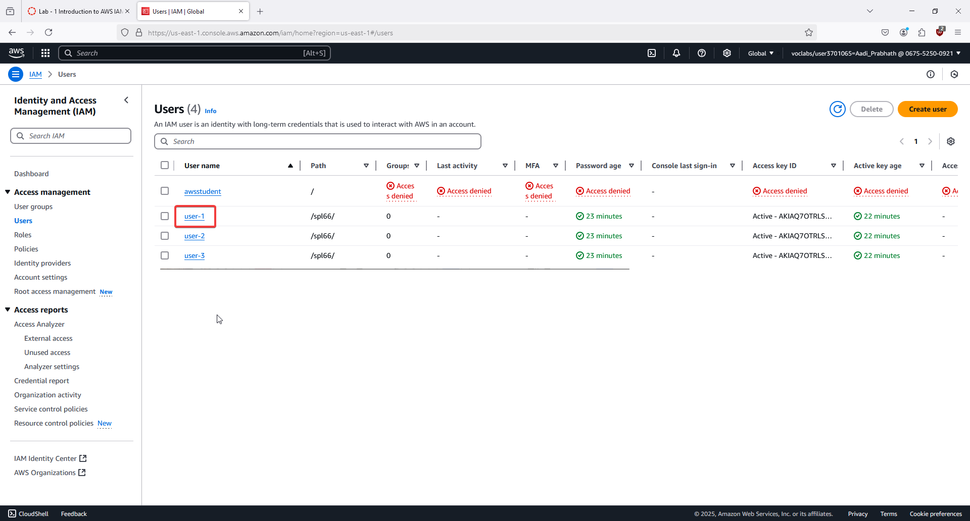

9. In the IAM console, go to Users and view the created users: user-1, user-2, and user-3. 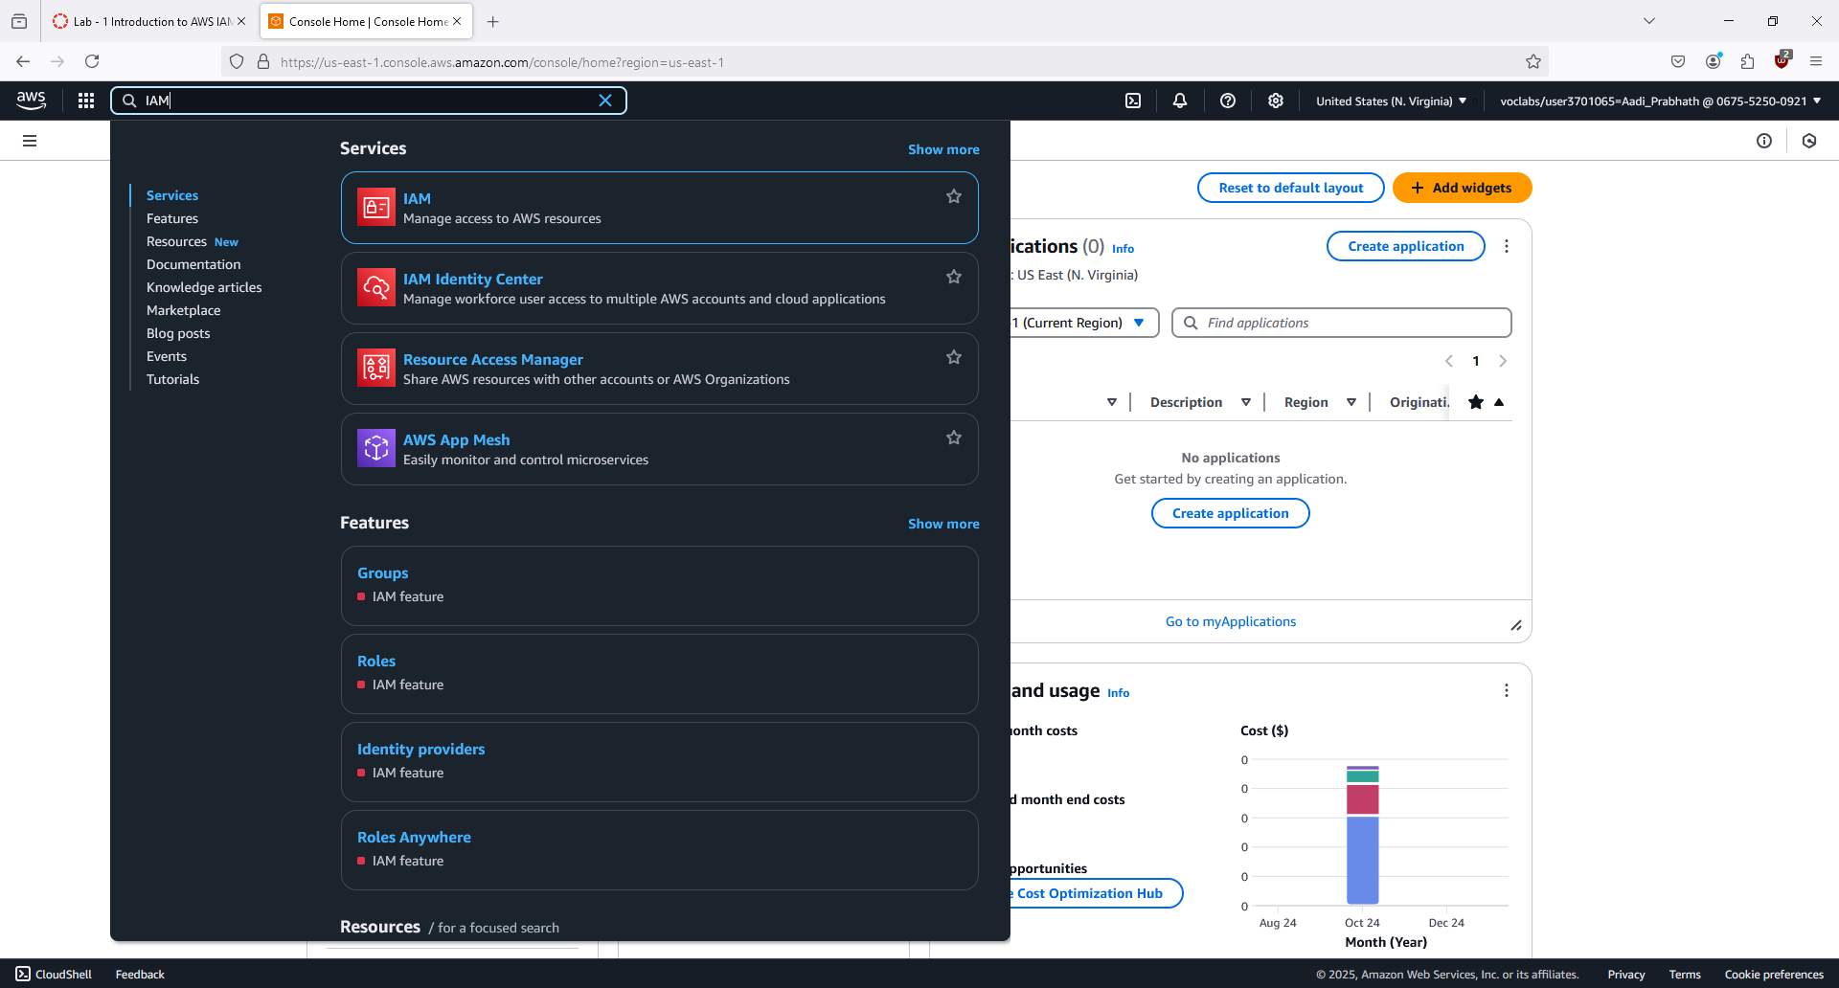

10. Click on user-1 to view their details. Note that they have no permissions or group memberships. 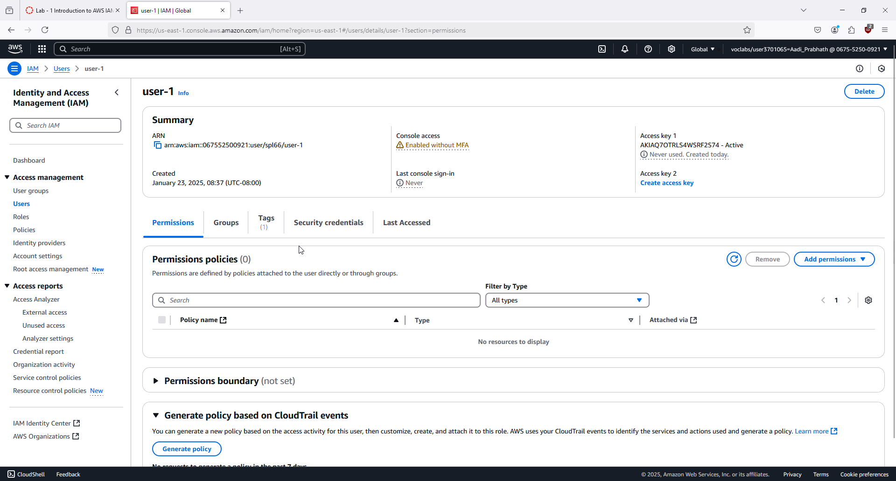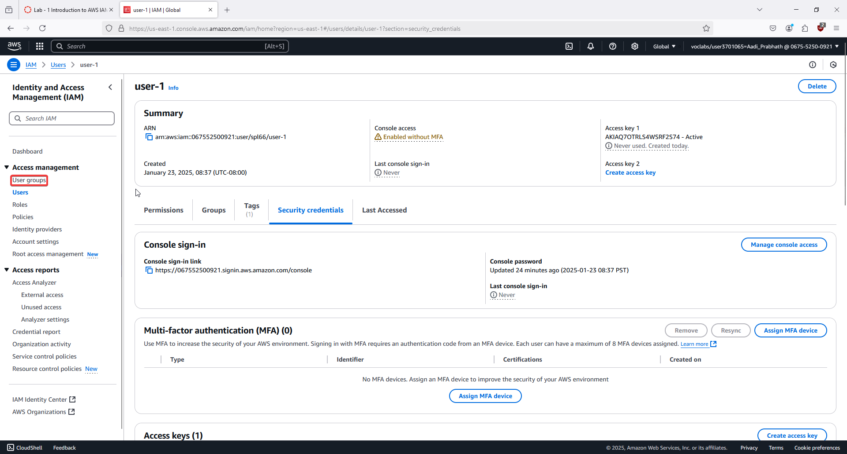

11. Go to User groups and view existing groups: EC2-Admin, EC2-Support, and S3-Support. 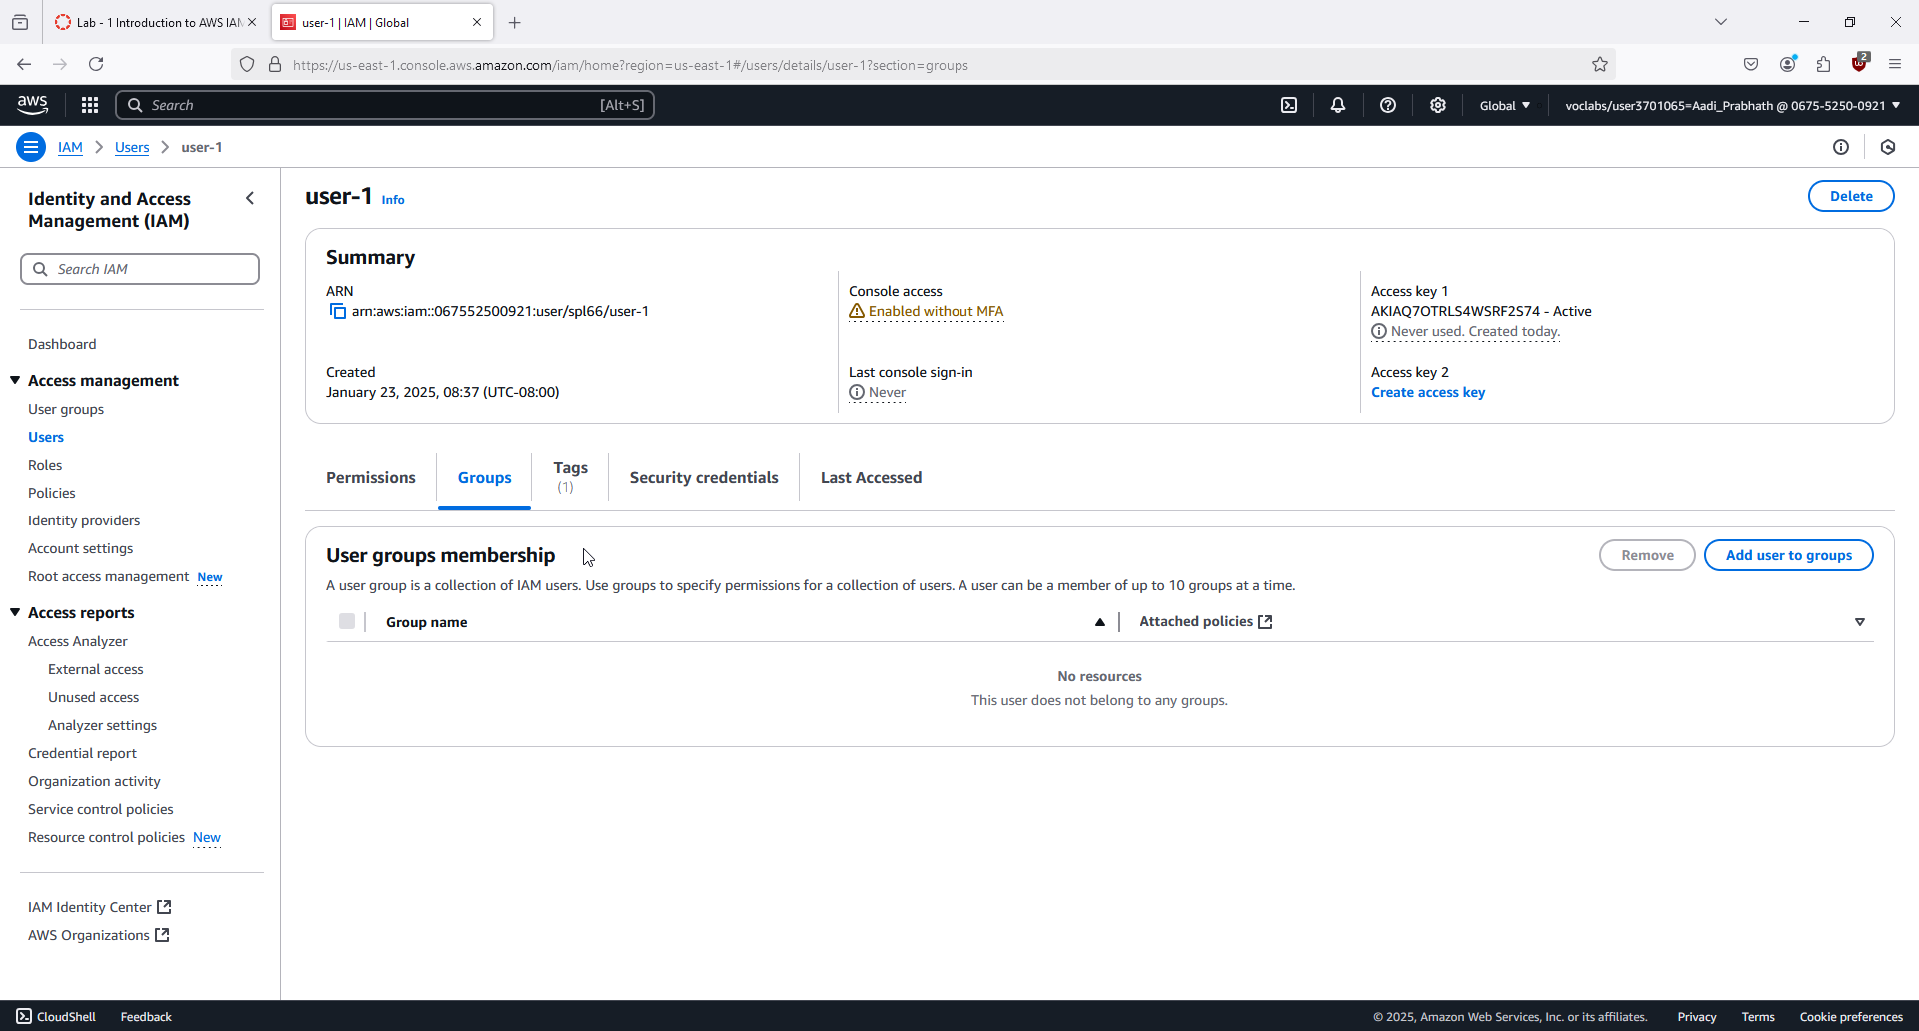

12. Click on the EC2-Support group and view its attached policy: AmazonEC2ReadOnlyAccess. 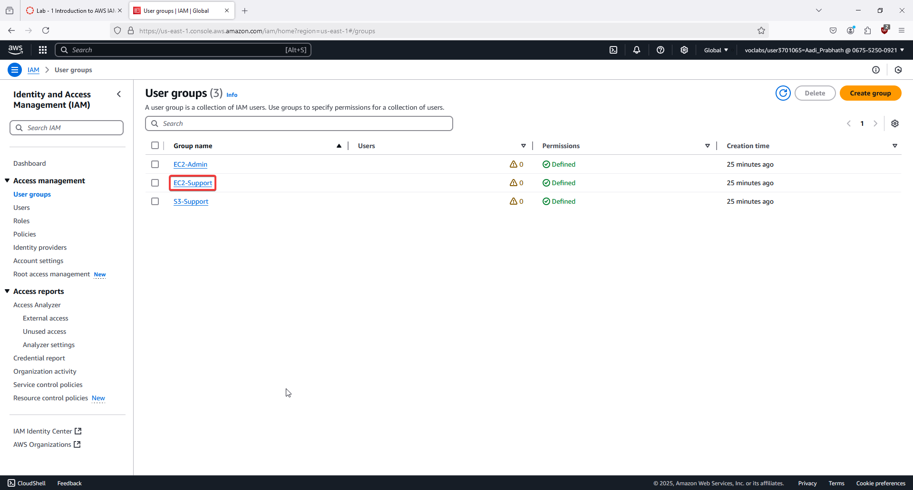

13. Click the plus icon (+) to view the policy details, explaining allowed actions and resources. 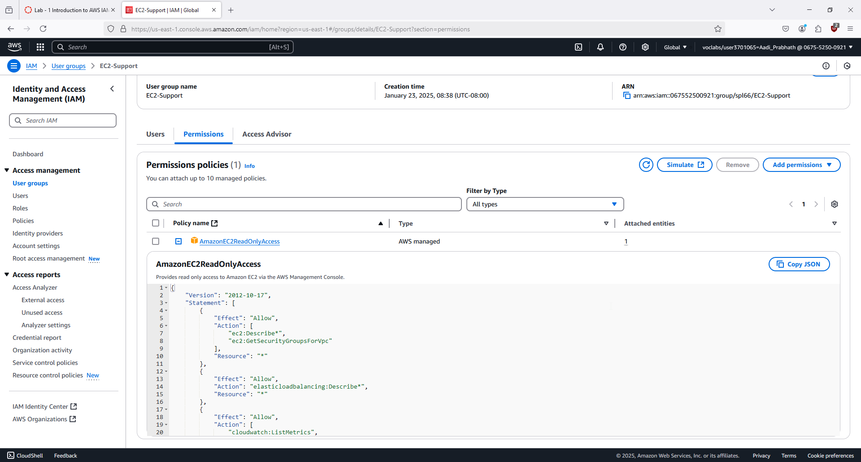

14. Go back and click the S3-Support group to view the AmazonS3ReadOnlyAccess policy. 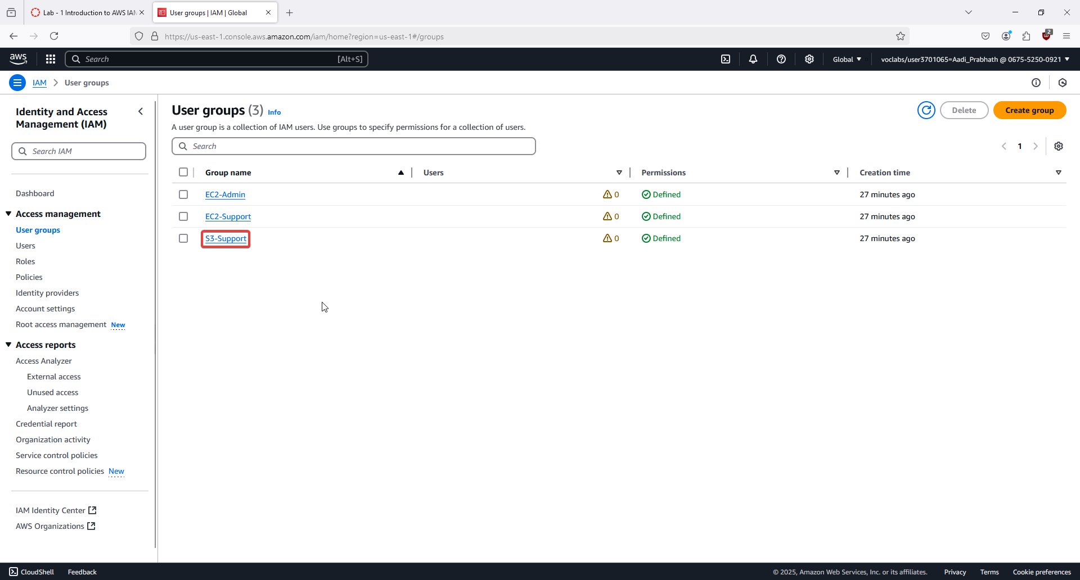

15. Click the plus icon (+) to view this policy’s permissions for S3 actions. 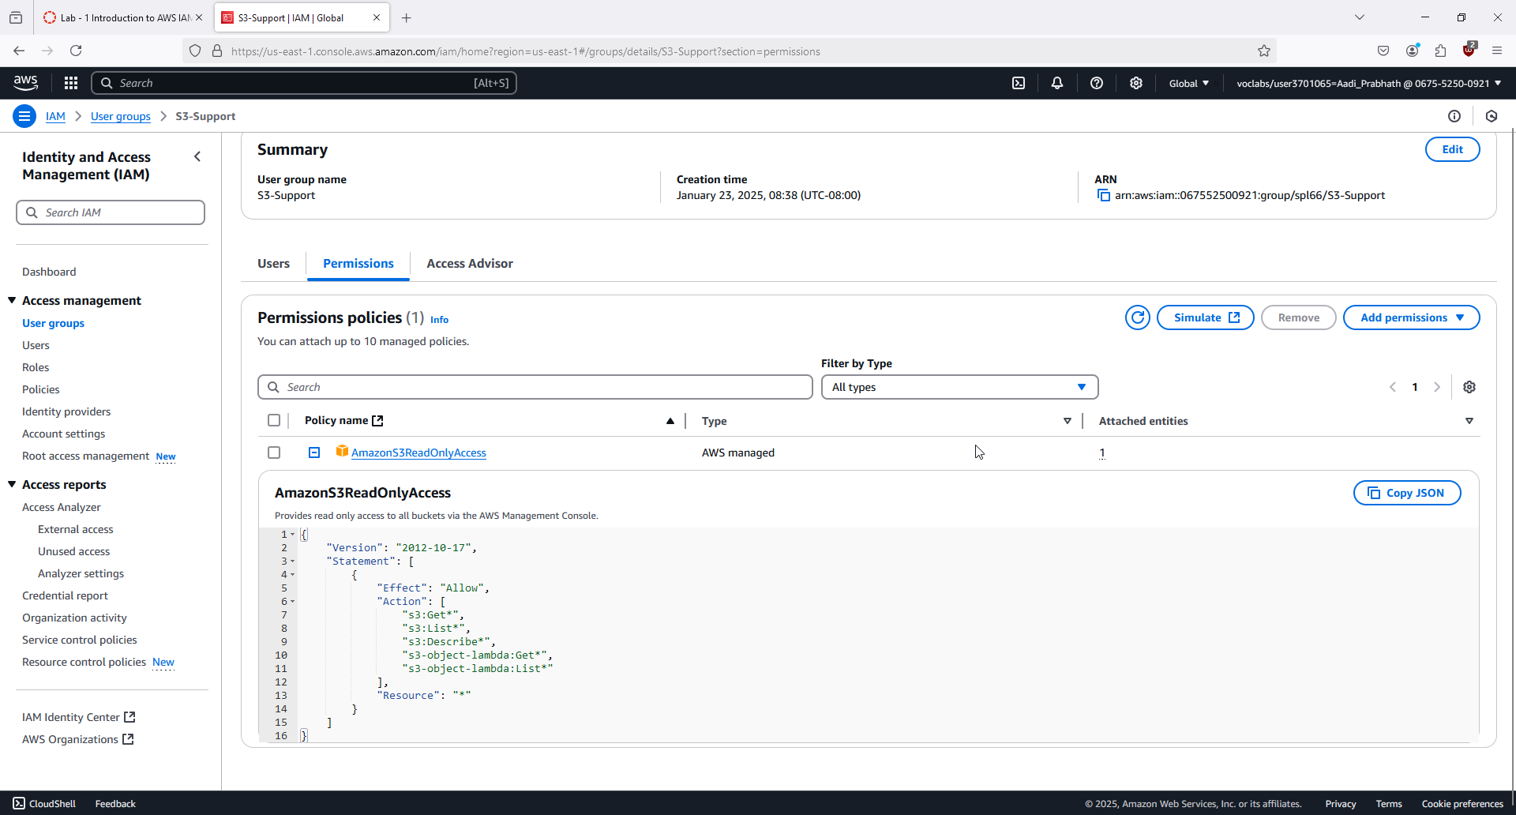

16. Go back and click the EC2-Admin group to view its inline policy for EC2 actions (e.g., start/stop instances). 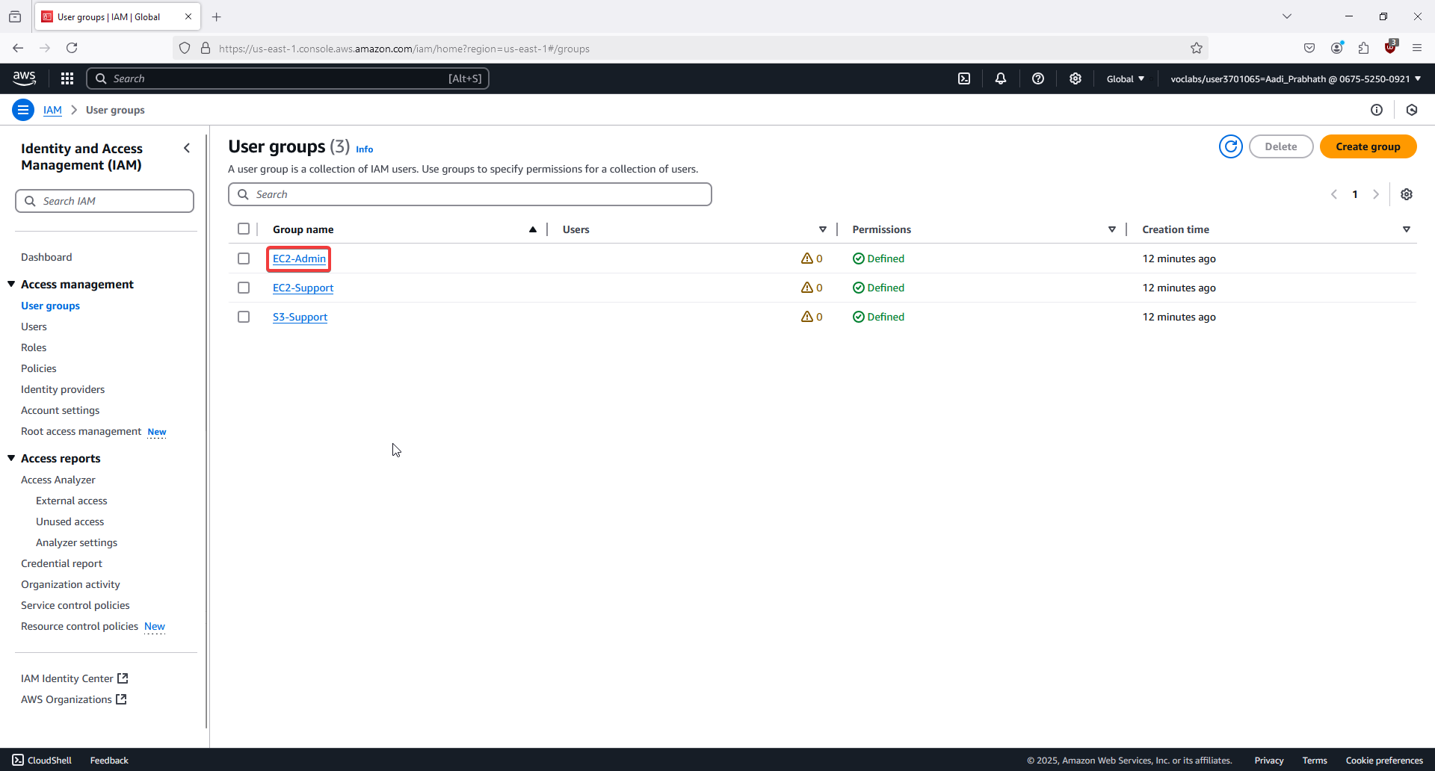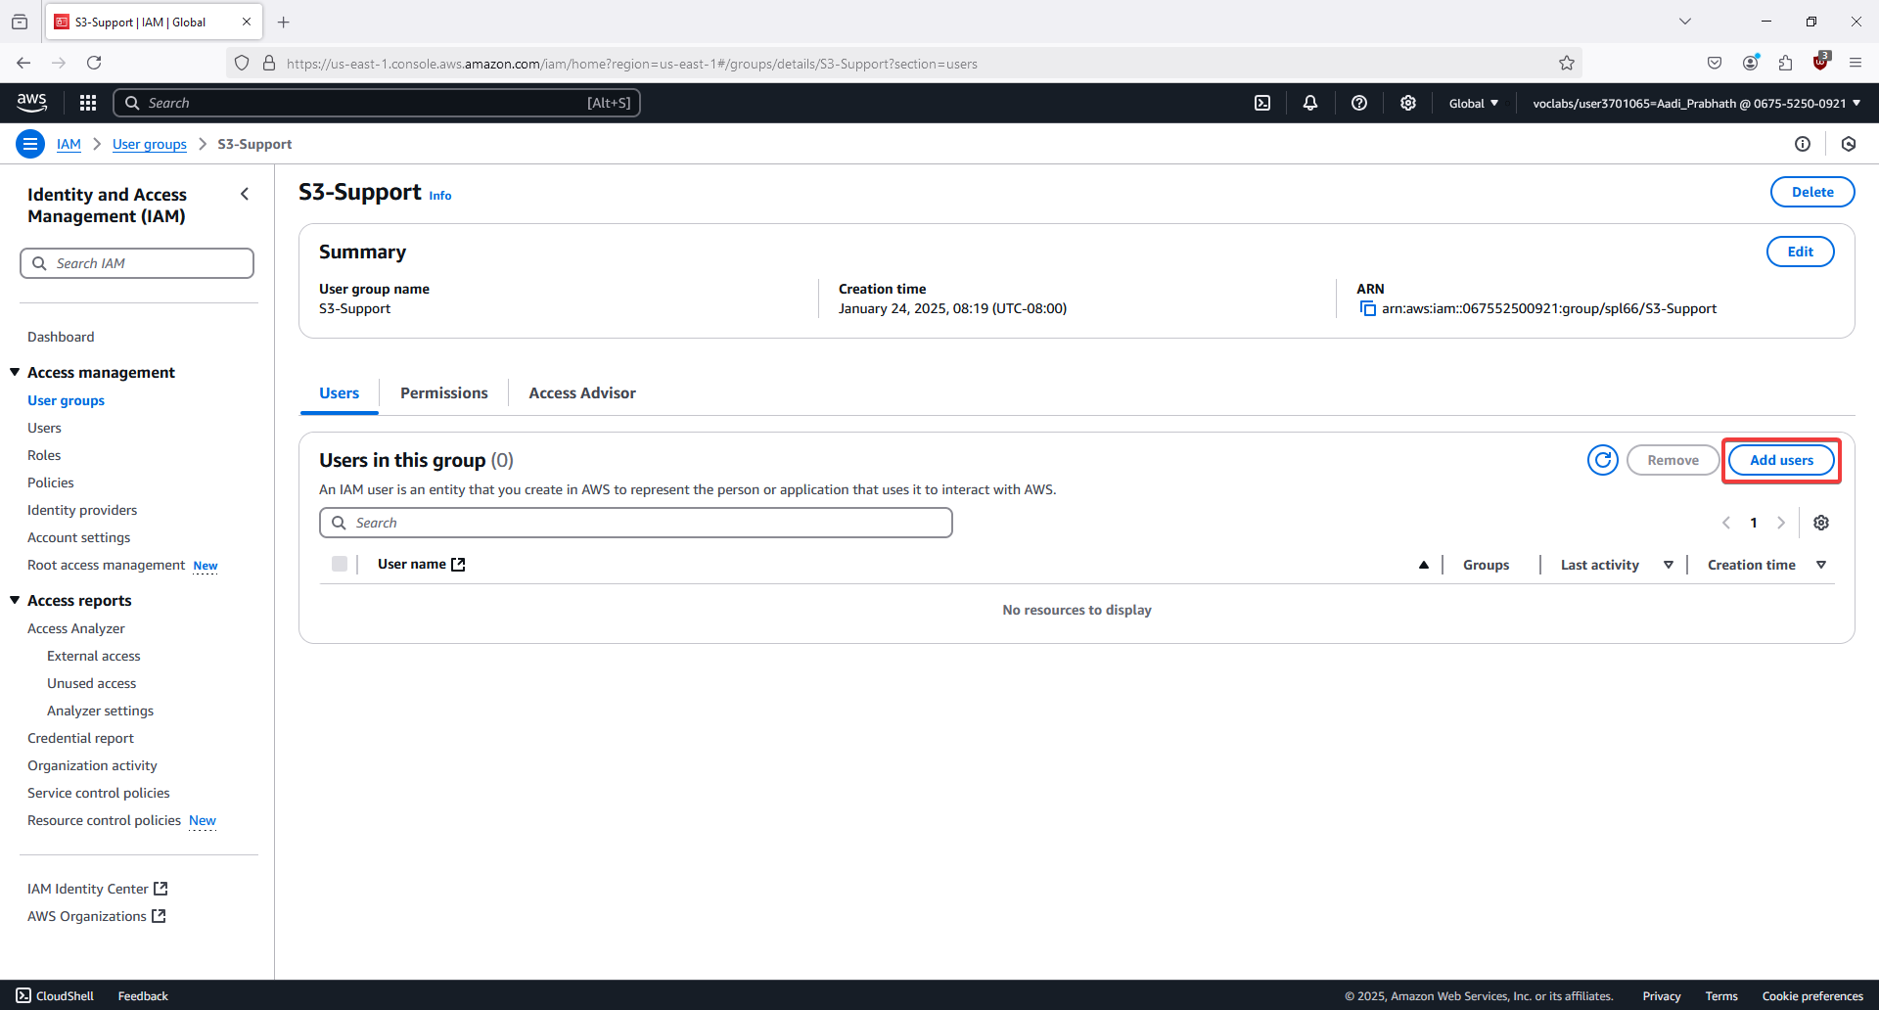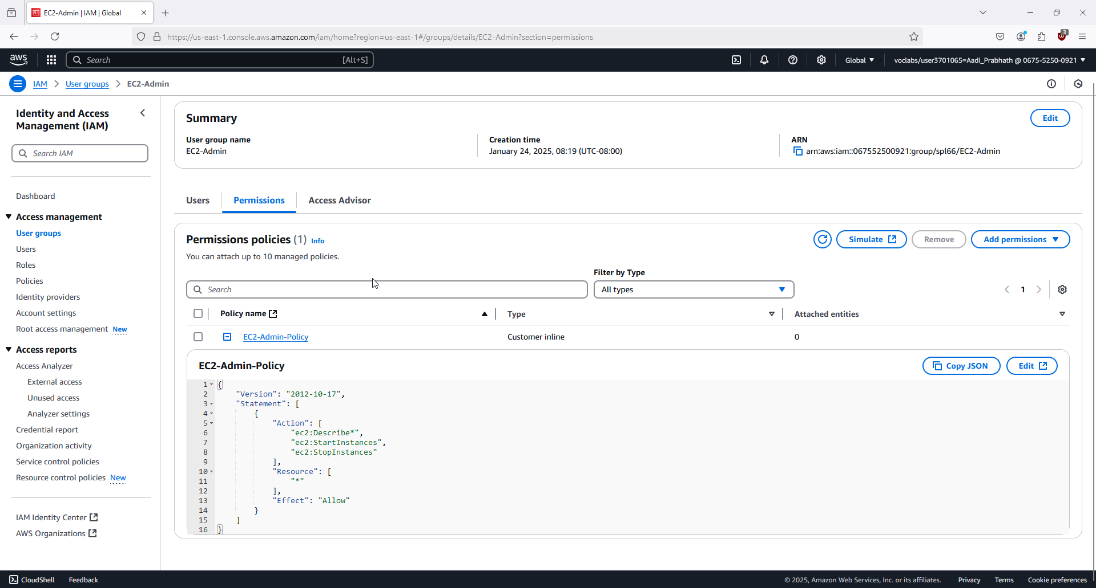

17. Now, you'll assign users to appropriate groups as per the business scenario.

18. In User groups, add user-1 to S3-Support group. 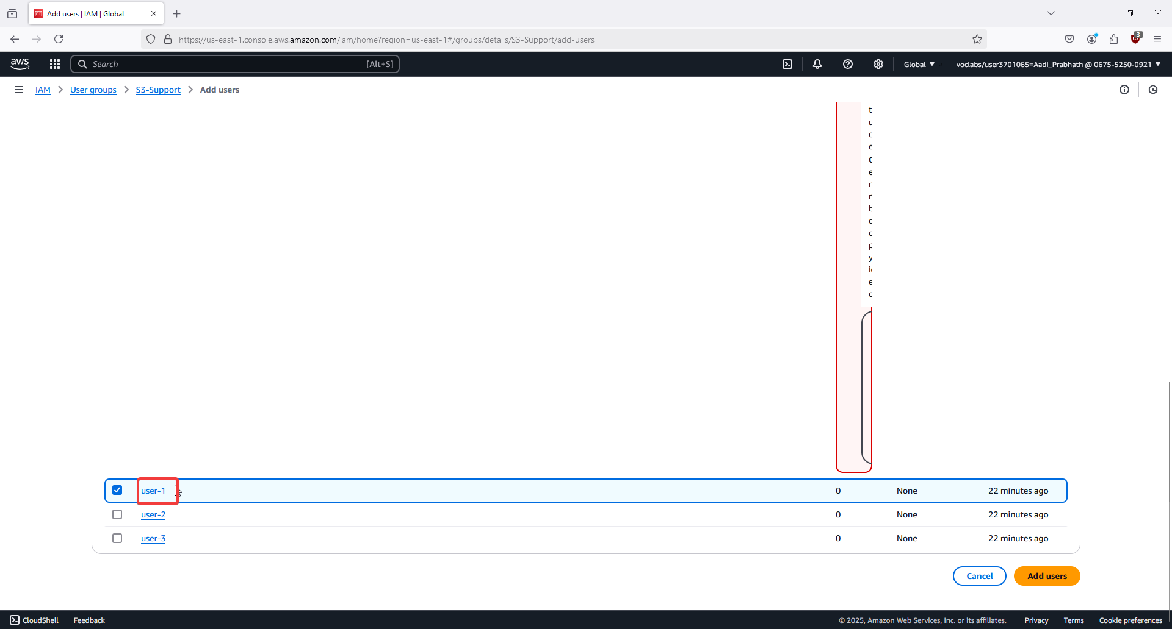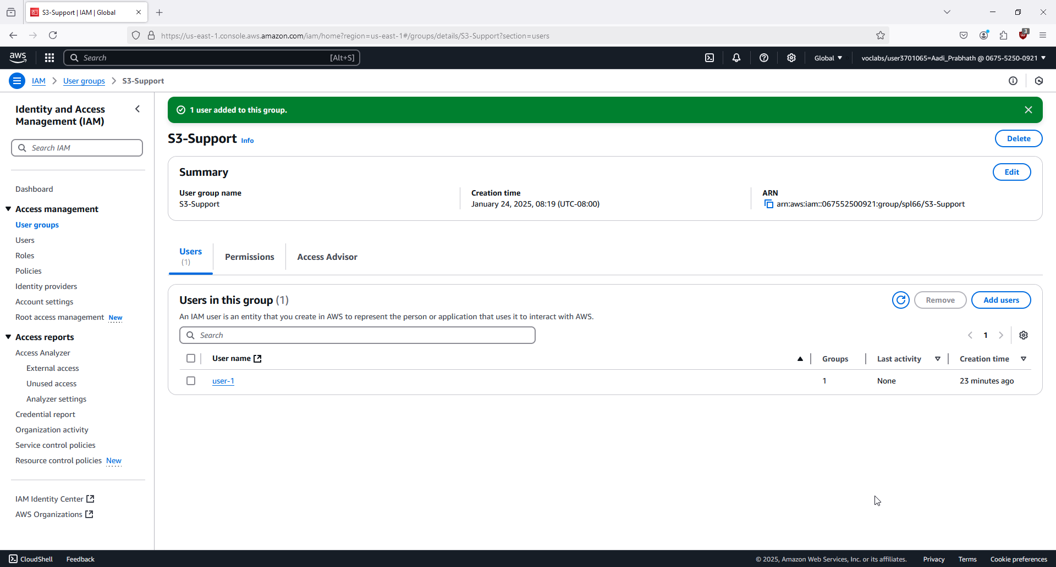

19. Similarly, add user-2 to EC2-Support group. 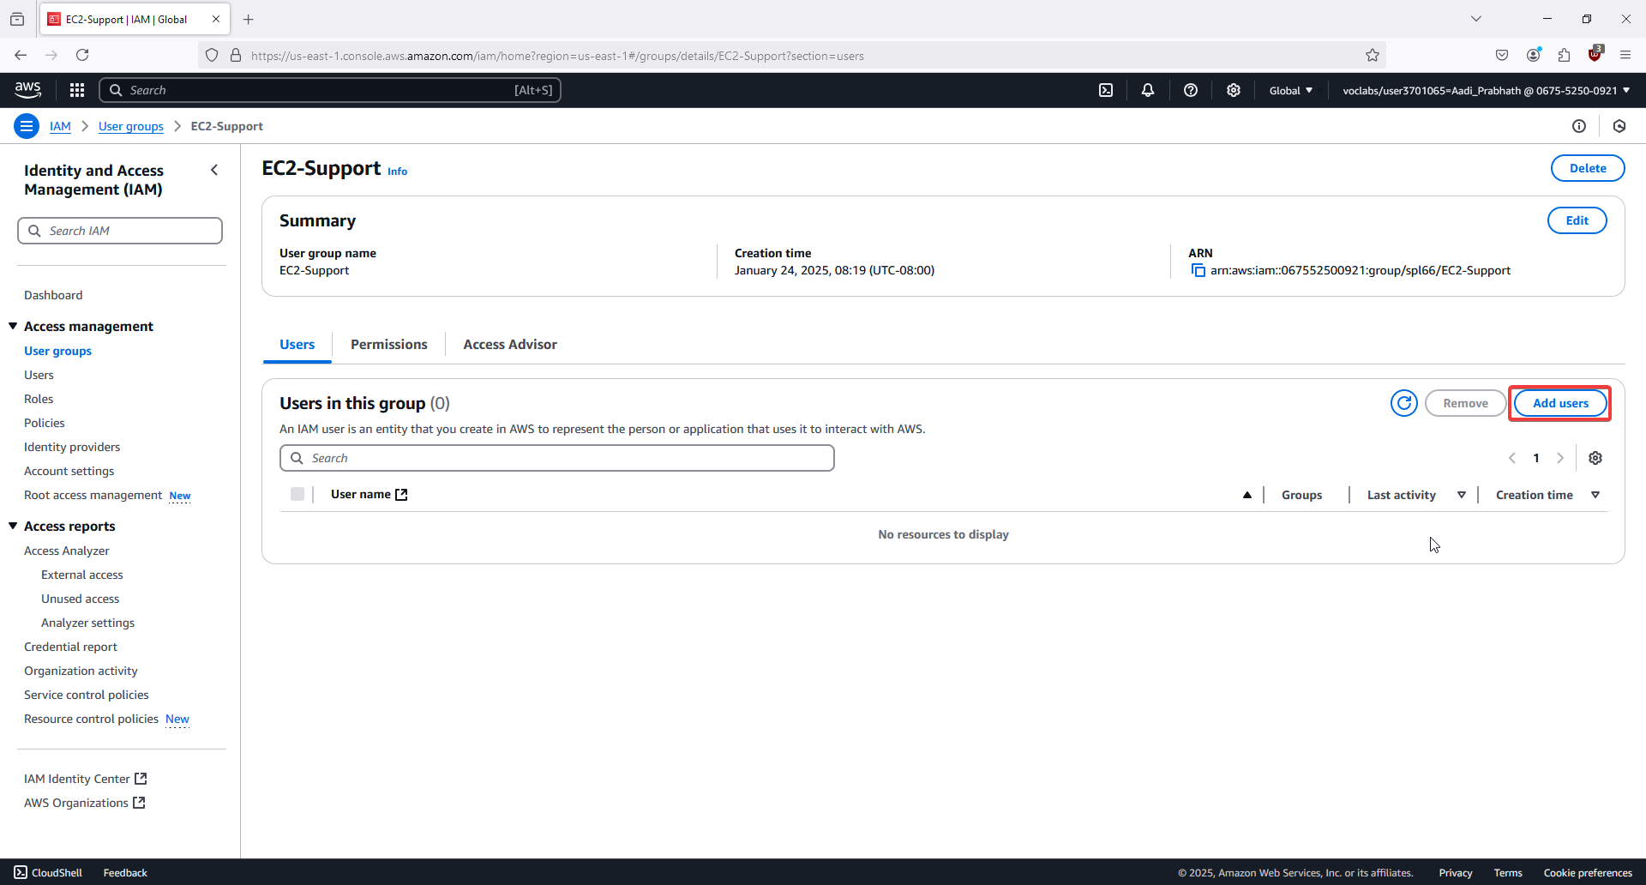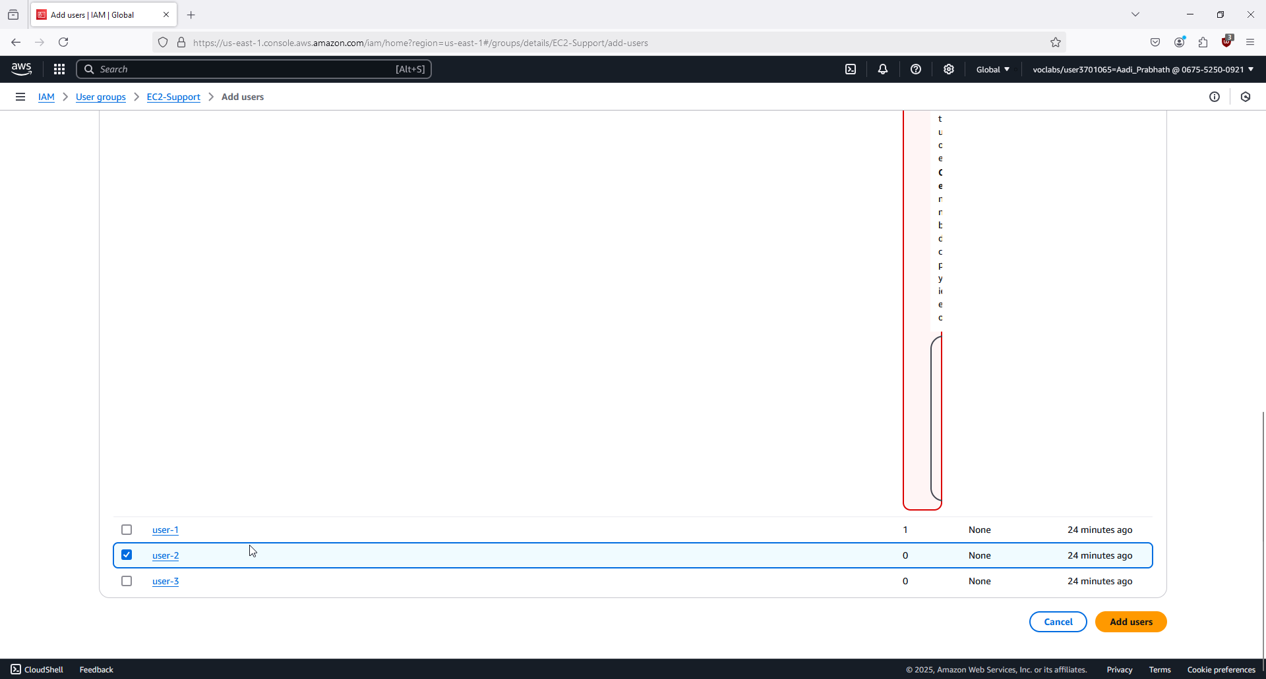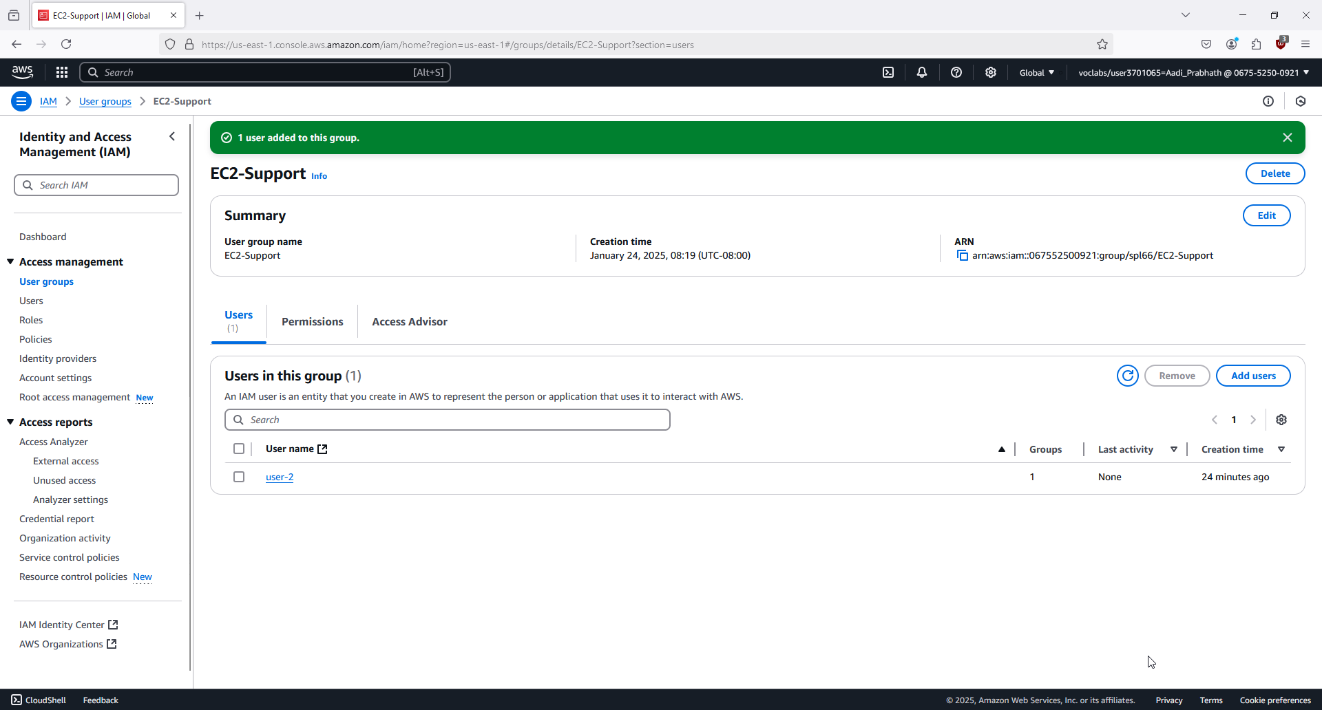

20. Add user-3 to the EC2-Admin group. 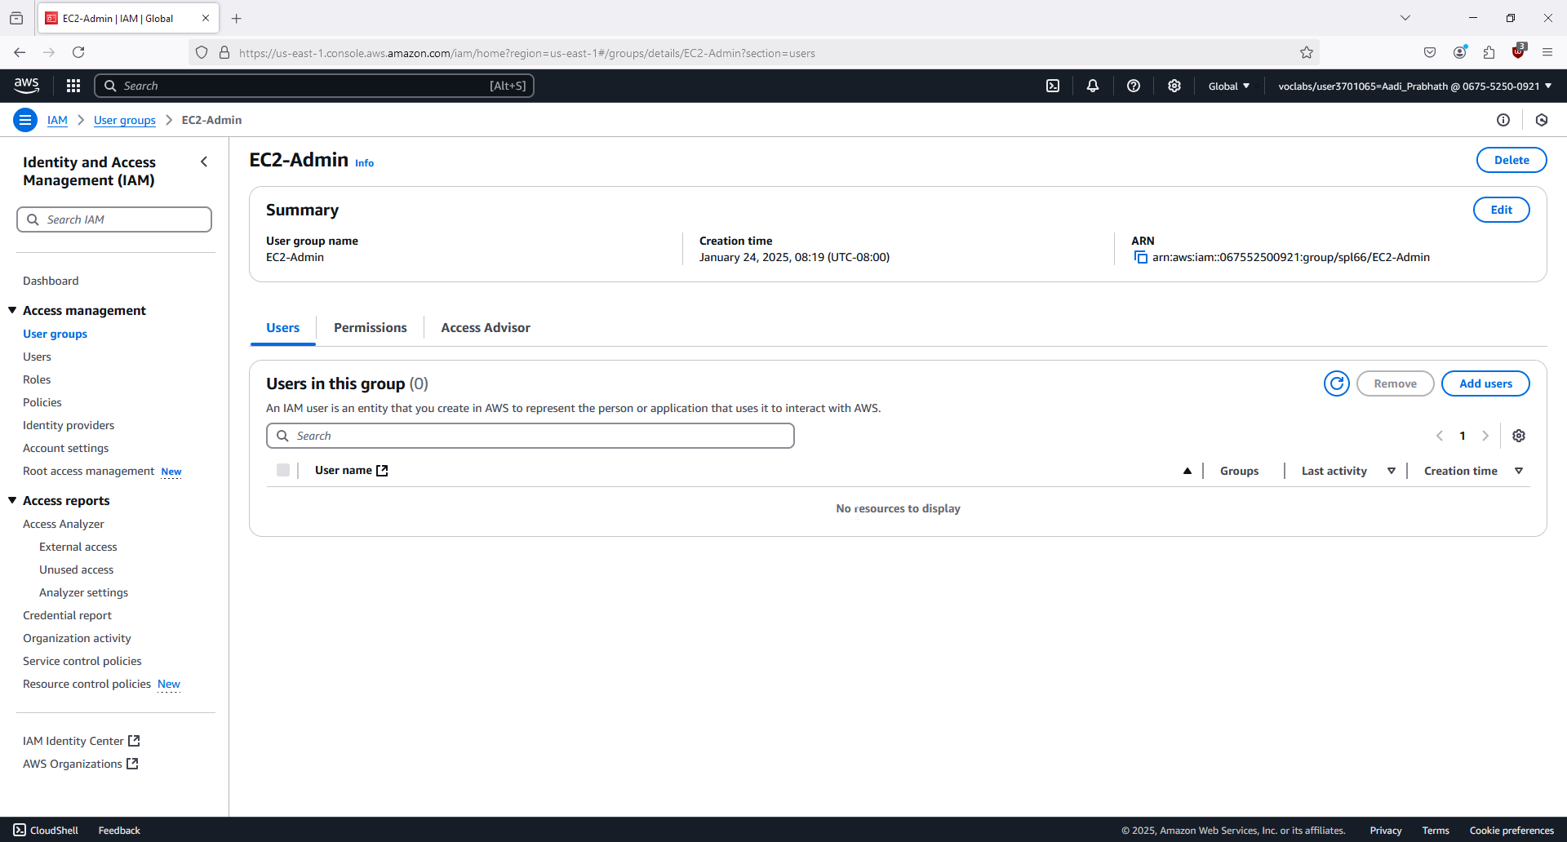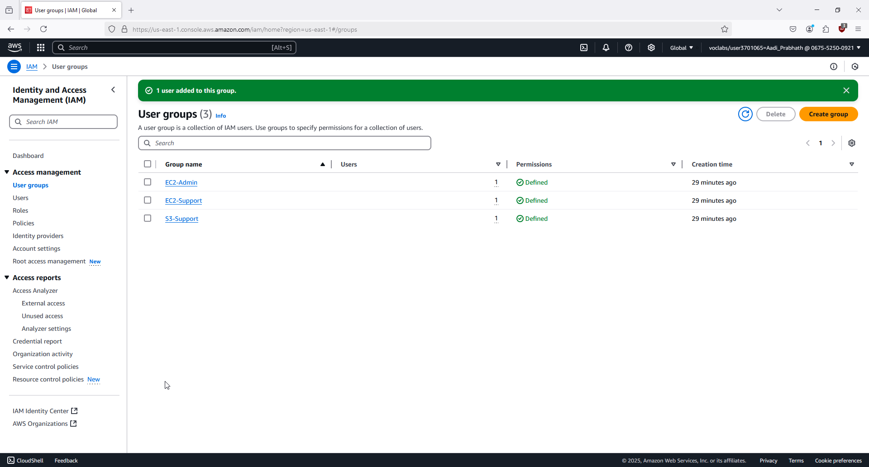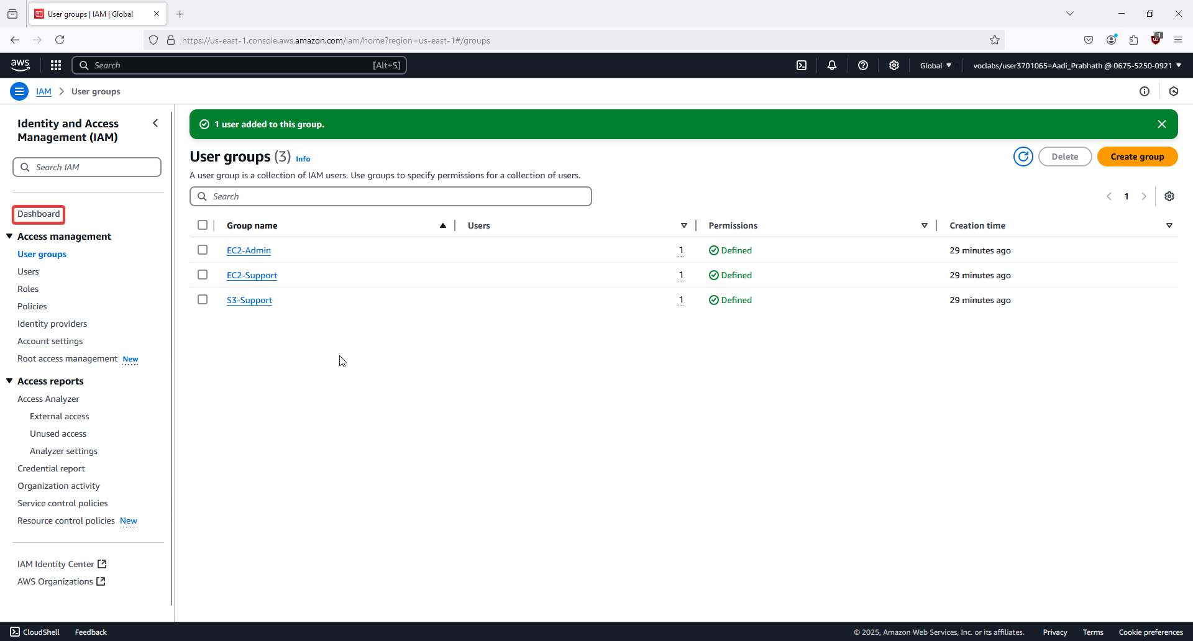

21. Ensure each user is listed in their corresponding group. 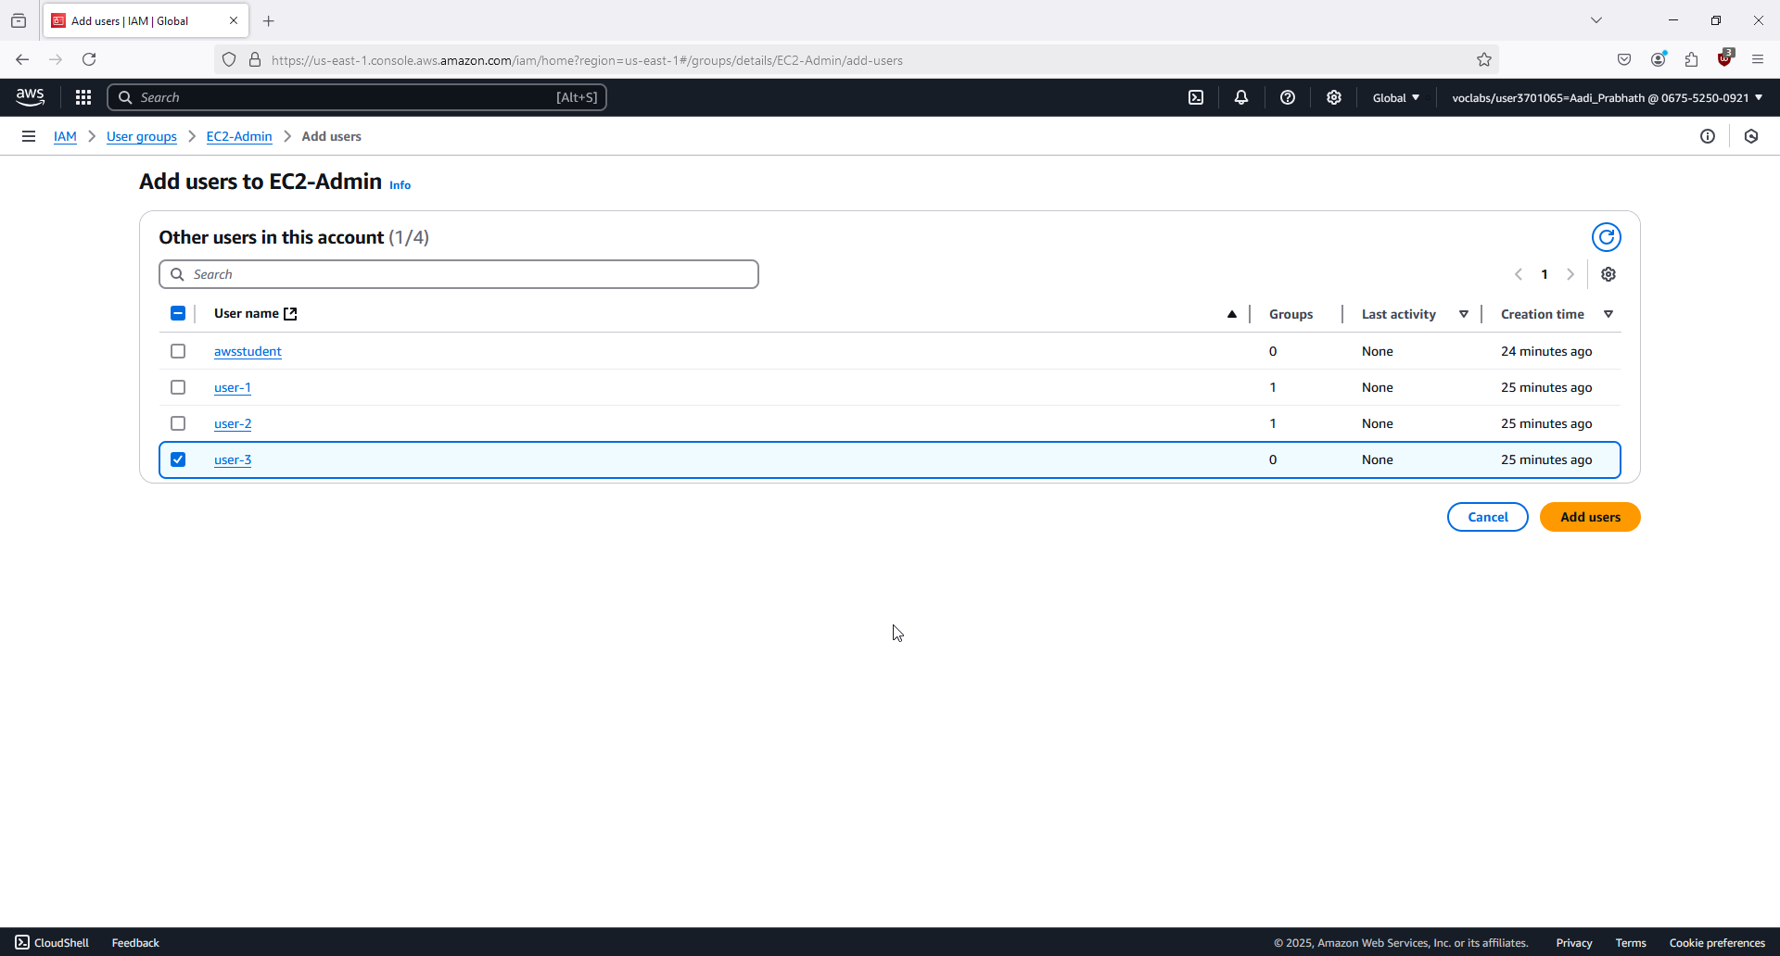

22. In the IAM console, click Dashboard and find the Sign-in URL for IAM users. 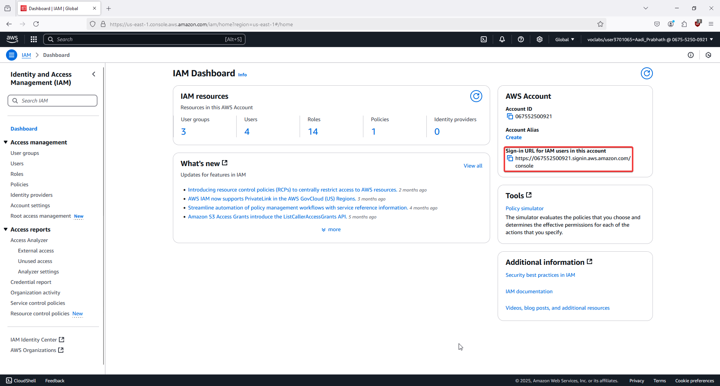

23. Copy the URL and open a private/incognito window in your browser. 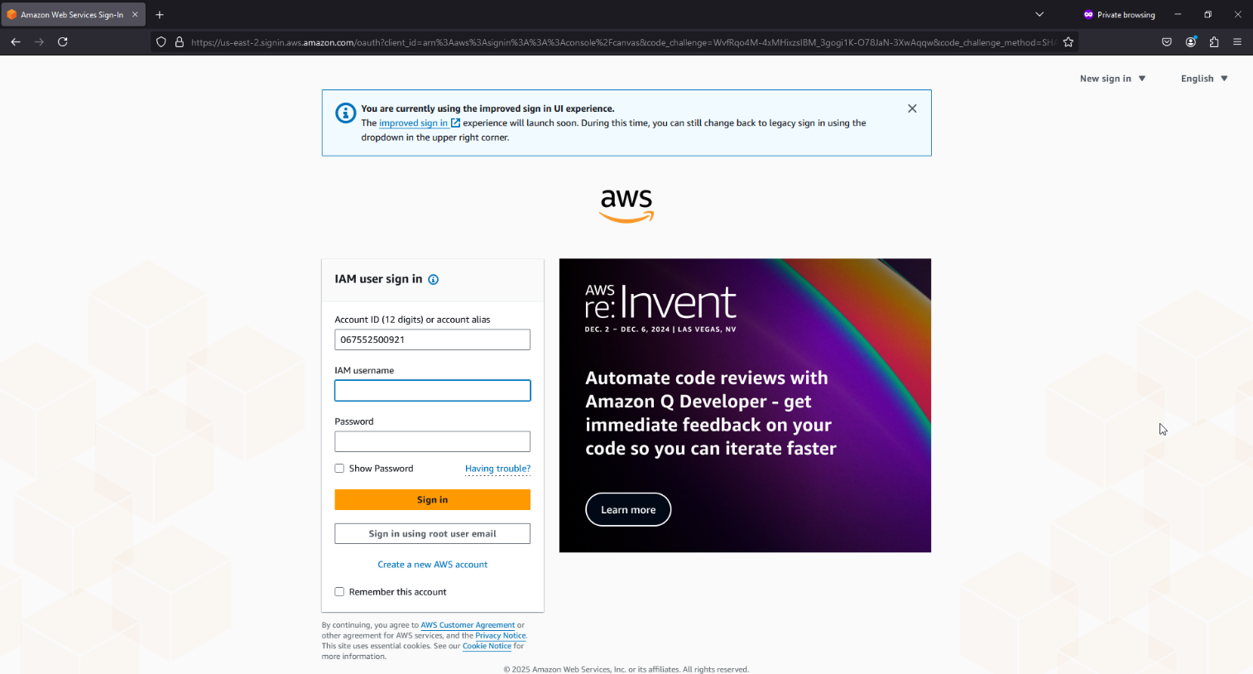

24. Sign in as user-1, test S3 access, and confirm EC2 access is denied. 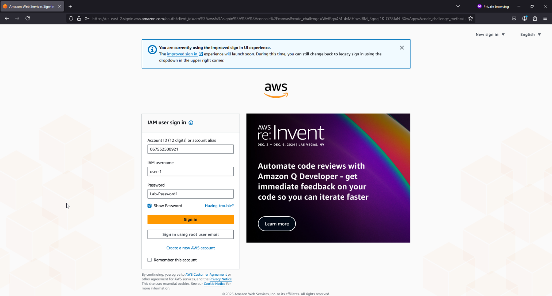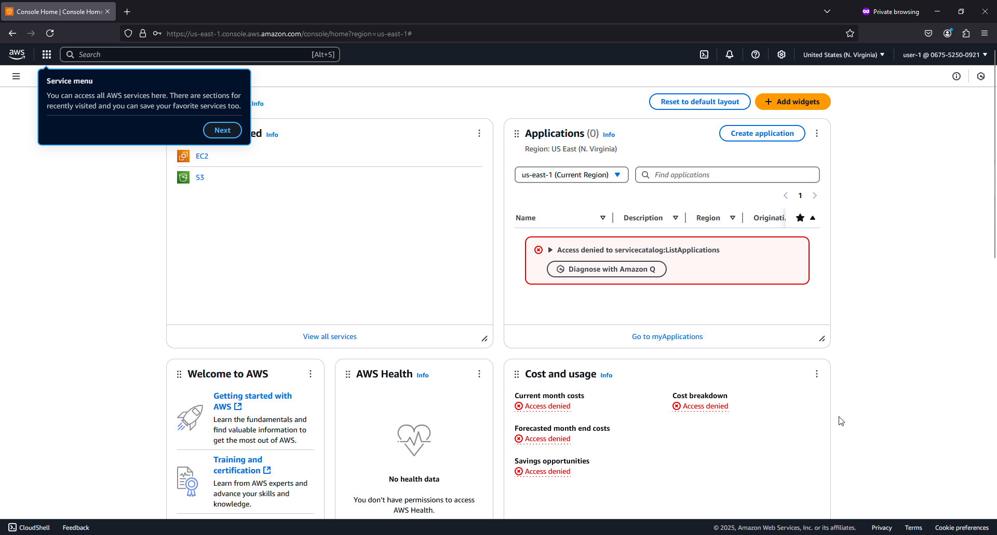

25. Sign out as user-1, then sign in as user-2, test EC2 read-only access, and confirm S3 access is denied. Repeat for user-3, confirming full EC2 permissions. Close the private window afterward. 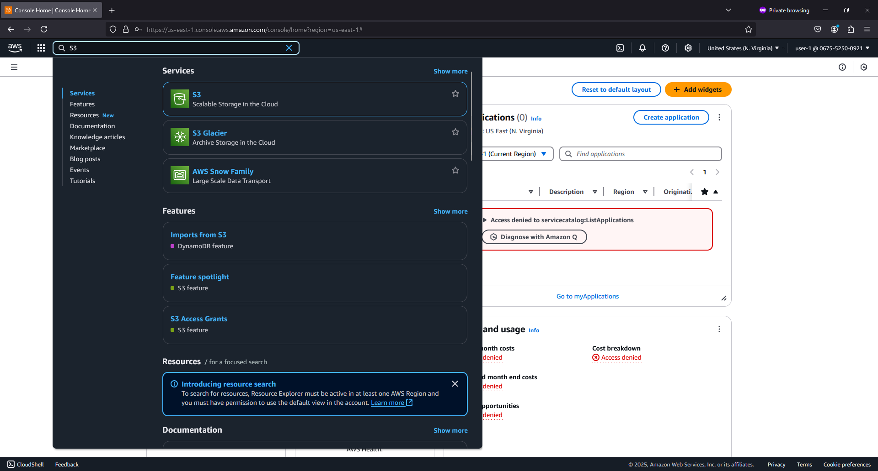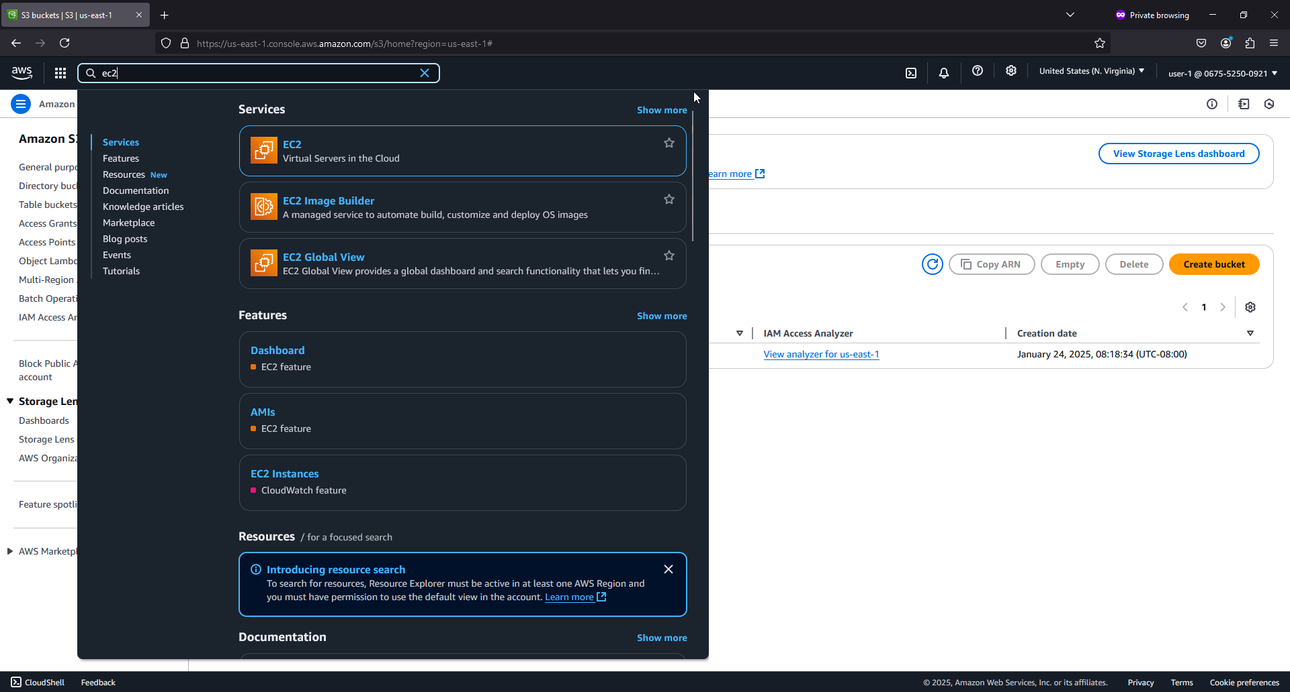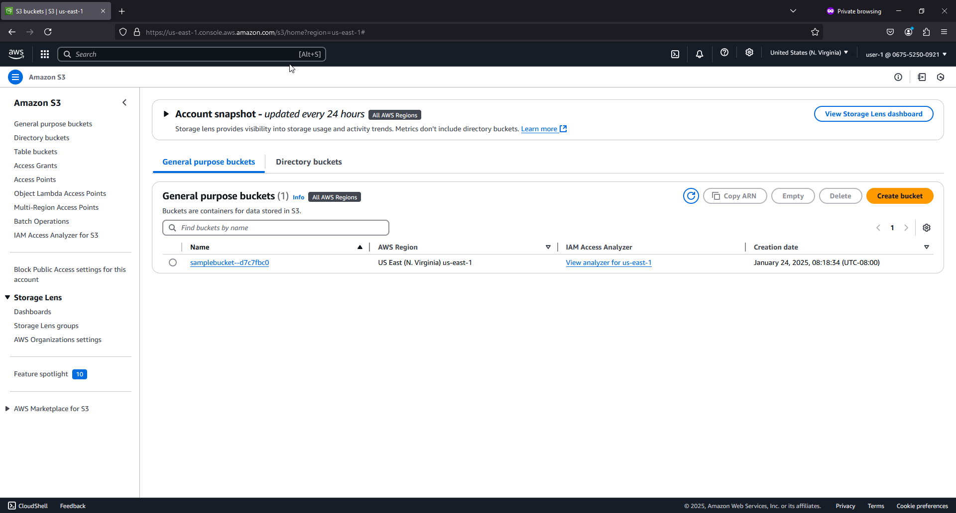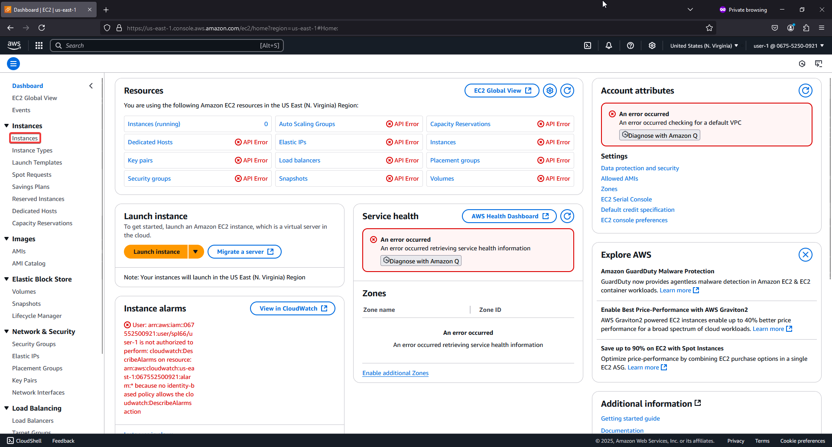

## Lab 2

1. In the VPC Console, search for and select VPC.

2. Verify the region is N. Virginia (us-east-1) in the top right corner.

3. Click the VPC dashboard link at the top left.

4. Click Create VPC (or Launch VPC Wizard if needed). 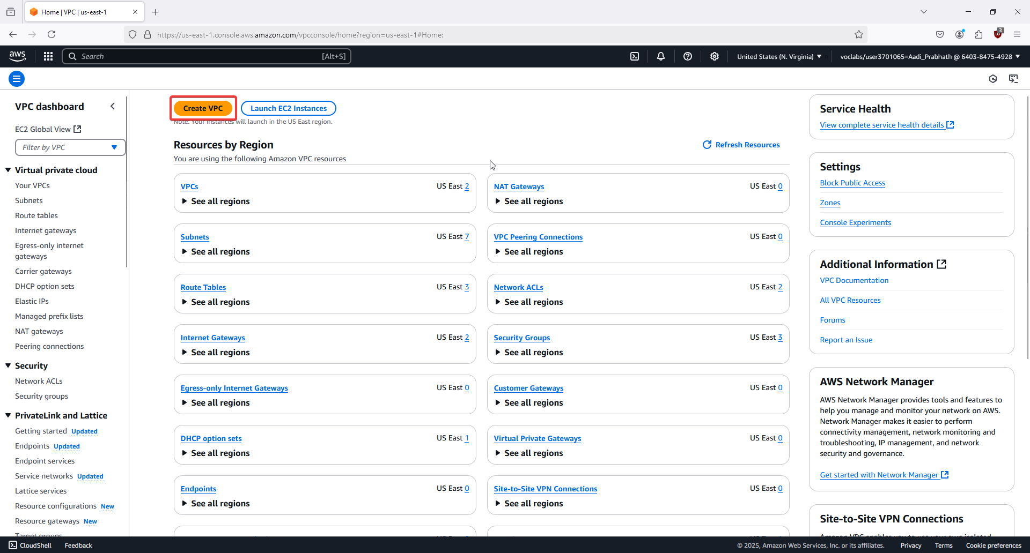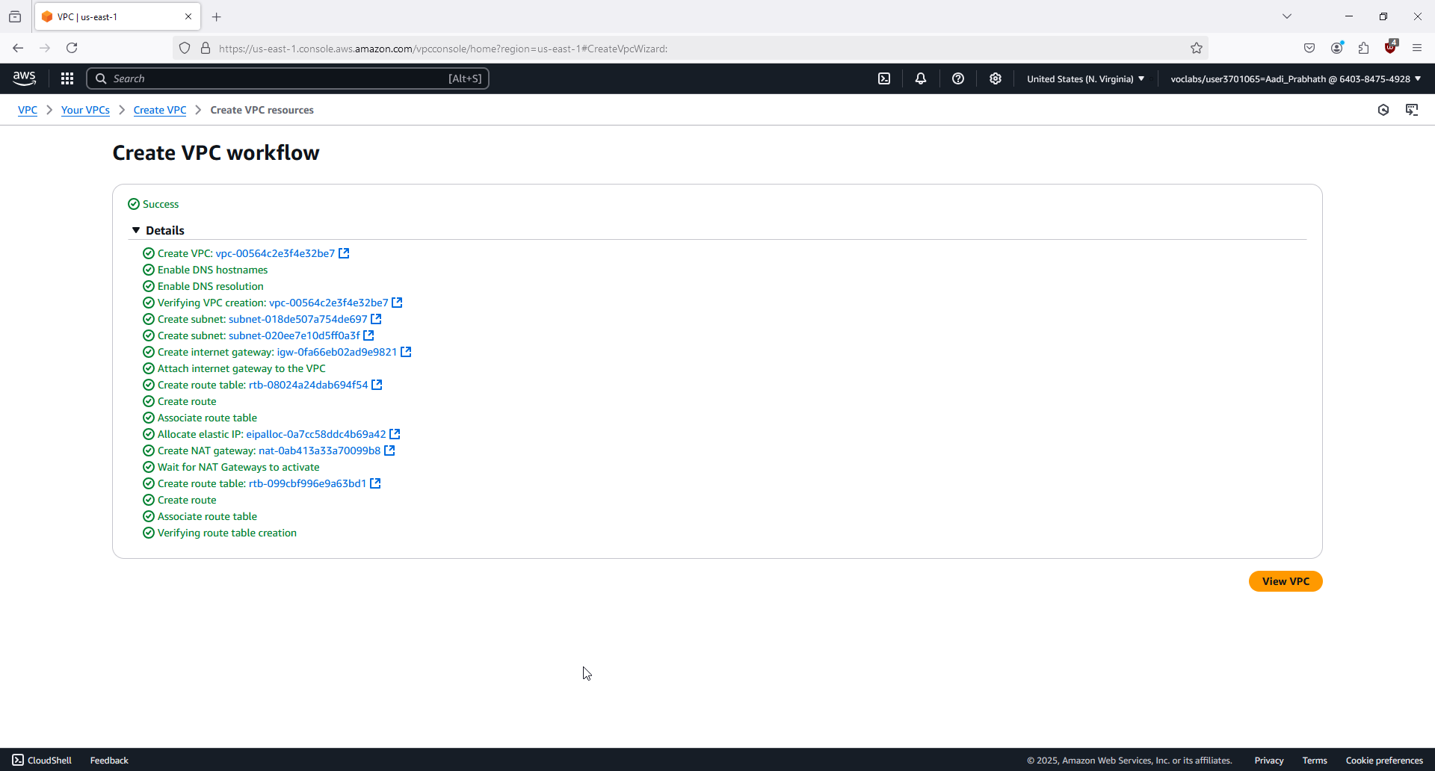

5. In the VPC settings, set the Name tag to lab (keep Auto-generate selected).

6. Set the IPv4 CIDR block to 10.0.0.0/16.

7. Choose 1 for the number of Availability Zones.

8. Set both Number of public subnets and Number of private subnets to 1.

9. Expand the Customize subnets CIDR blocks section.

10. Change Public subnet CIDR block in us-east-1a to 10.0.0.0/24.

11. Change Private subnet CIDR block in us-east-1a to 10.0.1.0/24.

12. Set NAT Gateway to 1 AZ.

13. Set VPC endpoints to None.

14. Ensure DNS hostnames and DNS resolution are enabled.

15. In the Preview panel, confirm the VPC and subnet settings.

16. Click Create VPC to start provisioning. 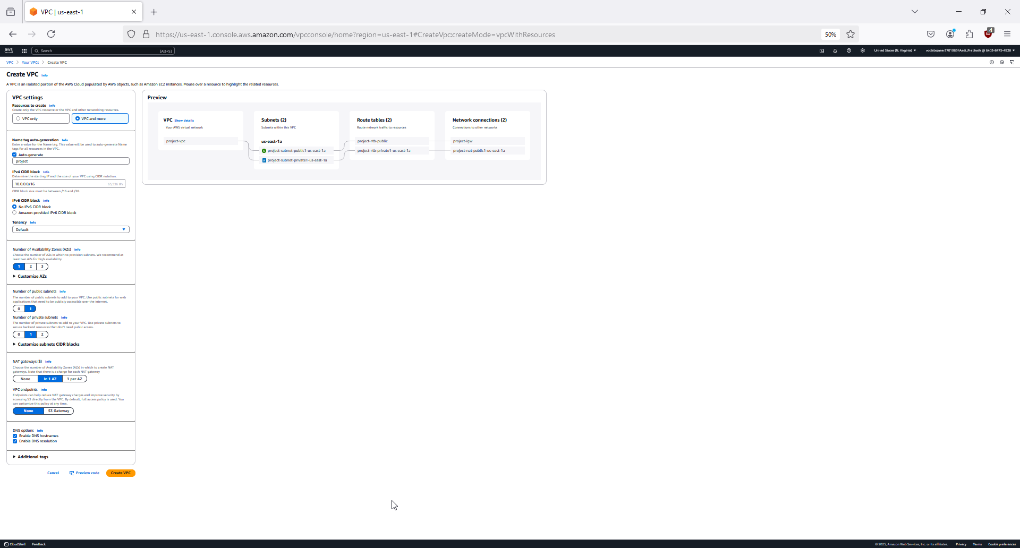

17. Wait for all resources to be created (including the NAT Gateway).

18. Once provisioning is complete, click View VPC to see the VPC details. 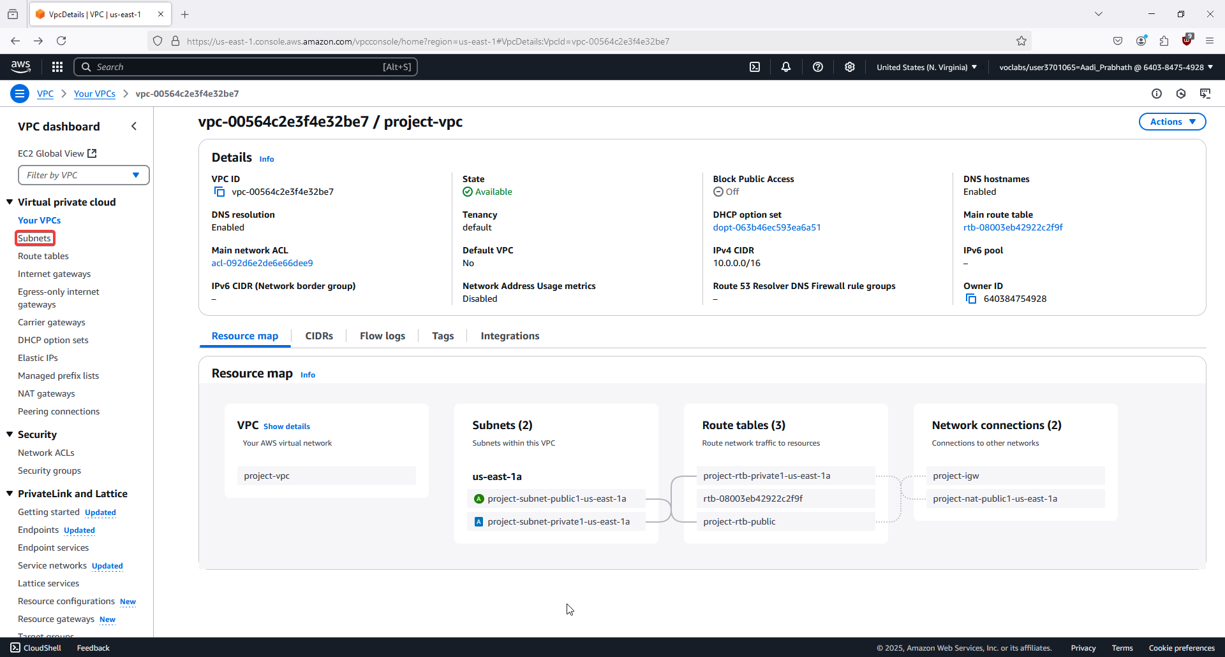

19. Review the created resources: VPC, subnets, route tables, IGW, and NAT Gateway.

20. In Task 1, understand the purpose of the public subnet (routes to IGW) and private subnet (uses NAT Gateway).

21. In Task 2, go to the Subnets section and click Create subnet. 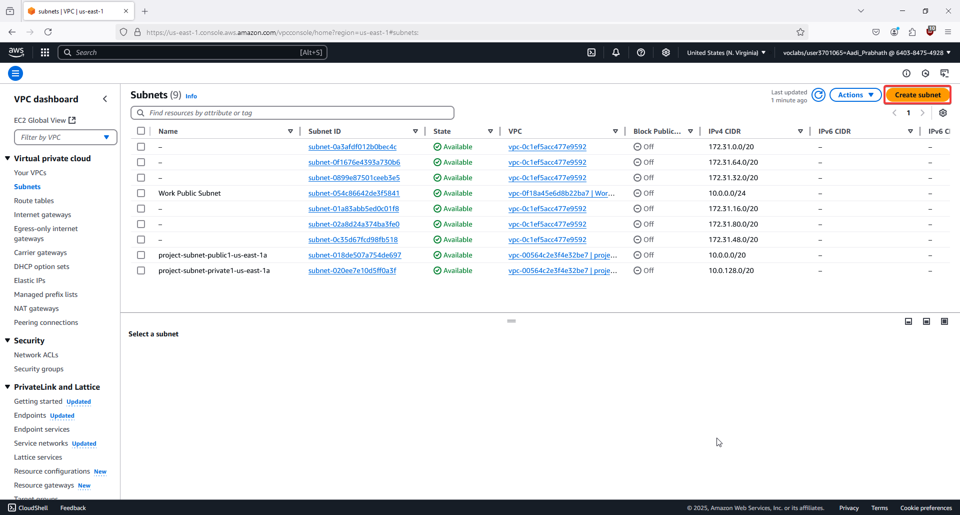

22. Create a second public subnet in us-east-1b with CIDR 10.0.2.0/24. 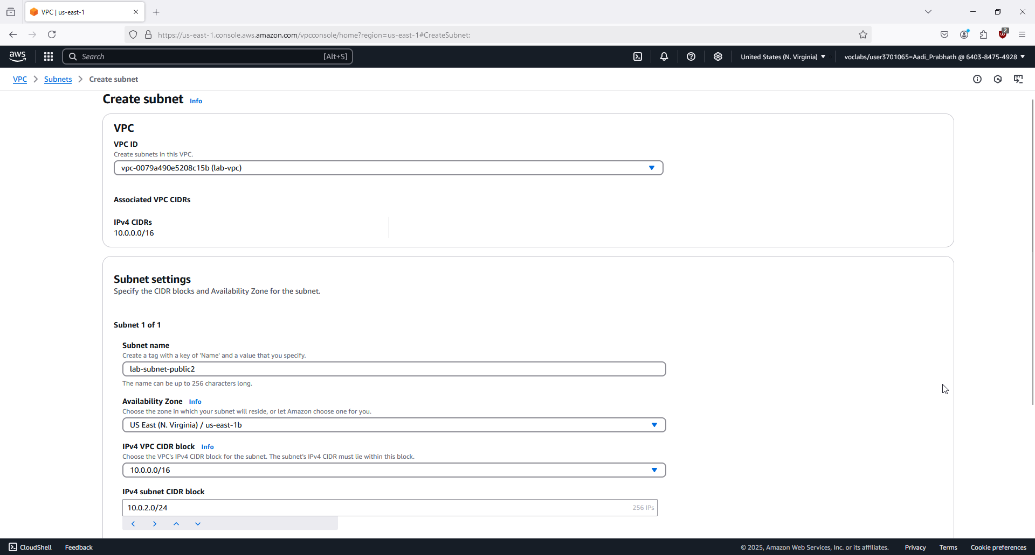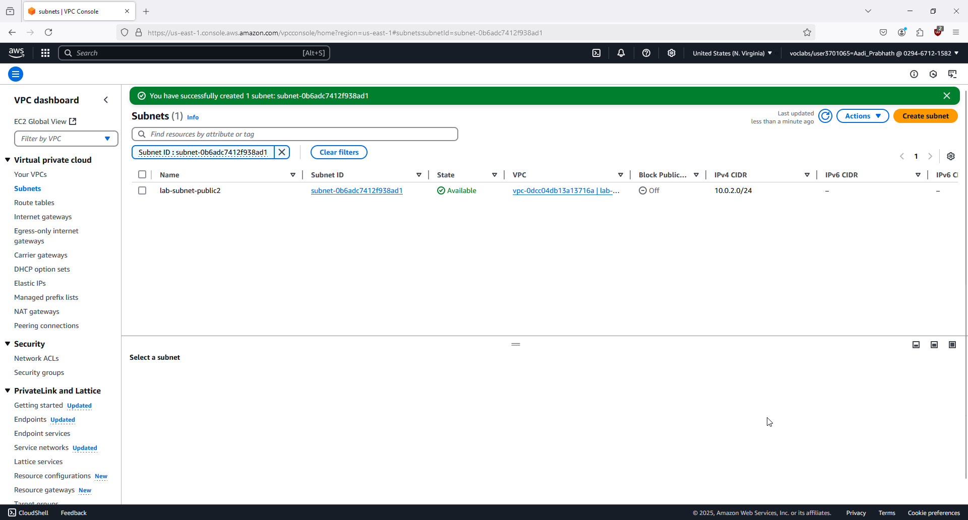

23. Create a second private subnet in us-east-1b with CIDR 10.0.3.0/24. 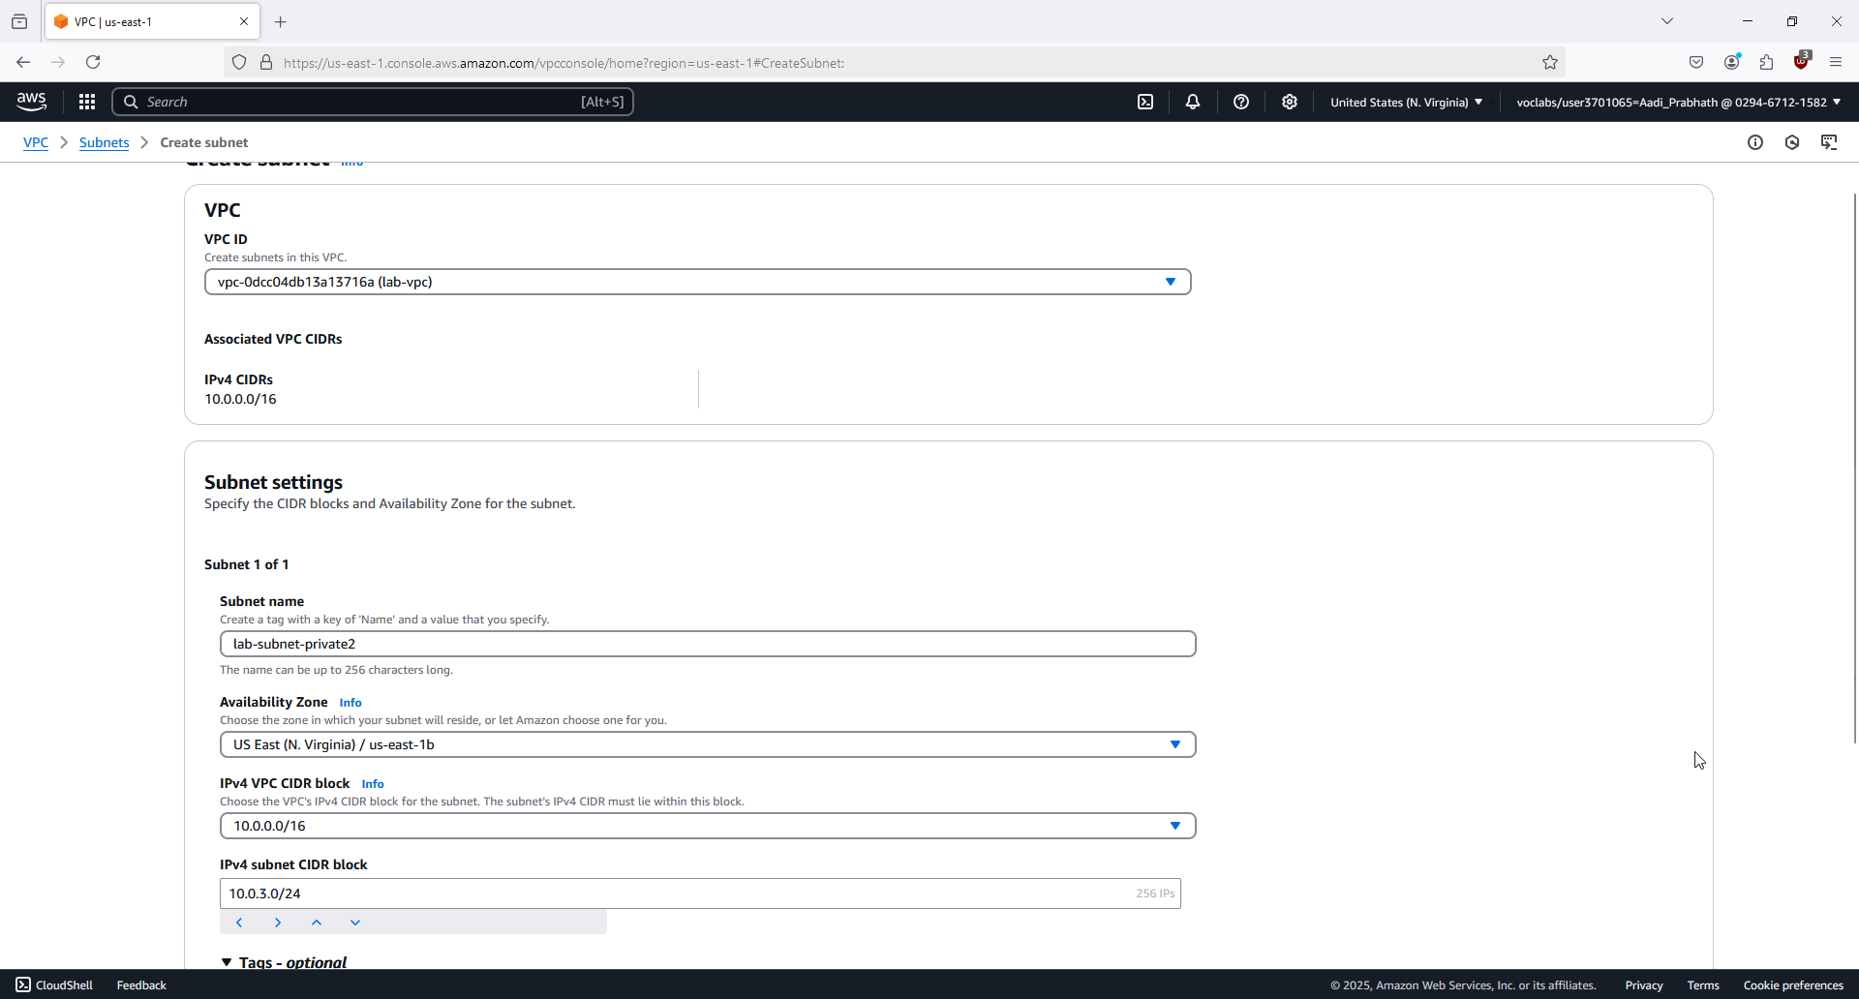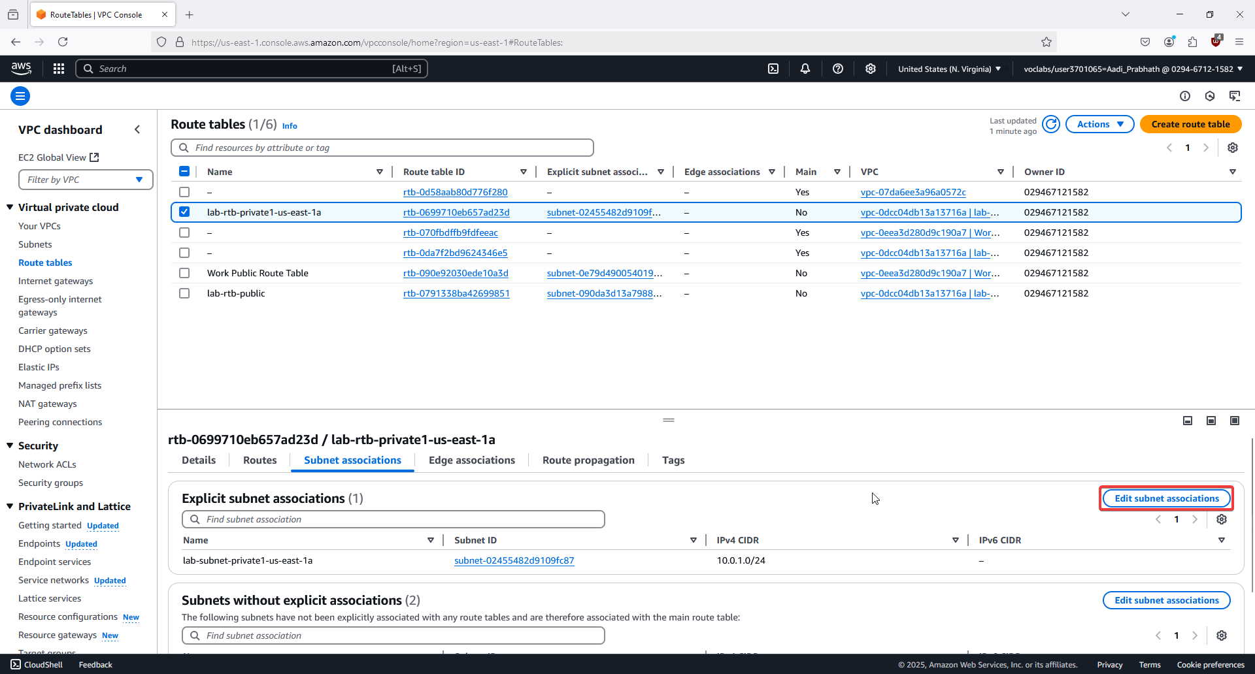

24. In Route tables, select the lab-rtb-private1-us-east-1a and update the Subnet associations to include lab-subnet-private2. 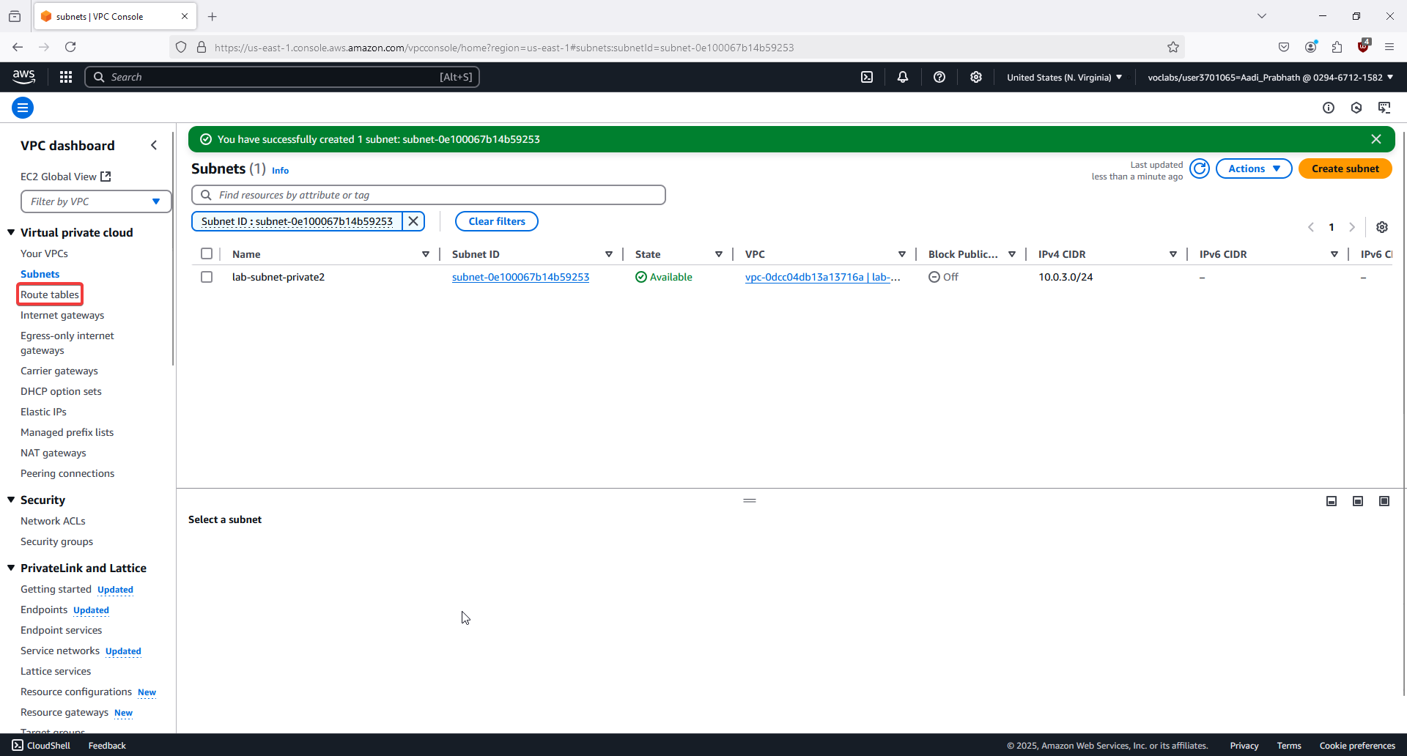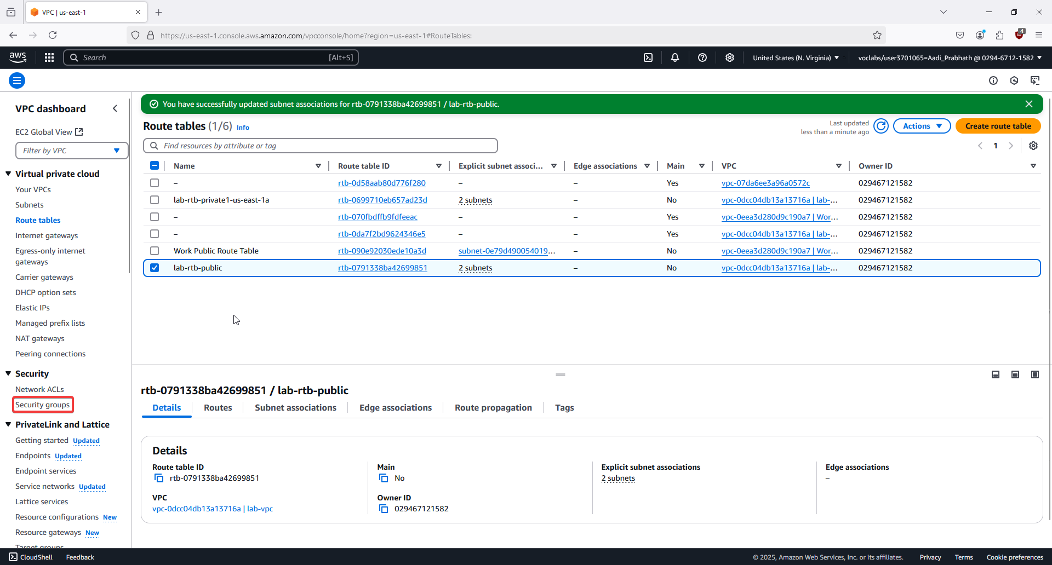

25. In Route tables, select the lab-rtb-public and update the Subnet associations to include lab-subnet-public2. 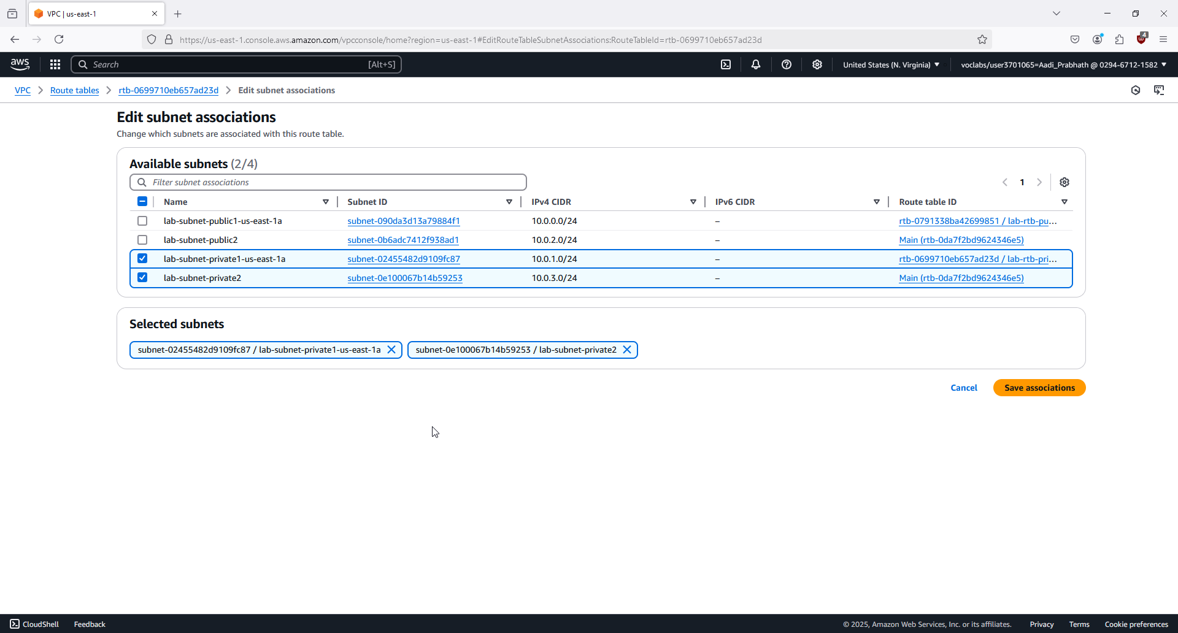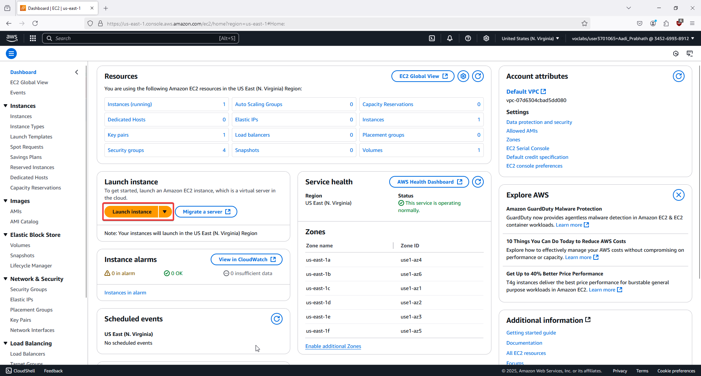

26. In Task 3, go to Security groups and click Create security group.

27. Name the security group Web Security Group and add an inbound rule for HTTP from anywhere (0.0.0.0/0).

28. In Task 4, go to the EC2 console and click Launch instance.

29. Name the instance Web Server 1 and configure it with:

- AMI: Amazon Linux 2023

- Instance type: t2.micro

- Key pair: Select vockey

- Network: Choose lab-vpc

- Subnet: Choose lab-subnet-public2

- Security group: Select Web Security Group.

30. Under Advanced details, add the script to install Apache, PHP, and the web app. Then click Launch instance and monitor its status. After the instance passes health checks, copy its Public DNS and test it in the browser to ensure the web server is working.

## Lab 3

1. In the AWS Management Console, select Services, then Compute, and choose EC2.

2. Verify the EC2 region is set to N. Virginia (us-east-1).

3. If not, select N. Virginia from the region dropdown.

4. Click the Launch instance button to begin creating a new instance. 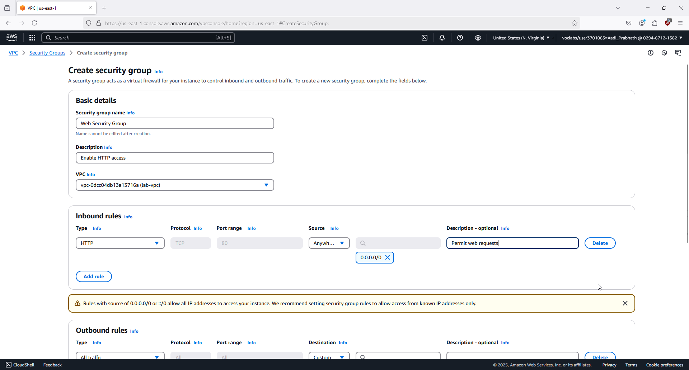

5. In Step 1, name the instance Web Server and assign a tag with the key "Name" and value "Web Server." 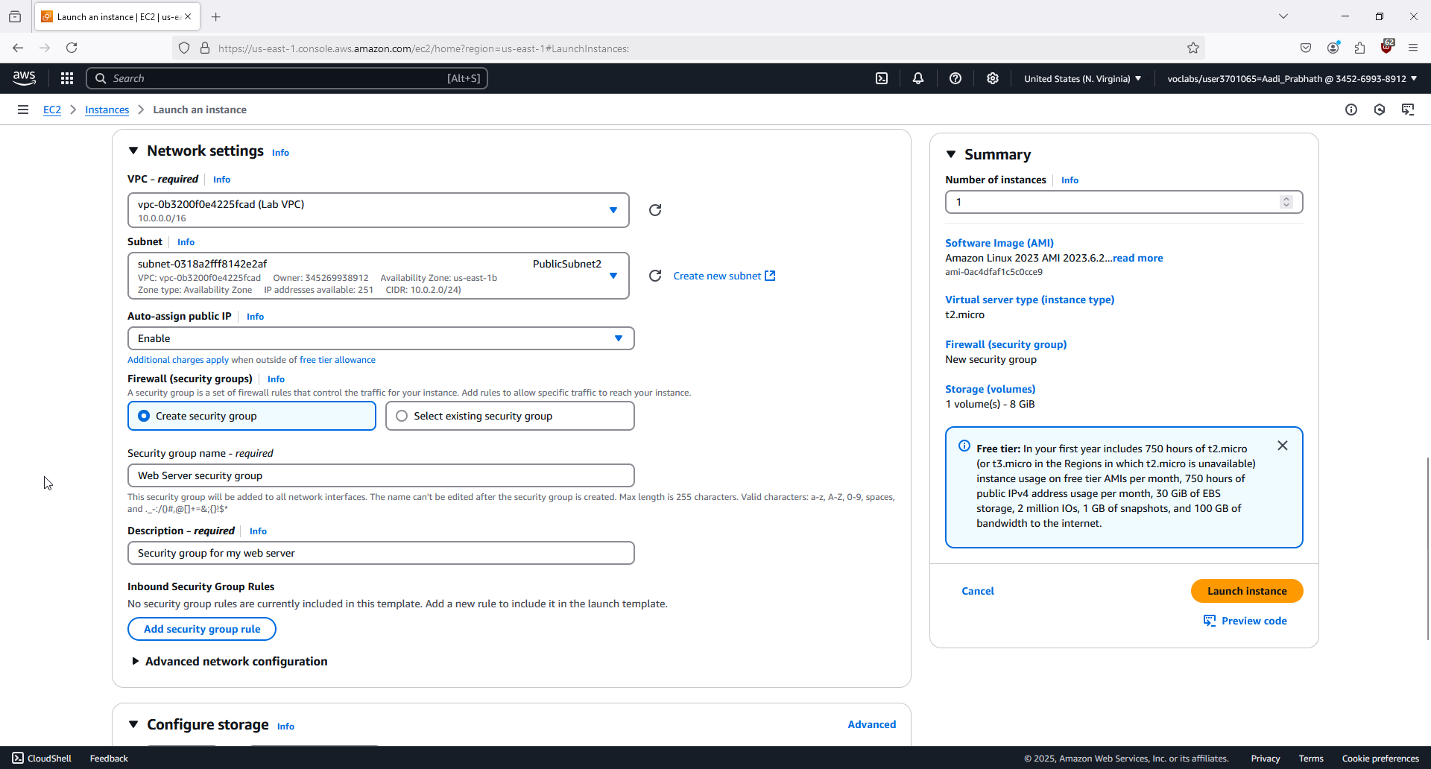

6. In Step 2, choose the default Amazon Linux 2023 AMI.

7. In Step 3, keep the default instance type, t2.micro.

8. In Step 4, for the Key pair name, choose vockey. (You won’t use it for login in this lab.)

9. In Step 5, for VPC, select Lab VPC, and keep the default subnet PublicSubnet1.

10. Ensure the instance will be assigned a public IP address.

11. Under Firewall (security groups), create a new security group called Web Server security group.

12. Add a description: "Security group for my web server."

13. Remove the default inbound rule.

14. In Step 6, keep the default storage settings (8 GiB root volume).

15. In Step 7, expand Advanced details. 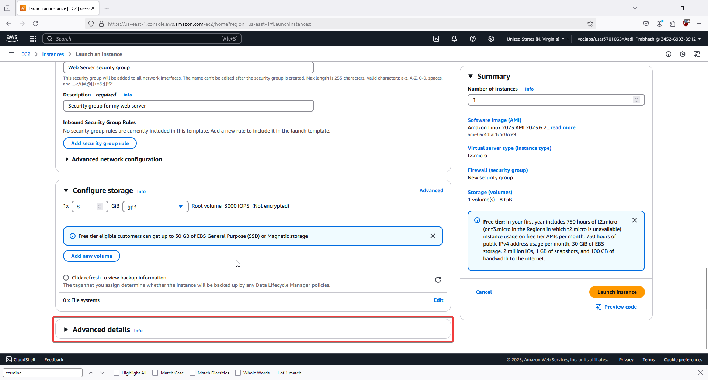

16. Enable Termination protection to prevent accidental termination.

17. Paste the provided user data script in the User data box to install and configure Apache and create a simple web page. 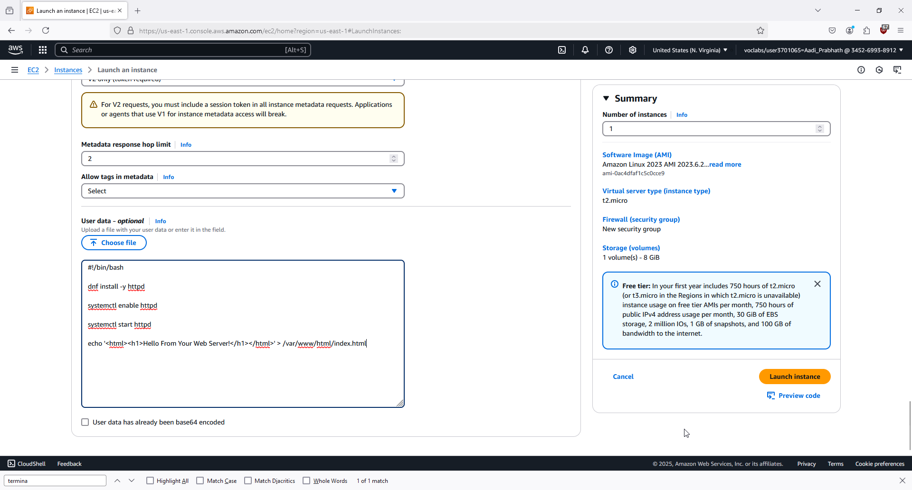

18. Click Launch instance to create the EC2 instance. 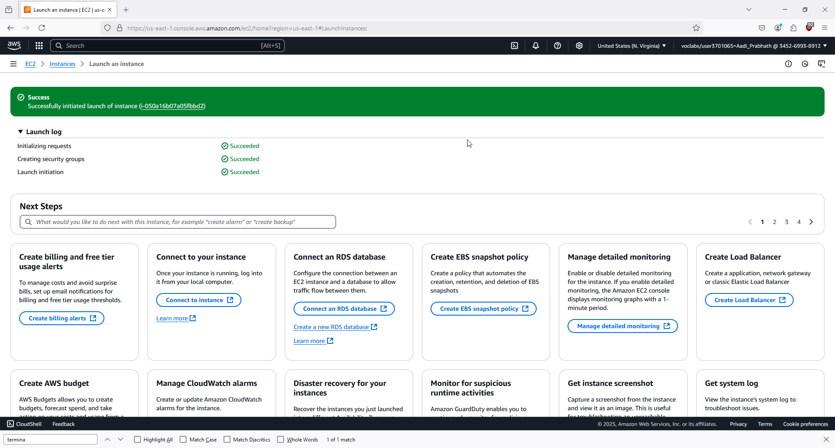

19. After the instance is launched, choose View all instances. 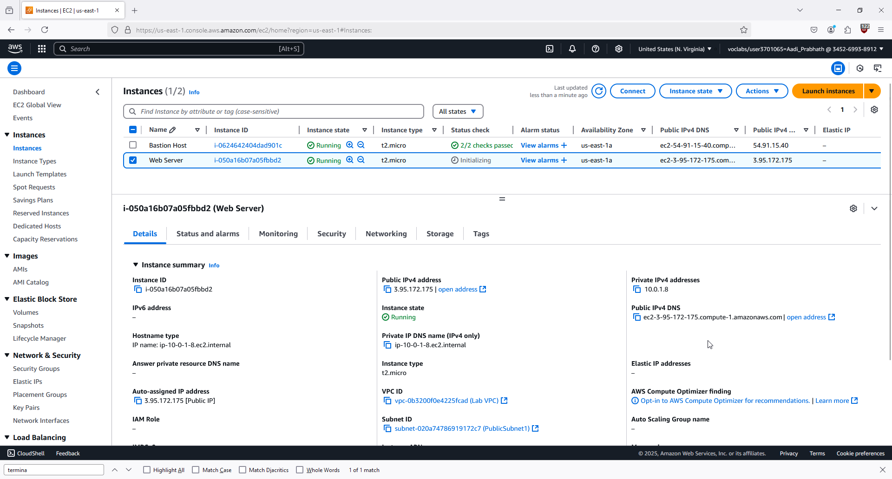

20. Select the Web Server instance and verify it’s in Running state with 2/2 status checks passed. 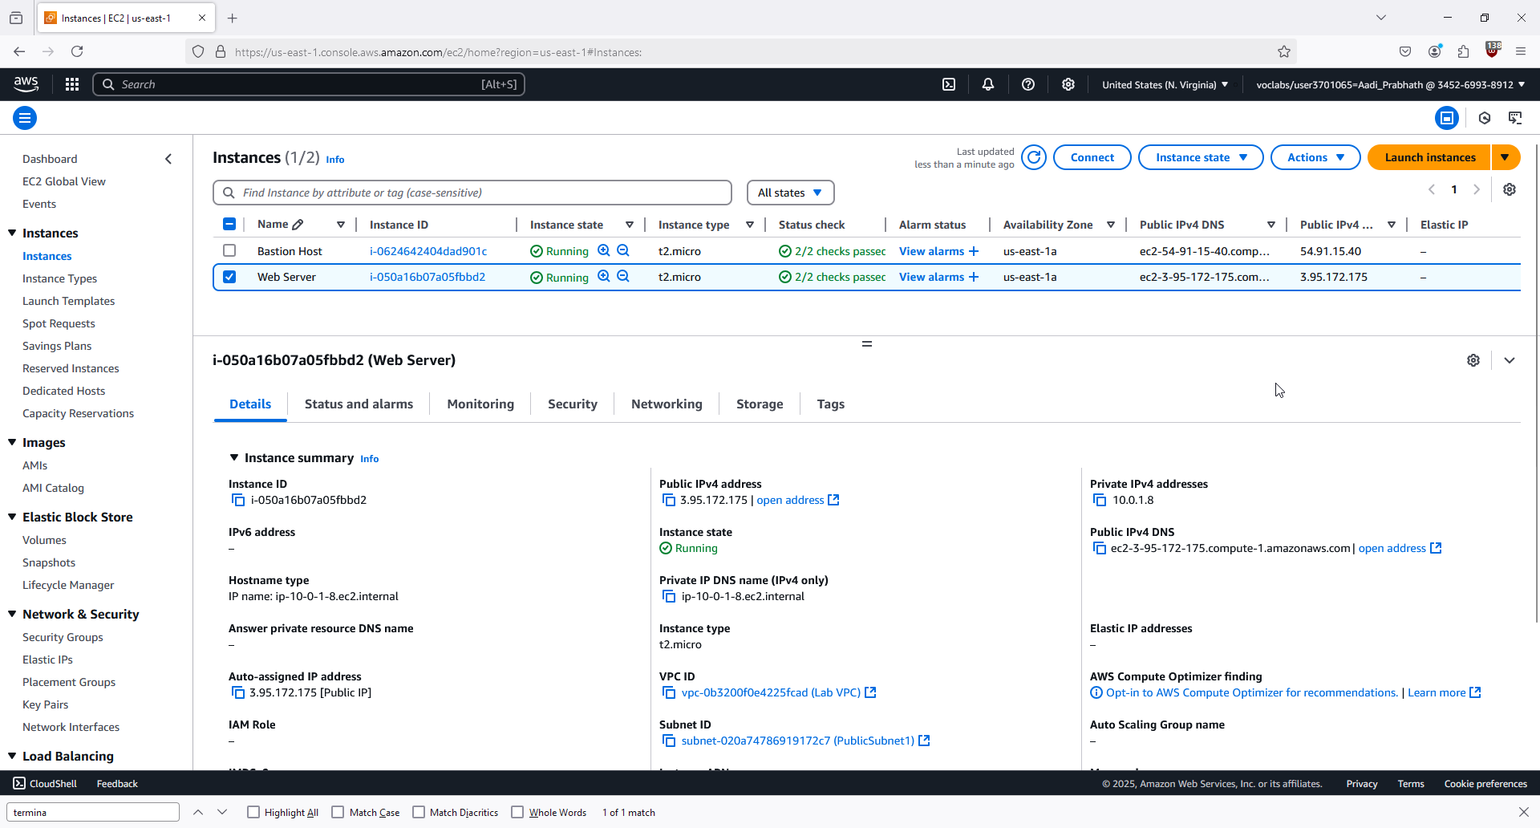

21. In the Status checks tab, ensure both system and instance reachability checks pass. 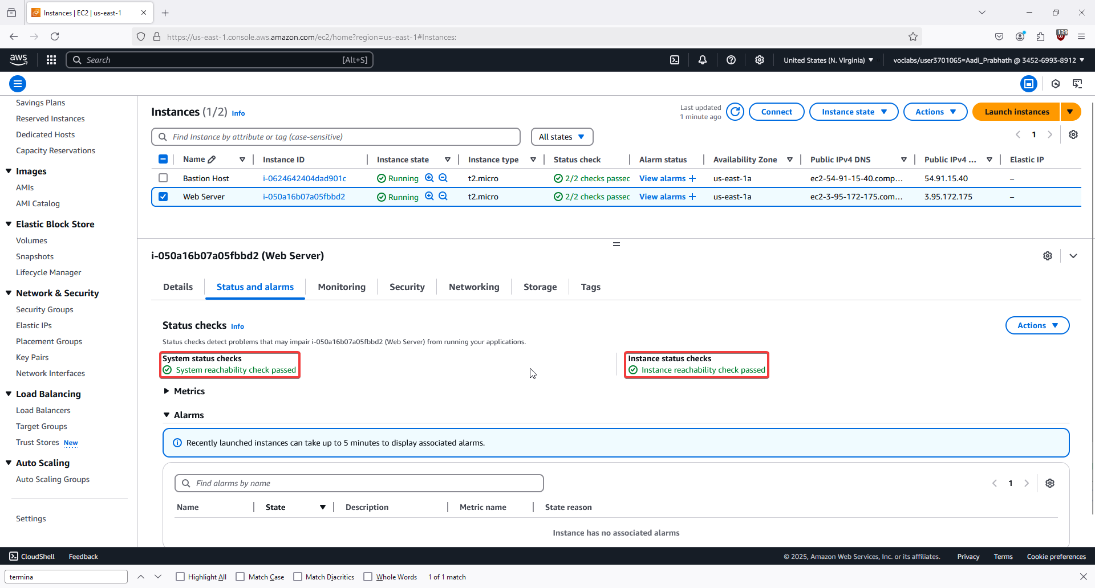

22. In the Monitoring tab, review the basic CloudWatch metrics for the instance.

23. Choose Actions, then Monitor and troubleshoot, and select Get system log to view console output. 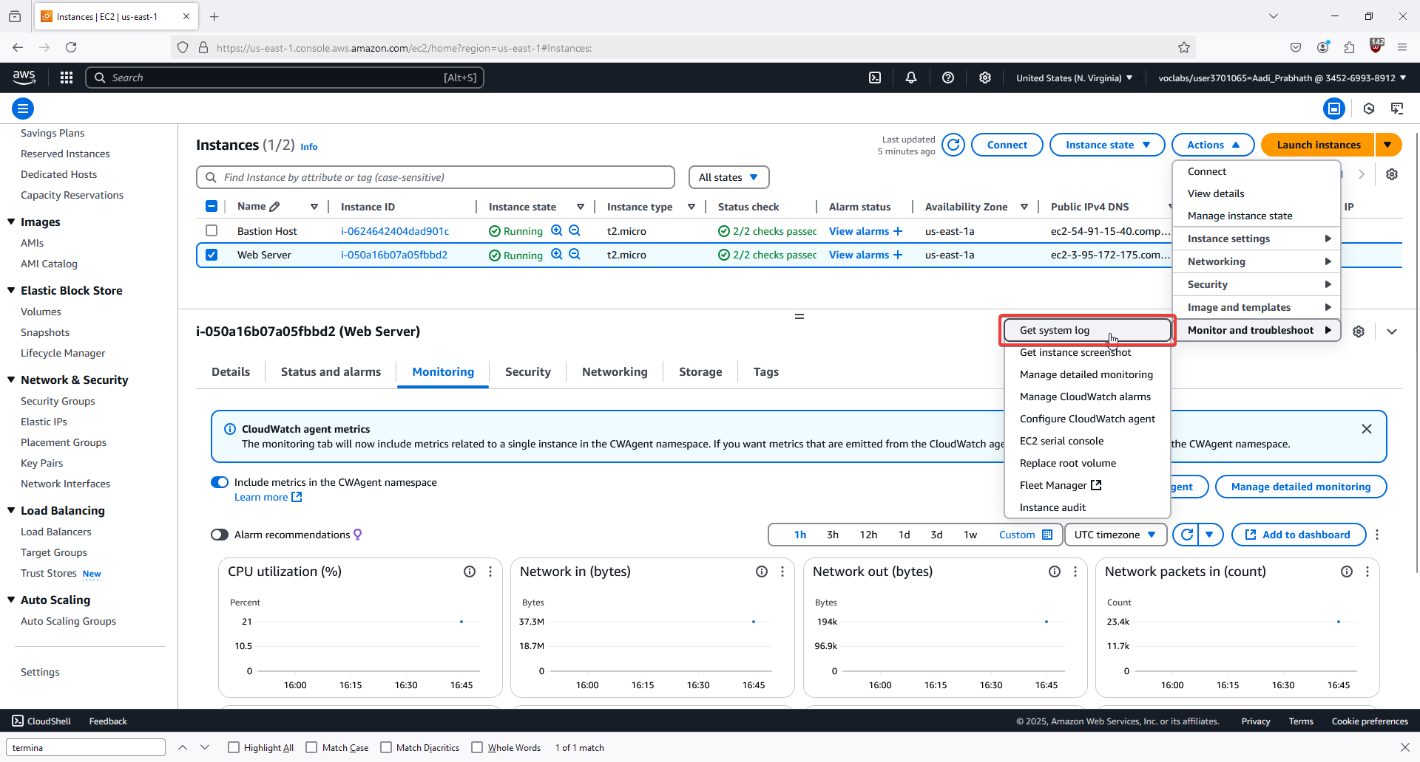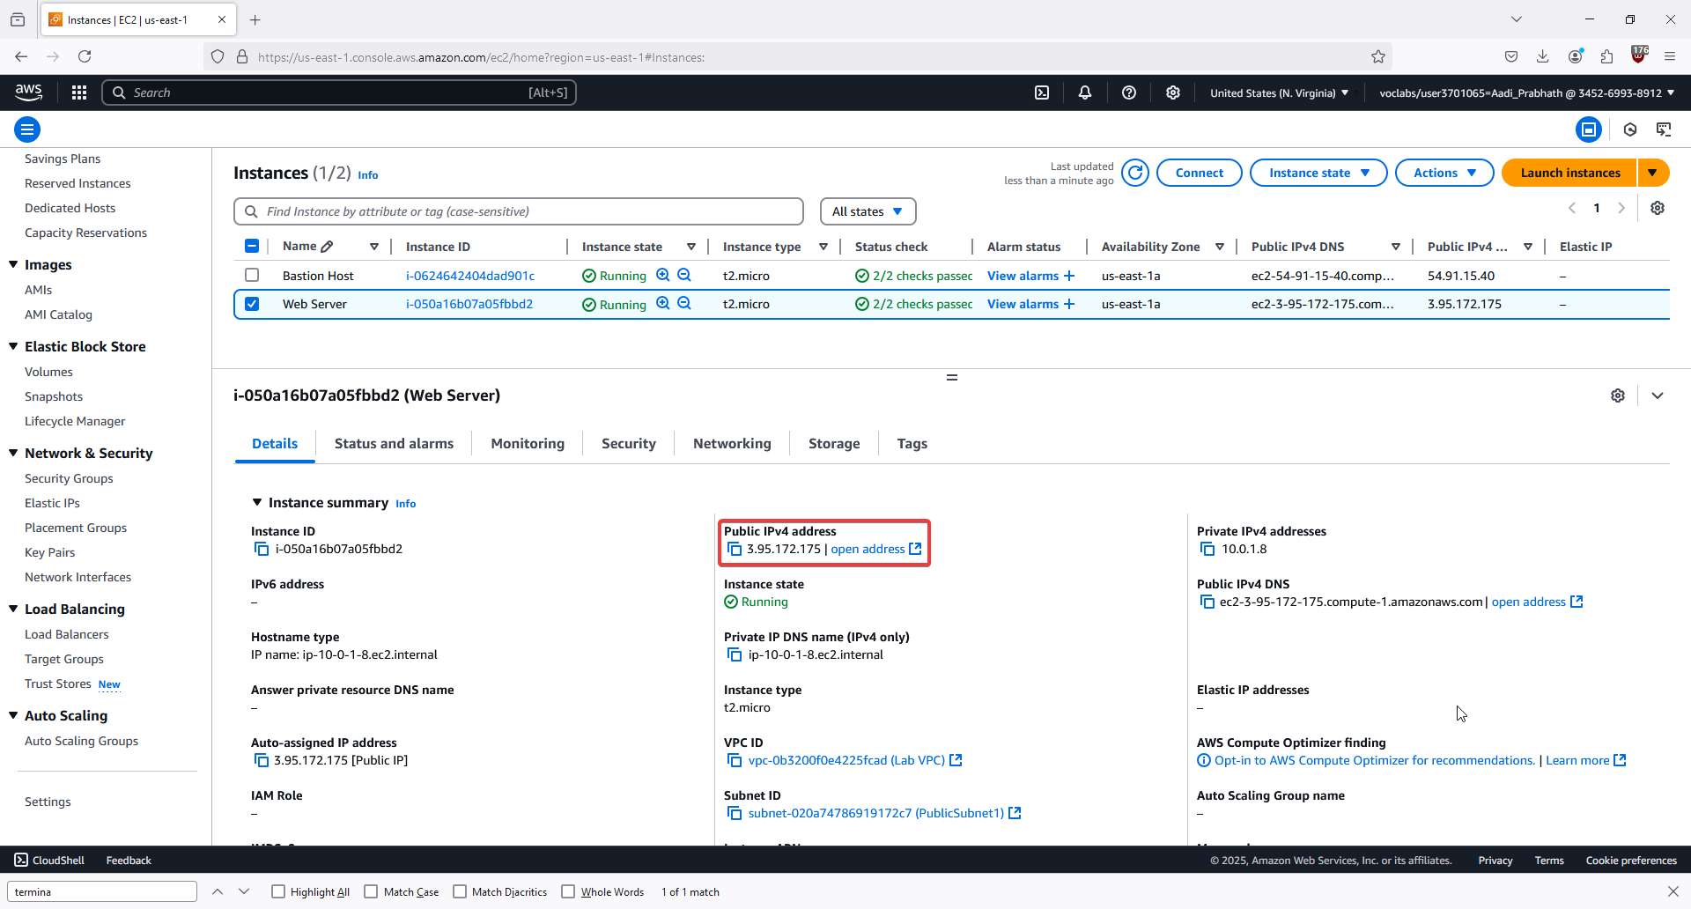

24. Look for the HTTP package installation in the system log.

25. In Actions, select Get instance screenshot to see the console screen output.

26. Copy the Public IPv4 address of the instance to your clipboard. 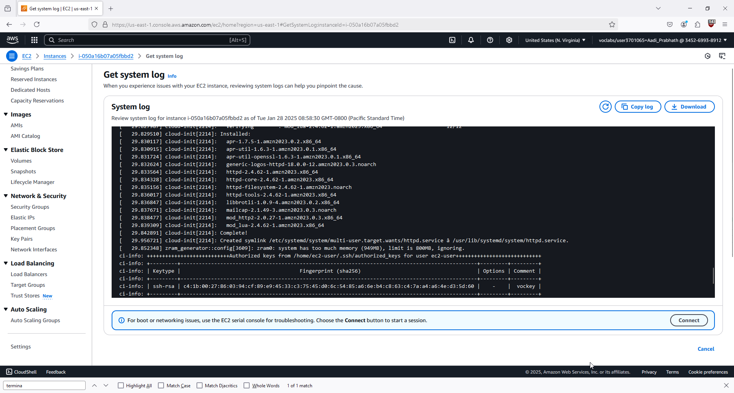

27. Paste the IP address in your browser’s address bar to try accessing the web server (you won’t be able to yet due to security settings). 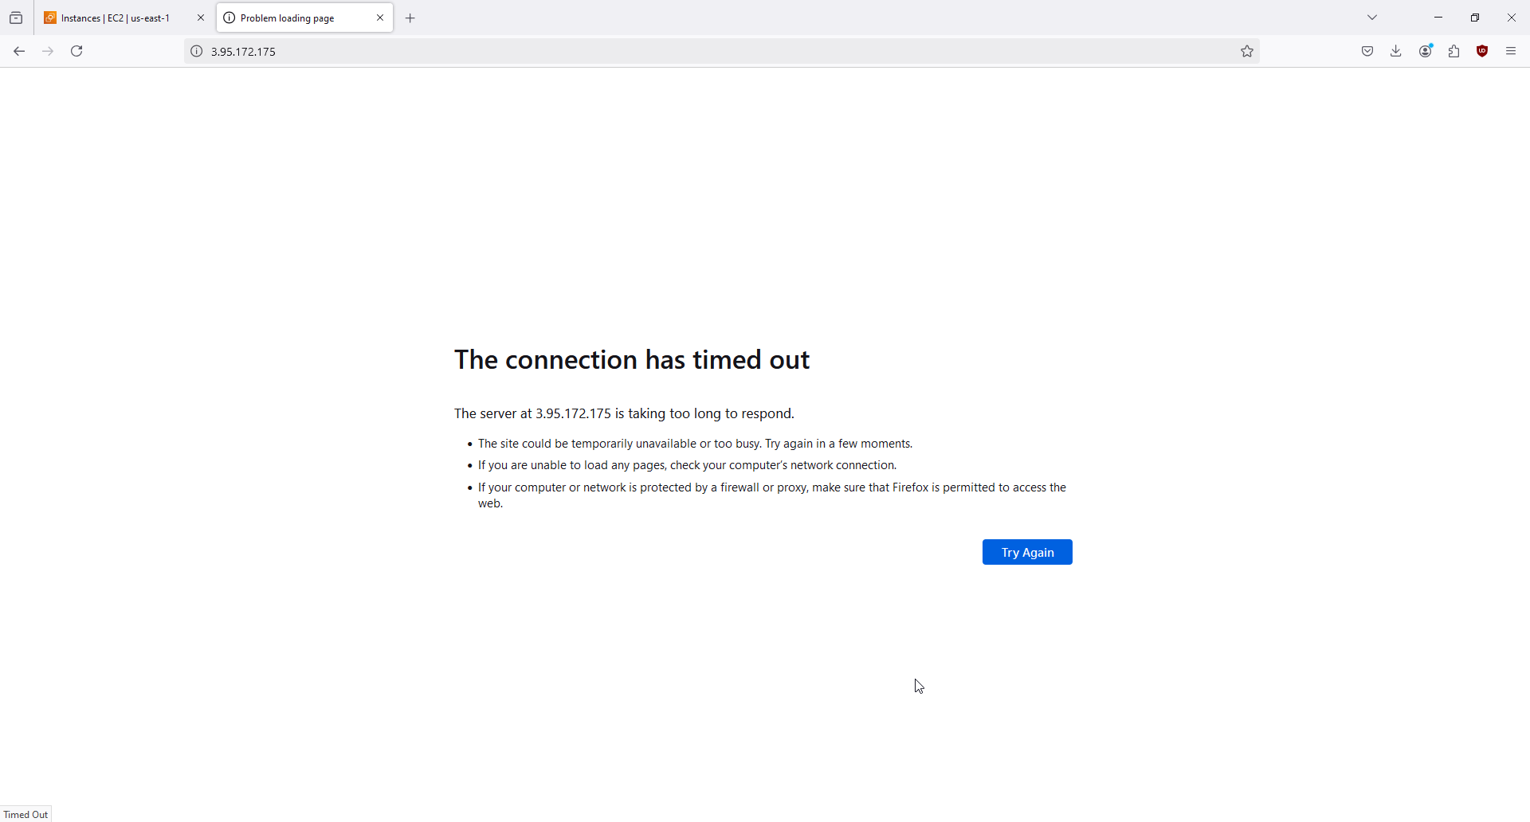

28. Go back to the EC2 Console and select Security Groups in the left navigation pane. 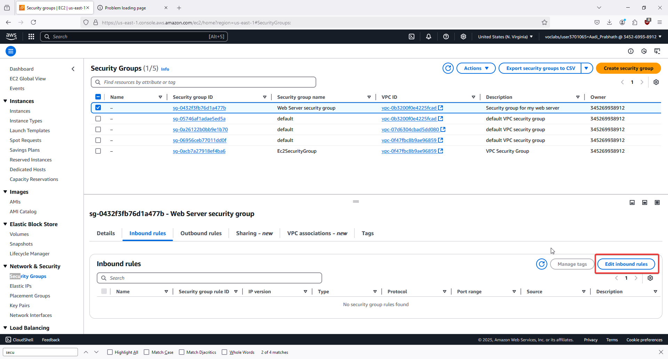

29. Select Web Server security group and go to the Inbound rules tab. 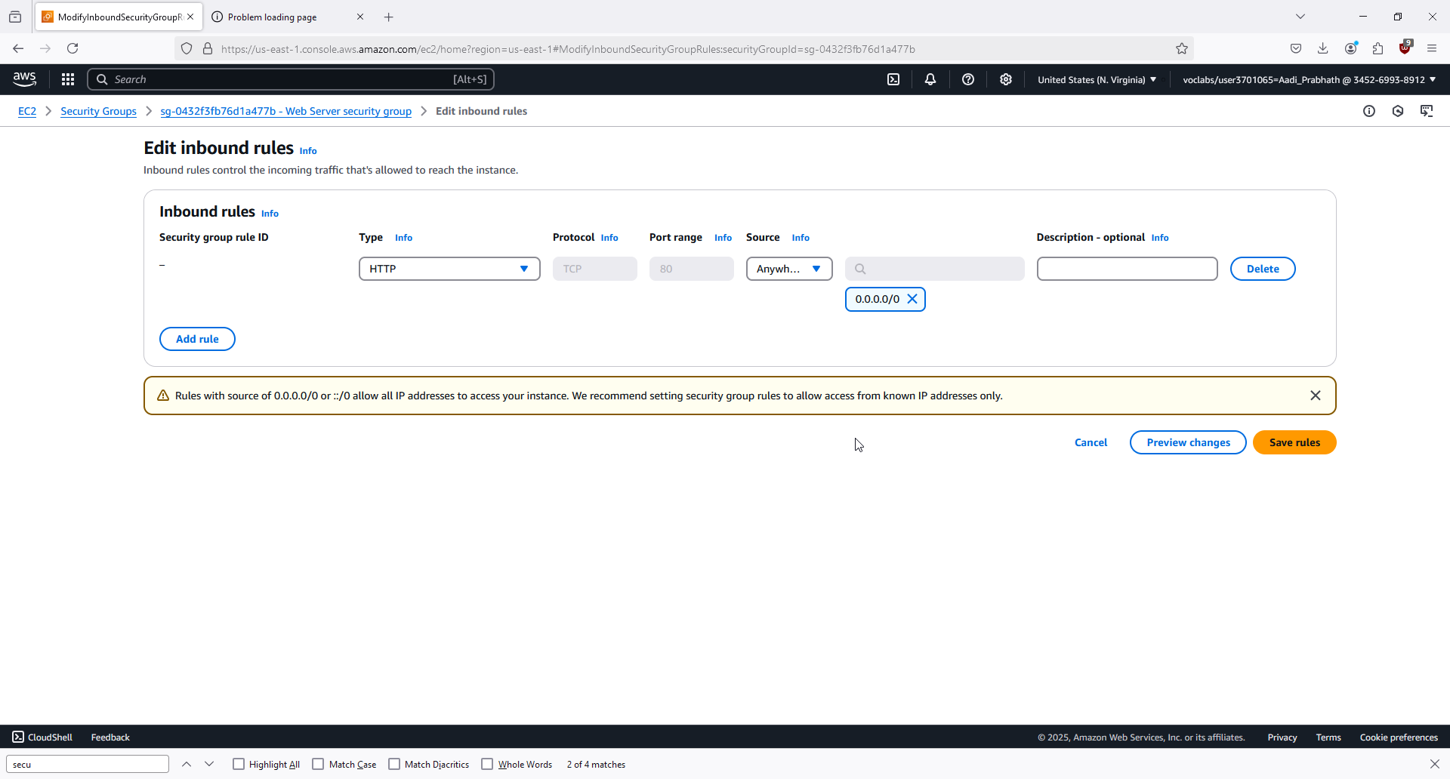

30. Click Edit inbound rules, select Add rule, and configure the rule as follows:

- Type: HTTP

- Source: Anywhere-IPv4

31. Save the rules.

32. Go back to your browser and refresh the page to see the message "Hello From Your Web Server!" 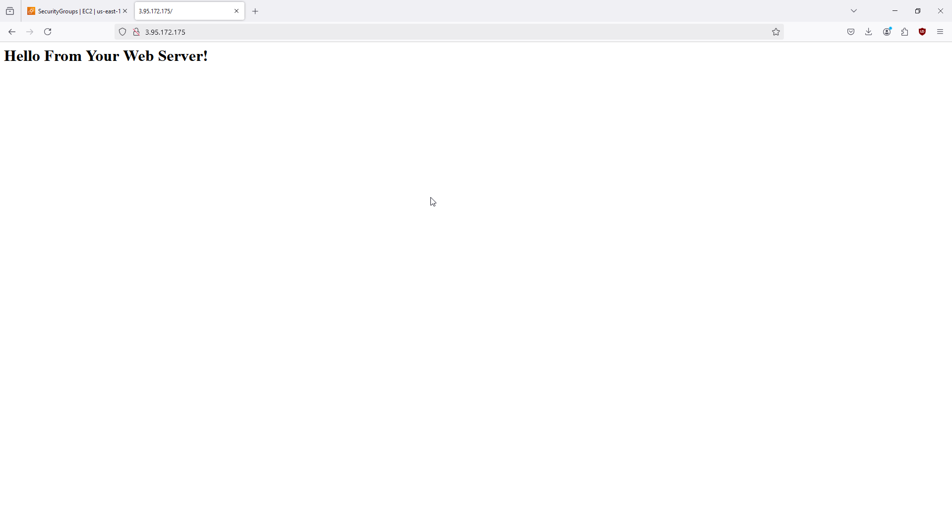

33. To resize the instance, stop it by selecting Stop instance from the Instance state menu. 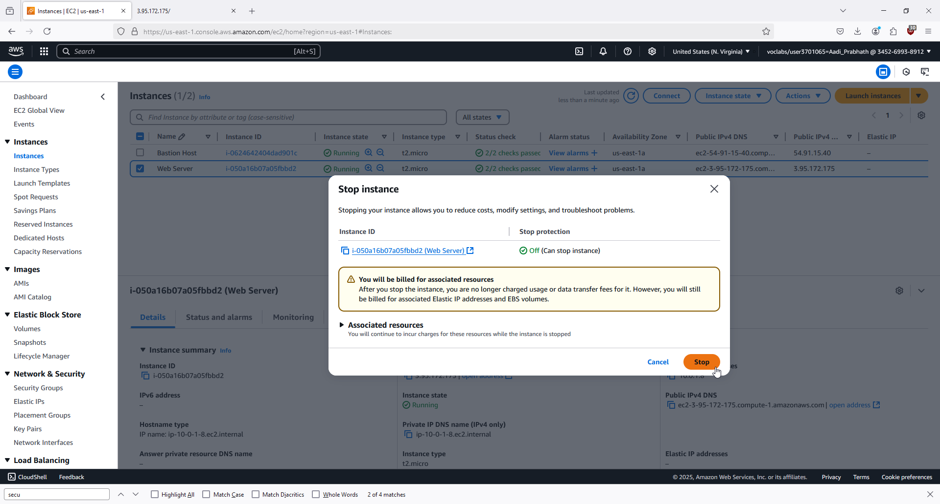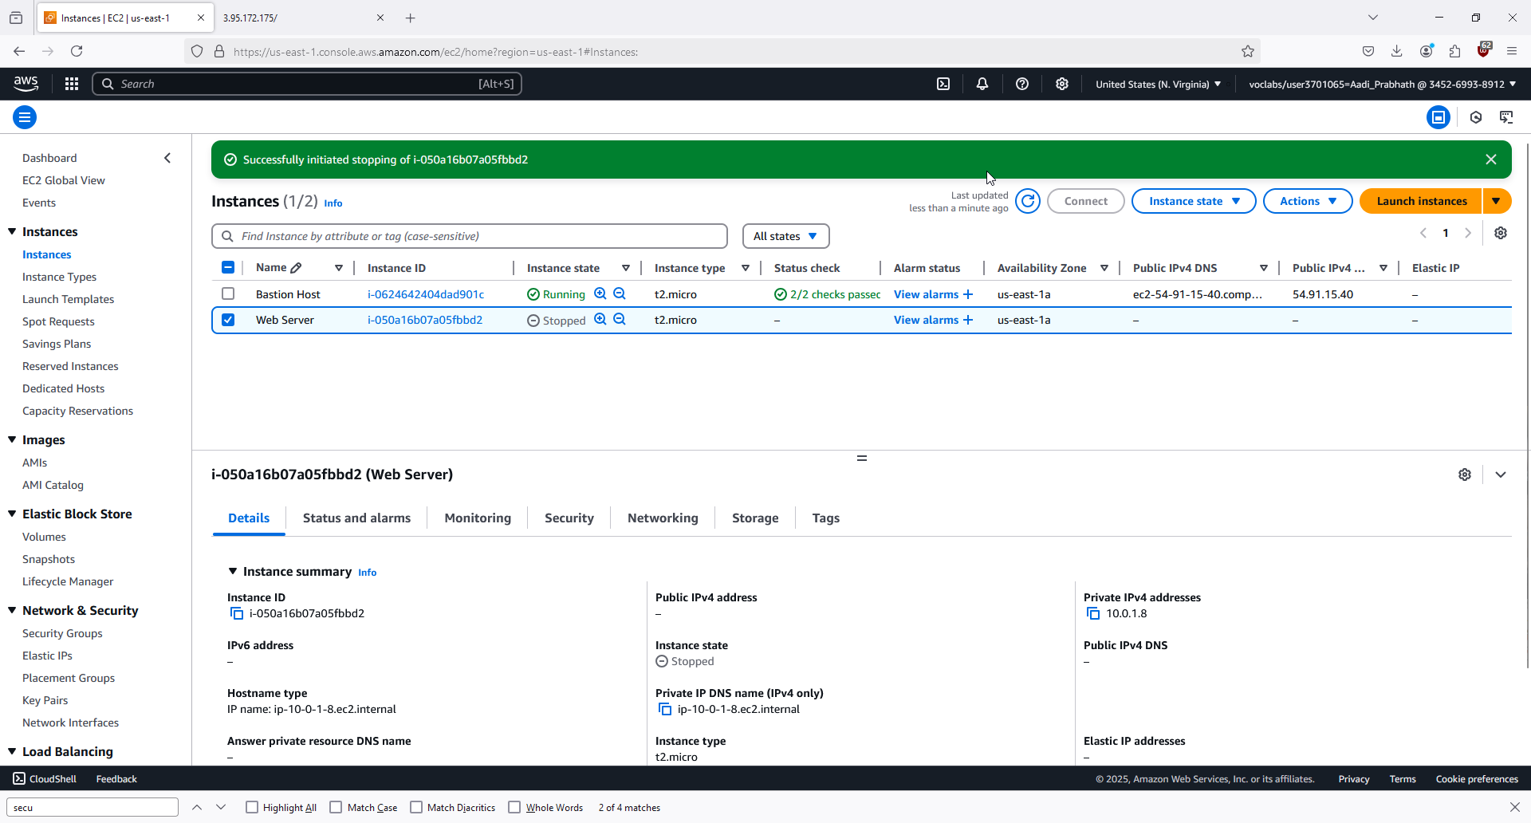

34. After the instance is stopped, change the instance type to t2.small and apply the change. 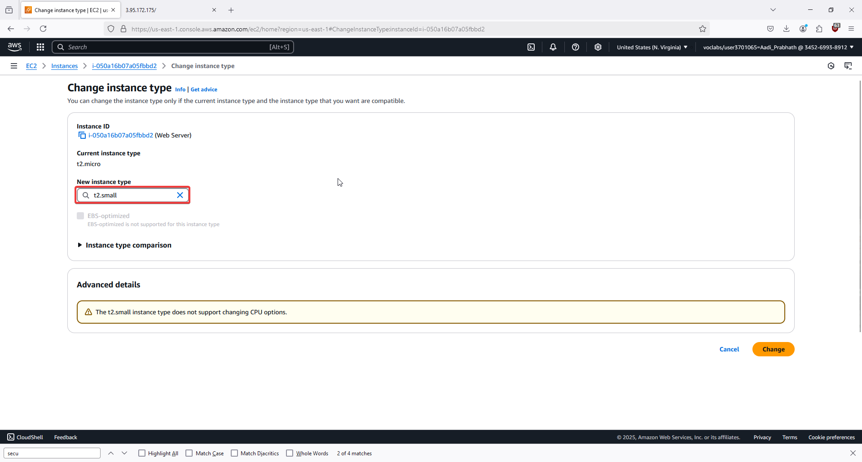

35. Enable stop protection to prevent accidental termination, then save the change.

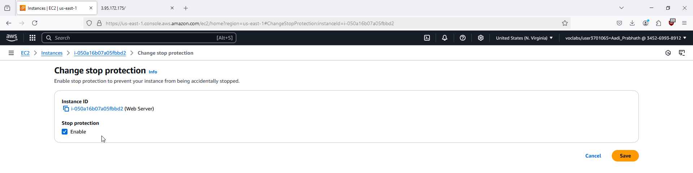

## Problems

Thanks to the intuitive nature of the AWS interface and the easy-to-follow instructions, there were no major problems.

## Conclusion

In this lab, we learned the basics of how to use AWS. We gained familiarity with the web GUI, and we also learned how to configure and launch basic services like EC2 instances, VPCs, firewalls, and subnets. We learned basic security principles like privilege management and firewall configuration. We also learned how to quickly scale the use of cloud resources to adapt to changing demands.

|  |
| --- |
| LAB 5:  AWS LABS 4-6 Aadithya Prabhath |
| Amazon Cloud Services, AWS Branding, Computing Logo Transparent |



## Purpose

Lab 4: To create scalable block storage for EC2 instances, ensuring access to data even when instances terminate. Lab 5: To learn how to set up a RDS DB on AWS to create a managed, scalable, and reliable database. Lab 6: To learn how to use the AWS ELB and Auto scaling to build scalable, reliable, and high availability applications on AWS.

## Background Information on Lab Concepts

AWS allows us to manage user groups and assign them responsibilities. This is important because it helps ensure security by ensuring that no one gets access to more resources than is necessary to do their job. By instituting this change, we ensure that our system is not vulnerable to privilege escalation attacks. We will use the Amazon Virtual Private Cloud to add additional components to create a customized network. We will also create and run an EC2 instance within a subnet in the VPC. EC2 stands for Elastic Compute Cluster, and is a service provided by AWS that gives us access to servers that can be easily scaled up and down according to demand, ensuring that we only use the minimum number of resources to accomplish a task, saving money. We will use EC2 instances, launching one from scratch and configuring it with the parameters we choose. We will set up routes to and from the server so that it can safely and securely access the internet. We will quickly scale up and down the size of the server in accordance with our compute needs. We will also utilize stop protection, so that administrators don’t accidentally shut down a critical process that should continue to run. Data for EC2 instances is stored in Elastic Block Stores. EBS are scalable block storage services that are reliable and available. Like EC2, they can be quickly scaled up and down to cope with additional demand, saving money while still providing enough memory for software needs. AWS uses relational databases, which are data structures that are similar to spreadsheets. In them, data points are linked with other data. They are commonly used in areas like transactions. To interact with AWS RDS, you need to use Structured Query Language, or SQL. SQL is the standard language for managing databases. It converts requests into code that the database can actually understand. In order to dynamically scale computational resources based on demand, we will be using AWS Elastic Load Balancer. ELB is a service that automatically distributes traffic between multiple EC2 instances, containers, and IP addresses. It works with the Auto Scaling of EC2 to cope with varied resource demands. We will be configuring our EC2 instances with preset Amazon Machine Images. In order to track and automatically log changes in computational resource use, we will be using Amazon CloudWatch. CloudWatch monitors the use of system resources, and can send alarms if resource use increases too much.

## Lab Summary

## Lab 4

1. In the AWS Management Console, search for and select EC2. 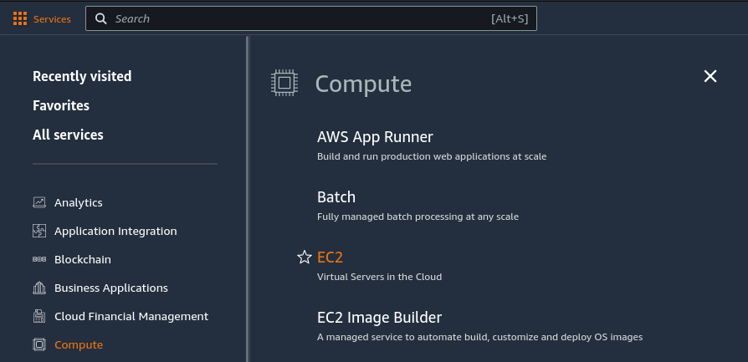

2. In the left navigation pane, choose Instances.

3. Note the Availability Zone of the existing Lab EC2 instance. 

4. In the left navigation pane, choose Volumes. 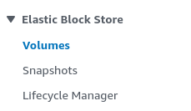

5. Click Create volume. 

6. Set the volume type to General Purpose SSD (gp2).

7. Set the size to 1 GiB and choose the same Availability Zone as your EC2 instance. 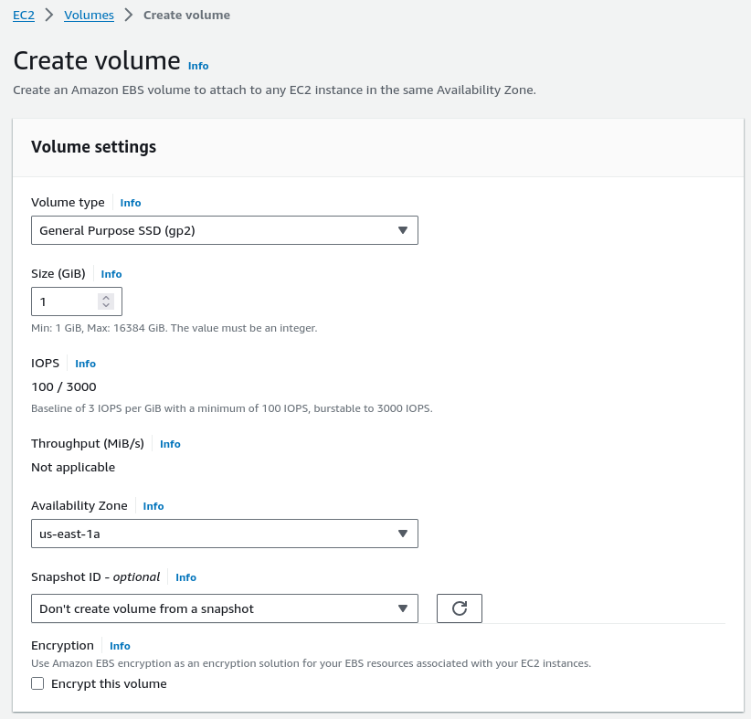

8. Add a tag with key "Name" and value "My Volume."

9. Click Create Volume.



10. The new volume will appear in the list, transitioning to Available state.

11. In the left navigation pane, choose Volumes again to view the new volume.

12. Select My Volume and choose Attach volume from the Actions menu. 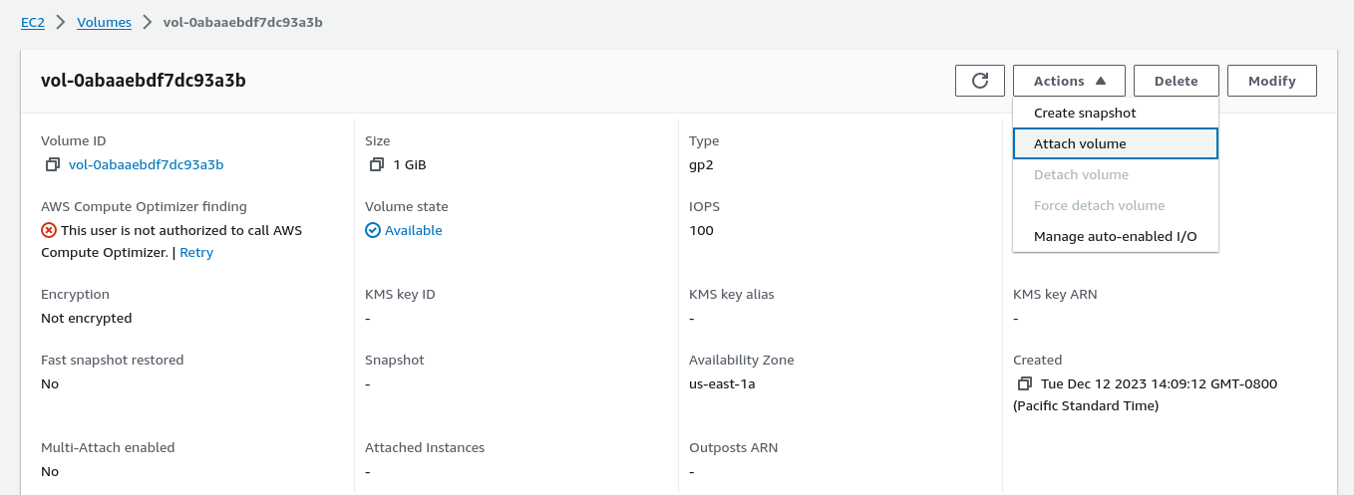 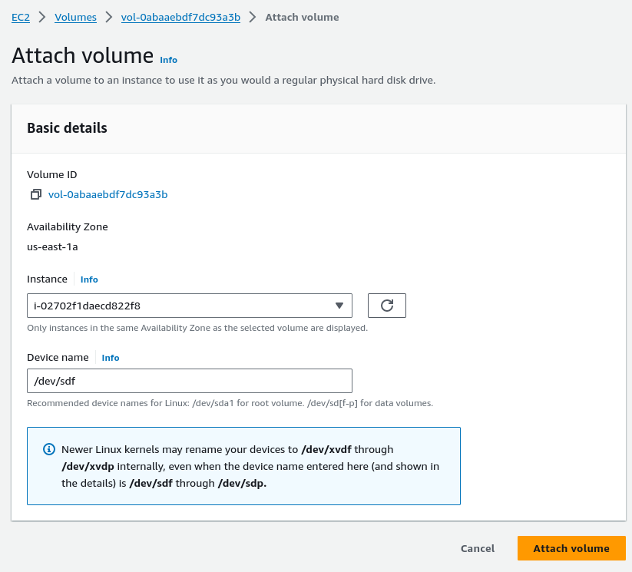

13. In the Instance field, select the Lab instance.

14. Confirm that the device name is /dev/sdf (note the potential for kernel renaming).

15. Click Attach volume. The volume state should change to In-use.

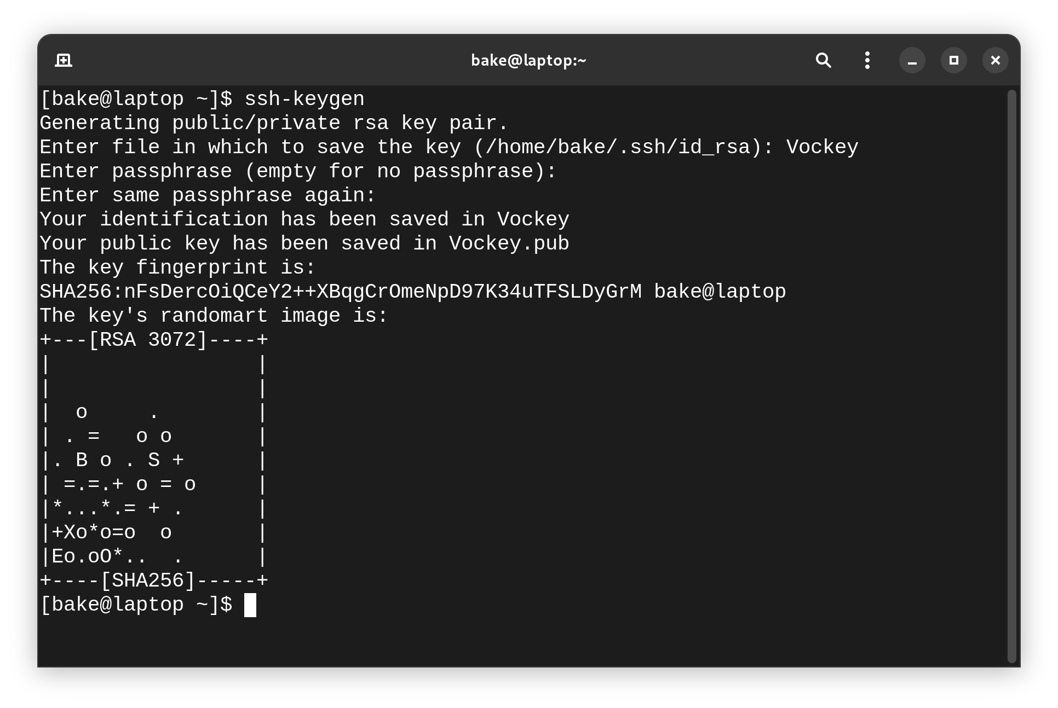16. In the AWS Management Console, search for EC2 and choose Instances.

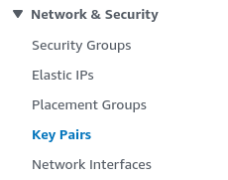

17. Select the Lab instance and click Connect.

18. On the EC2 Instance Connect tab, click Connect to open a terminal session.

19. In the terminal, run the command `df -h` to view available storage. 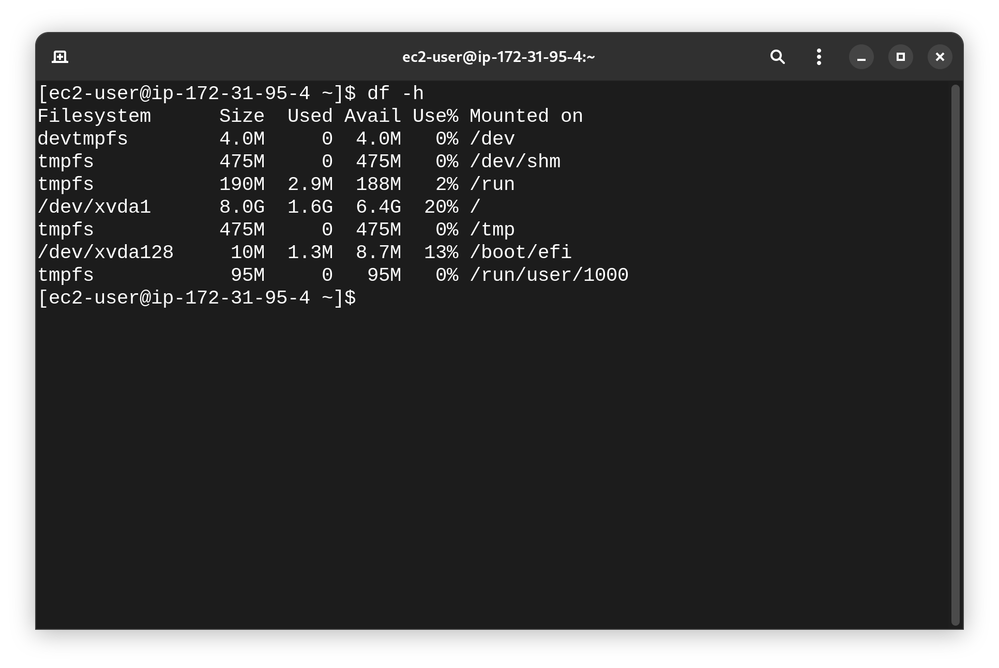

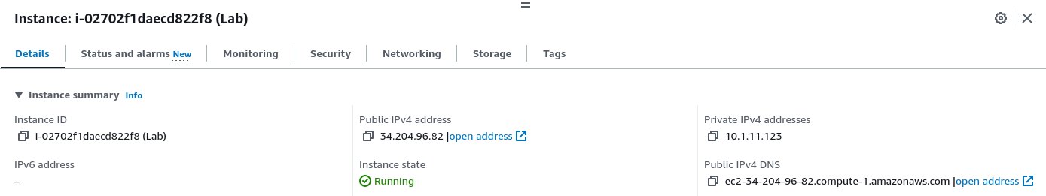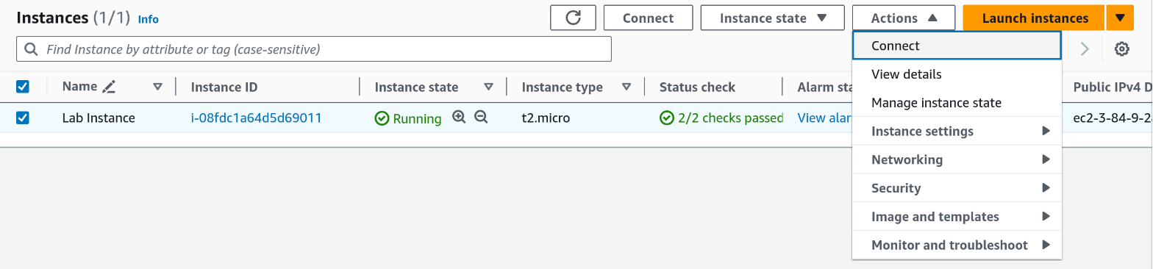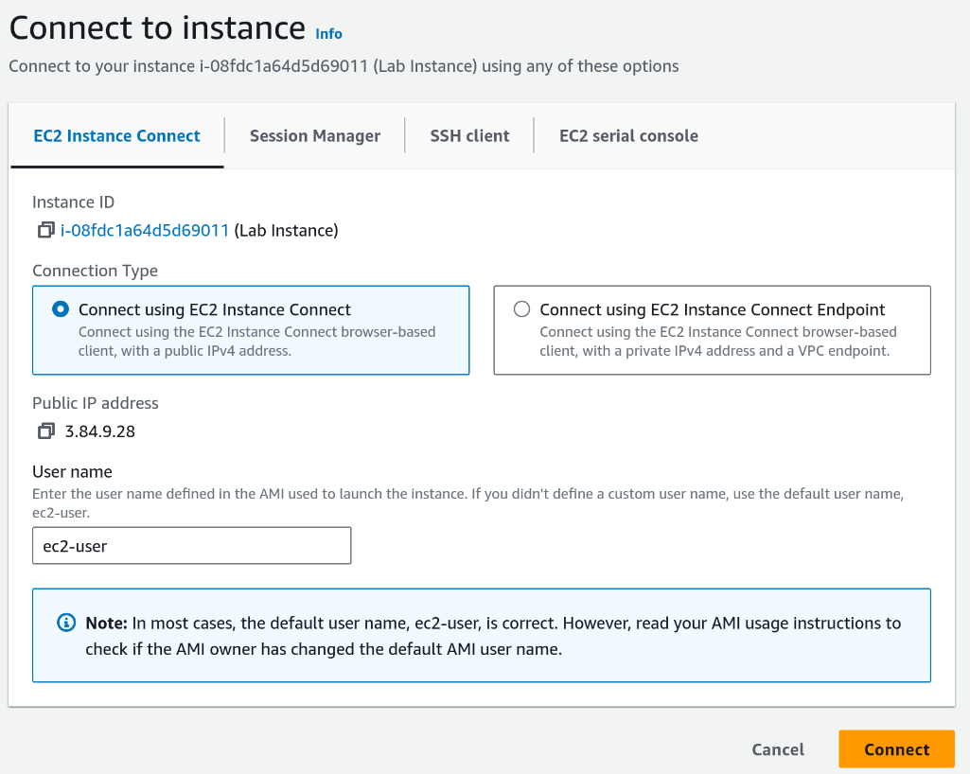20. You’ll see the root volume, /dev/xvda1, but not the attached volume.

21. Run the command `sudo mkfs -t ext3 /dev/sdf` to create an ext3 file system on the new volume. 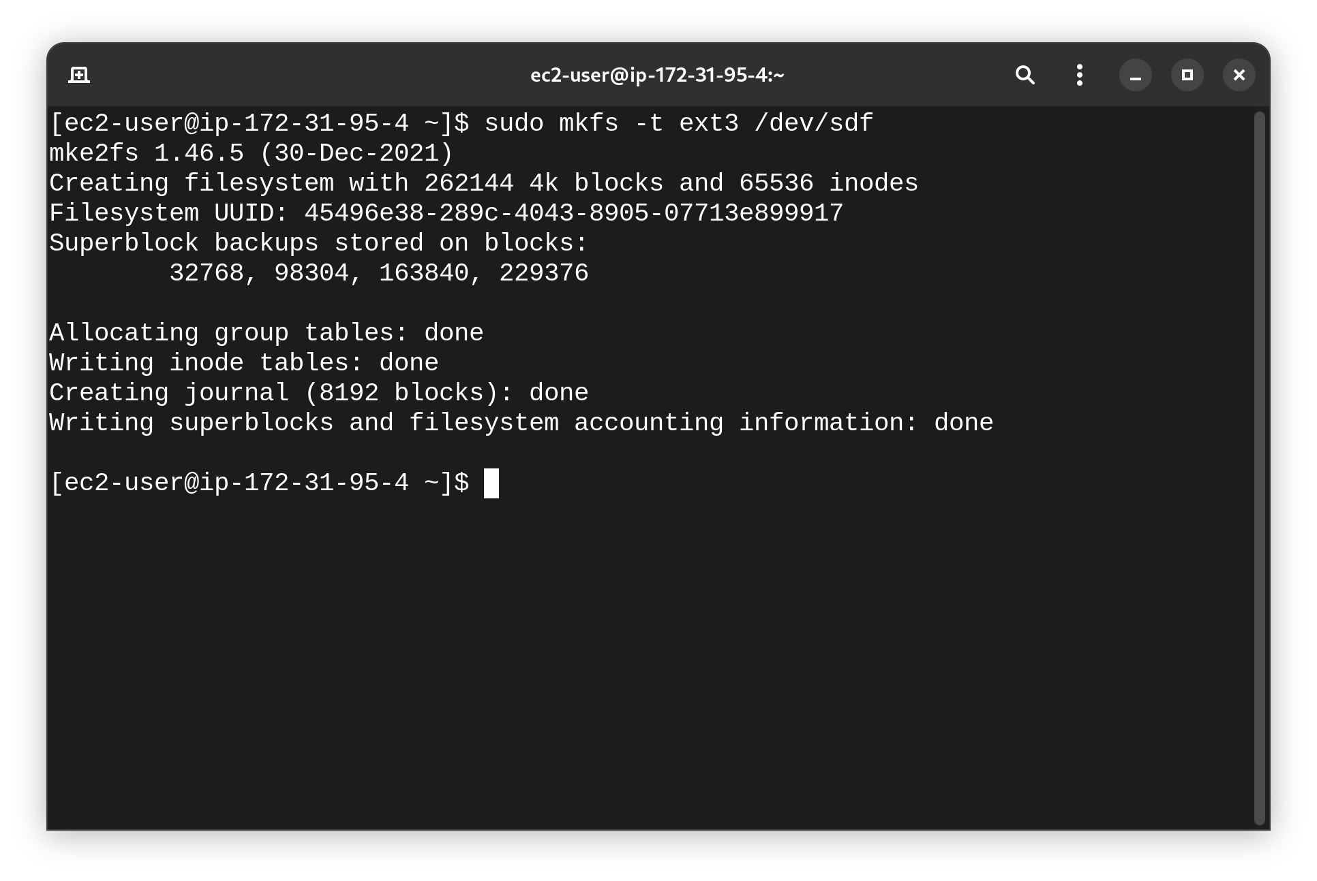

22. Create a mount directory: `sudo mkdir /mnt/data-store`. 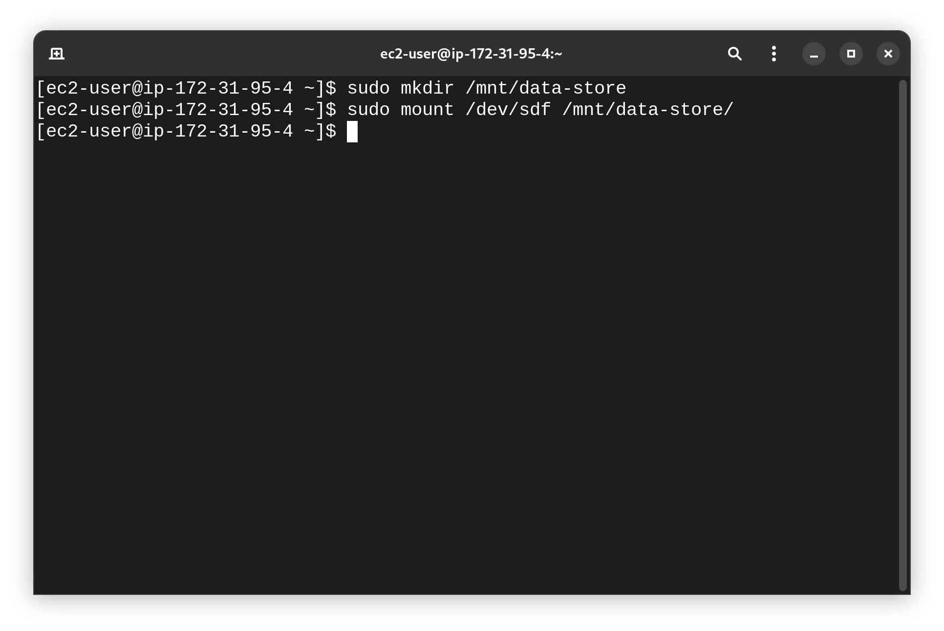

23. Mount the new volume: `sudo mount /dev/sdf /mnt/data-store`.

24. To mount the volume automatically on restart, run:

`echo "/dev/sdf /mnt/data-store ext3 defaults,noatime 1 2" | sudo tee -a /etc/fstab`.

25. Verify by viewing the `/etc/fstab` configuration: `cat /etc/fstab`. 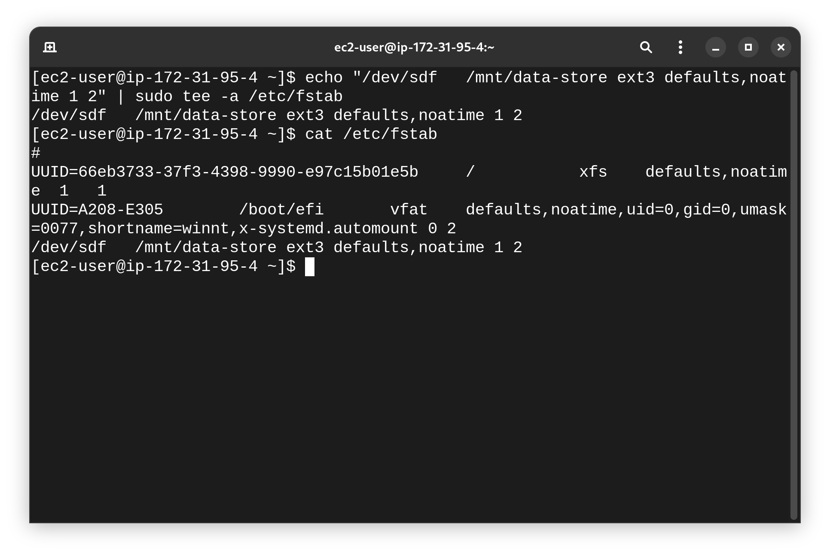

26. Run `df -h` again to confirm the new volume is mounted. 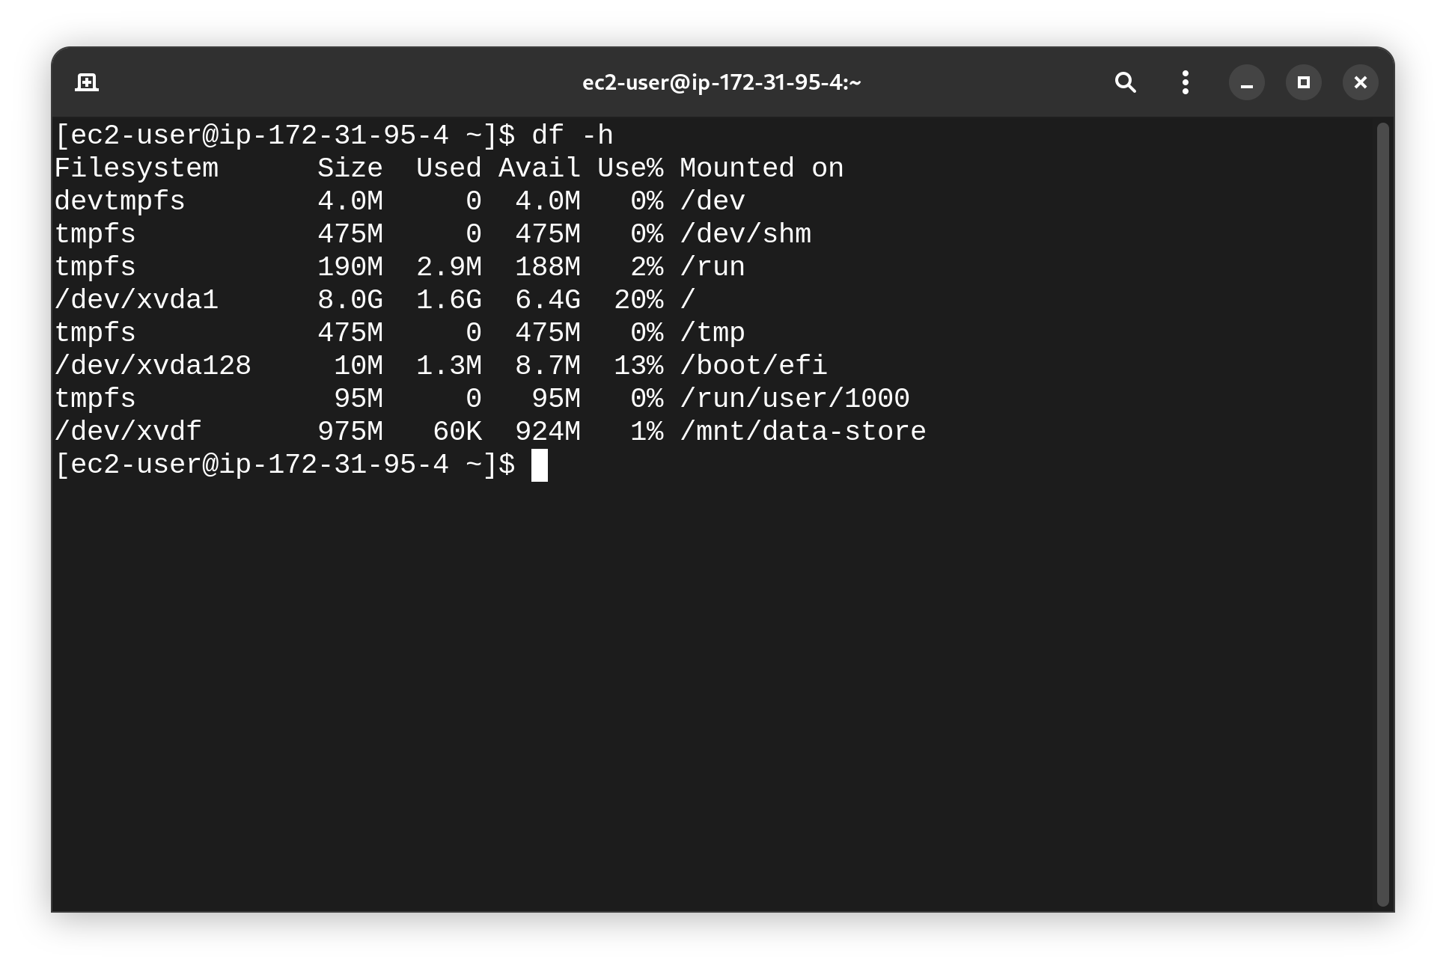

27. Create a file on the mounted volume: `sudo sh -c "echo some text has been written > /mnt/data-store/file.txt"`. 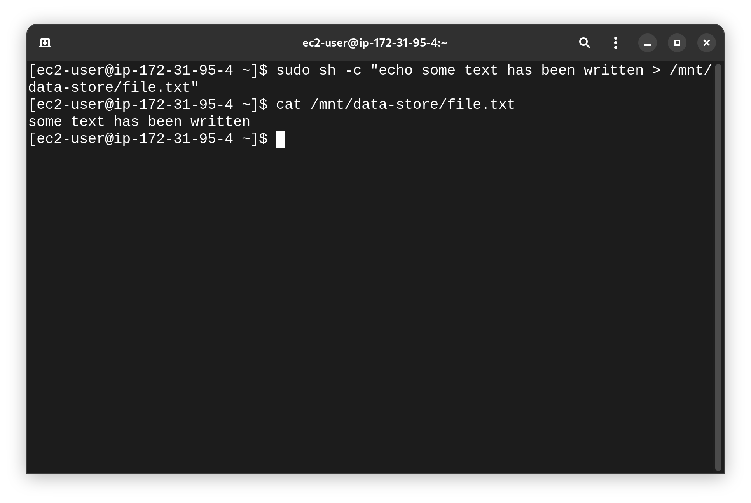

28. Verify the content by running `cat /mnt/data-store/file.txt`.

29. Leave the EC2 Instance Connect session open for later tasks.

30. In the EC2 Console, go to Volumes and select My Volume. 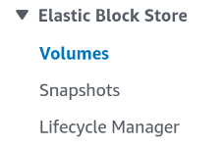

31. From the Actions menu, select Create snapshot.

32. Add a tag with key "Name" and value "My Snapshot." 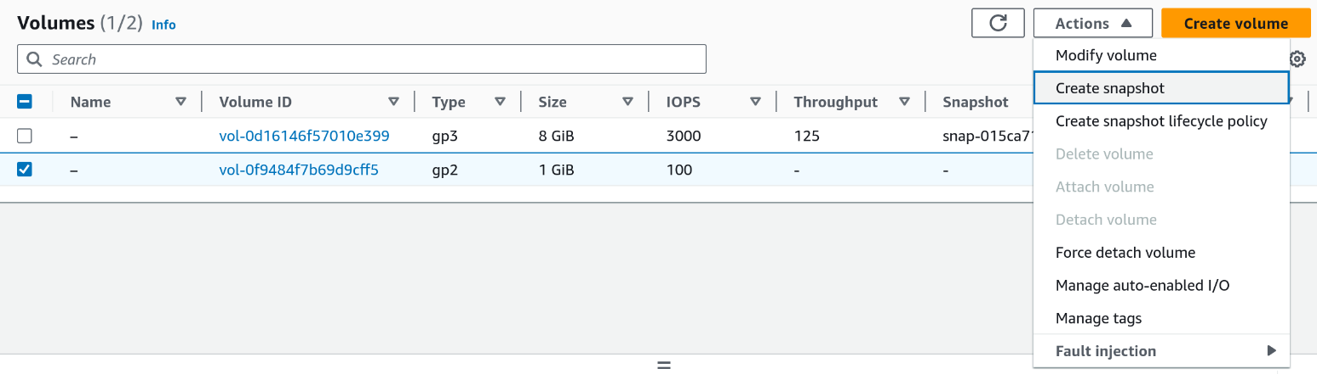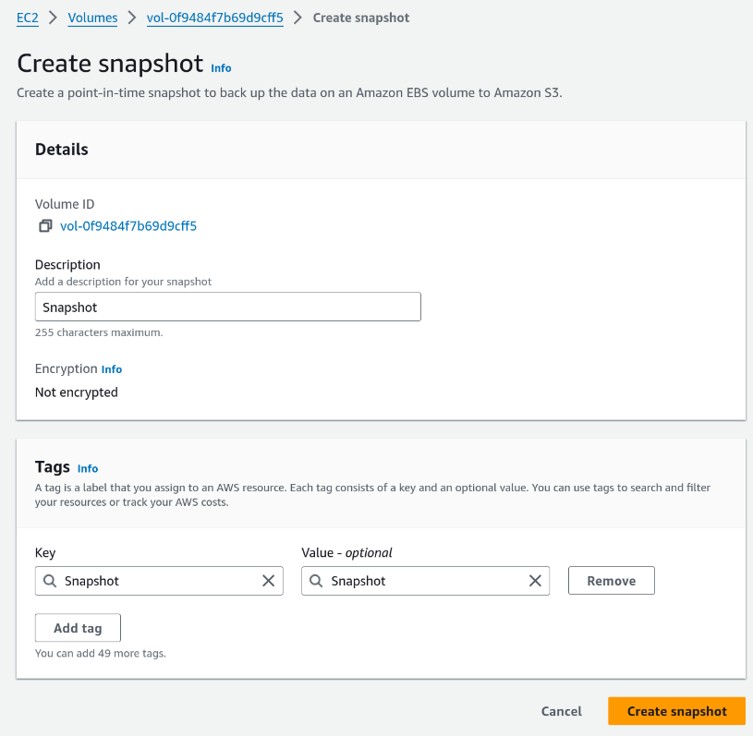

33. Click Create snapshot. The snapshot will first be in a Pending state, then Completed.

34. In your EC2 Instance Connect session, delete the file: `sudo rm /mnt/data-store/file.txt`. 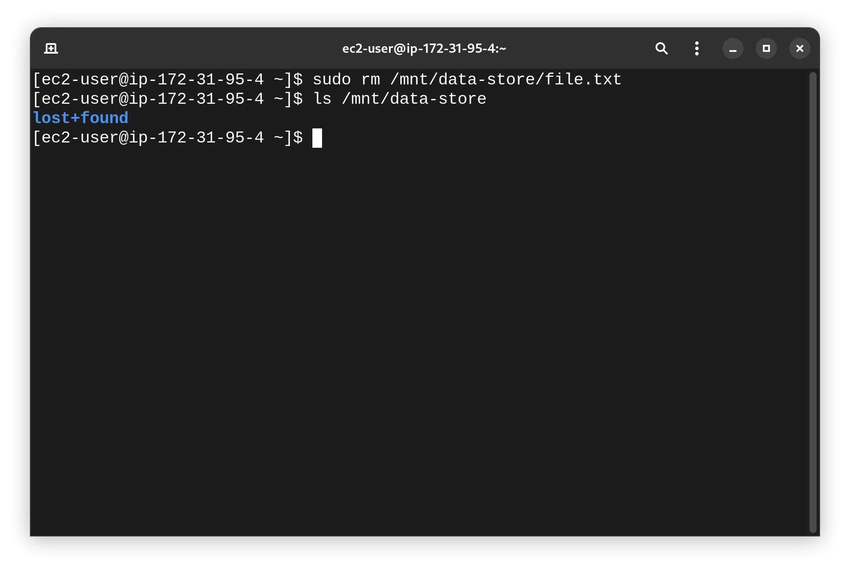

35. Verify the file deletion: `ls /mnt/data-store/`.

36. In the EC2 Console, go to Snapshots and select My Snapshot. 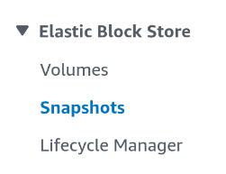

37. From the Actions menu, select Create volume from snapshot.

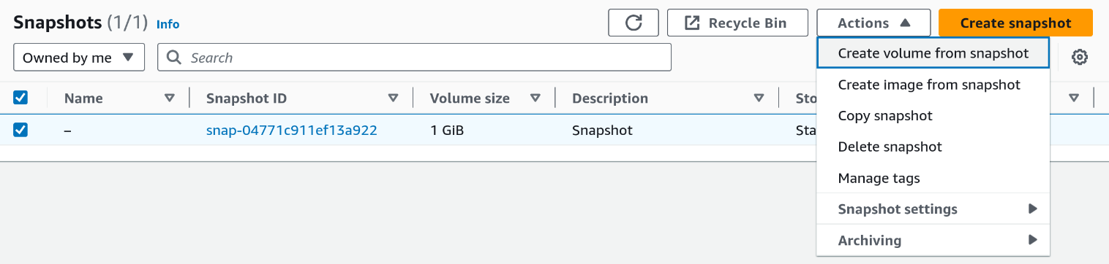38. Set the Availability Zone to match the original and add a tag with key "Name" and value "Restored Volume."

39. Click Create volume. 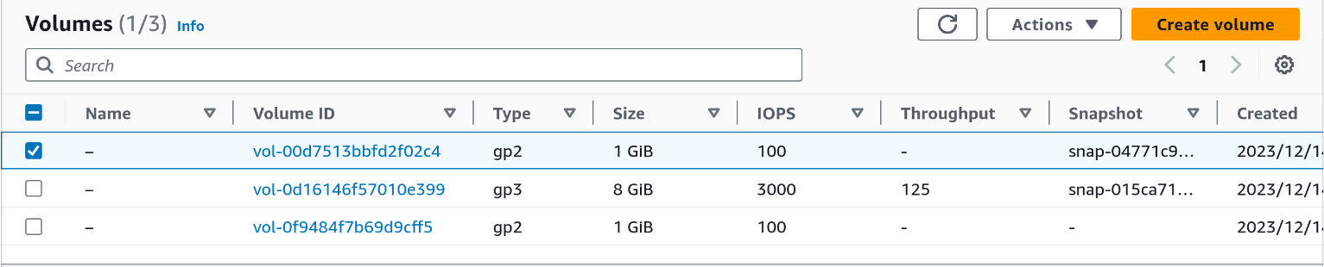

40. Go to Volumes, select Restored Volume, and choose Attach volume from the Actions menu.

41. Attach the volume to the Lab instance (device name should be /dev/sdg). 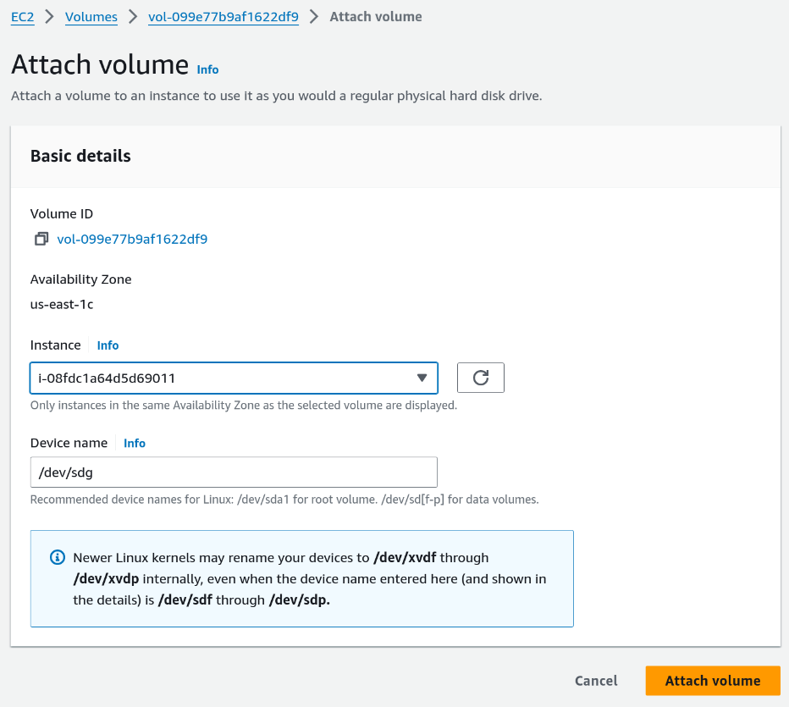

42. Create a new mount directory for the restored volume: `sudo mkdir /mnt/data-store2`.

43. Mount the restored volume: `sudo mount /dev/sdg /mnt/data-store2`. 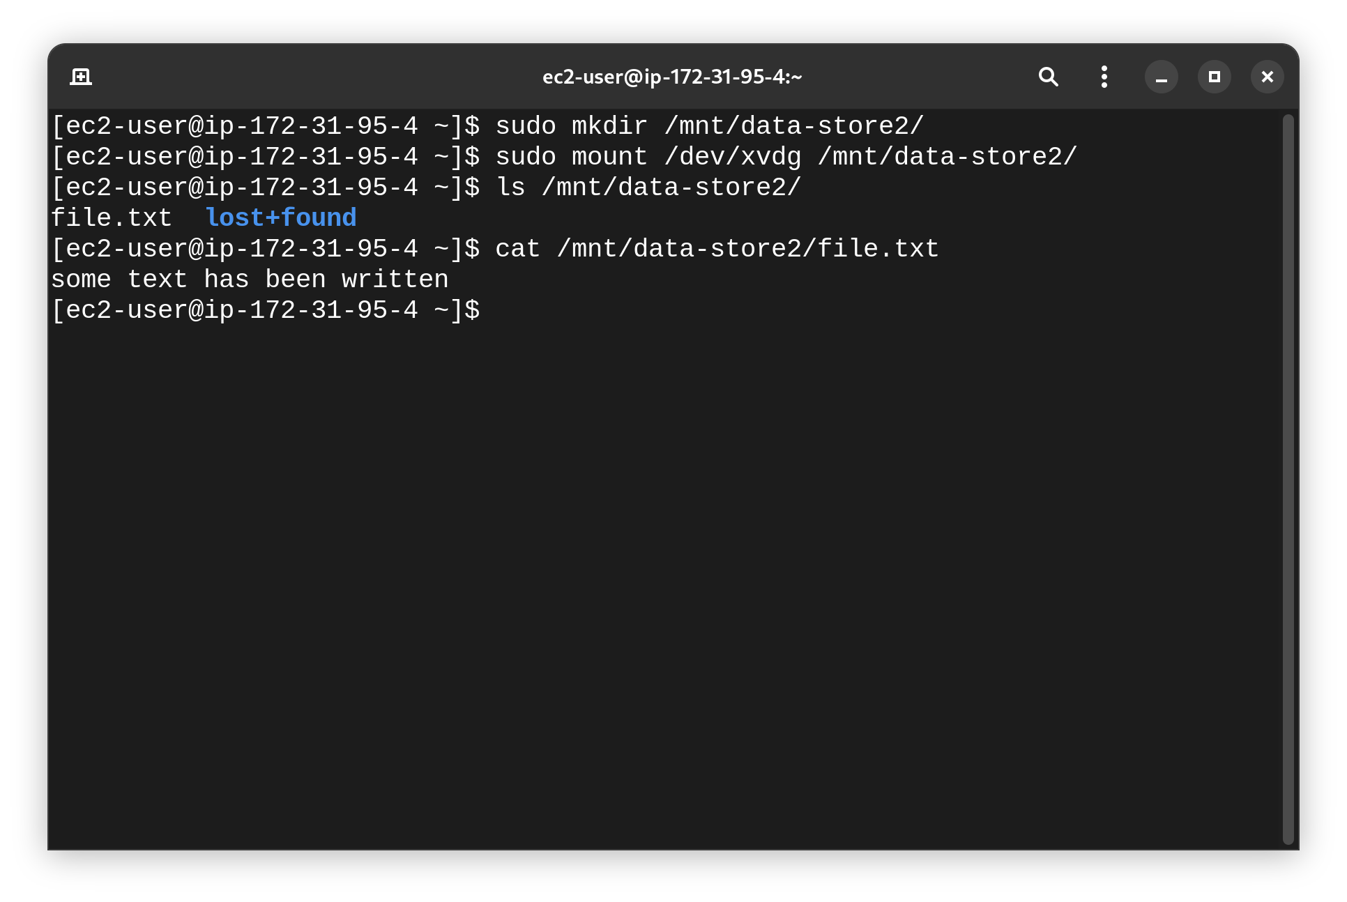

44. Verify the restored volume contains the file by running: `ls /mnt/data-store2/`.

45. You should see the file.txt from the earlier steps.

## Lab 5

1. In the AWS Management Console, search for and select VPC. 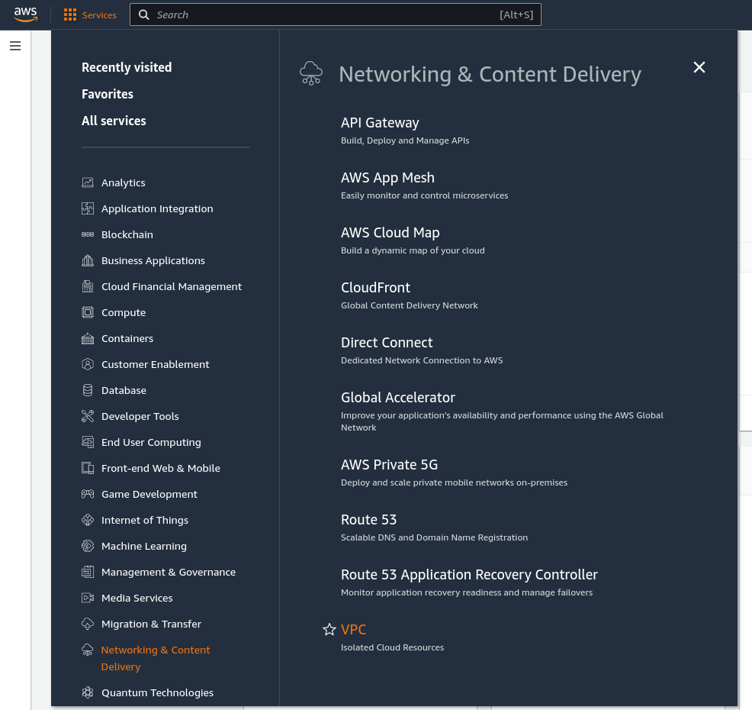

2. In the left navigation pane, choose Security Groups. 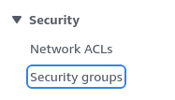

3. Click Create Security Group. 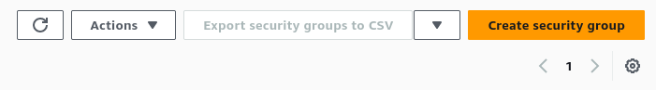

4. Name the security group "DB Security Group" and set the description to "Permit access from Web Security Group." 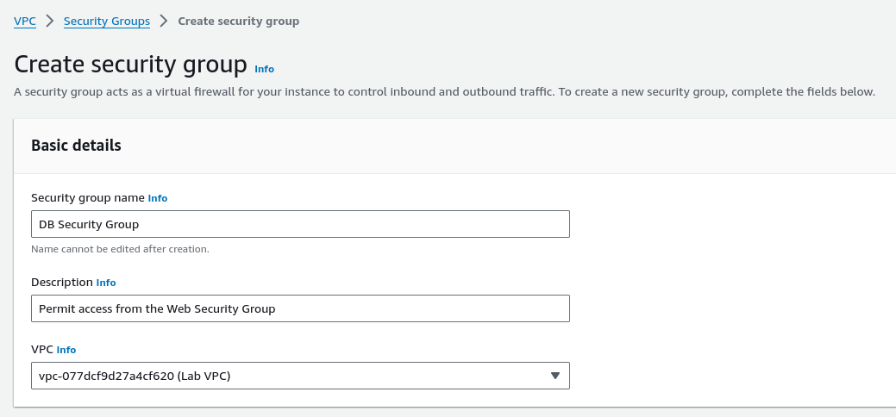

5. Choose the VPC: "Lab VPC."

6. In the Inbound Rules section, click Add Rule. 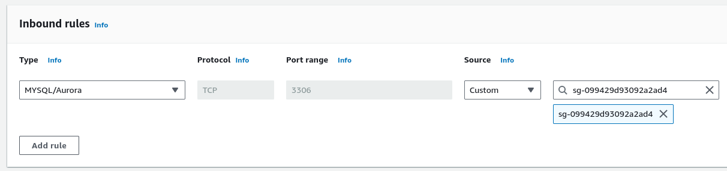

7. Set Type to "MySQL/Aurora (3306)" and Source to "Web Security Group."

8. Click Create Security Group.

9. This security group will be used when launching the RDS database.

10. In the AWS Management Console, search for and select RDS. 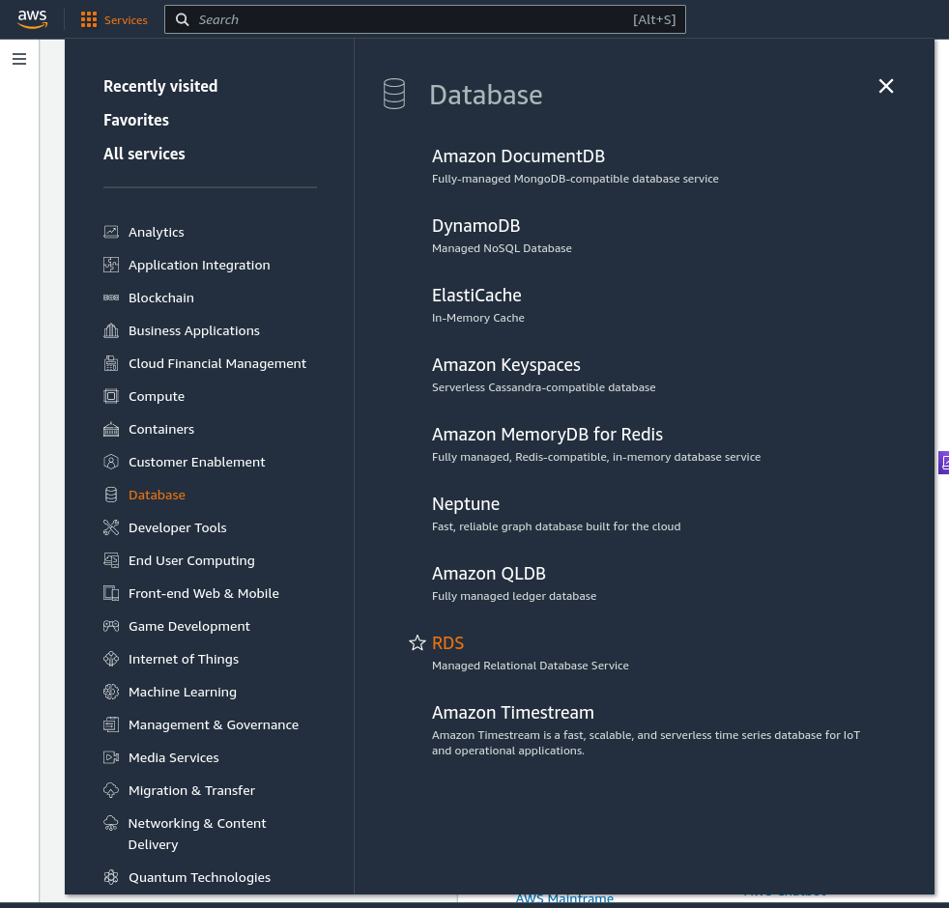

11. In the left navigation pane, choose Subnet Groups. 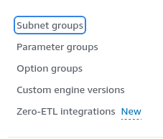

12. Click Create DB Subnet Group. 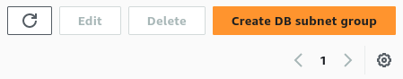

13. Name the group "DB-Subnet-Group" and set the description to "DB Subnet Group." 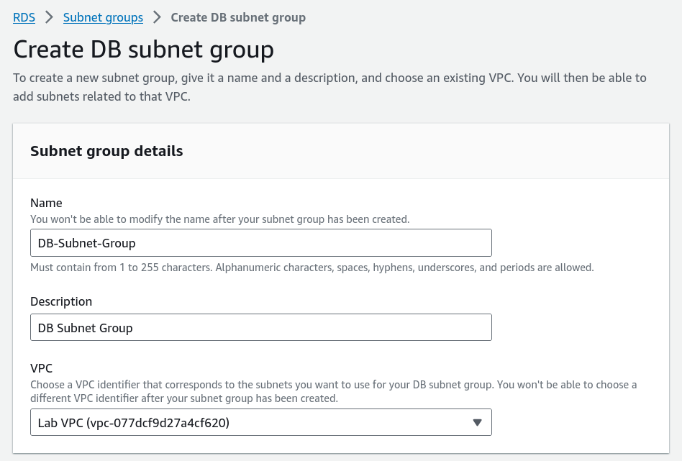

14. Select the VPC: "Lab VPC."

15. Under Availability Zones, select "us-east-1a" and "us-east-1b." 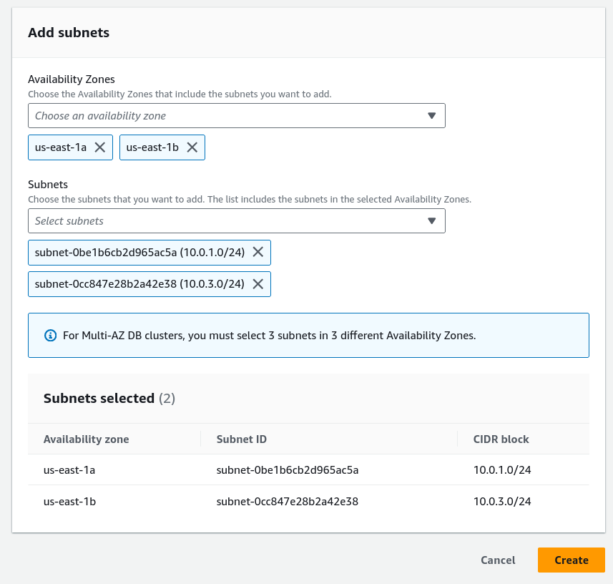

16. Under Subnets, select the CIDR ranges "10.0.1.0/24" and "10.0.3.0/24."

17. Click Create.

18. This subnet group will be used for the database deployment.

19. In the RDS Console, choose Databases. 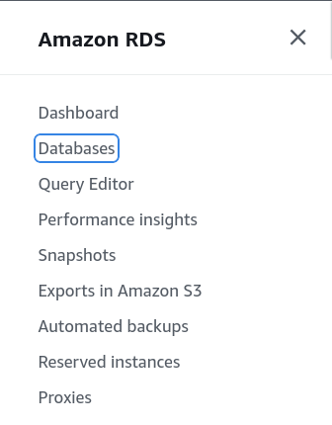

20. Click Create Database. 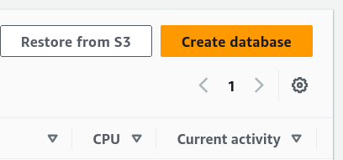

21. If prompted, choose to "Switch to the new database creation flow."

22. Select "MySQL" under Engine Options. 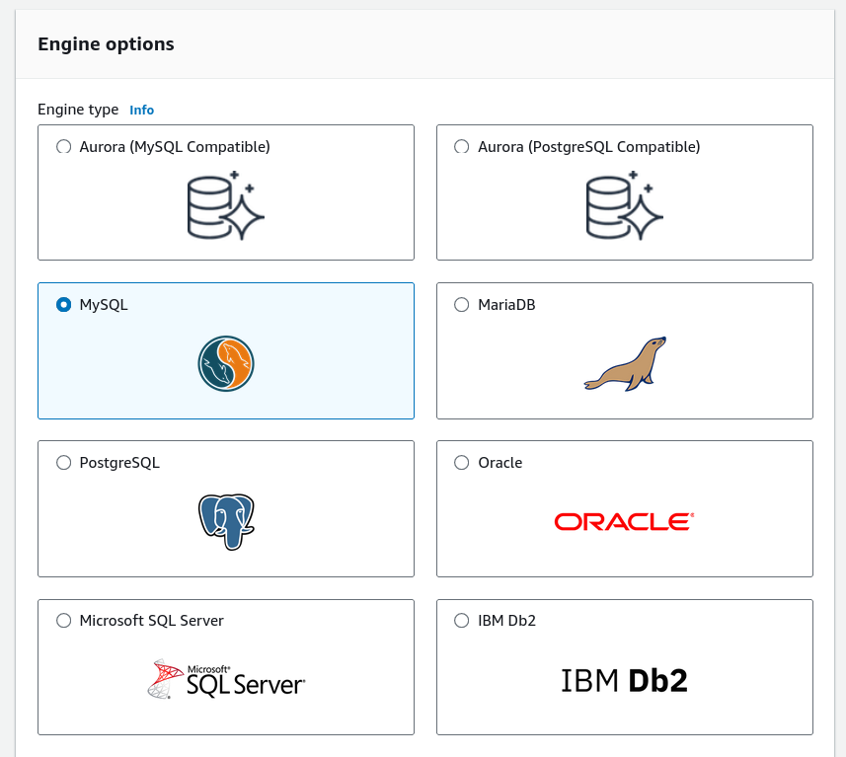

23. Choose "Dev/Test" under Templates. 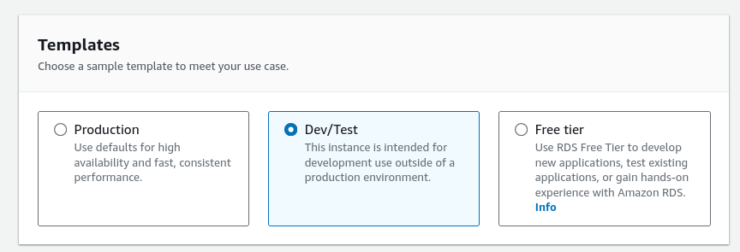

24. Under Availability and Durability, select "Multi-AZ DB instance." 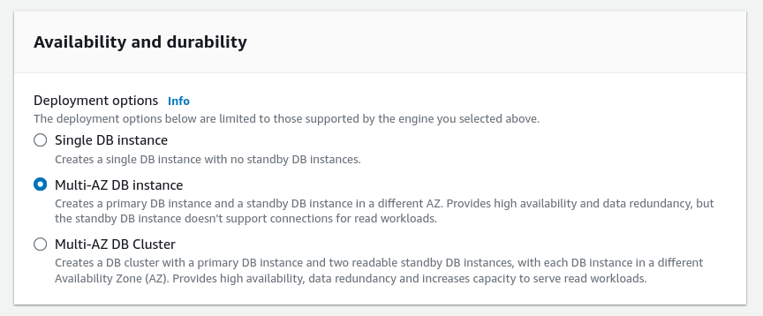

25. Configure the following under Settings:

- DB instance identifier: "lab-db"

- Master username: "main"

- Master password: "lab-password" 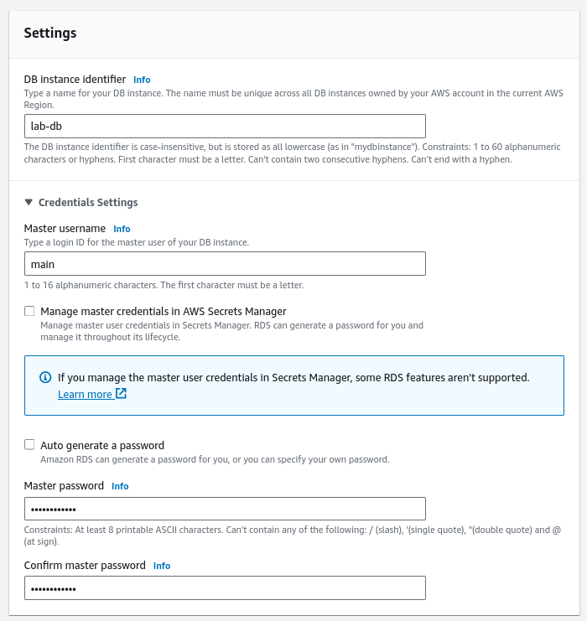

26. Under DB Instance Class, select "db.t3.micro." 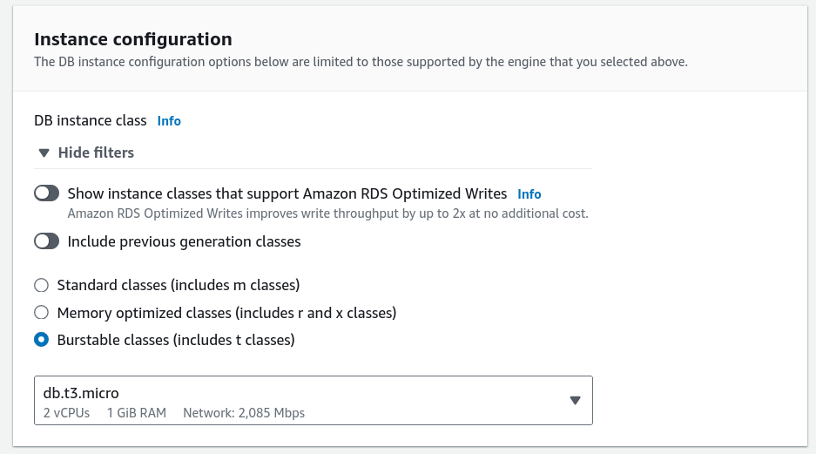

27. Under Storage, set Storage Type to "General Purpose (SSD)" and Allocated Storage to 20 GiB. 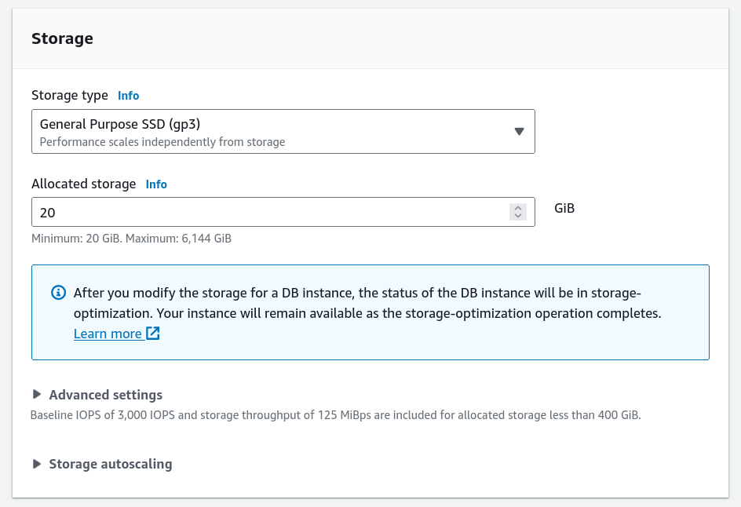

28. For Connectivity, select the VPC: "Lab VPC." 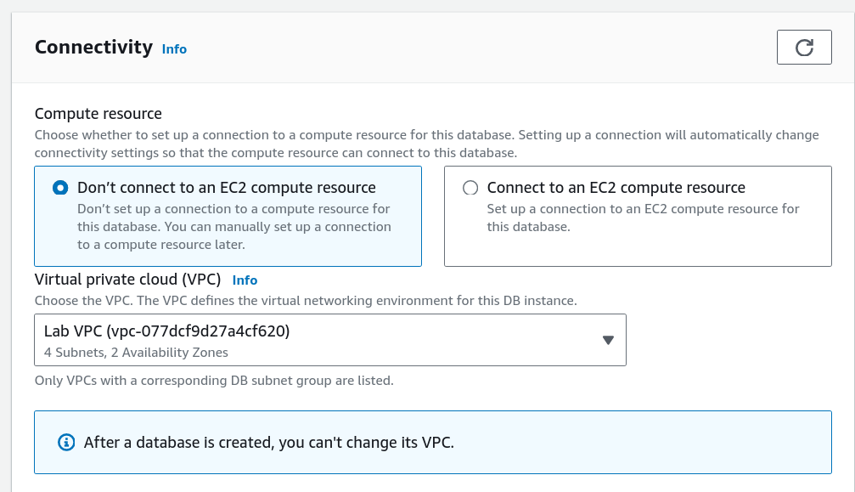

29. Under Existing VPC Security Groups, choose "DB Security Group." 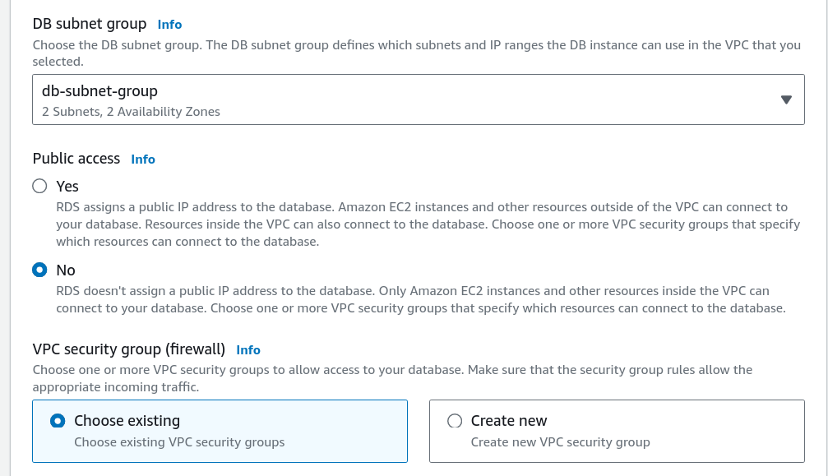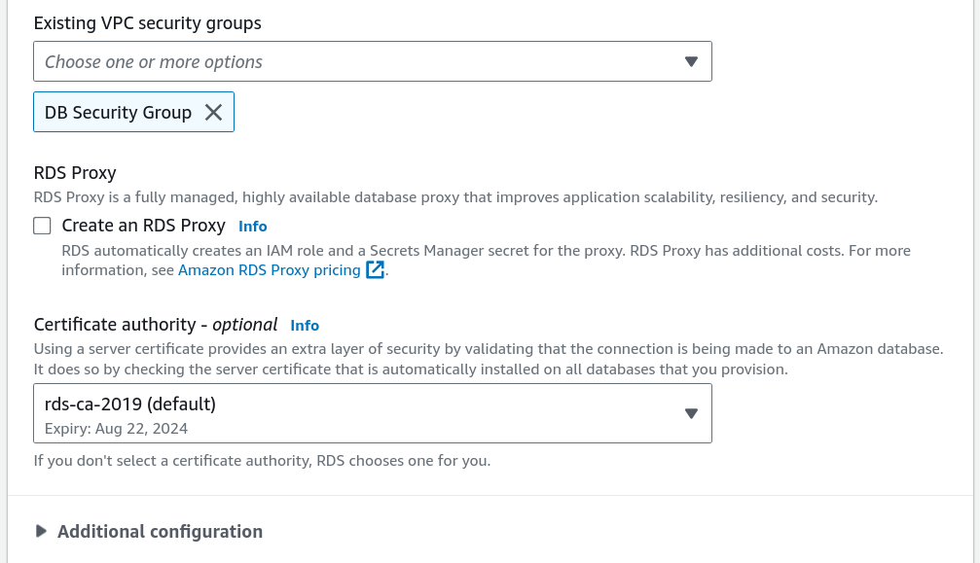

30. Under Monitoring, uncheck "Enable Enhanced Monitoring."

31. Under Additional Configuration, set Initial Database Name to "lab." 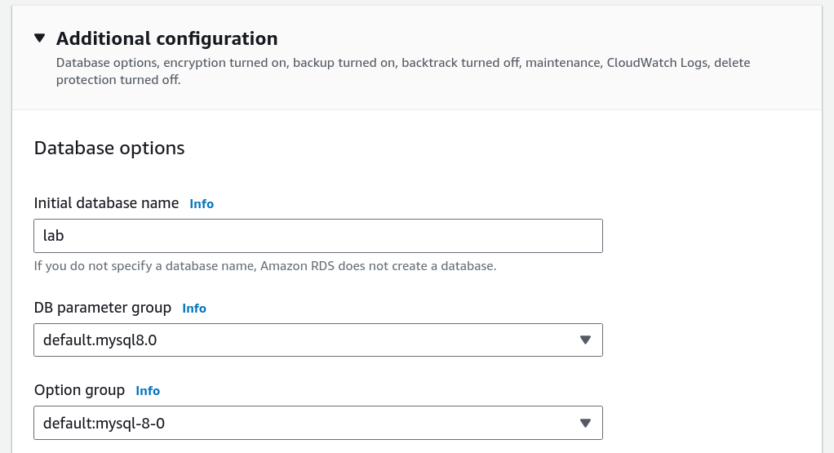

32. Uncheck "Enable automatic backups" and "Enable encryption."

33. Click Create Database. 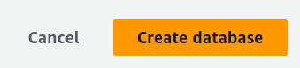

34. Wait for the database to become available (approximately 4 minutes). 

35. Once available, select the "lab-db" instance.

36. Copy the Endpoint from the Connectivity & Security section. 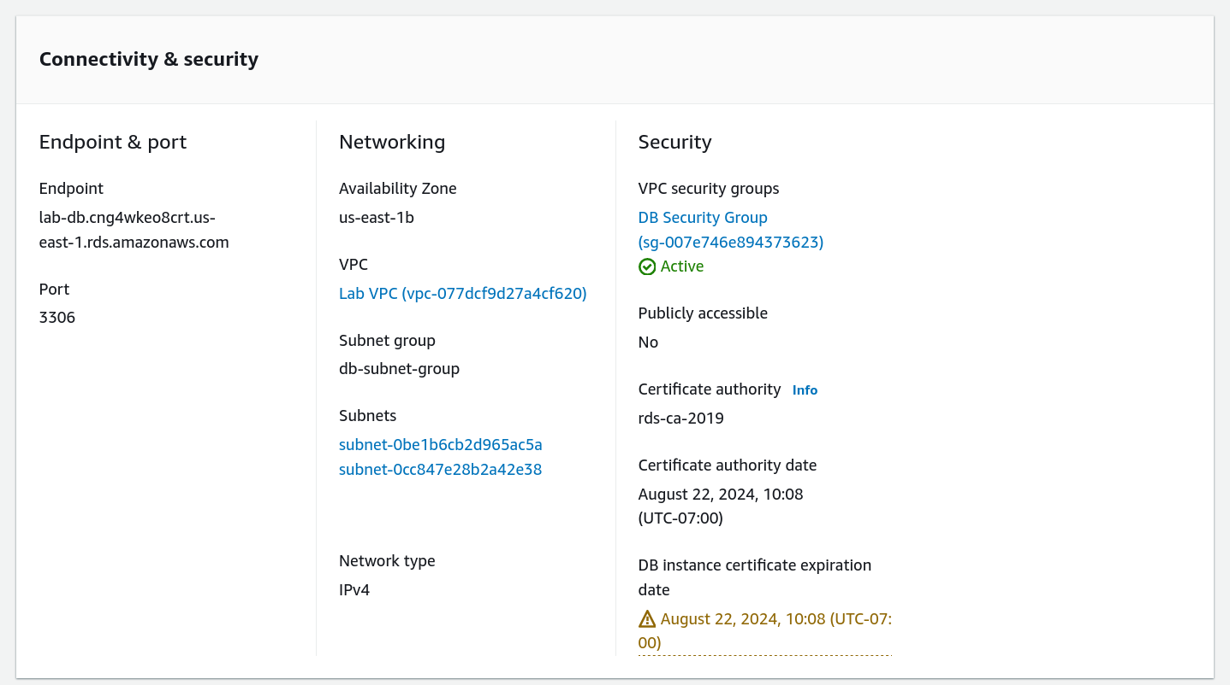

37. Paste the Endpoint into a text editor for later use.

38. Discover the WebServer IP address from the AWS Details dropdown menu. 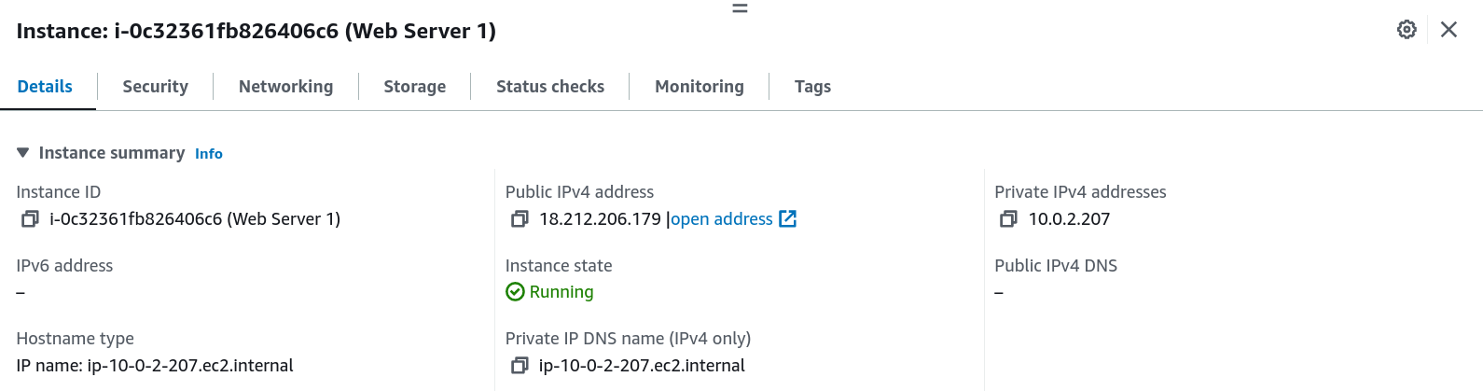

39. Open a new web browser tab, paste the WebServer IP address, and press Enter. 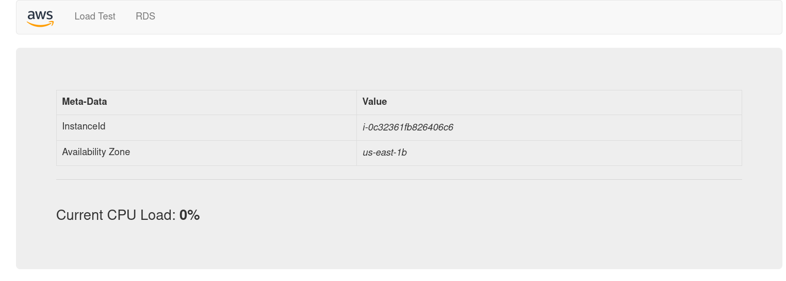

40. The web application will display EC2 instance information.

41. Click the RDS link at the top of the page.

42. Configure the web application to connect to your database:

- Endpoint: Paste the copied Endpoint

- Database: "lab"

- Username: "main"

- Password: "lab-password" 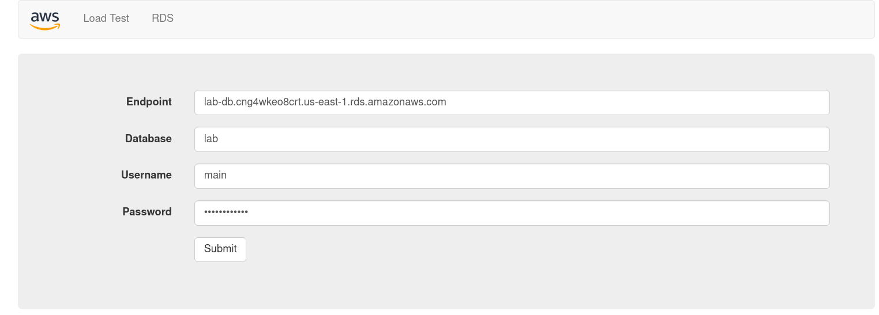

43. Click Submit to connect the web application to the RDS database.

44. The application will show an Address Book and explain data synchronization. 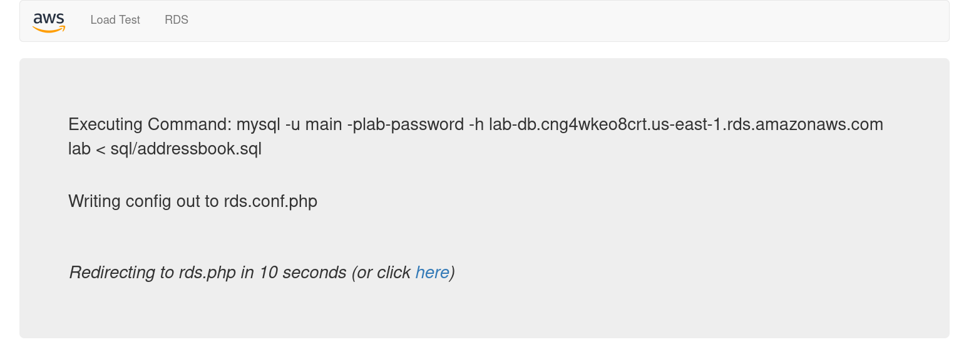

45. Test the application by adding, editing, and removing contacts. 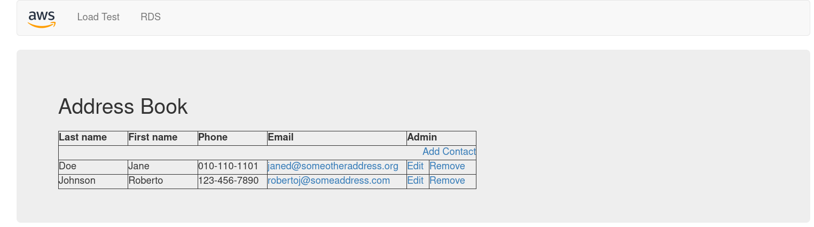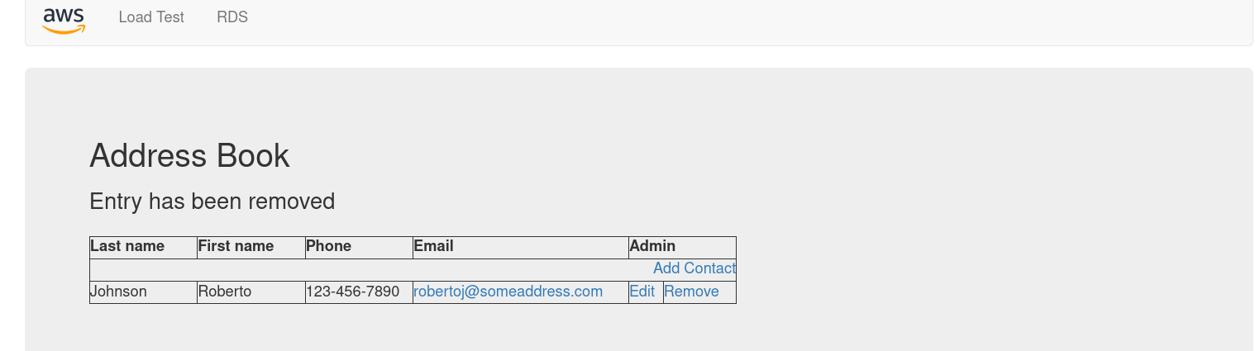

46. The data will persist to the database and be automatically replicated to the secondary Availability Zone.

## Lab 6

1. Start the lab by clicking Start Lab.

2. Wait for the AWS link icon to turn green before continuing.

3. Open the AWS Management Console in a new browser tab.

4. Search for EC2 in the AWS Management Console and go to Instances. 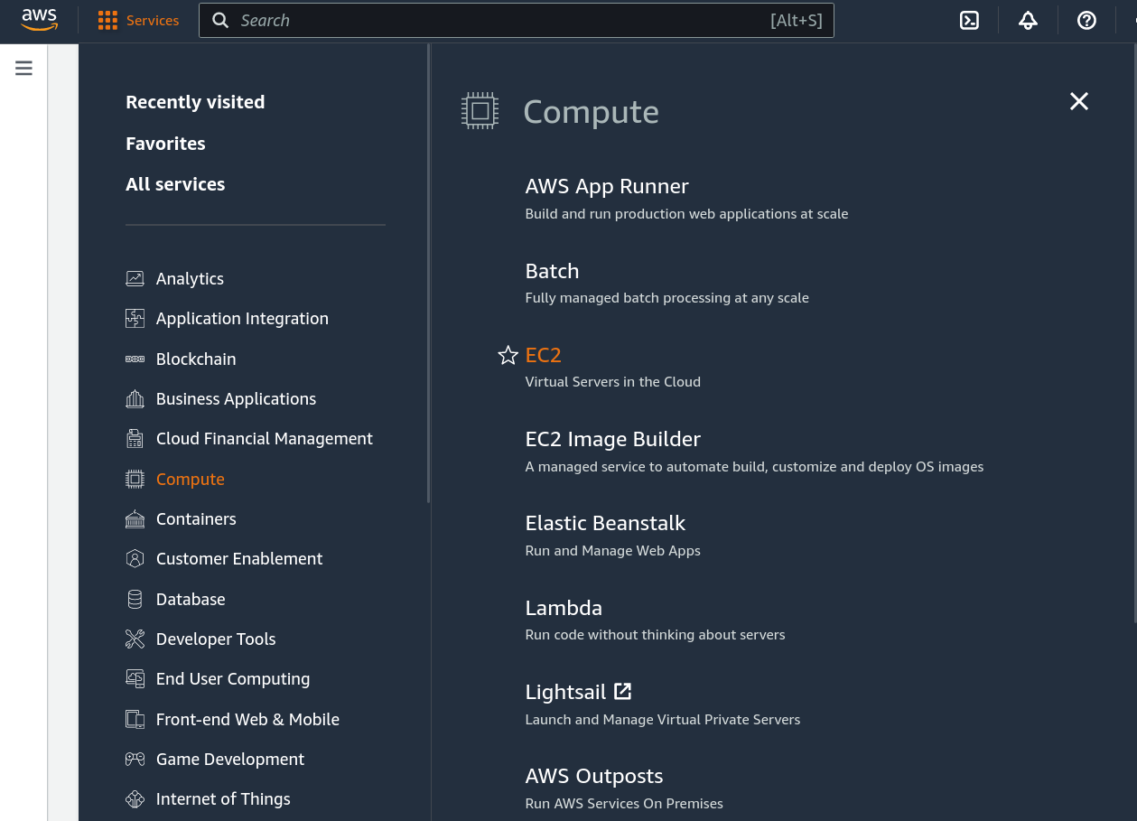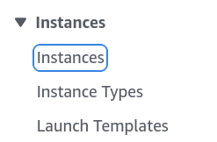

5. Confirm Web Server 1 is running with 2/2 status checks passed. 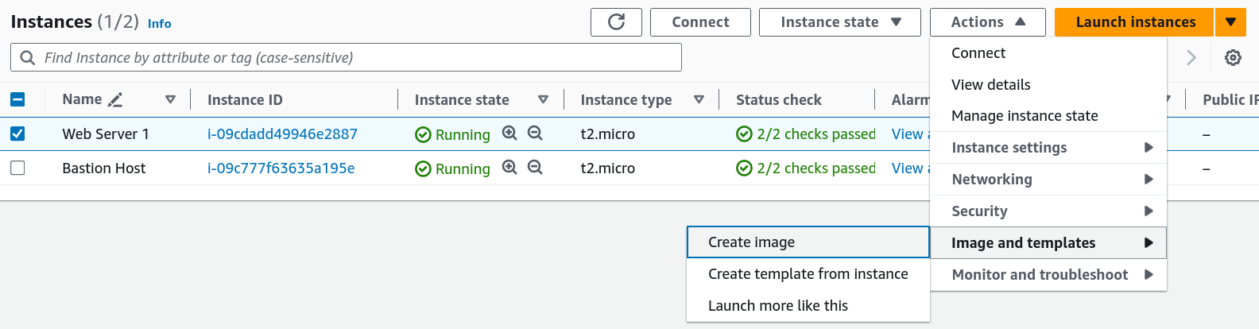

6. Select Web Server 1 and choose Actions > Image and templates > Create image. 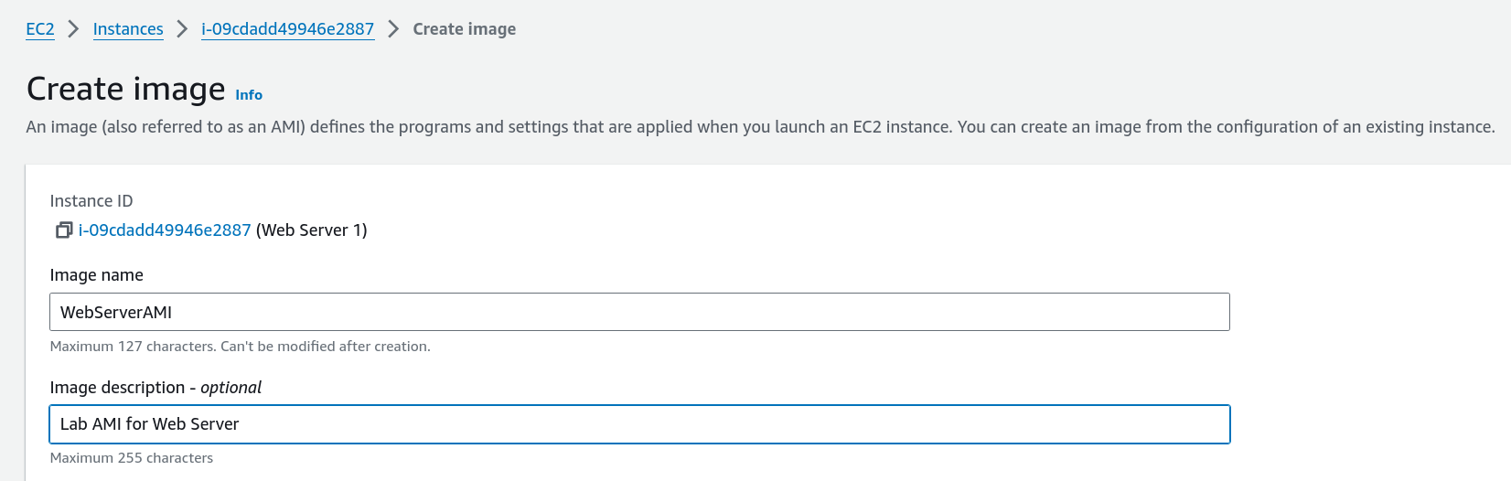

7. Enter image name WebServerAMI and description Lab AMI for Web Server.

8. Click Create image and note the AMI ID for future use. 

9. In the AWS Console, go to Target Groups under EC2. 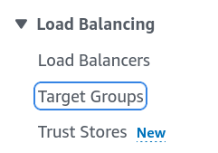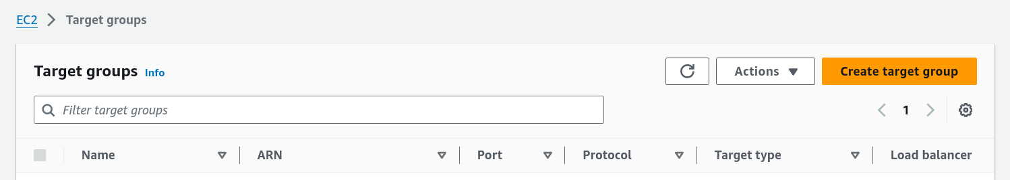

10. Create a new Target Group with the name LabGroup and type set to Instances. 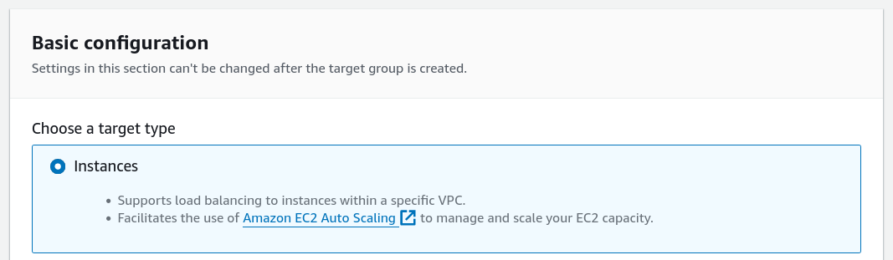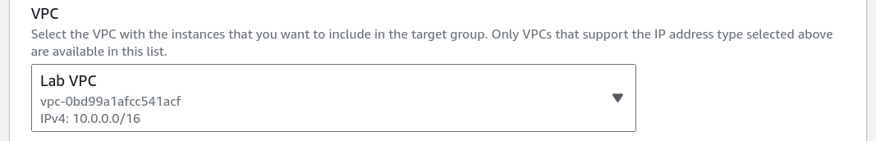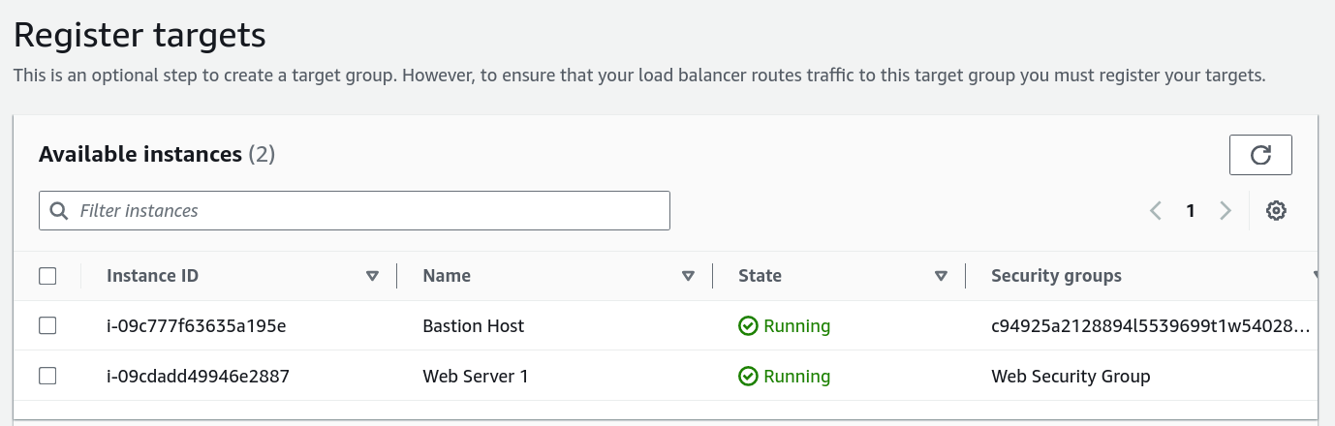

11. Set the VPC to Lab VPC and click Create target group. 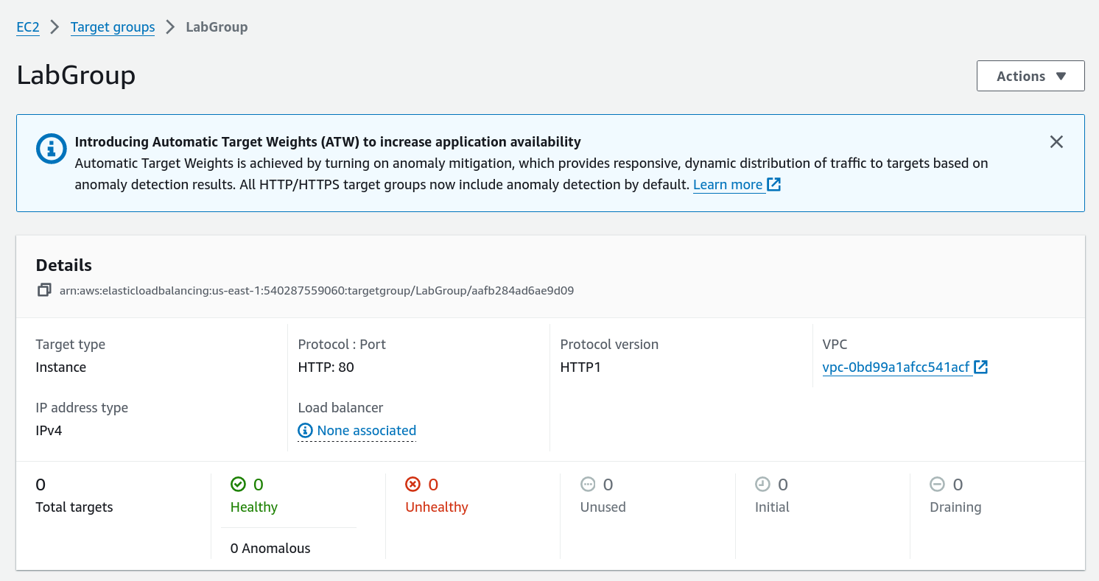

12. Go to Load Balancers and click Create load balancer. 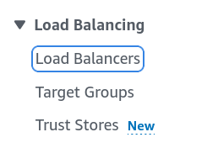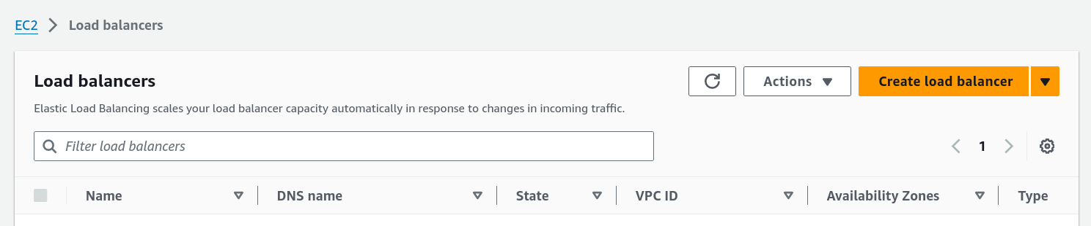

13. Choose Application Load Balancer, name it LabELB, and select Lab VPC. 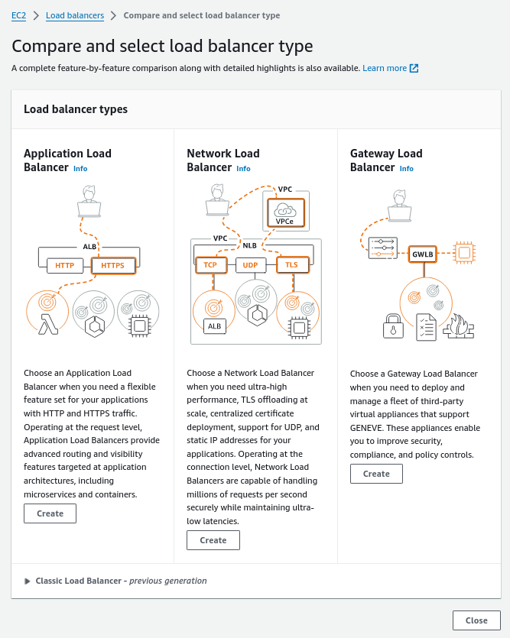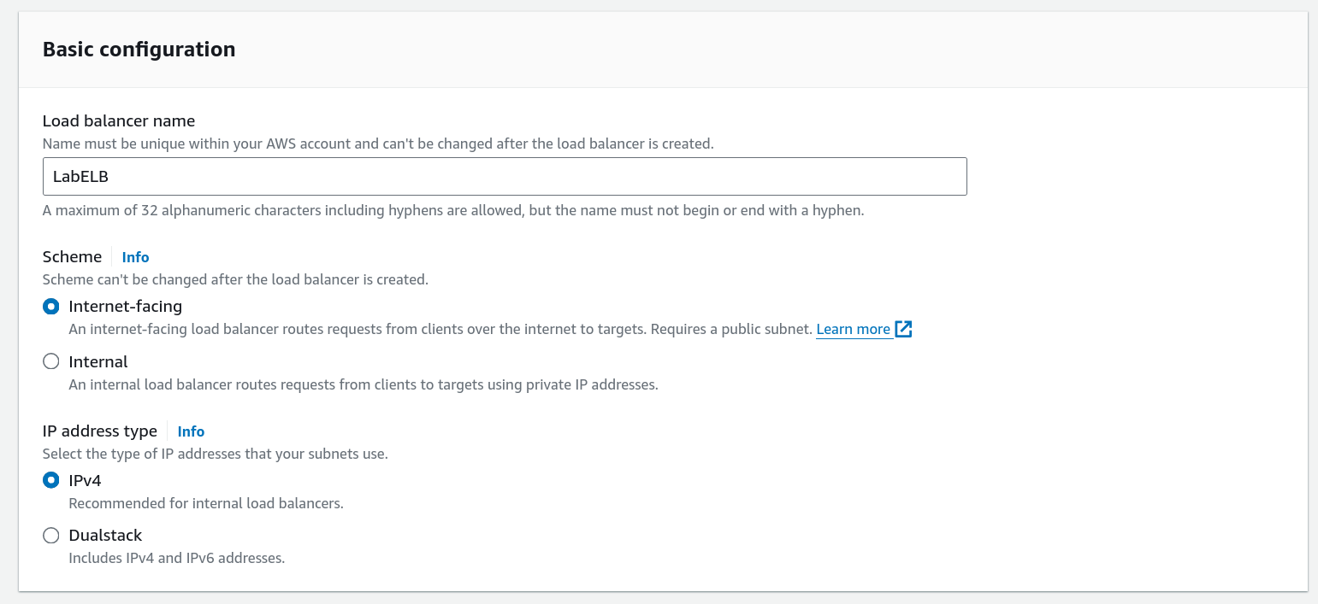

14. Choose Public Subnet 1 and Public Subnet 2 for Availability Zones. 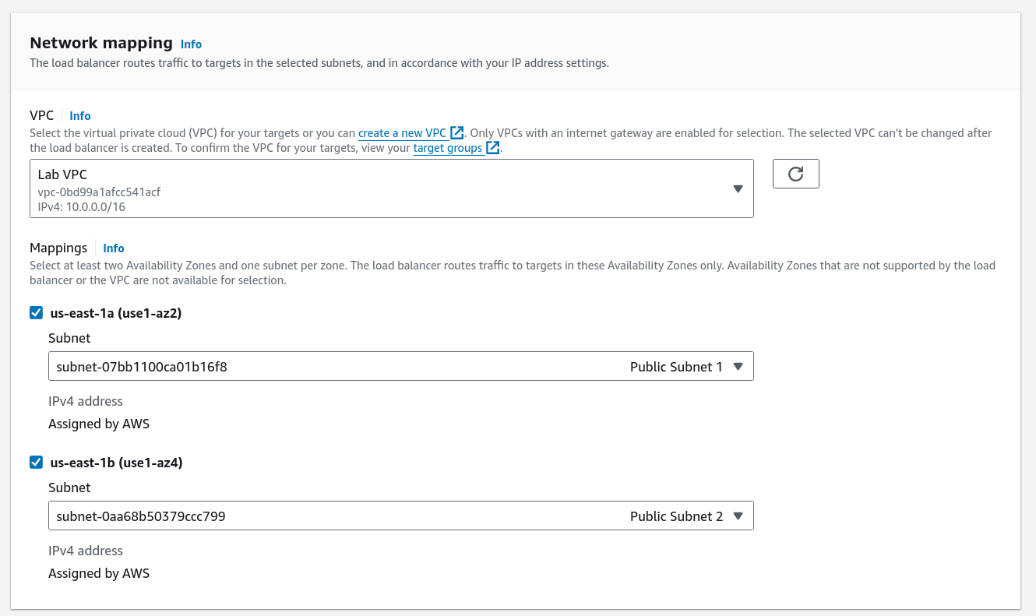

15. Select the Web Security Group for security settings. 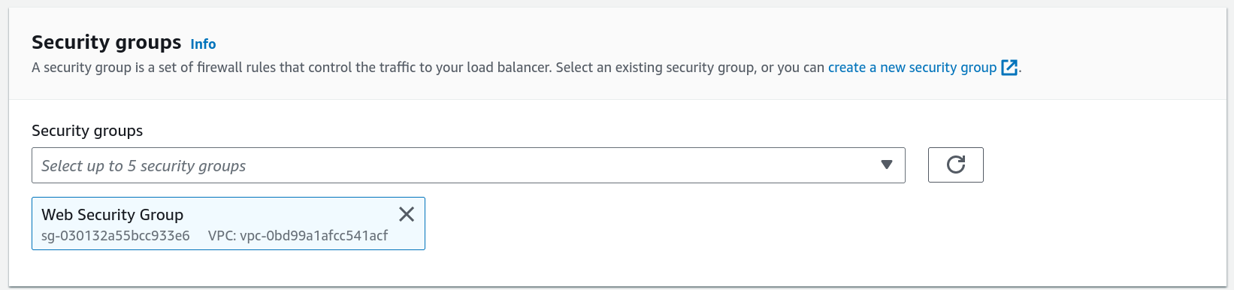

16. Set Listener HTTP:80 to forward traffic to LabGroup. 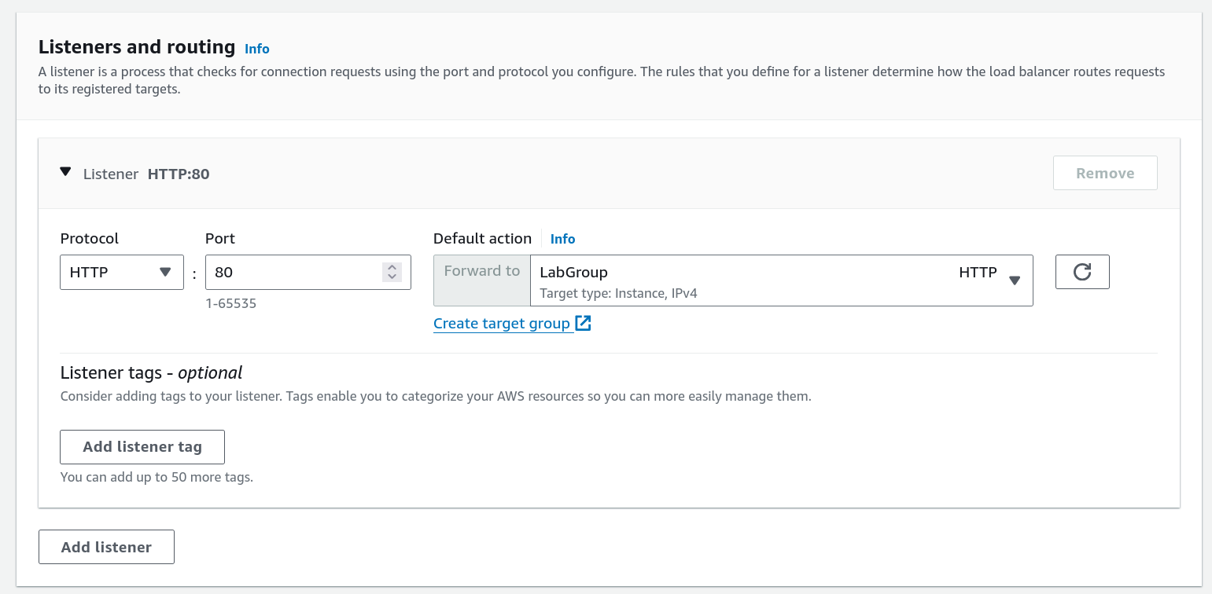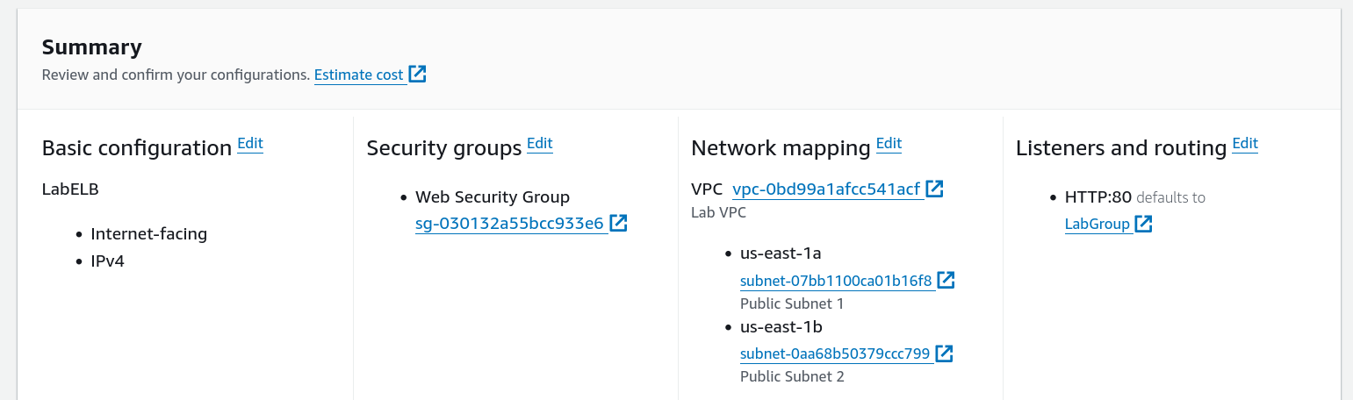

17. Click Create load balancer and then View load balancer. 

18. Navigate to Launch Templates in the left pane. 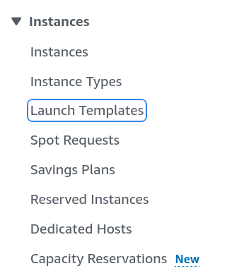

19. Create a new Launch Template named LabConfig. 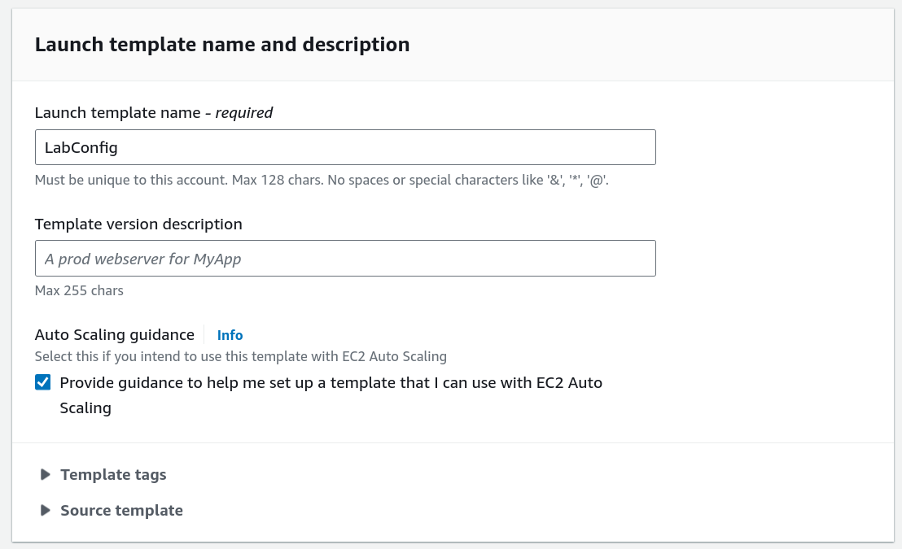

20. Choose Web Server AMI for the template’s image and t2.micro for instance type. 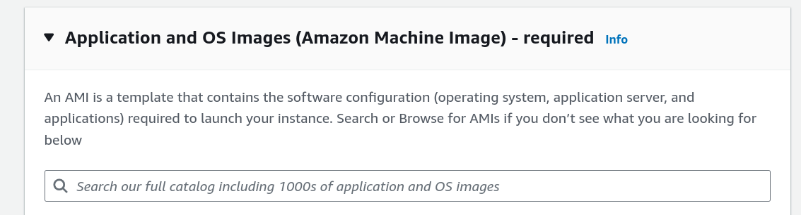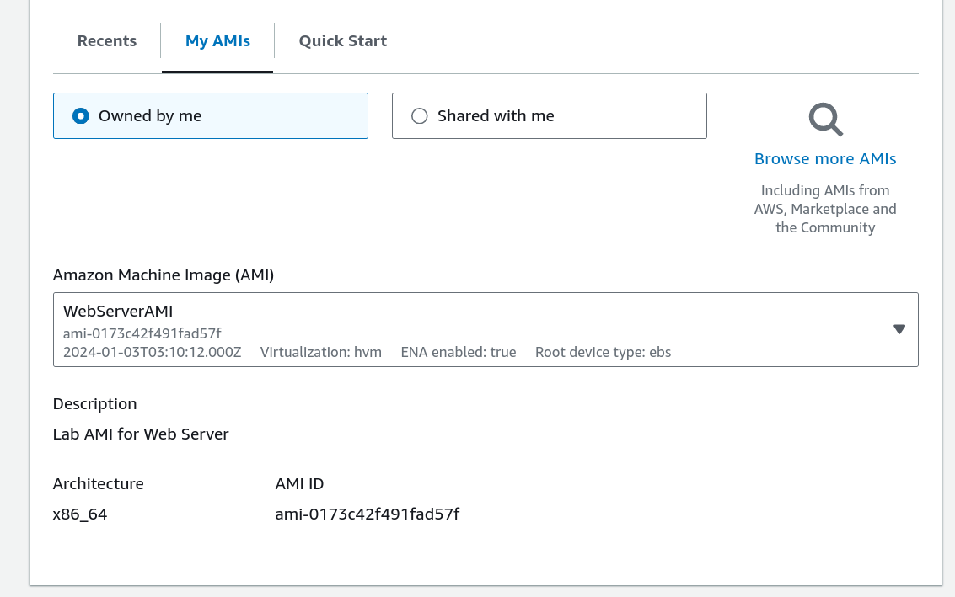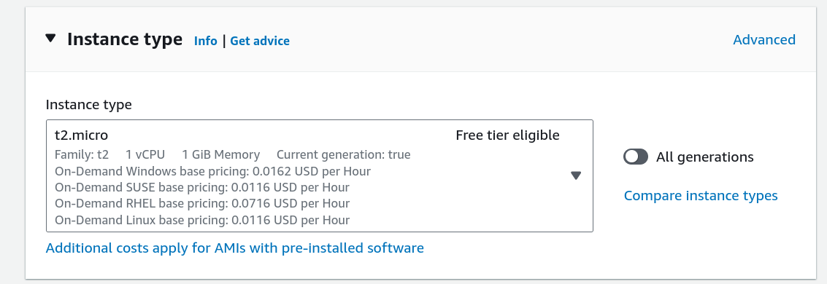

21. Select vockey as the key pair and Web Security Group for security. 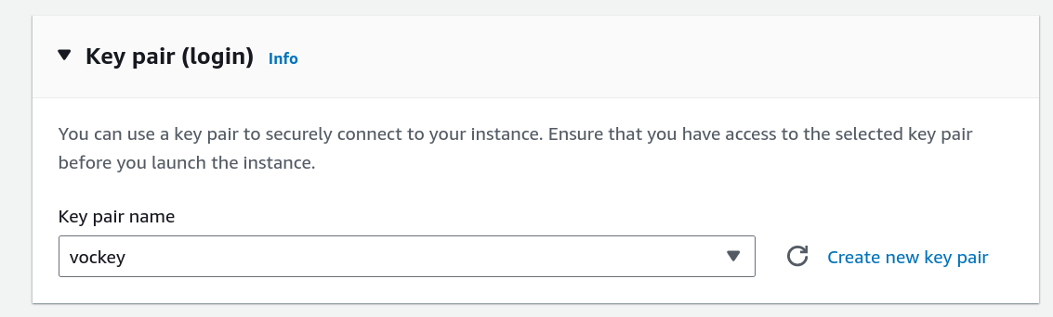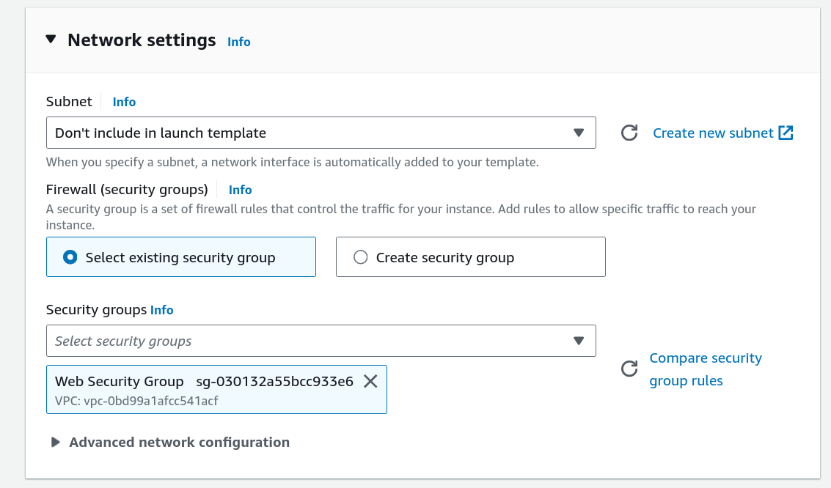

22. Enable CloudWatch detailed monitoring. 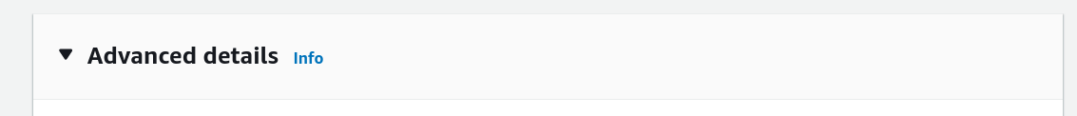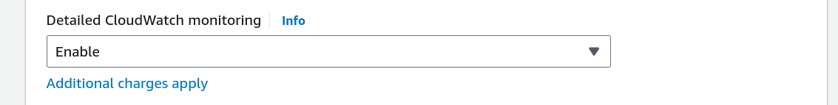

23. Click Create launch template. 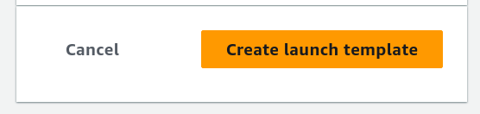

24. After successful creation, select the LabConfig template. 

25. Choose Actions > Create Auto Scaling group. 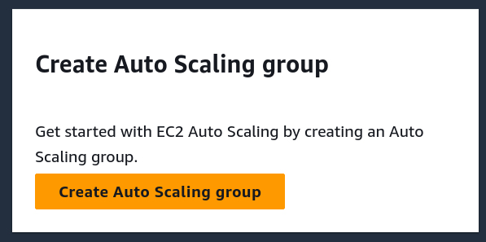

26. Name the Auto Scaling group Lab Auto Scaling Group, and select LabConfig as the template. 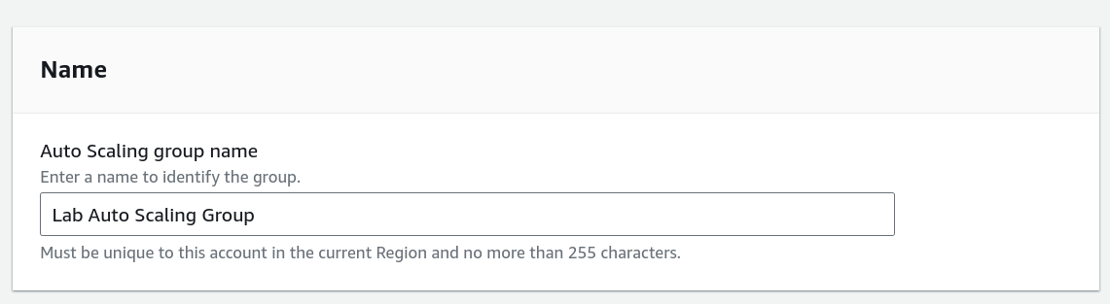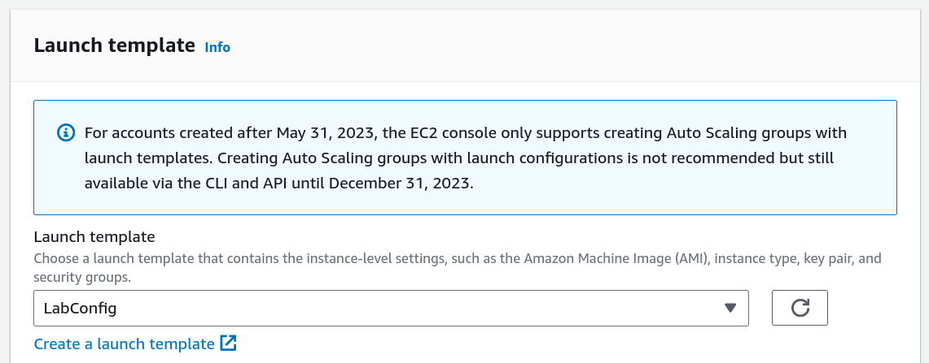

27. Select Private Subnet 1 and Private Subnet 2 for VPC and Availability Zones. 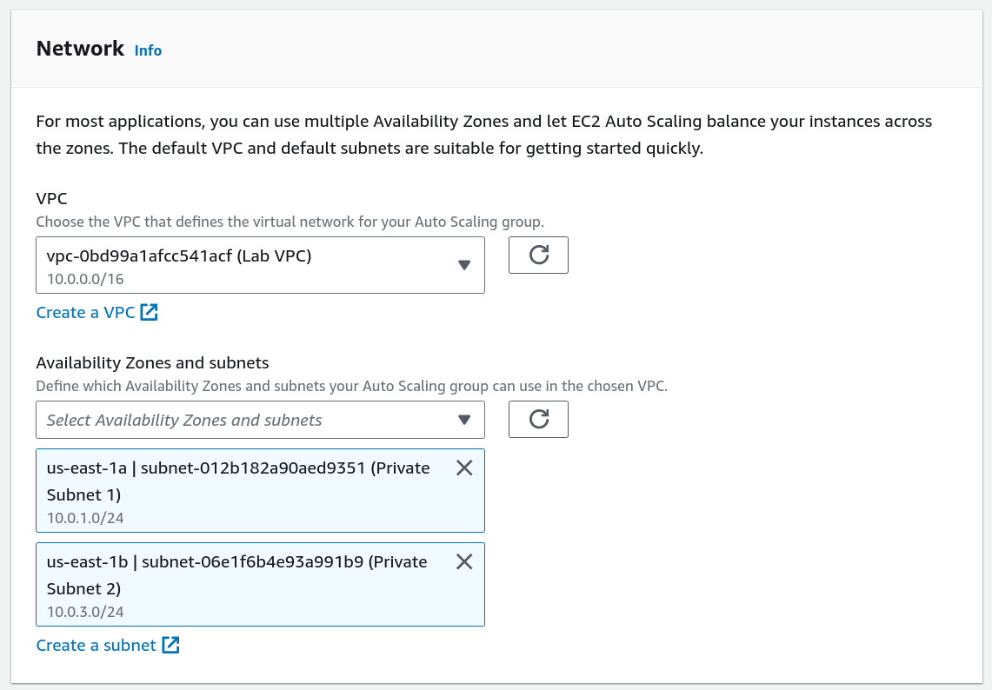

28. Attach the Auto Scaling group to the LabGroup target. 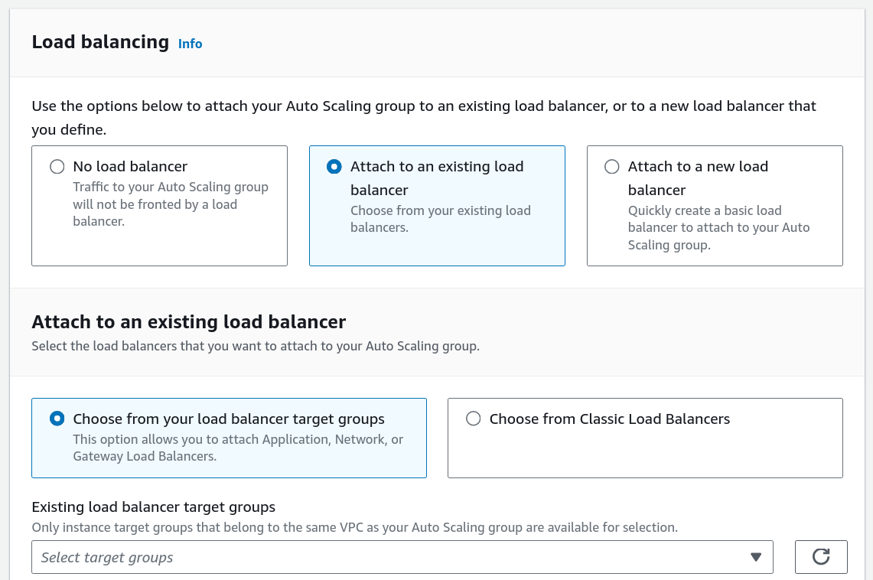

29. Enable CloudWatch metrics collection. 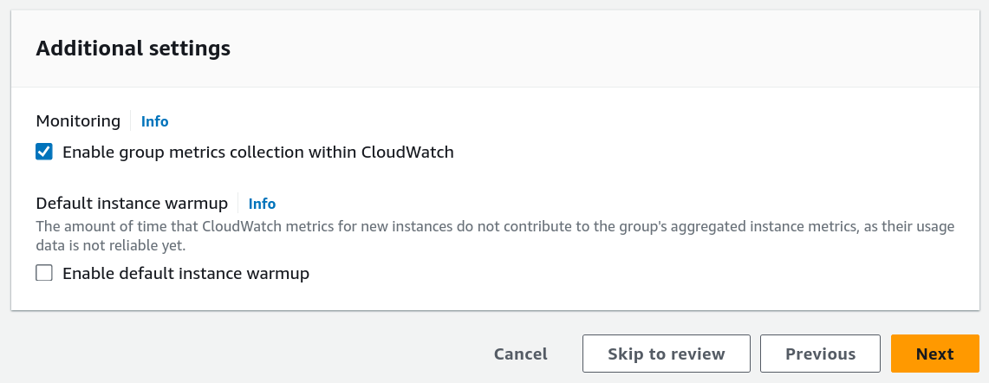

30. Set the Desired capacity to 2, Minimum to 2, and Maximum to 6 instances. 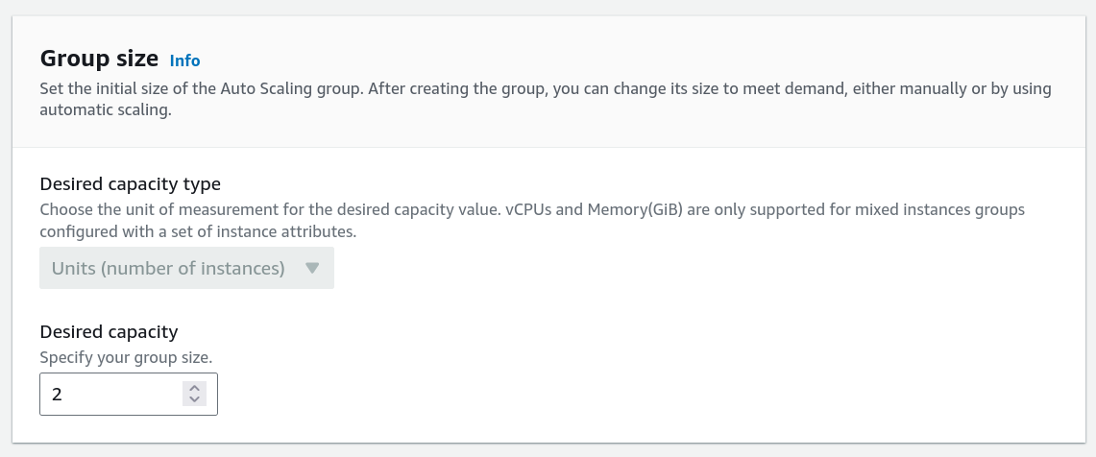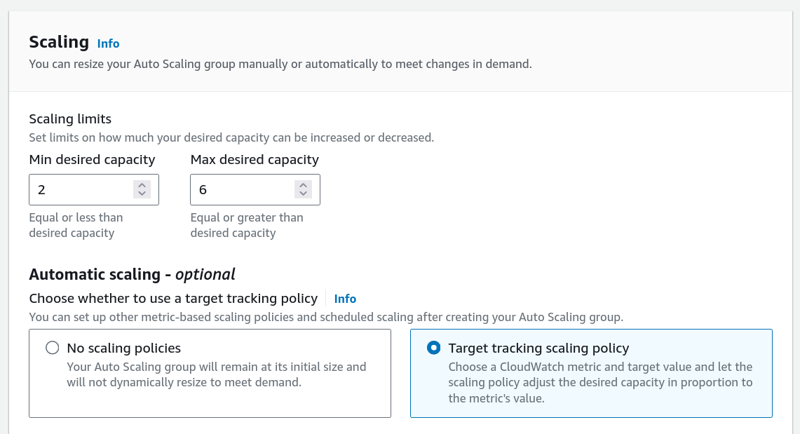

31. Configure the scaling policy to maintain 60% average CPU utilization. 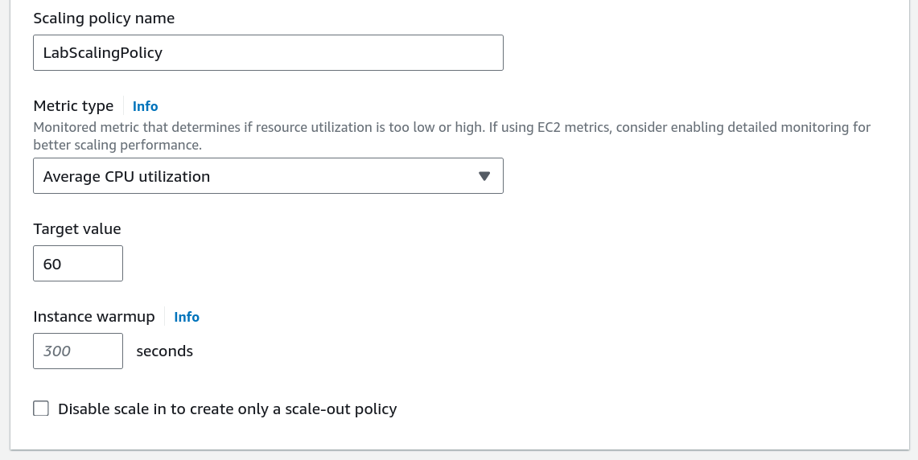

32. Review the settings and click Create Auto Scaling group. 

33. Navigate to Instances and confirm two Lab Instance EC2 instances are running. 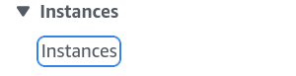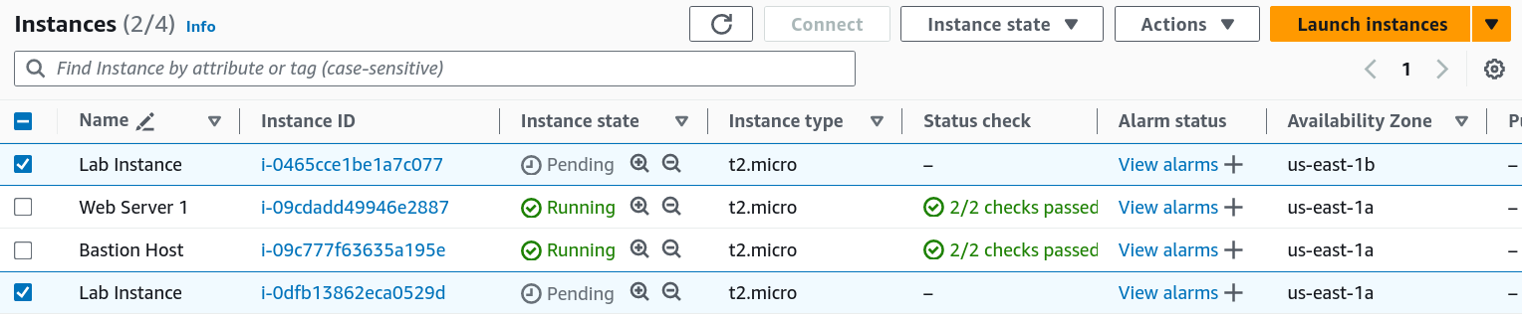

34. Go to Target Groups and select LabGroup. 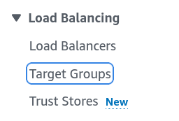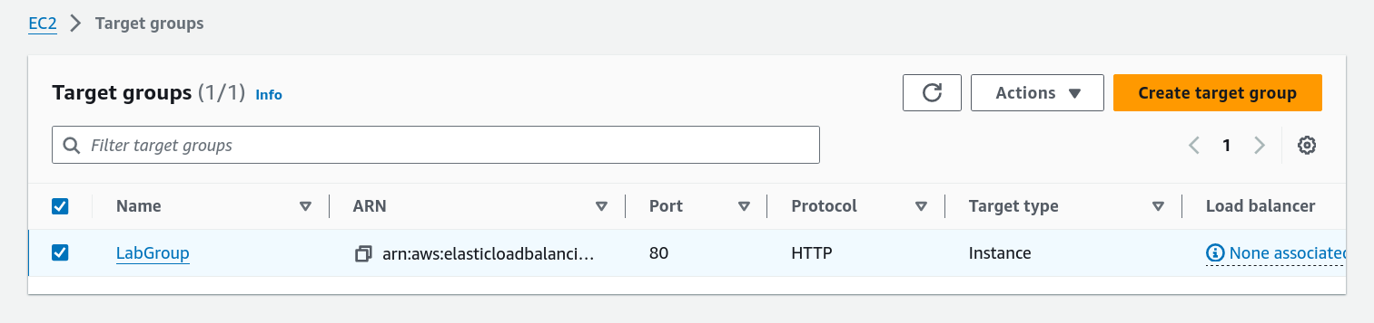

35. Confirm both instances are listed as Healthy. 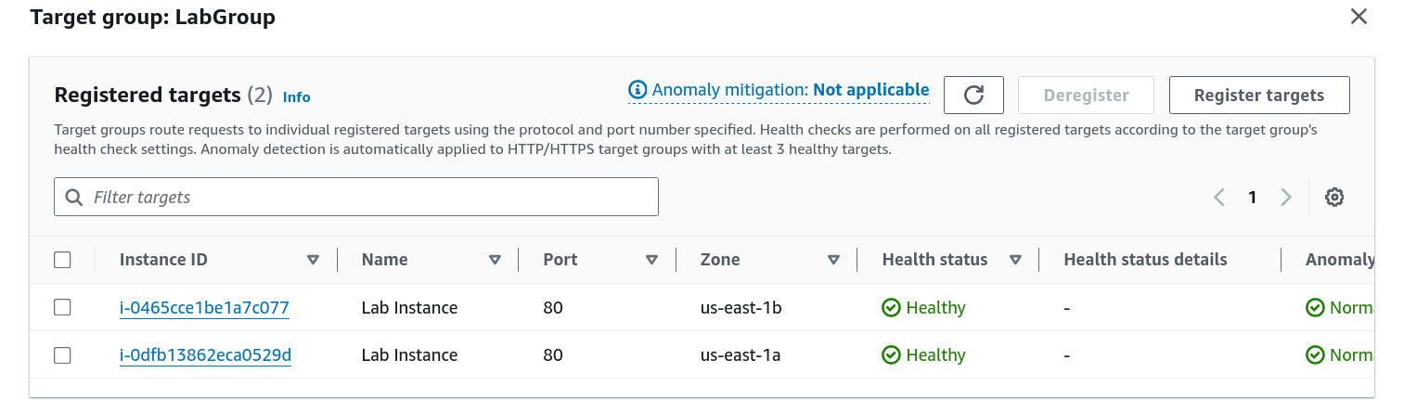

36. Copy the DNS name of the LabELB load balancer. 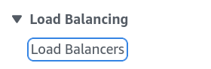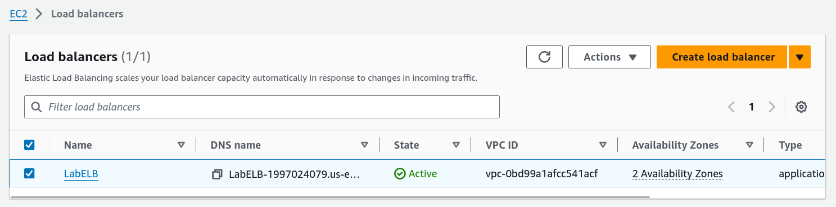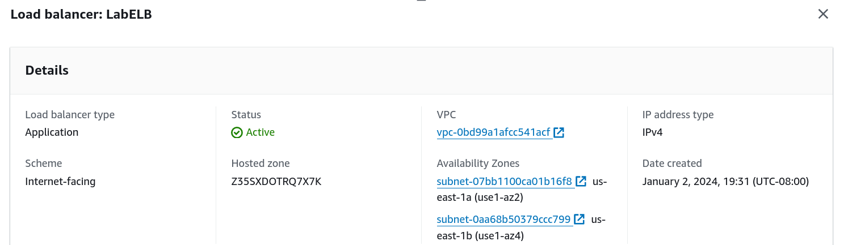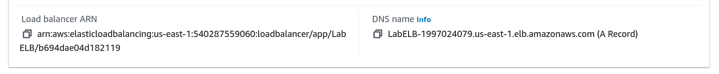

37. Open a browser, paste the DNS name, and verify the application loads.

38. Navigate to CloudWatch > All alarms and ensure alarms are created for scaling events. 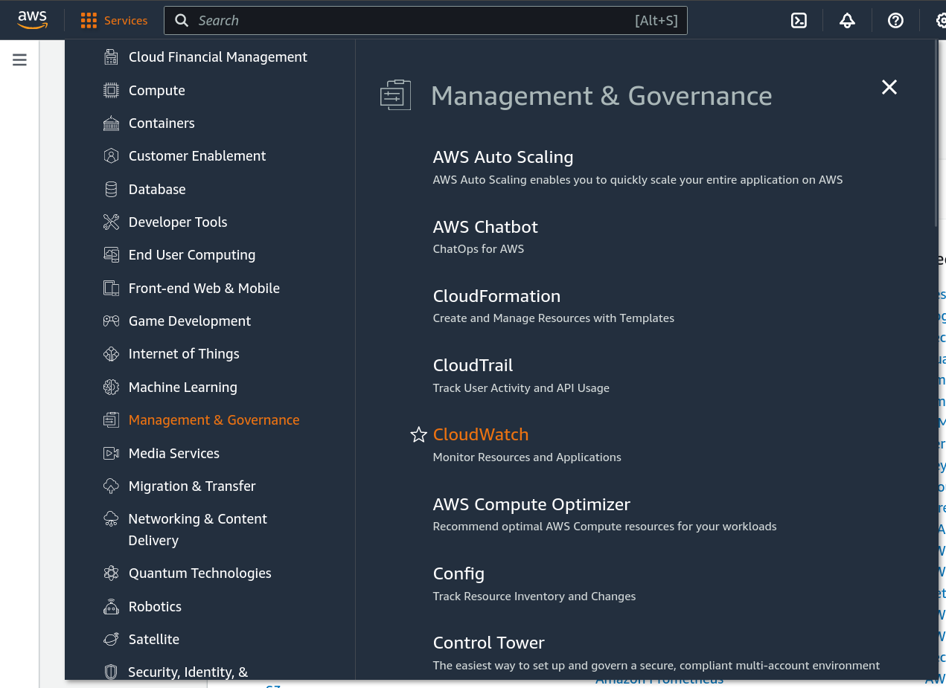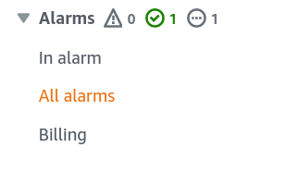

39. Trigger a load test by clicking Load Test on the web application. 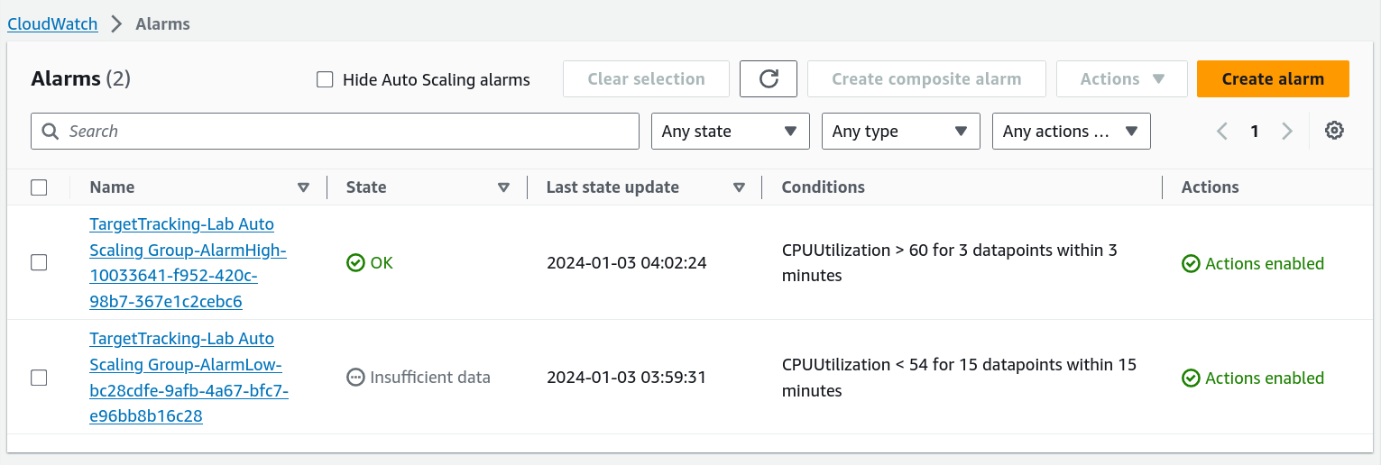

40. Monitor the AlarmHigh and AlarmLow states in CloudWatch. 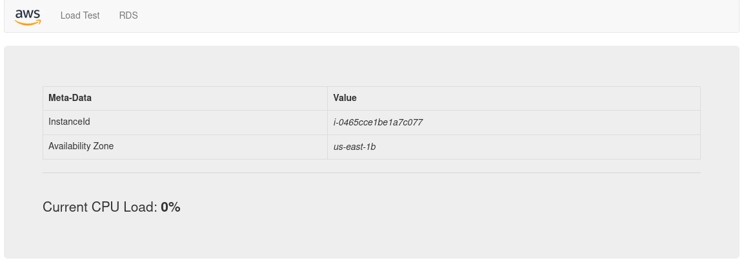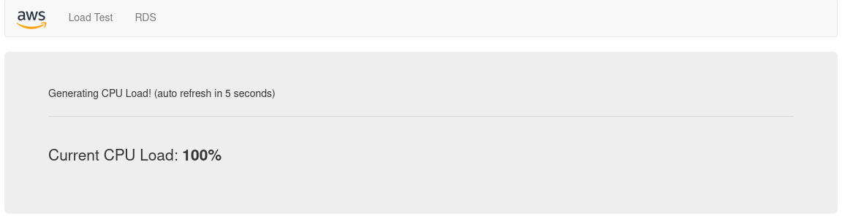

41. Wait for the AlarmHigh to enter In alarm state, which should trigger Auto Scaling. 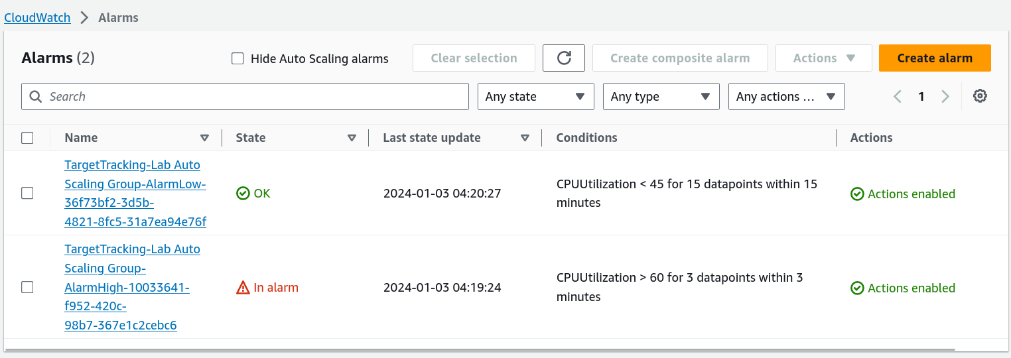

42. Check that additional instances are launched by going to EC2 > Instances. 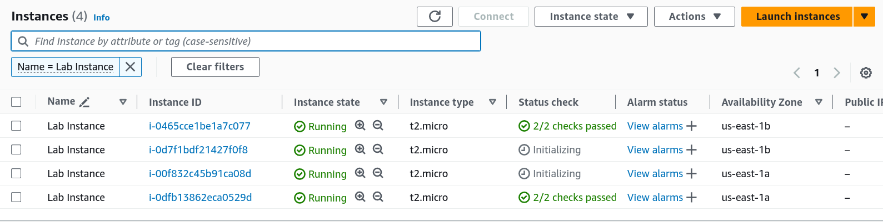

43. Verify more than two Lab Instance EC2 instances are now running.

44. Go to EC2 > Instances, select Web Server 1, and choose Instance State > Terminate. 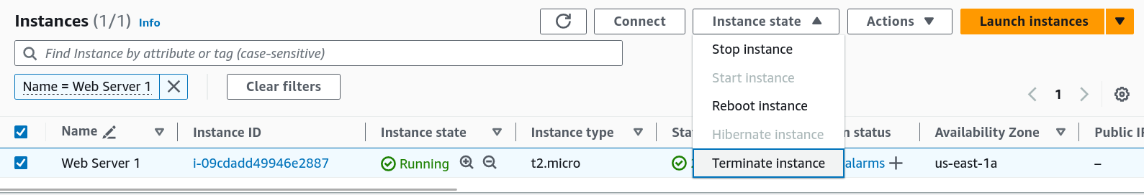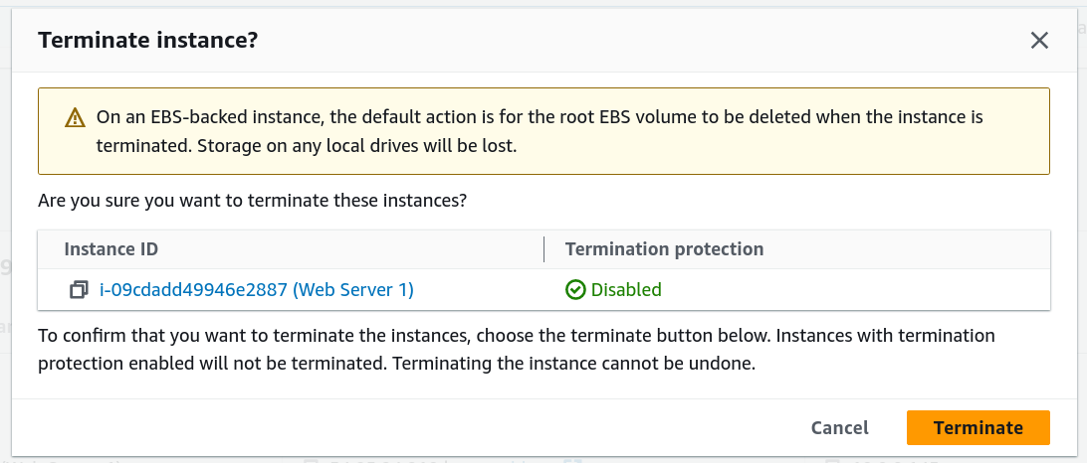

## Problems

Thanks to the intuitive nature of the AWS interface and the easy-to-follow instructions, there were no major problems.

## Conclusion

In these labs, we learned more advanced AWS features. We learned how to make use of the primary advantage of cloud computing, being its flexibility and scalability. We learned how to make EC2 instances scale automatically to efficiently make use of available resources. Similarly, we made use of EBS to dynamically scale memory resources to cope with demand. We also learned how to use RDS to neatly store data to be accessed and processed with AWS. We learned to use load balancing to handle spikes in traffic, and configured alarms to alert us that those spikes were occurring.

|  |
| --- |
| LAB 6:  WIRELESS ACCESS POINT LAB Aadithya Prabhath |
| Cisco white logo transparent PNG - StickPNG |



## Purpose

To configure a CISCO AP in autonomous mode with 3 SSIDs, including one which is authenticated with a RDIUS server.

## Background Information on Lab Concepts

While being able to connect computers to each other and the internet at large is incredible useful physical wired networks have some limitations to devices cannot be moved around and must be physically connected to the switches. This is solved through the use of wireless networks. The most common wireless protocol is Wi-Fi. However, to actually connect to the network, a host must connect to an access point or AP. In this lab, we will be configuring Cisco APs in autonomous mode. This means that they do not require a wireless LAN, controller or WLC to function. Autonomous deployments are advantageous because they are simpler to configure and require less overhead and expense. In this lab, we will be configuring three Service Set Identifiers, or SSIDs. Each SID represents a unique isolated Wi-Fi connection that hosts can make. Each society is associated with its own VLAN. The access point is connected via a trunk port to the rest of the network. An access point can transmit data at two frequencies; either 2.4 GHz or 5.0 GHz. One of our SSIDs will be at 2.4 GHz and the other two will be at 5.0 GHz. The 2.4 GHz one will be a guest as society and thus will not have a password to access it one of the 5.0 GHz SSIDs will use WPA2 – PSK to authenticate users. The other will use WPA2 – Enterprise with RADIUS authenticate users. RADIUS is an AAA protocol that uses an external server to authenticate users. The advantage of using RADIUS over something like PSK is that RADIUS only needs to be authenticated once per SSID, unlike PSK which requires authentication per access point. This makes larger networks easier to use. The RADIUS server will be a separate device also connected to the network. We will use FreeRadius, an open source application that allows a laptop to be used as a RADIUS server.We will be using the Debian distribution of Linux for the server.

## Lab Summary

The first thing we did was configure the physical network according to our network diagram. Next, we configured the switch router and access point with the correct configuration file. We used a tool called BalenaEtcher to flash a drive for the RADIUS server. We then installed and configured FreeRADIUS on the server.

## Lab Commands

* aaa new-model: Enables authentication, authorization, and accounting control commands.
* aaa group server radius <server-group-name>: Defines a RADIUS server group.
* server <ip-address> auth-port <port-number> acct-port <port-number>: Specifies a RADIUS server with its authentication and accounting ports.
* aaa authentication login <named-authentication-list> group radius: Sets an authentication list that uses the specified RADIUS server group.
* dot11 ssid <service-set-ID>: Enters the configuration mode for a service set ID (SSID).
* vlan <vlan-number>: Assigns the SSID to a specific VLAN.
* authentication open: Configures the SSID to allow open authentication (no key required).
* authentication key-management wpa version 2: Configures the SSID to use WPA2 for key management.
* mbssid guest-mode: Enables multiple SSIDs and broadcasts this SSID.
* wpa-psk ascii 0 <unencrypted-password>: Specifies a clear-text WPA2 pre-shared key.
* authentication open eap <eap-list-name>: Configures the SSID to use EAP authentication.
* authentication network-eap <eap-list-name>: Configures the SSID to use network-based EAP (e.g., RADIUS).
* bridge irb: Enables Integrated Routing and Bridging on the access point.
* radius-server host <ip-address> auth-port <port-number> acct-port <port-number> key 0 <unencrypted-password>: Configures a RADIUS server with authentication/accounting ports and shared key.
* bridge <bridge-group-number> route ip: Enables IP routing within the specified bridge group. sudo apt update: Updates the local package index from Debian repositories.
* sudo apt install freeradius freeradius-utils: Installs FreeRADIUS server and utility tools.
* sudo systemctl start freeradius: Starts the FreeRADIUS service.
* sudo systemctl enable freeradius: Enables FreeRADIUS to start automatically at boot.
* sudo systemctl restart freeradius: Restarts FreeRADIUS to apply configuration changes.
* sudo systemctl status freeradius: Displays the current running status of FreeRADIUS.
* sudo freeradius -X: Starts FreeRADIUS in debug mode with verbose output.
* sudo nano /etc/freeradius/3.0/clients.conf: Opens the configuration file to define RADIUS clients.
* sudo nano /etc/freeradius/3.0/users: Opens the user database file to add or modify RADIUS users.
* sudo nano /etc/freeradius/3.0/sites-enabled/default: Opens the default virtual server configuration for module settings.
* sudo nano /etc/freeradius/3.0/mods-enabled/eap: Edits EAP settings such as PEAP, TTLS, and TLS.
* sudo tail -f /var/log/freeradius/radius.log: Monitors the RADIUS log file for live updates and errors.
* sudo journalctl -u freeradius -f: Streams FreeRADIUS service logs from systemd in real time.
* sudo radtest <username> <password> localhost 0 testing123: Tests local RADIUS authentication using a test account and shared secret.

Network Diagram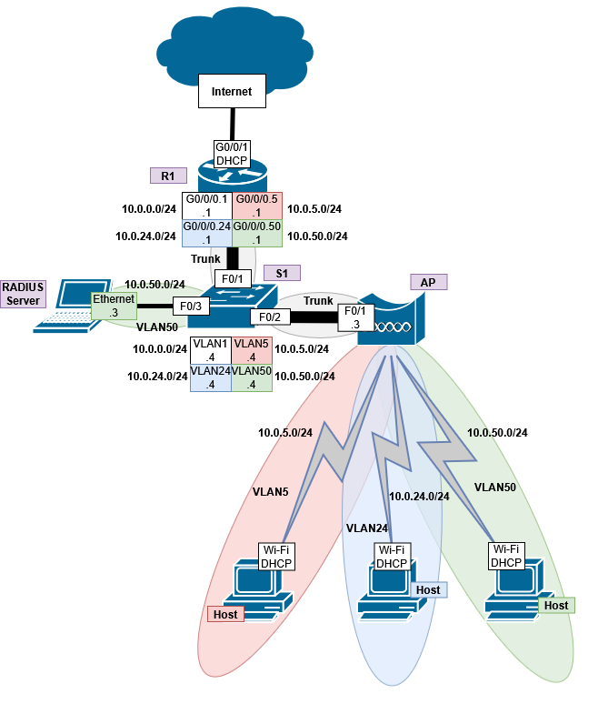

## Configurations

## R1

R1#sho run

Building configuration...

Current configuration : 2946 bytes

Last configuration change at 16:51:39 UTC Thu May 8 2025

version 15.5

service timestamps debug datetime msec

service timestamps log datetime msec

no platform punt-keepalive disable-kernel-core

hostname R1

boot-start-marker

boot-end-marker

vrf definition Mgmt-intf

address-family ipv4

exit-address-family

address-family ipv6

exit-address-family

no aaa new-model

ip dhcp excluded-address 10.0.0.1 10.0.0.4

ip dhcp excluded-address 10.0.24.1 10.0.24.4

ip dhcp excluded-address 10.0.5.1 10.0.5.4

ip dhcp excluded-address 10.0.50.1 10.0.50.4

ip dhcp pool vlan1

network 10.0.0.0 255.255.255.0

default-router 10.0.0.1

dns-server 9.9.9.9 1.1.1.1

ip dhcp pool vlan24

network 10.0.24.0 255.255.255.0

default-router 10.0.24.1

dns-server 9.9.9.9 1.1.1.1

ip dhcp pool vlan5

network 10.0.5.0 255.255.255.0

default-router 10.0.5.1

dns-server 9.9.9.9 1.1.1.1

ip dhcp pool vlan50

network 10.0.50.0 255.255.255.0

default-router 10.0.50.1

dns-server 9.9.9.9 1.1.1.1

login on-success log

subscriber templating

vtp domain cisco

vtp mode transparent

multilink bundle-name authenticated

license udi pid ISR4321/K9 sn FDO214421CU

spanning-tree extend system-id

redundancy

mode none

vlan internal allocation policy ascending

vlan 10,20

interface GigabitEthernet0/0/0

no ip address

ip nat inside

negotiation auto

interface GigabitEthernet0/0/0.1

encapsulation dot1Q 1 native

ip address 10.0.0.1 255.255.255.0

ip nat inside

interface GigabitEthernet0/0/0.5

encapsulation dot1Q 5

ip address 10.0.5.1 255.255.255.0

ip nat inside

interface GigabitEthernet0/0/0.24

encapsulation dot1Q 24

ip address 10.0.24.1 255.255.255.0

ip nat inside

interface GigabitEthernet0/0/0.50

encapsulation dot1Q 50

ip address 10.0.50.1 255.255.255.0

ip nat inside

interface GigabitEthernet0/0/1

ip address dhcp

ip nat outside

negotiation auto

interface Serial0/1/0

no ip address

shutdown

interface Serial0/1/1

no ip address

shutdown

interface GigabitEthernet0

vrf forwarding Mgmt-intf

no ip address

negotiation auto

interface Vlan1

no ip address

ip nat inside source list 1 interface GigabitEthernet0/0/1 overload

ip nat inside source list 5 interface GigabitEthernet0/0/1 overload

ip nat inside source list 24 interface GigabitEthernet0/0/1 overload

ip nat inside source list 50 interface GigabitEthernet0/0/1 overload

ip forward-protocol nd

ip http server

ip http authentication local

ip http secure-server

ip http client source-interface GigabitEthernet0/0/1

ip tftp source-interface GigabitEthernet0/0/1

access-list 1 permit 10.0.0.0 0.0.0.255

access-list 5 permit 10.0.5.0 0.0.0.255

access-list 24 permit 10.0.24.0 0.0.0.255

access-list 50 permit 10.0.50.0 0.0.0.255

control-plane

line con 0

exec-timeout 0 0

stopbits 1

line aux 0

stopbits 1

line vty 0 4

login

ntp server pool.ntp.org

end

## S1

S1#sho run

Building configuration...

Current configuration : 1847 bytes

version 12.2

no service pad

service timestamps debug datetime msec

service timestamps log datetime msec

no service password-encryption

hostname S1

boot-start-marker

boot-end-marker

no aaa new-model

system mtu routing 1500

authentication mac-move permit

ip subnet-zero

spanning-tree mode pvst

spanning-tree etherchannel guard misconfig

spanning-tree extend system-id

vlan internal allocation policy ascending

interface FastEthernet0/1

switchport trunk encapsulation dot1q

switchport mode trunk

spanning-tree portfast

interface FastEthernet0/2

switchport trunk encapsulation dot1q

switchport mode trunk

spanning-tree portfast

interface FastEthernet0/3

switchport access vlan 50

switchport trunk encapsulation dot1q

switchport mode access

spanning-tree portfast

interface FastEthernet0/4

spanning-tree portfast

interface FastEthernet0/5

interface FastEthernet0/6

interface FastEthernet0/7

interface FastEthernet0/8

interface FastEthernet0/9

interface FastEthernet0/10

interface FastEthernet0/11

interface FastEthernet0/12

interface FastEthernet0/13

interface FastEthernet0/14

interface FastEthernet0/15

interface FastEthernet0/16

interface FastEthernet0/17

interface FastEthernet0/18

interface FastEthernet0/19

interface FastEthernet0/20

interface FastEthernet0/21

interface FastEthernet0/22

interface FastEthernet0/23

interface FastEthernet0/24

interface GigabitEthernet0/1

interface GigabitEthernet0/2

interface Vlan1

ip address 10.0.0.4 255.255.255.0

interface Vlan5

no ip address

interface Vlan24

no ip address

interface Vlan50

no ip address

ip classless

ip http server

ip sla enable reaction-alerts

line con 0

line vty 5 15

monitor session 1 source interface Fa0/1 - 3

monitor session 1 destination interface Fa0/4

end

## AP

Lab-AP#sho run

Building configuration...

Current configuration : 4258 bytes

Last configuration change at 08:13:17 UTC Sun Mar 3 2002

version 15.3

no service pad

service timestamps debug datetime msec

service timestamps log datetime msec

service password-encryption

hostname Lab-AP

logging rate-limit console 9

enable secret 5 $1$3xv/$tCL154uWhyGwPSTjT2gBC1

aaa new-model

aaa group server tacacs+ tac_admin

aaa group server radius rad_eap

server name 10.0.50.3

aaa group server radius rad_mac

aaa group server radius rad_acct

server name 10.0.50.3

aaa group server radius rad_admin

server name 10.0.50.3

aaa group server radius rad_pmip

aaa group server radius dummy

aaa group server radius RAD

aaa authentication login eap_methods group rad_eap

aaa authentication login mac_methods local

aaa authorization exec default local

aaa accounting network acct_methods start-stop group rad_acct

aaa session-id common

no ip source-route

no ip cef

dot11 pause-time 100

dot11 syslog

dot11 ssid 2.4AA

vlan 24

authentication open

guest-mode

dot11 ssid 5.0AA

vlan 5

authentication open

authentication key-management wpa version 2

mbssid guest-mode

wpa-psk ascii 7 01030717481C091D25

dot11 ssid 5.0AAEnterprise

vlan 50

authentication open eap eap_methods

authentication network-eap eap_methods

authentication key-management wpa version 2

mbssid guest-mode

no ipv6 cef

username Cisco password 7 0802455D0A16

bridge irb

interface Dot11Radio0

no ip address

ssid 2.4AA

antenna gain 0

station-role root

bridge-group 1

bridge-group 1 subscriber-loop-control

bridge-group 1 spanning-disabled

bridge-group 1 block-unknown-source

no bridge-group 1 source-learning

no bridge-group 1 unicast-flooding

interface Dot11Radio0.24

encapsulation dot1Q 24

bridge-group 24

bridge-group 24 subscriber-loop-control

bridge-group 24 spanning-disabled

bridge-group 24 block-unknown-source

no bridge-group 24 source-learning

no bridge-group 24 unicast-flooding

interface Dot11Radio1

no ip address

encryption vlan 10 mode ciphers aes-ccm

encryption vlan 30 mode ciphers aes-ccm tkip

encryption vlan 5 mode ciphers aes-ccm

encryption vlan 50 mode ciphers aes-ccm tkip

ssid 5.0AA

ssid 5.0AAEnterprise

antenna gain 0

peakdetect

dfs band 3 block

mbssid

channel dfs

station-role root

bridge-group 1

bridge-group 1 subscriber-loop-control

bridge-group 1 spanning-disabled

bridge-group 1 block-unknown-source

no bridge-group 1 source-learning

no bridge-group 1 unicast-flooding

interface Dot11Radio1.5

encapsulation dot1Q 5

bridge-group 5

bridge-group 5 subscriber-loop-control

bridge-group 5 spanning-disabled

bridge-group 5 block-unknown-source

no bridge-group 5 source-learning

no bridge-group 5 unicast-flooding

interface Dot11Radio1.50

encapsulation dot1Q 50

bridge-group 50

bridge-group 50 subscriber-loop-control

bridge-group 50 spanning-disabled

bridge-group 50 block-unknown-source

no bridge-group 50 source-learning

no bridge-group 50 unicast-flooding

interface Dot11Radio1.301

interface GigabitEthernet0

no ip address

duplex auto

speed auto

bridge-group 1

bridge-group 1 spanning-disabled

no bridge-group 1 source-learning

interface GigabitEthernet0.5

encapsulation dot1Q 5

bridge-group 5

bridge-group 5 spanning-disabled

no bridge-group 5 source-learning

interface GigabitEthernet0.24

encapsulation dot1Q 24

bridge-group 24

bridge-group 24 spanning-disabled

no bridge-group 24 source-learning

interface GigabitEthernet0.50

encapsulation dot1Q 50

bridge-group 50

bridge-group 50 spanning-disabled

no bridge-group 50 source-learning

interface GigabitEthernet0.301

interface BVI1

mac-address 44d3.ca03.7dce

ip address 10.0.0.3 255.255.255.0

ipv6 address autoconfig

ipv6 enable

ip default-gateway 10.0.0.1

ip forward-protocol nd

ip http server

no ip http secure-server

ip http help-path http://www.cisco.com/warp/public/779/smbiz/prodconfig/help/eag

ip radius source-interface BVI1

radius-server attribute 32 include-in-access-req format %h

radius server 10.0.50.3

address ipv4 10.0.50.3 auth-port 1812 acct-port 1813

key 7 070C285F4D06

bridge 1 route ip

line con 0

line vty 0 4

transport input all

end

## Pings

-----------------------------------------------------5.0 GHz Enterprise-----------------------------------------------

Microsoft Windows [Version 10.0.26100.3775]

(c) Microsoft Corporation. All rights reserved.

C:\Users\Aadithya Prabhath>ipconfig

Windows IP Configuration

Ethernet adapter Ethernet 2:

Media State . . . . . . . . . . . : Media disconnected

Connection-specific DNS Suffix . :

Wireless LAN adapter Local Area Connection* 1:

Media State . . . . . . . . . . . : Media disconnected

Connection-specific DNS Suffix . :

Ethernet adapter Ethernet:

Connection-specific DNS Suffix . :

IPv6 Address. . . . . . . . . . . : 2001:db8:acad::2

Link-local IPv6 Address . . . . . : fe80::7149:8388:e986:b238%14

IPv4 Address. . . . . . . . . . . : 10.0.0.100

Subnet Mask . . . . . . . . . . . : 255.255.255.0

Default Gateway . . . . . . . . . : 2001:db8:acad::1

10.0.0.1

Wireless LAN adapter Wi-Fi:

Connection-specific DNS Suffix . :

Link-local IPv6 Address . . . . . : fe80::591d:cf7:bdef:3012%15

IPv4 Address. . . . . . . . . . . : 10.0.50.6

Subnet Mask . . . . . . . . . . . : 255.255.255.0

Default Gateway . . . . . . . . . : 10.0.50.1

Ethernet adapter Bluetooth Network Connection:

Media State . . . . . . . . . . . : Media disconnected

Connection-specific DNS Suffix . :

C:\Users\Aadithya Prabhath>ping 9.9.9.9

Pinging 9.9.9.9 with 32 bytes of data:

Reply from 9.9.9.9: bytes=32 time=11ms TTL=53

Reply from 9.9.9.9: bytes=32 time=11ms TTL=53

Reply from 9.9.9.9: bytes=32 time=11ms TTL=53

Reply from 9.9.9.9: bytes=32 time=10ms TTL=53

Ping statistics for 9.9.9.9:

Packets: Sent = 4, Received = 4, Lost = 0 (0% loss),

Approximate round trip times in milli-seconds:

Minimum = 10ms, Maximum = 11ms, Average = 10ms

C:\Users\Aadithya Prabhath>tracert 9.9.9.9

Tracing route to dns9.quad9.net [9.9.9.9]

over a maximum of 30 hops:

1 1 ms 4 ms 4 ms 10.0.50.1

2 1 ms 1 ms 1 ms 192.168.40.1

3 4 ms 1 ms 2 ms 172.28.128.1

4 4 ms 3 ms 2 ms 192.168.15.1

5 17 ms 20 ms 9 ms 10.61.242.195

6 29 ms 19 ms 24 ms po-316-316-rur402.bellevue.wa.seattle.comcast.net [24.153.84.165]

7 16 ms 12 ms 27 ms po-400-xar02.bellevue.wa.seattle.comcast.net [96.216.61.61]

8 20 ms 22 ms 28 ms be-300-arsc1.seattle.wa.seattle.comcast.net [24.124.128.89]

9 14 ms * * be-36121-cs02.seattle.wa.ibone.comcast.net [68.86.93.5]

10 18 ms 17 ms 16 ms be-2201-pe01.seattle.wa.ibone.comcast.net [96.110.39.206]

11 * * * Request timed out.

12 38 ms 40 ms 15 ms dns9.quad9.net [9.9.9.9]

Trace complete.

C:\Users\Aadithya Prabhath>ipconfig

Windows IP Configuration

Ethernet adapter Ethernet 2:

Media State . . . . . . . . . . . : Media disconnected

Connection-specific DNS Suffix . :

Wireless LAN adapter Local Area Connection* 1:

Media State . . . . . . . . . . . : Media disconnected

Connection-specific DNS Suffix . :

Wireless LAN adapter Local Area Connection* 2:

Media State . . . . . . . . . . . : Media disconnected

Connection-specific DNS Suffix . :

Ethernet adapter Ethernet:

Connection-specific DNS Suffix . :

IPv6 Address. . . . . . . . . . . : 2001:db8:acad::2

Link-local IPv6 Address . . . . . : fe80::7149:8388:e986:b238%14

IPv4 Address. . . . . . . . . . . : 10.0.0.100

Subnet Mask . . . . . . . . . . . : 255.255.255.0

Default Gateway . . . . . . . . . : 2001:db8:acad::1

10.0.0.1

Wireless LAN adapter Wi-Fi:

Connection-specific DNS Suffix . :

Link-local IPv6 Address . . . . . : fe80::591d:cf7:bdef:3012%15

IPv4 Address. . . . . . . . . . . : 10.0.50.6

Subnet Mask . . . . . . . . . . . : 255.255.255.0

Default Gateway . . . . . . . . . : 10.0.50.1

Ethernet adapter Bluetooth Network Connection:

Media State . . . . . . . . . . . : Media disconnected

Connection-specific DNS Suffix . :

--------------------------------------------------5.0GHz PSK------------------------------------------------------------------------

C:\Users\Aadithya Prabhath>ping 9.9.9.9

Pinging 9.9.9.9 with 32 bytes of data:

Reply from 9.9.9.9: bytes=32 time=26ms TTL=53

Reply from 9.9.9.9: bytes=32 time=14ms TTL=53

Reply from 9.9.9.9: bytes=32 time=13ms TTL=53

Reply from 9.9.9.9: bytes=32 time=13ms TTL=53

Ping statistics for 9.9.9.9:

Packets: Sent = 4, Received = 4, Lost = 0 (0% loss),

Approximate round trip times in milli-seconds:

Minimum = 13ms, Maximum = 26ms, Average = 16ms

C:\Users\Aadithya Prabhath>tracert 9.9.9.9

Tracing route to dns9.quad9.net [9.9.9.9]

over a maximum of 30 hops:

1 1 ms 1 ms 1 ms 10.0.5.1

2 1 ms 1 ms 1 ms 192.168.40.1

3 2 ms 1 ms 1 ms 172.28.128.1

4 2 ms 1 ms 1 ms 192.168.15.1

5 14 ms 13 ms 11 ms 10.61.242.195

6 12 ms 9 ms 13 ms po-316-316-rur402.bellevue.wa.seattle.comcast.net [24.153.84.165]

7 15 ms 14 ms 12 ms po-400-xar02.bellevue.wa.seattle.comcast.net [96.216.61.61]

8 12 ms 12 ms 17 ms be-300-arsc1.seattle.wa.seattle.comcast.net [24.124.128.89]

9 13 ms * 28 ms be-36121-cs02.seattle.wa.ibone.comcast.net [68.86.93.5]

10 13 ms 14 ms 12 ms be-2201-pe01.seattle.wa.ibone.comcast.net [96.110.39.206]

11 * * * Request timed out.

12 12 ms 13 ms 9 ms dns9.quad9.net [9.9.9.9]

Trace complete.

C:\Users\Aadithya Prabhath>ipconfig

Windows IP Configuration

Ethernet adapter Ethernet 2:

Media State . . . . . . . . . . . : Media disconnected

Connection-specific DNS Suffix . :

Wireless LAN adapter Local Area Connection* 1:

Media State . . . . . . . . . . . : Media disconnected

Connection-specific DNS Suffix . :

Wireless LAN adapter Local Area Connection* 2:

Media State . . . . . . . . . . . : Media disconnected

Connection-specific DNS Suffix . :

Ethernet adapter Ethernet:

Connection-specific DNS Suffix . :

IPv6 Address. . . . . . . . . . . : 2001:db8:acad::2

Link-local IPv6 Address . . . . . : fe80::7149:8388:e986:b238%14

IPv4 Address. . . . . . . . . . . : 10.0.0.100

Subnet Mask . . . . . . . . . . . : 255.255.255.0

Default Gateway . . . . . . . . . : 2001:db8:acad::1

10.0.0.1

Wireless LAN adapter Wi-Fi:

Connection-specific DNS Suffix . :

Link-local IPv6 Address . . . . . : fe80::591d:cf7:bdef:3012%15

IPv4 Address. . . . . . . . . . . : 10.0.5.7

Subnet Mask . . . . . . . . . . . : 255.255.255.0

Default Gateway . . . . . . . . . : 10.0.5.1

Ethernet adapter Bluetooth Network Connection:

Media State . . . . . . . . . . . : Media disconnected

Connection-specific DNS Suffix . :

--------------------------------------------------------------2.4 GHz-------------------------------------------------

C:\Users\Aadithya Prabhath>ping 9.9.9.9

Pinging 9.9.9.9 with 32 bytes of data:

Reply from 9.9.9.9: bytes=32 time=12ms TTL=53

Reply from 9.9.9.9: bytes=32 time=22ms TTL=53

Reply from 9.9.9.9: bytes=32 time=11ms TTL=53

Reply from 9.9.9.9: bytes=32 time=10ms TTL=53

Ping statistics for 9.9.9.9:

Packets: Sent = 4, Received = 4, Lost = 0 (0% loss),

Approximate round trip times in milli-seconds:

Minimum = 10ms, Maximum = 22ms, Average = 13ms

C:\Users\Aadithya Prabhath>tracert 9.9.9.9

Tracing route to dns9.quad9.net [9.9.9.9]

over a maximum of 30 hops:

1 1 ms 1 ms 2 ms 10.0.24.1

2 4 ms 2 ms 2 ms 192.168.40.1

3 12 ms 7 ms 12 ms 172.28.128.1

4 3 ms 2 ms 4 ms 192.168.15.1

5 21 ms 14 ms 25 ms 10.61.242.195

6 13 ms 9 ms 9 ms po-316-316-rur402.bellevue.wa.seattle.comcast.net [24.153.84.165]

7 10 ms 16 ms 14 ms po-400-xar02.bellevue.wa.seattle.comcast.net [96.216.61.61]

8 13 ms 13 ms 17 ms be-300-arsc1.seattle.wa.seattle.comcast.net [24.124.128.89]

9 20 ms 19 ms * be-36121-cs02.seattle.wa.ibone.comcast.net [68.86.93.5]

10 16 ms 11 ms 13 ms be-2201-pe01.seattle.wa.ibone.comcast.net [96.110.39.206]

11 * * * Request timed out.

12 20 ms 12 ms 22 ms dns9.quad9.net [9.9.9.9]

Trace complete.

C:\Users\Aadithya Prabhath>ipconfig

Windows IP Configuration

Ethernet adapter Ethernet 2:

Media State . . . . . . . . . . . : Media disconnected

Connection-specific DNS Suffix . :

Wireless LAN adapter Local Area Connection* 1:

Media State . . . . . . . . . . . : Media disconnected

Connection-specific DNS Suffix . :

Wireless LAN adapter Local Area Connection* 2:

Media State . . . . . . . . . . . : Media disconnected

Connection-specific DNS Suffix . :

Ethernet adapter Ethernet:

Connection-specific DNS Suffix . :

IPv6 Address. . . . . . . . . . . : 2001:db8:acad::2

Link-local IPv6 Address . . . . . : fe80::7149:8388:e986:b238%14

IPv4 Address. . . . . . . . . . . : 10.0.0.100

Subnet Mask . . . . . . . . . . . : 255.255.255.0

Default Gateway . . . . . . . . . : 2001:db8:acad::1

10.0.0.1

Wireless LAN adapter Wi-Fi:

Connection-specific DNS Suffix . :

Link-local IPv6 Address . . . . . : fe80::591d:cf7:bdef:3012%15

IPv4 Address. . . . . . . . . . . : 10.0.24.8

Subnet Mask . . . . . . . . . . . : 255.255.255.0

Default Gateway . . . . . . . . . : 10.0.24.1

Ethernet adapter Bluetooth Network Connection:

Media State . . . . . . . . . . . : Media disconnected

Connection-specific DNS Suffix . :

## Problems

The first problem that we had occurred when we were partitioning the drive when flashing it. Because it got partitioned and then aborted, we had to use the diskpart command to re-partition it. Next, an issue occurred during our FreeRadius installation and the file path did not exist. We manually added the path to the .bashrc file to fix this. There was also an unknown problem when we were trying to send traffic from the router through a switch to the internet. We resolved this by directly connecting the router to the internet. One of our SSIDs did not work because we forgot to make the VLAN associated with it. In the RADIUS authorize file, an = sign was replaced with a – sign, which caused FreeRADIUS to crash whenever we attempted to start it. We changed the sign and the server ran. One of our ACLs did not exist, so NAT was failing. Once we created the ACL, the network functioned. Finally, although this was not an issue with the devices themselves, someone hid or misplaced the laptop that was serving as our RADIUS server, so we had to start our configuration from scratch.

## Conclusion

In this lab, we learned how to configure a CISCO AP and how to use FreeRadius. We learned about the different types of authentication that can be used, and their strengths and weaknesses. We also learned how to troubleshoot better. This lab had many problems and was significantly more involved than many previous labs that we did. We learned how to debug efficiently, and use external tools like ChatGPT and Google to find solutions to our problems.

|  |
| --- |
| LAB 7: LAYER 2 ATTACK LAB Aadithya Prabhath |
| Cisco white logo transparent PNG - StickPNG |



## Purpose

To explore common Layer 2 network attacks and mitigation strategies.

## Background Information on Lab Concepts

The OSI model of networks consists of 7 layers: Layer 1, the physical layer; Layer 2, the data link layer; Layer 3, the network layer; Layer 4, the transport layer; Layer 5, the session layer; Layer 6, the presentation layer; and Layer 7, the application layer. Layer 2 handles single-link connections between devices like hosts and switches. The primary protocol used on this layer is Ethernet. In the operation of switches and the ethernet protocol, there are several weaknesses that can be exploited for attacks if they are not remediated. In this lab, we will be focusing on 3 such attacks: a MAC overflow attack, which targets a switch’s MAC address table; an ARP poisoning attack, which spoofs MAC addresses; and a DHCP starvation attack, which stops hosts from receiving DHCP services.

In a MAC overflow attack, the attacker spoofs its own Media Access Control (MAC) address and sends frames to a switch. The MAC address is a number that is unique to each Network Interface Card (NIC) that a device has and is used to identify the host in Layer 2 communication. Normally, each interface connected to a device will have 1 MAC address associated to it. This allows a switch to track and route traffic to that particular host. When a switch receives a frame from a port, it records the MAC address in a Content Addressable Memory (CAM) table. CAM tables are used to quickly look up data when two items correspond to each other. In a switch, each port has its own address in the CAM table, and when traffic from an unknown source is received by the switch, it updates the CAM table position associated with the receiving port with the MAC address of the sender. However, the maximum size of the CAM table is limited by memory constraints. If an attacker spoofs their own address and sends frames to the switch, they can cause the CAM table to overflow. This causes the switch to then send out all incoming traffic as broadcasts, which can be read by the attacker using a packet sniffer like WireShark. To set up our attack, we used the Yersinia tool to send ethernet frames to a switch with random source MAC addresses. In order to mitigate this attack, we set up port security, which limits the maximum number of MAC addresses per port.

In an ARP poisoning attack, the attacker sends gratuitous ARP requests that associate the MAC address of the attacker with the IP address of a legitimate device, often a default gateway. ARP is a protocol that is used when a host doesn’t know the MAC address of a destination host but does know the IP address. It broadcasts a message asking who has the IP address it is looking for, and the correct host responds back with its MAC address. The host then stores the MAC address association for future use. However, if an attacker sends a gratuitous ARP response, it can trick hosts into associating its MAC address with a legitimate IP address. The attacker can then get traffic switched to its MAC address and intercept traffic, creating a man-in-the-middle attack. We used Yersinia to conduct our attack. ARP poisoning can be mitigated with dynamic ARP inspection, which validates ARP messages.

In a DHCP starvation attack, the attacker sends fake DHCP requests to a DHCP server. This causes the DHCP server to allocate all of its IP addresses and be unable to assign them to legitimate hosts. It is often used to enable the creation of a rogue DHCP server to intercept traffic. DHCP is a protocol that is used to dynamically assign IP addresses to hosts that connect to a server. While DHCP operates at the application layer, the mitigation for the attack takes place on switches, a Layer 2 device. In this lab, we used a router as our DHCP server. We also used Yersinia to conduct our attack. In order to mitigate the attack, we used DHCP snooping, which monitors and authenticates DHCP requests to ensure that only legitimate hosts are receiving DHCP responses.

## Lab Summary

For each attack, we set up a simple network, typically consisting of 2 hosts, a switch, an attacker, and potentially a router. We then ran the attack once without any steps to mitigate the attack. Next, we configured the mitigation. We re-ran the attack and confirmed that the mitigation was successful.

## Lab Commands

switchport port-security: Enables MAC address-based port security on the interface.  
switchport port-security maximum x: Limits the port to allow only x MAC addresses.

ip dhcp snooping: Enables DHCP snooping on the switch.

ip arp inspection vlan [range]: Enables Dynamic ARP Inspection (DAI) on VLANs in range.

ip arp inspection validate ip: Configures DAI to inspect and validate IP address bindings in ARP packets.

ip arp inspection trust: Marks the interface as trusted for ARP traffic.

ip dhcp snooping trust: Marks the interface as trusted for receiving DHCP server messages. Usually done on the interface connected to the known DHCP server.

## Network Diagram

## Rogue DHCP

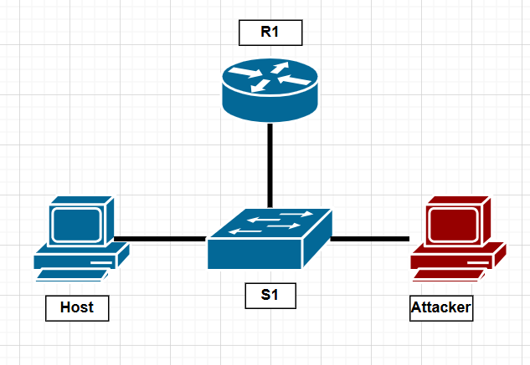

## ARP Poisoning/MAC Overflow

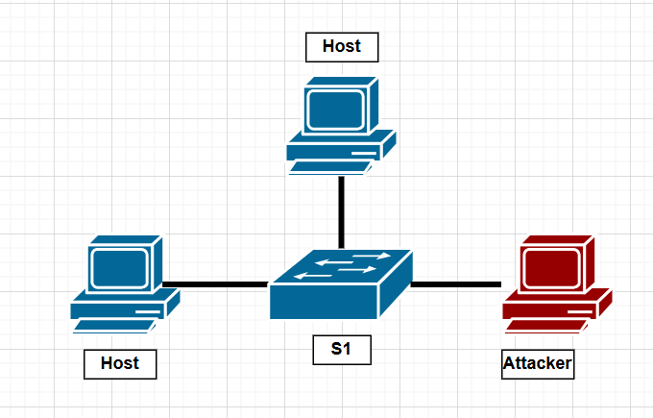

## Problems

In this lab, the biggest issue we had was during our ARP poisoning attack. Whenever we would stop the attack, the switch would re-learn the correct addressing information. We got around this by constantly running the attack while traffic was being sent.

## Conclusion

In this lab we explored some common Layer 2 attacks and how to mitigate them. By analyzing how the different attacks occur and how to mitigate them in a lab environment, we learned how to better protect future networks we make against these attacks. In addition, the commands we learned in this lab protect against more than just these attacks, as many different attacks can be prevented with similar commands.

|  |
| --- |
| LAB 8: IS-IS LAB Aadithya Prabhath |
| Cisco white logo transparent PNG - StickPNG |



## Purpose

To configure a network to distribute routing information using the IS-IS routing protocol.

## Background Information on Lab Concepts

IS-IS is an interior gateway protocol, originally designed by a team including Radia Pearlman for DECnet. It was originally made in 1990 and designed to work with the Connectionless-mode Network Service protocol.

IS-IS is an interior gateway protocol, like protocols like RIP, EIGRP, and OSPF. It is designed to route within an autonomous system. It is also a link-state routing protocol like OSPF. Each router sends out link state advertisements, and each router receives the advertisements and builds their own routing table. This allows each router to get a sense of the configuration of the network independently. Next, each router builds its own map of the network and uses Dijkstra’s algorithm to route traffic.

When configuring IS-IS, a router (independent system, or IS) is assigned a single identification number: a NET (Network Entity Title). Because of this, the individual physical interfaces are not assigned addresses. A NET consists of an Area number, a System ID, and an NSEL. In our lab, we used an AFI of 49, which denotes a private address, like a 192.168.x.x/24 IP address. We used 3 different areas, 0001, 0002, and 0003. Together, these to numbers combine to complete the Area field. The System ID is a unique number in the form XXXX.XXXX.XXXX. It identifies the individual router. Lastly, the NSEL must be 00 to form an IS-IS connection.

There are no areas in IS-IS. However, each router can have one of two levels. Level 1 routers function similarly to stub areas in OSPF, and they can only receive routing information from other Level 1 routers that are directly adjacent to them. These are often used as nodes that connect directly to hosts. Level 2 routers form the backbone of an IS-IS network and can receive routing information through other Level 2 routers that are not directly connected to them. However, they cannot directly talk to level 1 routers. Luckily, routers can also be run as Level 1-2 routers. They can simultaneously receive routes from indirectly connected routers, while sharing that routing information with Level 1 routers.

## Lab Summary

We configured the network according to our diagram. We then configured each of the routers according to our configuration plan, having all of the routers except the border routers as Level 1-2 routers and the border routers as Level 1 routers.

## Lab Commands

router isis x: This is used to enable IS-IS routing and configure IS-IS routing information.

net [NET]: This command is used to assign the router a NET.

is-type [Type]: This command is used to assign the router a IS-IS level. Type can be replaced with either level-1, level-2. If configuring a router for Level 1-2 operation, this command can be skipped as IS-IS routers are Level 1-2 by default.

ip router isis x: This is used to enable an IS-IS process on a router’s interface.

Network Diagram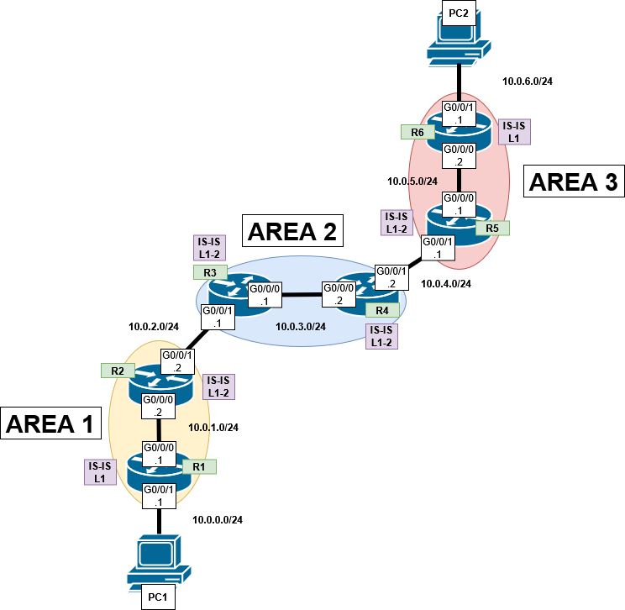

## Configurations

---------------------------------------------------------R1--------------------------------------------------------

R1#sho run

Building configuration...

Current configuration : 1522 bytes

Last configuration change at 16:19:14 UTC Tue Apr 29 2025

version 15.5

service timestamps debug datetime msec

service timestamps log datetime msec

no platform punt-keepalive disable-kernel-core

hostname R1

boot-start-marker

boot-end-marker

vrf definition Mgmt-intf

address-family ipv4

exit-address-family

address-family ipv6

exit-address-family

no aaa new-model

subscriber templating

vtp domain cisco

vtp mode transparent

multilink bundle-name authenticated

license udi pid ISR4321/K9 sn FDO214421BY

spanning-tree extend system-id

redundancy

mode none

vlan internal allocation policy ascending

interface GigabitEthernet0/0/0

ip address 10.0.1.1 255.255.255.0

ip router isis 1

negotiation auto

interface GigabitEthernet0/0/1

ip address 10.0.0.1 255.255.255.0

ip router isis 1

negotiation auto

interface Serial0/1/0

interface Serial0/1/1

interface GigabitEthernet0/2/0

no ip address

shutdown

negotiation auto

interface GigabitEthernet0/2/1

no ip address

shutdown

negotiation auto

interface GigabitEthernet0

vrf forwarding Mgmt-intf

no ip address

shutdown

negotiation auto

interface Vlan1

no ip address

shutdown

router isis 1

net 49.0001.0000.0000.0001.00

is-type level-1

ip forward-protocol nd

no ip http server

no ip http secure-server

ip tftp source-interface GigabitEthernet0

control-plane

line con 0

stopbits 1

line aux 0

stopbits 1

line vty 0 4

login

end

R1#sho ip route

Codes: L - local, C - connected, S - static, R - RIP, M - mobile, B - BGP

D - EIGRP, EX - EIGRP external, O - OSPF, IA - OSPF inter area

N1 - OSPF NSSA external type 1, N2 - OSPF NSSA external type 2

E1 - OSPF external type 1, E2 - OSPF external type 2

i - IS-IS, su - IS-IS summary, L1 - IS-IS level-1, L2 - IS-IS level-2

ia - IS-IS inter area, * - candidate default, U - per-user static route

o - ODR, P - periodic downloaded static route, H - NHRP, l - LISP

a - application route

+ - replicated route, % - next hop override, p - overrides from PfR

Gateway of last resort is 10.0.1.2 to network 0.0.0.0

i*L1 0.0.0.0/0 [115/10] via 10.0.1.2, 00:05:04, GigabitEthernet0/0/0

10.0.0.0/8 is variably subnetted, 5 subnets, 2 masks

C 10.0.0.0/24 is directly connected, GigabitEthernet0/0/1

L 10.0.0.1/32 is directly connected, GigabitEthernet0/0/1

C 10.0.1.0/24 is directly connected, GigabitEthernet0/0/0

L 10.0.1.1/32 is directly connected, GigabitEthernet0/0/0

i L1 10.0.2.0/24 [115/20] via 10.0.1.2, 00:05:15, GigabitEthernet0/0/0

R1#

------------------------------------------------------------------------------R2---------------------------------------------------

R2#sho run

Building configuration...

Current configuration : 1514 bytes

Last configuration change at 16:21:34 UTC Tue Apr 29 2025

version 15.5

service timestamps debug datetime msec

service timestamps log datetime msec

no platform punt-keepalive disable-kernel-core

hostname R2

boot-start-marker

boot-end-marker

vrf definition Mgmt-intf

address-family ipv4

exit-address-family

address-family ipv6

exit-address-family

no aaa new-model

subscriber templating

vtp domain cisco

vtp mode transparent

multilink bundle-name authenticated

license udi pid ISR4321/K9 sn FDO214420QQ

license accept end user agreement

license boot level securityk9

spanning-tree extend system-id

redundancy

mode none

vlan internal allocation policy ascending

interface GigabitEthernet0/0/0

ip address 10.0.1.2 255.255.255.0

ip router isis 1

negotiation auto

interface GigabitEthernet0/0/1

ip address 10.0.2.2 255.255.255.0

ip router isis 1

negotiation auto

interface Serial0/1/0

no ip address

shutdown

interface Serial0/1/1

no ip address

shutdown

interface GigabitEthernet0

vrf forwarding Mgmt-intf

no ip address

shutdown

negotiation auto

interface Vlan1

no ip address

shutdown

router isis 1

net 49.0001.0000.0000.0002.00

ip forward-protocol nd

no ip http server

no ip http secure-server

ip tftp source-interface GigabitEthernet0

control-plane

line con 0

stopbits 1

line aux 0

stopbits 1

line vty 0 4

login

end

R2#sho ip route

Codes: L - local, C - connected, S - static, R - RIP, M - mobile, B - BGP

D - EIGRP, EX - EIGRP external, O - OSPF, IA - OSPF inter area

N1 - OSPF NSSA external type 1, N2 - OSPF NSSA external type 2

E1 - OSPF external type 1, E2 - OSPF external type 2

i - IS-IS, su - IS-IS summary, L1 - IS-IS level-1, L2 - IS-IS level-2

ia - IS-IS inter area, * - candidate default, U - per-user static route

o - ODR, P - periodic downloaded static route, H - NHRP, l - LISP

a - application route

+ - replicated route, % - next hop override, p - overrides from PfR

Gateway of last resort is not set

10.0.0.0/8 is variably subnetted, 9 subnets, 2 masks

i L1 10.0.0.0/24 [115/20] via 10.0.1.1, 00:06:51, GigabitEthernet0/0/0

C 10.0.1.0/24 is directly connected, GigabitEthernet0/0/0

L 10.0.1.2/32 is directly connected, GigabitEthernet0/0/0

C 10.0.2.0/24 is directly connected, GigabitEthernet0/0/1

L 10.0.2.2/32 is directly connected, GigabitEthernet0/0/1

i L2 10.0.3.0/24 [115/20] via 10.0.2.1, 00:06:23, GigabitEthernet0/0/1

i L2 10.0.4.0/24 [115/30] via 10.0.2.1, 00:06:17, GigabitEthernet0/0/1

i L2 10.0.5.0/24 [115/40] via 10.0.2.1, 00:06:17, GigabitEthernet0/0/1

i L2 10.0.6.0/24 [115/50] via 10.0.2.1, 00:06:17, GigabitEthernet0/0/1

R2#

-------------------------------------------------------------R3---------------------------------------------------

R3#sho run

Building configuration...

Current configuration : 1412 bytes

Last configuration change at 17:02:15 UTC Tue Apr 29 2025

version 15.5

service timestamps debug datetime msec

service timestamps log datetime msec

no platform punt-keepalive disable-kernel-core

hostname R3

boot-start-marker

boot-end-marker

vrf definition Mgmt-intf

address-family ipv4

exit-address-family

address-family ipv6

exit-address-family

no aaa new-model

subscriber templating

vtp domain cisco

vtp mode transparent

multilink bundle-name authenticated

license udi pid ISR4321/K9 sn FDO214420HY

license boot level securityk9

spanning-tree extend system-id

redundancy

mode none

vlan internal allocation policy ascending

vlan 10,20

interface GigabitEthernet0/0/0

ip address 10.0.3.1 255.255.255.0

ip router isis 2

negotiation auto

interface GigabitEthernet0/0/1

ip address 10.0.2.1 255.255.255.0

ip router isis 2

negotiation auto

interface Serial0/1/0

no ip address

interface Serial0/1/1

no ip address

interface GigabitEthernet0

vrf forwarding Mgmt-intf

no ip address

negotiation auto

interface Vlan1

no ip address

router isis 2

net 49.0002.0000.0000.0003.00

ip forward-protocol nd

no ip http server

no ip http secure-server

control-plane

line con 0

stopbits 1

line aux 0

stopbits 1

line vty 0 4

login

end

R3#sho ip route

Codes: L - local, C - connected, S - static, R - RIP, M - mobile, B - BGP

D - EIGRP, EX - EIGRP external, O - OSPF, IA - OSPF inter area

N1 - OSPF NSSA external type 1, N2 - OSPF NSSA external type 2

E1 - OSPF external type 1, E2 - OSPF external type 2

i - IS-IS, su - IS-IS summary, L1 - IS-IS level-1, L2 - IS-IS level-2

ia - IS-IS inter area, * - candidate default, U - per-user static route

o - ODR, P - periodic downloaded static route, H - NHRP, l - LISP

a - application route

+ - replicated route, % - next hop override, p - overrides from PfR

Gateway of last resort is not set

10.0.0.0/8 is variably subnetted, 9 subnets, 2 masks

i L2 10.0.0.0/24 [115/30] via 10.0.2.2, 00:07:16, GigabitEthernet0/0/1

i L2 10.0.1.0/24 [115/20] via 10.0.2.2, 00:07:16, GigabitEthernet0/0/1

C 10.0.2.0/24 is directly connected, GigabitEthernet0/0/1

L 10.0.2.1/32 is directly connected, GigabitEthernet0/0/1

C 10.0.3.0/24 is directly connected, GigabitEthernet0/0/0

L 10.0.3.1/32 is directly connected, GigabitEthernet0/0/0

i L1 10.0.4.0/24 [115/20] via 10.0.3.2, 00:55:48, GigabitEthernet0/0/0

i L2 10.0.5.0/24 [115/30] via 10.0.3.2, 00:55:41, GigabitEthernet0/0/0

i L2 10.0.6.0/24 [115/40] via 10.0.3.2, 00:55:41, GigabitEthernet0/0/0

R3#

------------------------------------------------------R4--------------------------------------------------------------------

R4#sho run

Building configuration...

Current configuration : 1532 bytes

Last configuration change at 15:45:42 UTC Tue Apr 29 2025

version 15.5

service timestamps debug datetime msec

service timestamps log datetime msec

no platform punt-keepalive disable-kernel-core

hostname R4

boot-start-marker

boot-end-marker

vrf definition Mgmt-intf

address-family ipv4

exit-address-family

address-family ipv6

exit-address-family

no aaa new-model

subscriber templating

vtp domain cisco

vtp mode transparent

multilink bundle-name authenticated

license udi pid ISR4321/K9 sn FDO21491LXV

license accept end user agreement

license boot level securityk9

spanning-tree extend system-id

redundancy

mode none

vlan internal allocation policy ascending

vlan 2

name v2

vlan 3

name v3

vlan 4

name v4

vlan 10,20

interface GigabitEthernet0/0/0

ip address 10.0.3.2 255.255.255.0

ip router isis 2

negotiation auto

interface GigabitEthernet0/0/1

ip address 10.0.4.2 255.255.255.0

ip router isis 2

negotiation auto

interface Serial0/1/0

interface Serial0/1/1

interface GigabitEthernet0

vrf forwarding Mgmt-intf

no ip address

shutdown

negotiation auto

interface Vlan1

no ip address

shutdown

router isis 2

net 49.0002.0000.0000.0004.00

ip forward-protocol nd

no ip http server

no ip http secure-server

ip tftp source-interface GigabitEthernet0

control-plane

line con 0

stopbits 1

line aux 0

stopbits 1

line vty 0 4

login

end

R4#sho ip route

Codes: L - local, C - connected, S - static, R - RIP, M - mobile, B - BGP

D - EIGRP, EX - EIGRP external, O - OSPF, IA - OSPF inter area

N1 - OSPF NSSA external type 1, N2 - OSPF NSSA external type 2

E1 - OSPF external type 1, E2 - OSPF external type 2

i - IS-IS, su - IS-IS summary, L1 - IS-IS level-1, L2 - IS-IS level-2

ia - IS-IS inter area, * - candidate default, U - per-user static route

o - ODR, P - periodic downloaded static route, H - NHRP, l - LISP

a - application route

+ - replicated route, % - next hop override, p - overrides from PfR

Gateway of last resort is not set

10.0.0.0/8 is variably subnetted, 9 subnets, 2 masks

i L2 10.0.0.0/24 [115/40] via 10.0.3.1, 00:08:08, GigabitEthernet0/0/0

i L2 10.0.1.0/24 [115/30] via 10.0.3.1, 00:08:08, GigabitEthernet0/0/0

i L1 10.0.2.0/24 [115/20] via 10.0.3.1, 00:08:14, GigabitEthernet0/0/0

C 10.0.3.0/24 is directly connected, GigabitEthernet0/0/0

L 10.0.3.2/32 is directly connected, GigabitEthernet0/0/0

C 10.0.4.0/24 is directly connected, GigabitEthernet0/0/1

L 10.0.4.2/32 is directly connected, GigabitEthernet0/0/1

i L2 10.0.5.0/24 [115/20] via 10.0.4.1, 00:56:37, GigabitEthernet0/0/1

i L2 10.0.6.0/24 [115/30] via 10.0.4.1, 00:56:37, GigabitEthernet0/0/1

R4#

-----------------------------------------------------------R5---------------------------------------------------

R5#sho run

Building configuration...

Current configuration : 1403 bytes

Last configuration change at 16:34:06 UTC Tue Apr 29 2025

version 15.5

service timestamps debug datetime msec

service timestamps log datetime msec

no platform punt-keepalive disable-kernel-core

hostname R5

boot-start-marker

boot-end-marker

vrf definition Mgmt-intf

address-family ipv4

exit-address-family

address-family ipv6

exit-address-family

no aaa new-model

subscriber templating

vtp domain cisco

vtp mode transparent

multilink bundle-name authenticated

license udi pid ISR4321/K9 sn FDO21400XZX

spanning-tree extend system-id

redundancy

mode none

vlan internal allocation policy ascending

interface GigabitEthernet0/0/0

ip address 10.0.5.1 255.255.255.0

ip router isis 3

negotiation auto

interface GigabitEthernet0/0/1

ip address 10.0.4.1 255.255.255.0

ip router isis 3

negotiation auto

interface Serial0/1/0

no ip address

shutdown

interface Serial0/1/1

no ip address

shutdown

interface GigabitEthernet0

vrf forwarding Mgmt-intf

no ip address

shutdown

negotiation auto

interface Vlan1

no ip address

shutdown

router isis 3

net 49.0003.0000.0000.0005.00

ip forward-protocol nd

no ip http server

no ip http secure-server

ip tftp source-interface GigabitEthernet0

control-plane

line con 0

stopbits 1

line aux 0

stopbits 1

line vty 0 4

login

end

R5#sho ip route

Codes: L - local, C - connected, S - static, R - RIP, M - mobile, B - BGP

D - EIGRP, EX - EIGRP external, O - OSPF, IA - OSPF inter area

N1 - OSPF NSSA external type 1, N2 - OSPF NSSA external type 2

E1 - OSPF external type 1, E2 - OSPF external type 2

i - IS-IS, su - IS-IS summary, L1 - IS-IS level-1, L2 - IS-IS level-2

ia - IS-IS inter area, * - candidate default, U - per-user static route

o - ODR, P - periodic downloaded static route, H - NHRP, l - LISP

a - application route

+ - replicated route, % - next hop override, p - overrides from PfR

Gateway of last resort is not set

10.0.0.0/8 is variably subnetted, 9 subnets, 2 masks

i L2 10.0.0.0/24 [115/50] via 10.0.4.2, 00:09:05, GigabitEthernet0/0/1

i L2 10.0.1.0/24 [115/40] via 10.0.4.2, 00:09:05, GigabitEthernet0/0/1

i L2 10.0.2.0/24 [115/30] via 10.0.4.2, 00:09:11, GigabitEthernet0/0/1

i L2 10.0.3.0/24 [115/20] via 10.0.4.2, 00:57:33, GigabitEthernet0/0/1

C 10.0.4.0/24 is directly connected, GigabitEthernet0/0/1

L 10.0.4.1/32 is directly connected, GigabitEthernet0/0/1

C 10.0.5.0/24 is directly connected, GigabitEthernet0/0/0

L 10.0.5.1/32 is directly connected, GigabitEthernet0/0/0

i L1 10.0.6.0/24 [115/20] via 10.0.5.2, 00:58:54, GigabitEthernet0/0/0

R5#

----------------------------------------------------------R6---------------------------------------------------

R6#sho run

Building configuration...

Current configuration : 1474 bytes

Last configuration change at 15:46:38 UTC Tue Apr 29 2025

version 15.5

service timestamps debug datetime msec

service timestamps log datetime msec

no platform punt-keepalive disable-kernel-core

hostname R6

boot-start-marker

boot-end-marker

vrf definition Mgmt-intf

address-family ipv4

exit-address-family

address-family ipv6

exit-address-family

no aaa new-model

subscriber templating

vtp domain cisco

vtp mode transparent

multilink bundle-name authenticated

license udi pid ISR4321/K9 sn FDO21491FHX

spanning-tree extend system-id

redundancy

mode none

vlan internal allocation policy ascending

interface GigabitEthernet0/0/0

ip address 10.0.5.2 255.255.255.0

ip router isis 3

negotiation auto

interface GigabitEthernet0/0/1

ip address 10.0.6.1 255.255.255.0

ip router isis 3

negotiation auto

interface GigabitEthernet0/1/0

no ip address

shutdown

negotiation auto

interface GigabitEthernet0/1/1

no ip address

shutdown

negotiation auto

interface GigabitEthernet0

vrf forwarding Mgmt-intf

no ip address

shutdown

negotiation auto

interface Vlan1

no ip address

shutdown

router isis 3

net 49.0003.0000.0000.0006.00

is-type level-1

ip forward-protocol nd

no ip http server

no ip http secure-server

ip tftp source-interface GigabitEthernet0

control-plane

line con 0

stopbits 1

line aux 0

stopbits 1

line vty 0 4

login

end

R6#sho ip route

Codes: L - local, C - connected, S - static, R - RIP, M - mobile, B - BGP

D - EIGRP, EX - EIGRP external, O - OSPF, IA - OSPF inter area

N1 - OSPF NSSA external type 1, N2 - OSPF NSSA external type 2

E1 - OSPF external type 1, E2 - OSPF external type 2

i - IS-IS, su - IS-IS summary, L1 - IS-IS level-1, L2 - IS-IS level-2

ia - IS-IS inter area, * - candidate default, U - per-user static route

o - ODR, P - periodic downloaded static route, H - NHRP, l - LISP

a - application route

+ - replicated route, % - next hop override, p - overrides from PfR

Gateway of last resort is 10.0.5.1 to network 0.0.0.0

i*L1 0.0.0.0/0 [115/10] via 10.0.5.1, 00:58:11, GigabitEthernet0/0/0

10.0.0.0/8 is variably subnetted, 5 subnets, 2 masks

i L1 10.0.4.0/24 [115/20] via 10.0.5.1, 00:58:22, GigabitEthernet0/0/0

C 10.0.5.0/24 is directly connected, GigabitEthernet0/0/0

L 10.0.5.2/32 is directly connected, GigabitEthernet0/0/0

C 10.0.6.0/24 is directly connected, GigabitEthernet0/0/1

L 10.0.6.1/32 is directly connected, GigabitEthernet0/0/1

R6#

-----------------------------------Tracerts-------------------------------------

C:\Users\Aadithya Prabhath>tracert 10.0.6.2

Tracing route to DESKTOP-CH27SQT [10.0.6.2]

over a maximum of 30 hops:

1 <1 ms <1 ms <1 ms 10.0.0.1

2 <1 ms <1 ms <1 ms 10.0.1.2

3 <1 ms <1 ms <1 ms 10.0.2.1

4 <1 ms <1 ms <1 ms 10.0.3.2

5 <1 ms <1 ms <1 ms 10.0.4.1

6 <1 ms <1 ms <1 ms 10.0.5.2

7 1 ms 1 ms 1 ms DESKTOP-CH27SQT [10.0.6.2]

Trace complete.

C:\Users\Allen Wu>tracert 10.0.0.2

Tracing route to DESKTOP-ETOO76H [10.0.0.2]

over a maximum of 30 hops:

1 <1 ms <1 ms <1 ms 10.0.6.1

2 <1 ms <1 ms <1 ms 10.0.5.1

3 <1 ms <1 ms <1 ms 10.0.4.2

4 <1 ms <1 ms <1 ms 10.0.3.1

5 <1 ms <1 ms <1 ms 10.0.2.2

6 <1 ms <1 ms <1 ms 10.0.1.1

7 1 ms 1 ms <1 ms DESKTOP-ETOO76H [10.0.0.2]

Trace complete.

## Problems

Due to the simple nature of the lab, we had no major problems in the configuration of the network. One of the ports on the router went down, but this issue was most likely caused by our routers being configured in the wrong order. A no shut command on the interface was enough the get the link to restart up.

## Conclusion

In this lab, we learn how to configure IS-IS. Although less commonly used than OSPF, it can be more useful because it is easier to configure because it uses a single NET number. This also means that the topology is more resilient to changes because it requires less pre-configuration.